SPRINT SARI 2024 Monthly Report - May

2024-06-01

Table of Contents

Overall cohort 1

Stratified by pathogen type 5

This report covers the period from 22nd April 2024 to 31st May 2024.

# 

# Overall cohort

During the study period (22nd April 2024 to 31st May 2024), there were **215** SARI patients admitted to the a participating SPRINT-SARI ICU. The cumulative number of patients in the SPRINT-SARI recorded for the year 2024 (1st January to 19 May) is now **858**. The weekly number of SARI admissions aggregated by calendar month is shown in the **Figure 1**. Baseline characteristics of these patients are summarised in the **Table 1**.

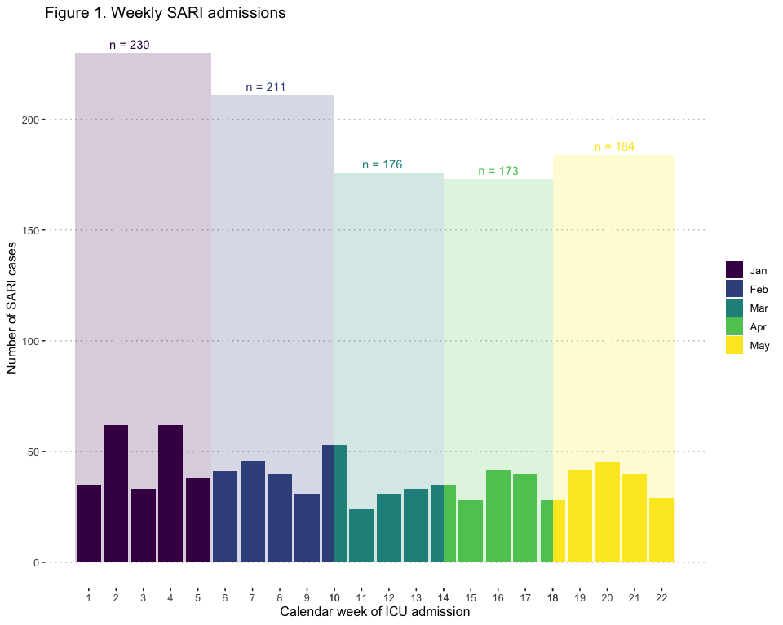

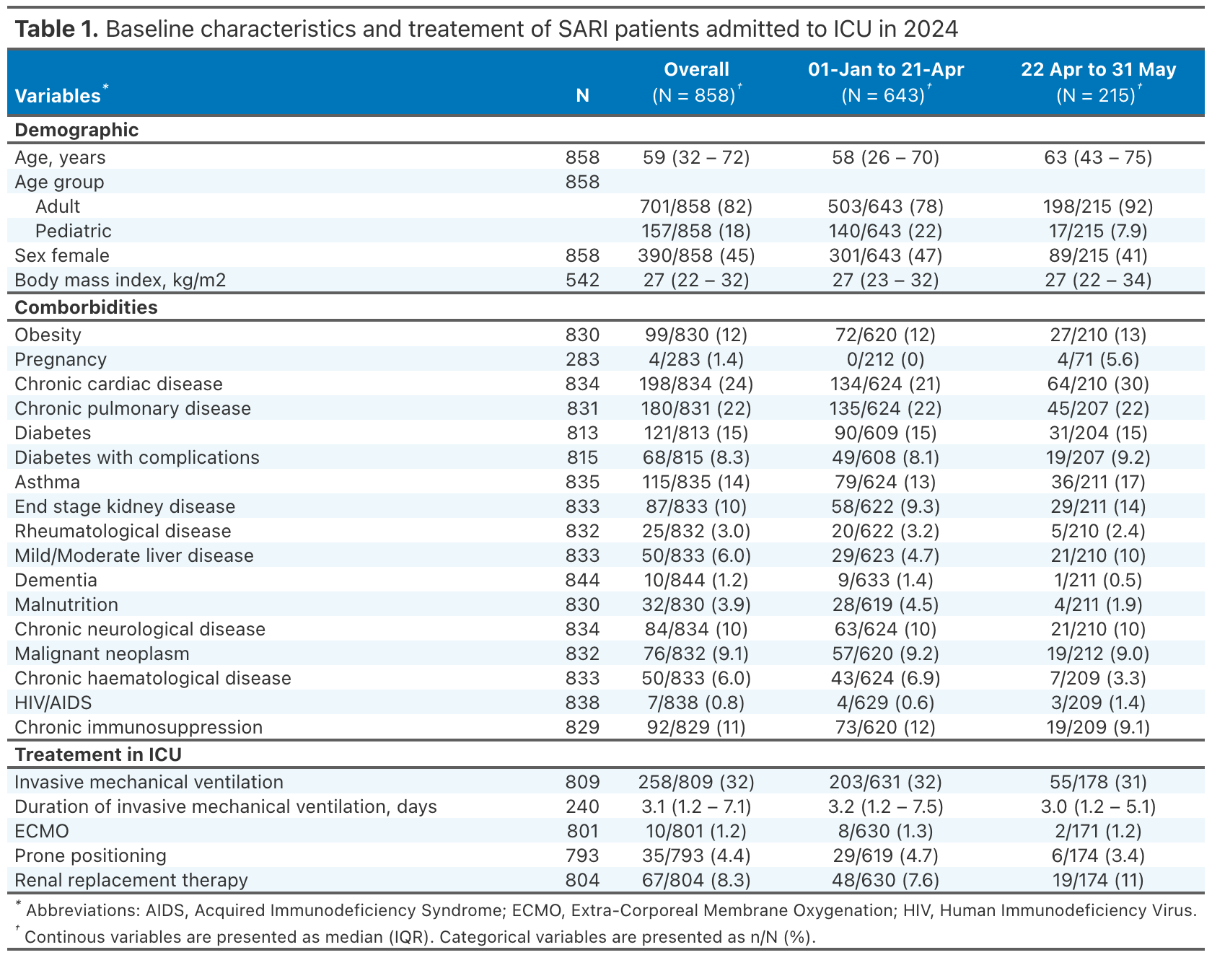

During the current study period 15/215 (7%) patients died in hospital, 101/215 (47%) were discharged home and 91/215 were still in hospital. The leading cause of death was treatment withdrawal (n = 6, 40%) followed by hypoxic respiratory failure (n = 3, 20%). The median length of stay in ICU and in hospital was 3 (2-5) and 6 (4-10) days, respectively. The outcomes of these patients are summarised in the **Table 2**.

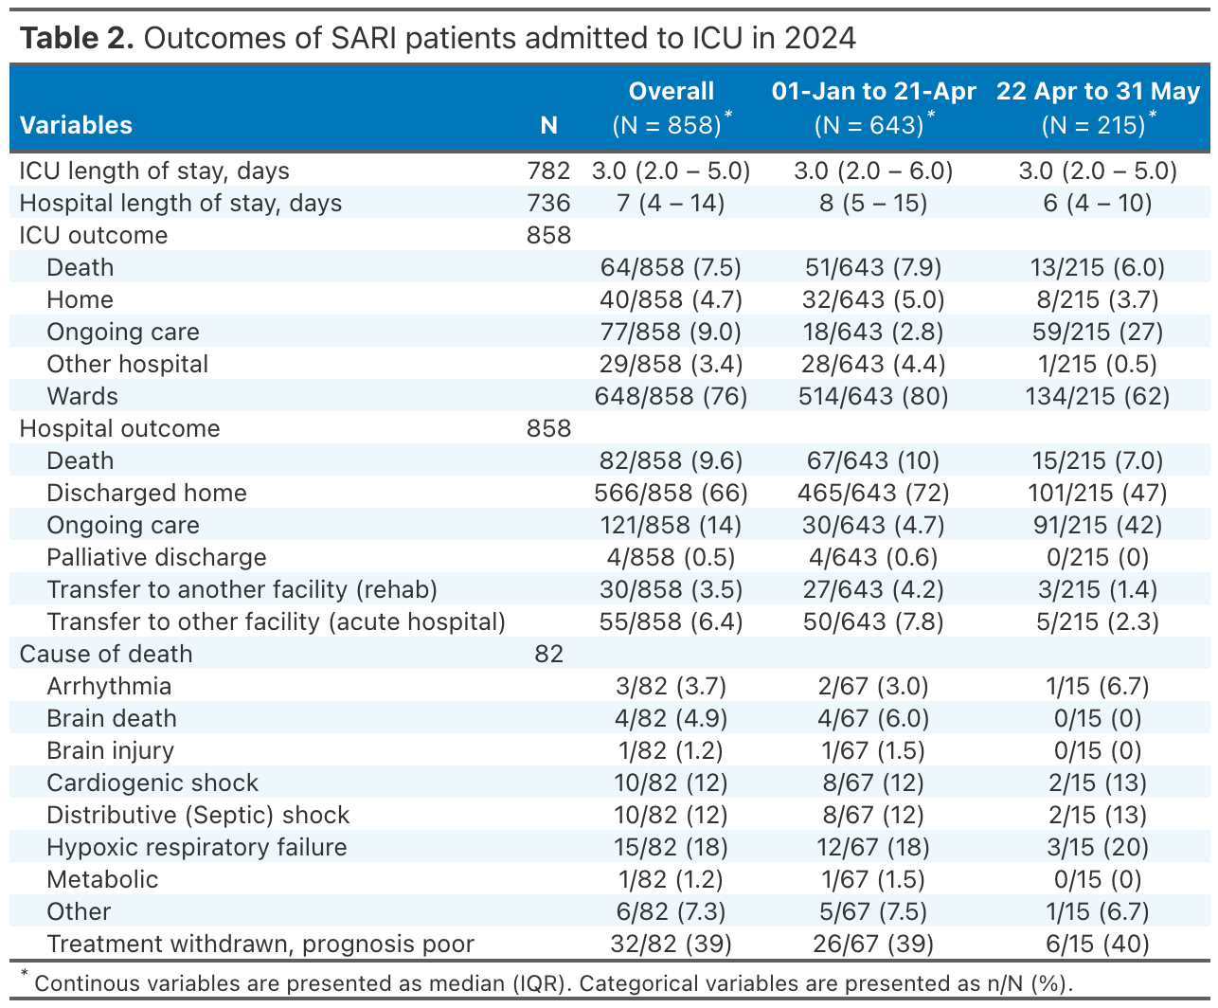

# Stratified by pathogen type

