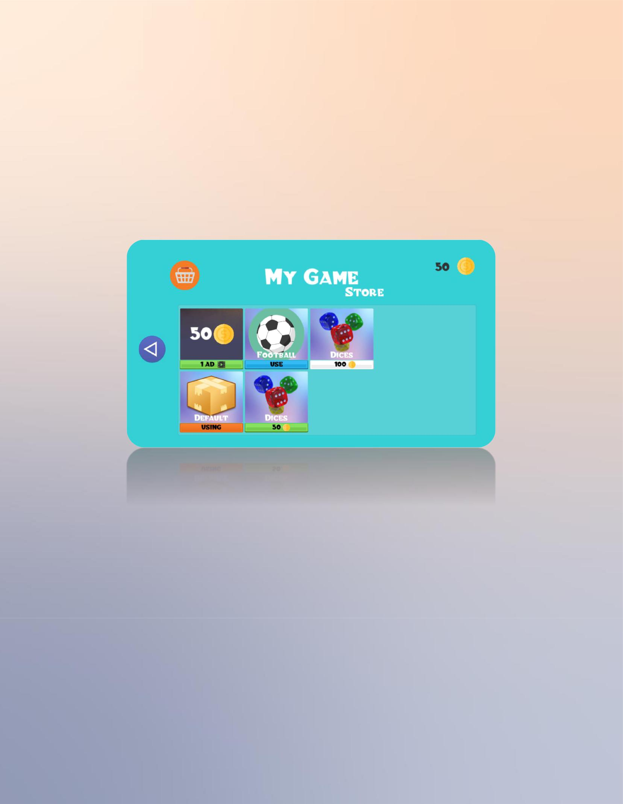
TECH AND PRO Presents

RateMe

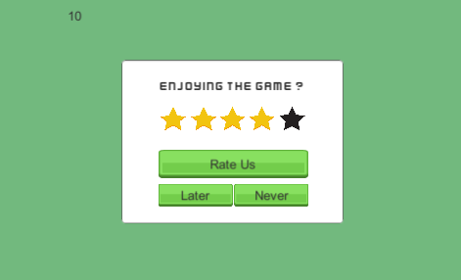

Asset By:

Tech & Pro and Anis Brachemi

Features :

- Easy to implement (2 minutes).

- Easy to use.

- Easy to customize.

- Demo Scene Included.

- Documentation and support in less than 24 hours.

Setup :

- Drag the RatingManager prefab from the prefab folder into your scene.

- Drag the RateUsPanel prefab from the prefab folder into the Canvas in your scene.

- Drag the newly add RateUsPanel to the RateUsPanel variable of the RatingManager.
- Add this code when your user dies or finishes a level (See video Tutorial for more details).
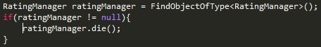

- You’re all set up, now fill the RatingManager Script variables.

NOTE : If you want to edit the RateUsPanel, make sure you only change sprites, do not touch buttons.

