**Chapter 1: Problem Statement & Description**

* 1. Project Background & Description

This app is being developed by developers for Taiba Tourism. This app is concerned with promoting tourism in Riyadh and it is also concerned with providing a convenient and an easy app for tourists who are visiting Riyadh for the first time. This app provides all the information a tourist needs when vising Riyadh: restaurants, hotels, attractions and even a google maps integration for tourists who are planning to rent a car in Riyadh.

This app has the following functionalities:

* Providing information for tourists and residents about the history of Riyadh, different attractions (cafes, museums, parks, malls and restaurants), different hotels (3 stars, 4 stars and 5 stars), different modes of transportation in Riyadh (budget taxis, London taxis and rent-a-car shops) and new events and happenings in Riyadh (which will be constantly updated) and all that is done in a simple and an easy to find manner.
* Google maps integration for tourists who think of renting a car during their visit to Riyadh. This integration helps the tourists to find different places they wish to visit and the easiest way to reach those places using Google maps.
* A weather widget integration in the app which constantly provides the tourists and residents with the weather of the place they are.
  1. Problem Statement/Opportunity

Such a system is being developed now because previously the number of tourists visiting Riyadh was a little, but since nowadays the number of tourists is increasing and the ministry of tourism wants to improve tourism and promote Riyadh; the need for such an app is required. Even though there are different tourism apps for Riyadh, all of them have one thing in common; bad programming and paying attention to details, that’s why until now there isn’t any official app that is sponsored by the ministry of tourism and this app is aiming at eliminating all the negative things the other apps contain and bring out a complete and a beautiful app for tourists who are visiting Riyadh.

* 1. Rationale

The main reasons of creating and developing this app is to promote Riyadh and make it a tourist destination in Saudi Arabia and also because the other tourism apps for Riyadh are inefficient and incomplete, hence this app is aiming to tackle all the incompleteness of these apps and bring out an app which is complete and functional for tourists and lastly to make this app the official tourism mobile app for Riyadh which will be supported by the ministry of tourism and this will allow us to take the app to the next level.

* 1. Project Objectives

The objectives of the project are as follows:

* To build an app which helps in promoting Riyadh.
* To build an app which provides easy information and eases traveling in Riyadh for tourists.
* Promote upcoming events and happenings in Riyadh.

1.5 Stakeholders

The stakeholders for this project are the tourists who are visiting Riyadh and even the residents of Riyadh as this app will be updated regularly with new happenings in Riyadh and after sometime the stakeholders will also be the tourists who are visiting Saudi Arabia, because this project is mainly for Riyadh for now, but after it’s done, it will be made for the whole of Saudi Arabia (the main cities) to help promote for tourism in Riyadh and Saudi Arabia.

1.6 Project Scope

The project scope is within Taiba Tourism requirements, which is providing a simple and a clean mobile app that promotes tourism in Riyadh for tourists and tells them about Riyadh, its main attractions, any new events in it, hotels to stay in and where to enjoy good food.

**Chapter 2: Research**

2.1 Academic Research

2.1.1 Language

For this particular programming project, HTML5 would be used as the programming language as it is well suited for mobile app development. HTML5 which stands for Hypertext Markup Language has the freedom of running in different mobile operating system platforms. HTML5 does not use a lot of system’s resources hence allowing it to run fast and does not slow down the processes. HTML5 is an open source and the current version to be used for this programming project is stable. With the presence of the HTML5 Rocks Community, it allows them to work together to fix any bugs encountered on the version and provide users with continuous support to expand the capabilities of HTML5 to cater the users’ needs.

Advantages of using HTML5:

* Most widely used programming language hence, easy to learn and familiarize with the language due to the books and online help available from the internet.
* It is free at no cost. This can be a good news for programmers and developers who want to start venture in the online market at low cost.
* Allowing better support and integration of different mobile operating systems such as iOS, Android and Windows Phone.

Disadvantages of using HTML5:

* May not be suitable for large applications as it is not modular which may be hard to maintain.

2.1.2 Database

2.2 Secondary Research

2.2.1 Findings of Similar Implemented Systems

The system that is to be implemented is categorized as a tourism application for mobile. There are not so many tourism applications for mobile about Riyadh that can be found online. With that, it makes it easier to make a research on the other applications to get an idea on developing the mobile app intended for Taiba Tourism. Most of the apps found are most likely to have the same functionalities hence; this will be discussed deeper on the similarities and comparisons.

The apps that will be discussed and compared are:

* Riyadh Travel Guide
* Riyadh City Guide

2.2.1.1 Riyadh Travel Guide

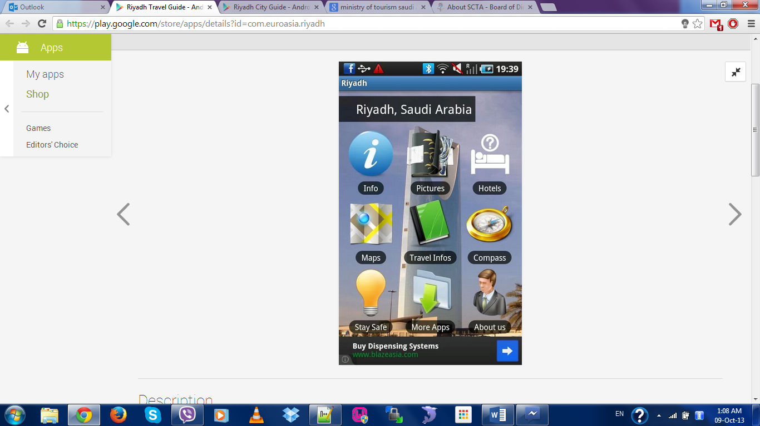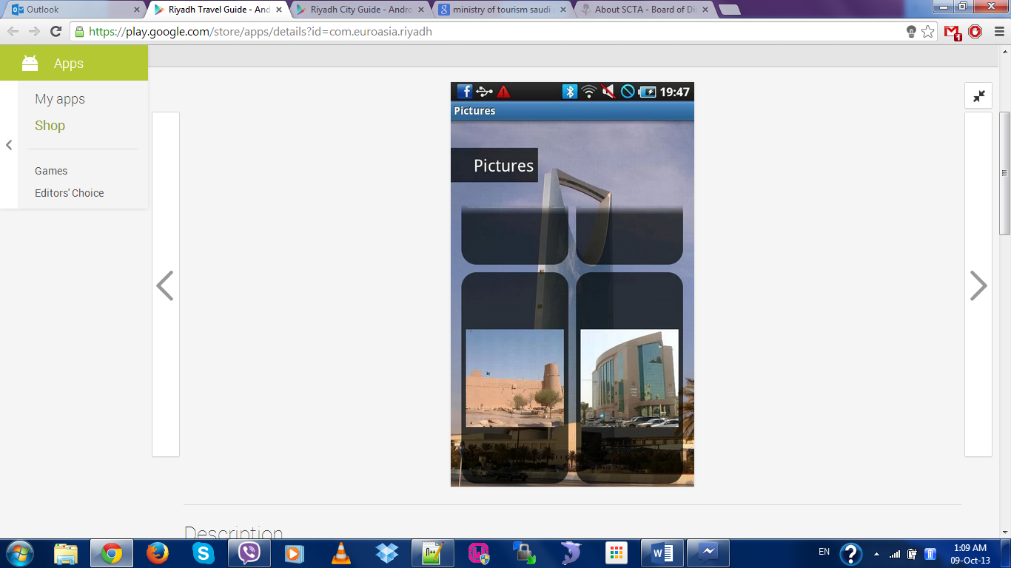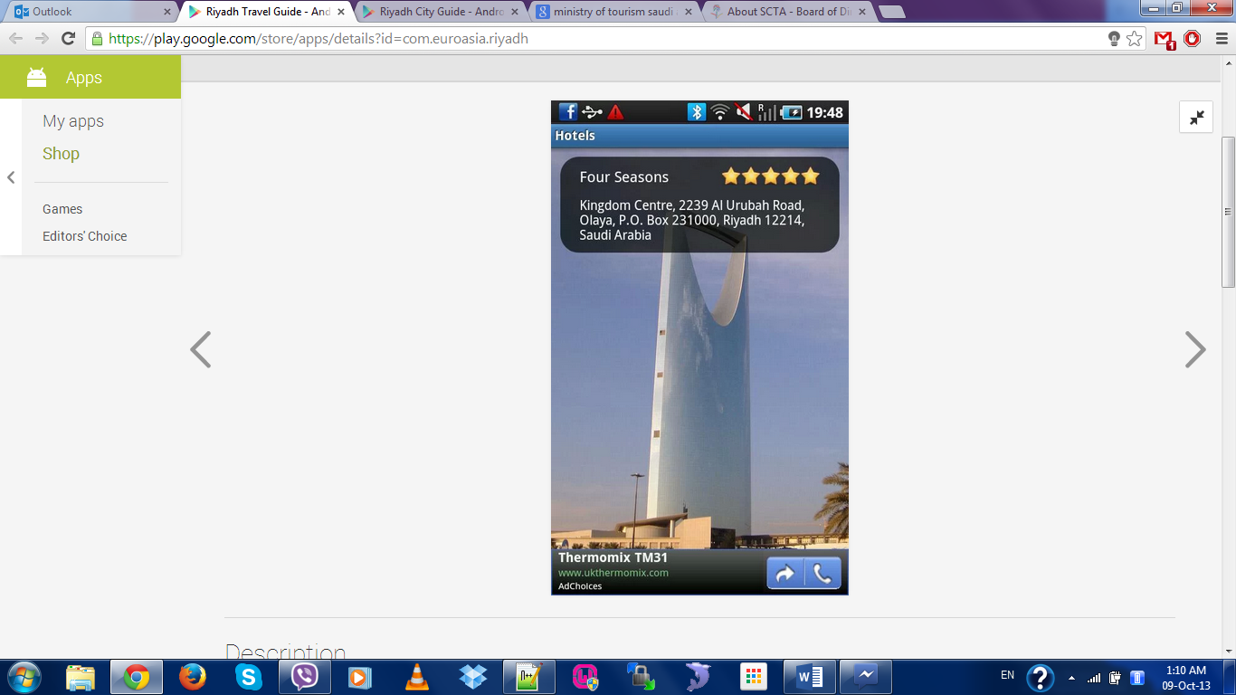

Figure 1: Screen Shots of Riyadh Travel Guide

|  |  |
| --- | --- |
| Features | Description |
| Provides General Information | Provides the tourists with general information about Riyadh. |
| Provides a Photo Library | Provides the tourists with photos taken from all around Riyadh. |
| Provides Information about Hotels | Provides the tourists with information about hotels (rating, phone number and address). |
| Google Maps integration | Provides the tourists with maps of Riyadh and Saudi Arabia using Google Maps. |
| Navigational Compass | Provides the tourists with a compass to help them identify the directions. |

2.2.1.2 Riyadh City Guide

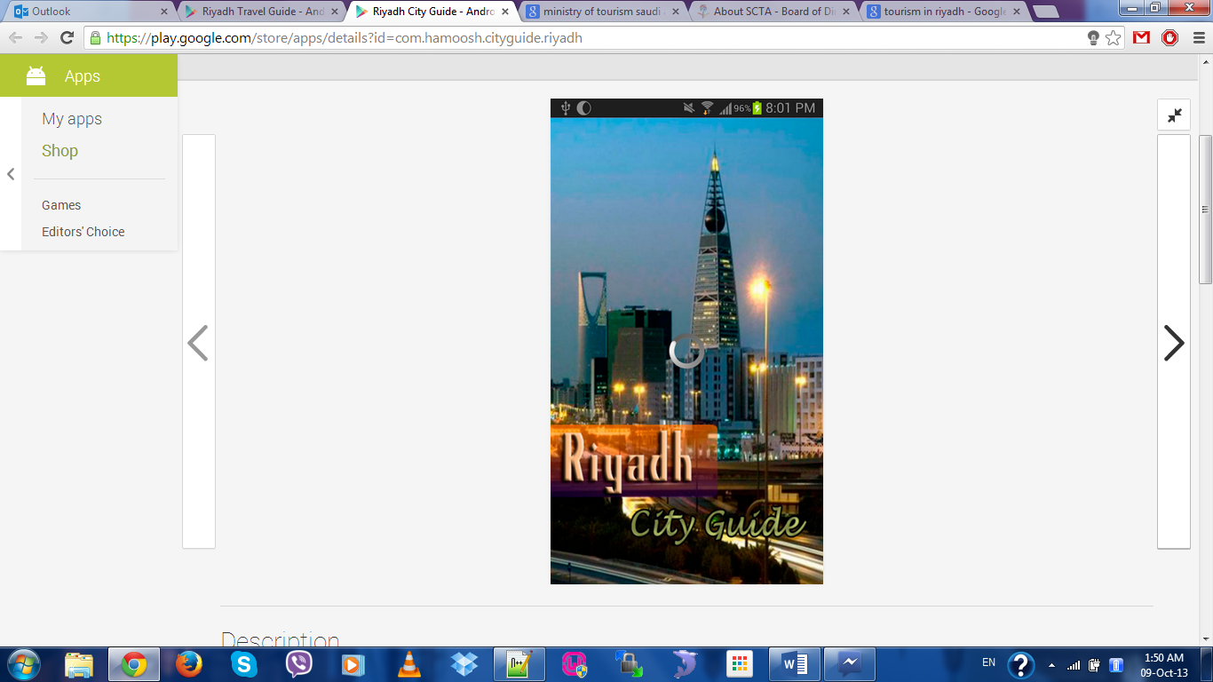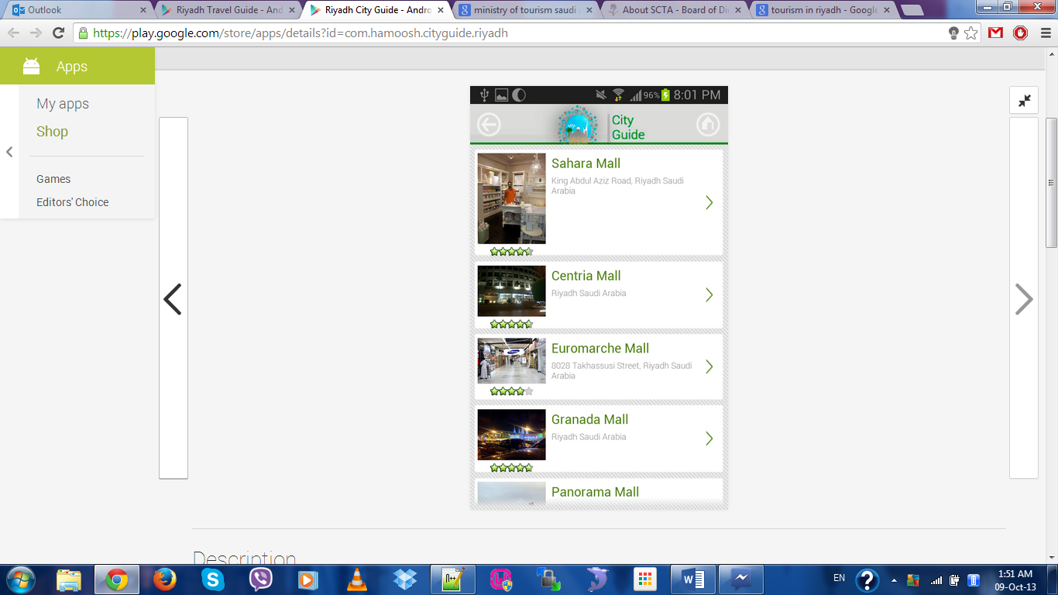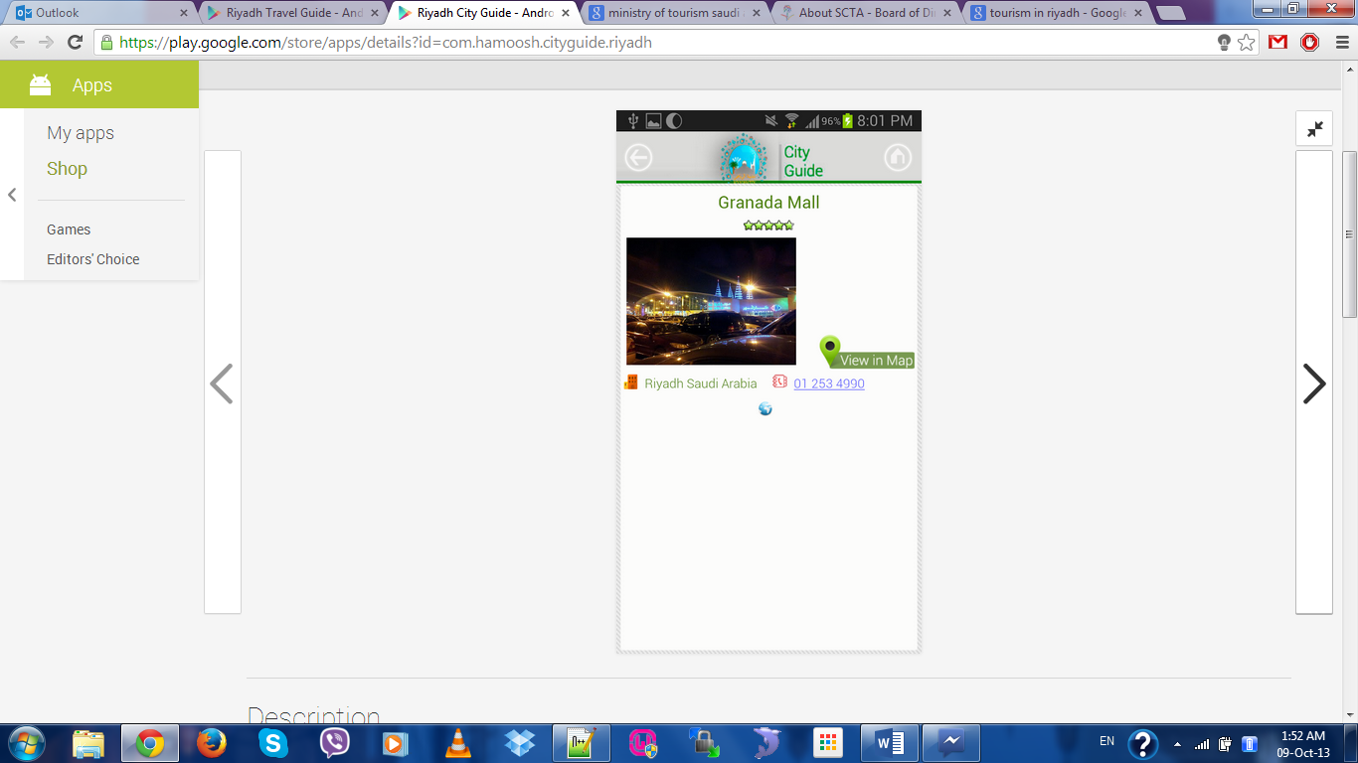

Figure 2: Screen Shots of Riyadh City Guide

|  |  |
| --- | --- |
| Features | Description |
| Provides Information about Hotels, banks, restaurants, hospitals, etc. | Provides the tourists with information about hotels, banks, restaurants, hospitals (phone number and address). |
| Google Maps integration | Provides the tourists with maps of Riyadh and Saudi Arabia using Google Maps. |

2.3 Primary Research

2.3.1 Rationale

Before the starting of the project, the developer had an interview session over Skype with the project support of Taiba Tourism. The purpose of conducting this interview is to gather requirements needed for developing the mobile app. Suggestions and feedbacks were given by the client on the ideas suggested to be built for the app. The interview held intends to understand clearly what the client wants in the app in order to avoid any doubt and ambiguities between developer and client.

2.3.2 Interview

Interview session over Skype was held in the very beginning of the stage of developing the project. The person interviewed is the project support of Taiba Tourism by the name of Eng. Abdul Aziz bin Abdullah Al Nasr.

**Chapter 3: Systems Analysis**

3.1 Analysis and Conclusion of Interview

After the interview session with the representative of Taiba Tourism, an analysis has been made. The Developer is expected to prepare a mobile app allowing the tourists and residents of Riyadh to download the app on their smartphones and browse through the application. In addition, there will be an admin view of the app to cater for management purposes.

Admin page will consist of:

* Ability to manage and update the mobile app with new attractions and places.
* Ability to update the events page to cater for all the new events and happenings.

Due to time constraints, the client had agreed that if the developer may have other better ideas during the development process to improve on the requirements given would be good for the client. In addition, by regularly updating the client would make it easier to get their feedback on the app’s design and features.

3.4 Risk Analysis

Every project involves there must be a risk and by identifying it at an early stage would make us easier to prevent the risk. According to Investopedia, risk management is the process of identification, analysis and either acceptance or mitigation of uncertainty in investment decision-making (Investopedia, 2013). Based on the simple definition of risk management, it proves that by identifying the risks of the project involve at an early stage would let the developer to take appropriate action to deal with the risk. By ignoring the risk would lead into a huge impact on the project outcome by end of the day.

Risk identified for this project:

* A proper time management to insure that work can be done on time.
* Too much feedback/suggestions from client could lead to moving away from the initial objectives of the app that is to be built.

**Chapter 4: Requirements Specification**

4.1 Functional Requirements

4.1.1 Use Case Diagram

4.1.2 Use Case Specification

4.2 Non-Functional Requirements (If Any)

4.3 Technical Specification

4.4 Gantt Chart