SAVITRIBAI PHULE PUNE UNIVERSITY

A MINI PROJECT REPORT ON

# CLOTHES DONATION APP

BY

|  |  |
| --- | --- |
| Mr.Anish Dhage | 31105 |
| Mr.Apoorv Dixit | 31106 |
| Mr.Ashwin Sapre | 31107 |
| Mr.Dhruv Inamdar | 31118 |

Under The Guidance of

Prof. U.S.Pawar

Class : TE 1



Pune Institute of Computer Technology Dhankawadi, Pune-411043



Pune Institute of Computer Technology

DEPARTMENT OF COMPUTER ENGINEERING

CERTIFICATE

This is to certify that the Project Entitled

## CLOTHES DONATION APP

Submitted by

|  |  |
| --- | --- |
| Student Name: Anish Dhage | Exam No: 3105 |
| Student Name: Apoorv Dixit | Exam No: 3106 |
| Student Name: Ashwin Sapre | Exam No: 3107 |
| Student Name: Dhruv Inamdar | Exam No: 3118 |

is a bona fide work carried out by Students under the supervision of Prof.U.S.Pawar and it is submitted towards the partial fulfilment of the requirement of Bachelor of Engineering (Computer Engineering).

Signature of Internal Examiner Signature of External Examiner

## Abstract

**INTRODUCTION**

The main aim of our project- ‘CloDo’ app is to enhance the experience of donating clothes online.

In today’s fast paced world, multiple NGOs have various events to increase donations from the masses. Our app aims to bring these organizations together and help people make informed choices about donating their clothes.

**MOTIVATION**

The motivation to make our app came from the need for a platform that allows individuals to donate items of clothing that they no longer use to organizations of their choice. CloDo is a user friendly application that can run on any Android devices running version 4.3+.

**OUTCOME**

Through the app we have donated clothes to organizations of the user’s choice with the help of a few clicks.

## Acknowledgments

It gives us great pleasure in presenting the preliminary project report on `CloDo APP'.

We would like to take this opportunity to thank my internal guide Prof.U.S.Pawar for giving us all the help and guidance we needed. We are really grateful to them for their kind support. Their valuable suggestions were very helpful.

We are also grateful to Dr. Rajesh B. Ingle, Head of Computer Engineering Department, PICT for his indispensable support and suggestions.

Anish Dhage

Apoorv Dixit

Ashwin Sapre

Dhruv Inamdar

(T.E. Computer Engg.)

# **Contents**

* **1. INTRODUCTION**
* **2. DESIGN AND ANALYSIS OF THE SYSTEM**
* **3. DISCUSSION ON THE IMPLEMENTATION OF RESULTS**
* **4. CONCLUSION AND FUTURE ENHANCEMENTS**
* **5. REFERENCES**

## CloDo

**Abstract:**

CloDo is an Android Application that helps the user donate clothes to an organization of his choice.

The user can view all organizations that can receive a donation. The organizations have a portal of their own to accept or reject donations based on feasibility.

**Keywords:** Android, Application etc.

**Introduction:**

CLoDo is a sophisticated platform with two separate portals for users and organizations. Users can donate a package of clothes to an organization of their liking at any time of the year.

Hence, we have attempted to devise an app which would help the user make informed choices with regards to charity.

**Requirements:**

User requirements:

The user expects that the complete list of all charitable organizations functioning in or around his area be displayed in a user friendly way. The organization is notified on their portal about the donation, and they have the option to accept or reject it based on the feasibility of the package.

System requirements:

In this project the developer's requirement is a robust database management system. The database is needed to store the following attributes of a user- email id, password, name, phone number, address etc. Furthermore, he would need a web hosting service which acts as an interface between the app and the database server. The web hosting service is expected to process multiple requests at a time without freezing. The obvious requirements are Android Studio, mobile phone (Android OS) for testing purposes.

**Design and analysis of system:**

The design of the system is based on the feasibility factor which allows the organization to accept or reject donations. The user is notified about the same in order to maintain transparency.

If the Donation is accepted, the organization picks the package up from the specified address. If it is rejected, the user can re-upload the donation and it can be serviced by another organization.

**Discussion on implementation of results:**

The result obtained by the system can be discussed as follows:

The user has to sign up to the app service with his name, contact number, email id, age, address and password. Unless all the fields are filled out the user is not allowed to sign up. After sign up, the user can login using his unique contact number and password.

The user can choose from a variety of organizations based on personal preference. From here on, the user can upload a package to donate. This shows up on the organization portal, who are given a choice between accepting or rejecting the package.

Thus, the result obtained by the system is categorized into 3 parts:

1. Sign up and subsequent logging in to the user's account.
2. Display of all available organizations.
3. Acceptance or rejection of Donation on organization portal.

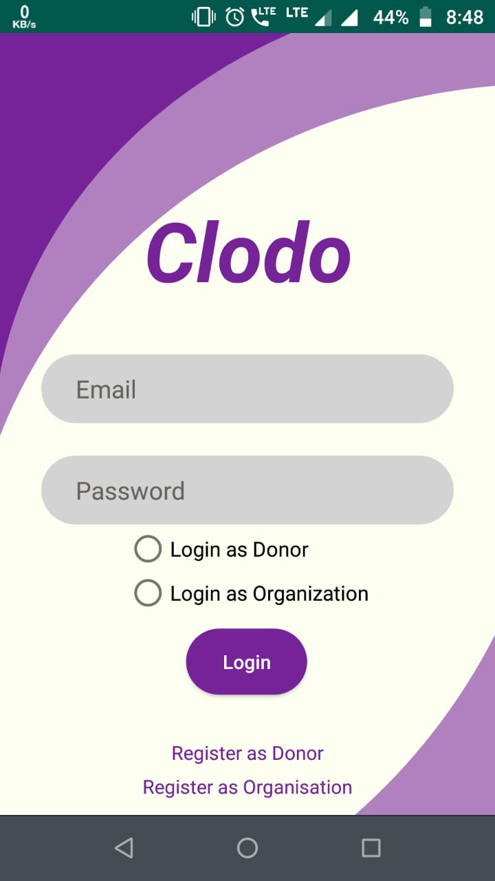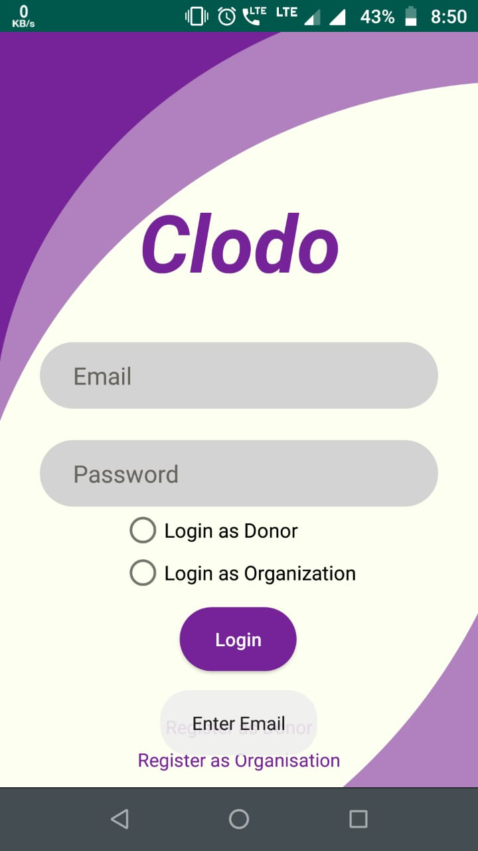

## 

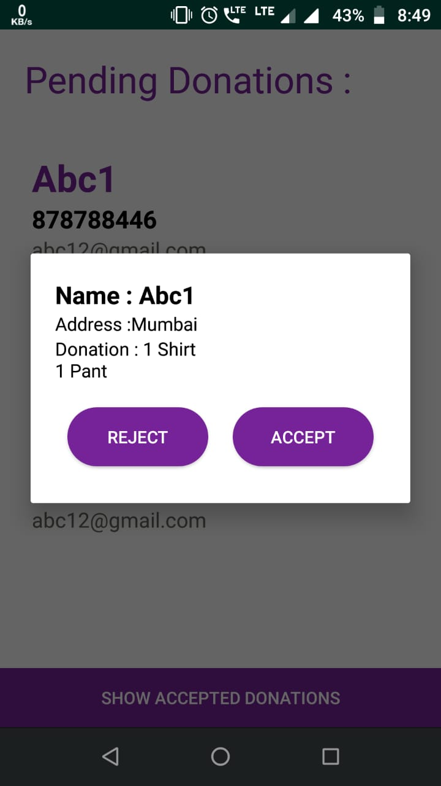

**Conclusion and future enhancements:**

With CloDo, we have essentially created a platform to allow users to donate clothes to organizations of their choice.

Enhancements that can be done to CloDo are:

-GPS facility to locate organizations closest to the user’s current location.

-Live Tracking of the package.

-Requests from organizations for seasonal clothing.

-Email prompts and SMS prompts.

**References:**

* + **stackoverflow.com**
  + **developer.android.com**
  + **Youtube videos on Android development**