Basic Arduino Info:

[You can learn Arduino in 15 minutes.](https://www.youtube.com/watch?v=nL34zDTPkcs)

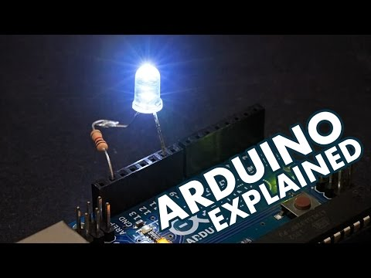

We can use this and apply it to pretty much every arduino board out there, so defo worth a watch.

The Adafruit Metro Board is an Arduino Uno Equivalent with a few extra features.

Here are some Arduino Uno Wifi Robot Car Projects:

[How to Make Arduino ESP8266 WiFi Robot Car | Controlled with Application](https://www.youtube.com/watch?v=2AL7HfiRlp4&ab_channel=MERTArduino%26Tech)

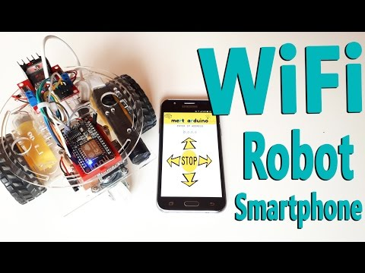

[How to Make DIY Arduino SmartPhone controlled WiFi car Using NodeMCU Esp8266, L298N Motor Driver](https://www.youtube.com/watch?v=o_AvH5nuwLg&ab_channel=MakeDIY)

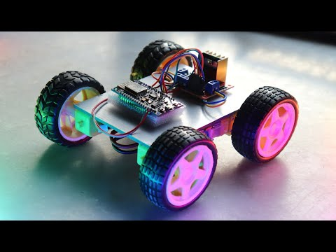



https://learn.adafruit.com/adafruit-winc1500-wifi-shield-for-arduino/pinouts

https://cdn-learn.adafruit.com/downloads/pdf/adafruit-winc1500-wifi-shield-for-arduino.pdf

https://www.adafruit.com/product/2999

https://www.youtube.com/watch?v=ZH7ufemP8e0

https://www.arduino.cc/reference/en/libraries/wifi101/

http://docs.arduino.cc/hardware/mkr-1000-wifi

https://www.youtube.com/watch?v=aQcJ4uHdQEA

https://docs.arduino.cc/software/ide-v1/tutorials/installing-libraries

https://github.com/edstott/EEERover/tree/main/metro-starter-arduino

https://learn.adafruit.com/adafruit-metro-m0-express/arduino-ide-setup

https://github.com/khoih-prog/WiFiWebServer

https://www.adafruit.com/product/3505

https://www.youtube.com/watch?v=dWM4p_KaTHY

<https://www.arduino.cc/reference/en/libraries/wifi101/>

Okay. 20th May 2022.

We can control the motor speed using the potentiometers, the next step is to make it purely digitial without the potentiometers.

For reference, here is the schematic for potentiometers, and a back up: