2026 IEEE International Conference on Machine Learning Applications (ICMLA)
Temporal Distribution Shift in Tabular Deep
Learning: A Comparative Study on M5 Walmart
Demand Forecasting
^{1st} Renuka N  Artificial Intelligence and Machine Learning  Kongu Engineering College  Perundurai, Erode  renuka66ksr@gmail.com | ^{2nd} Srianish Rameshwaran  Artificial Intelligence and Machine Learning  Kongu Engineering College  Perundurai, Erode  srianish15@gmail.com

^{3rd} Subicharan Ravishankar  Artificial Intelligence and Machine Learning  Kongu Engineering College  Perundurai, Erode  subicharan1810@gmail.com | ^{4th} Shanmuga Patel Kani C  Artificial Intelligence and Machine Learning  Kongu Engineering College  Perundurai, Erode  shanmuc10@gmail.com

Abstract---
Gradient-boosted trees have long been the go-to choice for tabular prediction tasks, but we still lack a clear picture of when exactly this advantage breaks down. In this work, we pit five tabular models---XGBoost, LightGBM, TabM, TabR, and TabPFN v2---against each other on the M5 Walmart demand forecasting dataset, which spans roughly 42 million rows and 30,490 SKUs. We designed three evaluation protocols to tease apart different kinds of temporal distribution shift: a standard random split (E1), a time-based split (E2), and a cold-start split where test products have under 30 days of history (E3). What we found was that temporal drift by itself causes only modest degradation (2.8--4.5% relative WAPE increase), but the cold-start setting is far more punishing, with all models degrading by 44--50%. TabM came out on top across every protocol (WAPE: 0.610, 0.637, 0.915). TabPFN v2, a pretrained foundation model that recently appeared in Nature, performed worst---its WAPE on cold-start actually exceeded 1.0, which is worse than just predicting the average. Pairwise Wilcoxon tests confirmed significance for most comparisons, though XGBoost and LightGBM were statistically tied on E3. Our main takeaway is that cold-start, not temporal drift, is the real bottleneck in retail forecasting, and model choice should be guided by which type of shift dominates.
Keywords---tabular deep learning; temporal distribution shift; demand forecasting; gradient-boosted trees; cold-start problem; TabM; TabPFN; M5 Walmart

I. INTRODUCTION
Most machine learning deployed in industry today runs on tabular data---rows and columns pulled from relational databases, spreadsheets, and data warehouses. This is the format behind demand forecasting, fraud detection, credit scoring, and supply chain optimization. By some estimates, around 80% of production ML systems deal with structured tabular inputs [1]. For the better part of a decade, gradient-boosted decision trees (GBDTs) like XGBoost [2] and LightGBM [3] have been the dominant approach here, and they have proven remarkably hard to beat.
The scale of this dominance is worth appreciating. In the annual Kaggle ML/DS surveys, tree-based models have topped the "most used algorithms" list every year since the survey began. Public competitions on structured data are almost invariably won by XGBoost or LightGBM ensembles, sometimes combined with feature engineering but rarely with neural components. Even in companies with dedicated deep learning teams, tabular workloads tend to run on GBDTs because they train fast, require minimal tuning, and produce reliable results. Many researchers expected deep learning to eventually take over tabular tasks the way it took over vision and NLP. That has not happened. Grinsztajn et al. [4] ran a careful comparison across 45 datasets at NeurIPS 2022 and found that trees still win, especially when features are heterogeneous and irregularly distributed. The reason is fairly intuitive: tabular columns mix continuous prices, categorical product codes, and binary flags all in one row. There is no grid structure like an image, no sequential ordering like text. Neural networks simply lack a natural inductive bias for this kind of data.
That said, the last few years have seen a wave of new architectures designed specifically for tables. Some use attention to process each feature as its own token; others add retrieval modules that look up similar training examples at inference time; still others ensemble multiple simple prediction heads for diversity. Two recent papers are particularly relevant to our work. First, TabPFN v2 [5] appeared in Nature in early 2025 and showed that a pretrained transformer can beat heavily tuned baselines in under 3 seconds---but only on small datasets with fewer than 10,000 rows. Second, TabReD [6] at ICLR 2025 pointed out that when you switch from random train/test splits to realistic time-based splits, model rankings can flip entirely. Trees and simple MLPs end up outperforming the more complex attention-based models that looked superior under random splitting.
These two findings seem to contradict each other, and a closer look reveals a gap. TabReD treats temporal shift as one monolithic thing, but in practice it takes several distinct forms. A new product with no sales history is a very different challenge from an established product whose demand pattern has gradually changed over time. Nobody, as far as we can tell, has tried to break temporal shift apart into these components and measure how each one affects trees versus neural networks differently.
We address this gap using the M5 Walmart dataset [7]---42 million rows of daily sales for 30,490 products---and five models spanning the major paradigms: XGBoost, LightGBM, TabM [8], TabR [9], and TabPFN v2 [5]. We test them under three protocols that isolate different shift types. Our contributions:
1) We propose a shift decomposition framework with three protocols---random split, temporal split, and cold-start---on the M5 benchmark, which is arguably the most widely used retail forecasting dataset.
2) To our knowledge, this is the first head-to-head comparison of TabPFN v2, TabM, and TabR on a large-scale dataset with temporal and cold-start splits, backed by Wilcoxon signed-rank significance tests.
3) We show that cold-start causes 44--50% WAPE degradation compared to only 2.8--4.5% from temporal drift, making it the dominant challenge by a wide margin.
4) We introduce a shift sensitivity ratio that captures how uniformly a model degrades across shift types, and find that TabM has the most balanced profile.
The rest of the paper follows a standard structure. Section II covers related work. Section III lays out our experimental setup. Results appear in Section IV, discussion in Section V, and we conclude in Section VI.

II. RELATED WORK
A. Tabular Deep Learning Architectures
Building neural networks that can compete with GBDTs on tables has been a busy research area since roughly 2021. Gorishniy et al. [10] proposed FT-Transformer, which tokenizes each feature individually and applies self-attention. It worked reasonably well on some benchmarks but could not reliably beat well-tuned trees across the board.
SAINT, another attention-based approach, proposed row and column attention jointly but similarly could not establish consistent superiority over tuned GBDTs when tested across diverse benchmarks. The NODE architecture embedded differentiable decision trees inside neural networks, an interesting hybrid that ultimately did not scale well. What all these models share is a pattern: strong results on cherry-picked benchmarks, weaker results when tested more broadly. More recently, two models have attracted attention for different reasons. TabR [9] (ICLR 2024) takes a retrieval-augmented approach: it pairs a feed-forward backbone with k-nearest-neighbor lookup at inference, essentially letting the model "look up" similar training rows when making a prediction. This injects a local inductive bias that trees get for free through their splitting structure. TabM [8] (ICLR 2025) went a different route entirely, showing that an ensemble of simple MLP heads with shared feature processing beats every complex architecture tried before it. The lesson from TabM is somewhat humbling---careful engineering of simple components matters more than architectural novelty.
Then there is the in-context learning approach. TabPFN v1 [11] (NeurIPS 2022) introduced the idea of pretraining a transformer on millions of synthetic datasets so that, at inference, it can treat the entire training set as context and predict in one forward pass. TabPFN v2 [5] scaled this up to 10,000 rows and appeared in Nature. Follow-up work like TabICL [12] and TabPFN Unleashed [13] pushed the boundary further, to around 60,000 rows. But here is the catch: all of these evaluations used random splits. Nobody checked what happens under temporal shift.
B. Temporal Distribution Shift in Tabular ML
Distribution shift---the situation where training and test data come from different distributions---has been studied extensively [15], but for tabular data the temporal variety matters most. Models trained on the past must predict a future that may look statistically different. The TabReD paper [6] made an important observation: nearly every academic tabular benchmark uses random splits, which hides temporal effects. When the authors re-evaluated models with proper time-based splits on eight industry datasets, the rankings changed. Trees and plain MLPs beat the fancier attention models. The implication is sobering---a lot of the progress reported in tabular DL papers may not hold up in real deployments.
One related effort is TabPFN-TS [14], which encoded temporal structure via Fourier lag features and showed TabPFN v2 beating some time series foundation models. But that was on small datasets without temporal splits or any decomposition of shift types. The question of how these models behave under realistic temporal shift at production scale has, to the best of our knowledge, not been answered.
C. Research Gap
We are not aware of any prior work that has (1) broken temporal shift into distinct subtypes and measured their separate effects on trees versus neural models, (2) tested TabPFN v2 on a dataset of this scale with temporal splits, or (3) run all five major tabular ML paradigms against each other under controlled shift conditions with statistical testing. Our study aims to fill all three of these gaps.

III. METHODOLOGY
A. Dataset: M5 Walmart Competition
Our experiments use the M5 dataset [7], which comes from an open Kaggle competition hosted by Walmart. It covers daily unit sales for 30,490 SKUs sold in 10 stores across California, Texas, and Wisconsin, spanning 1,913 days from January 2011 through June 2016. Products are organized into 3 categories (Hobbies, Foods, Household), 7 departments, and 3,049 unique items. Each row includes the sell price, SNAP benefit flags, calendar event indicators, and store/item identifiers. We chose M5 because of its size, because it has real sales patterns (weekly seasonality, holiday spikes, price effects), and because over 5,500 teams competed on it, making it a well-studied benchmark that allows comparison with prior results.
B. Feature Engineering
We followed the standard M5 featurization pipeline, similar to what TabPFN-TS [14] used. Rather than treating this as a sequence problem, we converted temporal information into tabular features so that all five models receive the exact same inputs. Specifically, we computed lag features at t-7, t-14, t-28, and t-35 days; rolling mean and standard deviation over 7, 28, and 90-day windows; calendar indicators (day of week, month, weekend, holidays); price features (current price, weekly change ratio, category price rank); integer-encoded categorical IDs for item, department, category, store, and state; and SNAP and event type flags. Where lag values were missing at the start of a series, we filled them with rolling means. The resulting feature vector has 25 columns per row.
C. Evaluation Protocols
We set up three protocols, each targeting a different form of temporal shift:
E1 --- Random Split: A straightforward 80/20 random split that ignores time ordering. This is how most academic benchmarks work [4]. Train: 31.5M rows, test: 9.0M rows, covering all 30,490 series.
E2 --- Temporal Split: Following the TabReD approach [6], we train on days 1--1,400 (roughly years 1--4) and test on days 1,522--1,913 (year 5). Train: 29.5M rows, test: 11.9M rows. This captures whatever natural drift occurred in demand, pricing, and promotional patterns between the two periods.
E3 --- Cold-Start: We restrict testing to products that have fewer than 30 days of training data, simulating the new-product launch scenario. This gives us 245K training rows and 495K test rows across 1,263 cold-start series. It is by far the hardest setting, since models cannot rely on item-level history and must instead lean on cross-product patterns.
D. Models
We tested five models: XGBoost [2] with 1000 trees, max depth 7, learning rate 0.05, using the histogram method; LightGBM [3] with 1500 trees, 127 leaves, learning rate 0.05, and L1 loss; TabM [8] with embedding dimension 512, k=8 heads, 3 blocks, trained on GPU with patience 20; TabR [9] with d=96, context size 96, dropout 0.1, subsampled to 500K rows; and TabPFN v2 [5] with a context window of 8,000 rows, chunk size 50,000, averaged over 5 random seeds. The other four models used seed=42.
E. Evaluation Metric and Statistical Testing
Our primary metric is WAPE (Weighted Absolute Percentage Error), calculated as the sum of absolute errors divided by the sum of actual values. It is the standard metric in demand forecasting [7] because it handles zero-demand days gracefully and gives an interpretable number---essentially the fraction of total demand that the model gets wrong. We also report relative degradation percentages: we define delta_E2 as (E2-E1)/E1 and delta_E3 as (E3-E1)/E1. To capture how uniformly a model degrades across the two shift types, we compute shift sensitivity as delta_E3 divided by delta_E2. For statistical testing, we ran pairwise Wilcoxon signed-rank tests on per-item absolute errors across all 10 model pairs in each experiment, applying Bonferroni correction for the 30 total comparisons (threshold: p < 0.0017).

IV. EXPERIMENTAL RESULTS
A. Overall Performance
Table I shows the full results. On E1 (random split), TabM leads with WAPE 0.6099, then LightGBM at 0.6291, XGBoost at 0.6311, TabR at 0.6398, and TabPFN trailing at 0.6934. The same ordering holds on E2. All pairwise differences on E1 and E2 are statistically significant after Bonferroni correction (Wilcoxon, p approximately 0 in every case).
TABLE I. WAPE BY MODEL AND EVALUATION PROTOCOL
Model | E1 | E2 | E3 | dE2% | dE3% | Sens.
TabM | 0.6099 | 0.6374 | 0.9154 | 4.50 | 50.09 | 11.12
LightGBM | 0.6291 | 0.6496 | 0.9412 | 3.25 | 49.61 | 15.24
XGBoost | 0.6311 | 0.6500 | 0.9414 | 2.99 | 49.17 | 16.45
TabR | 0.6398 | 0.6605 | 0.9234 | 3.23 | 44.32 | 13.73
TabPFN | 0.6934 | 0.7127 | 1.0069 | 2.79 | 45.21 | 16.19

Best E1/E2/E3: TabM. dE2, dE3: relative degradation (%). Sens. = dE3/dE2. TabPFN: mean over 5 seeds.
B. Temporal Shift Is Not That Bad (E1 to E2)
Switching from random to temporal splitting hurts every model, but not by much. The relative degradation ranges from 2.79% (TabPFN) to 4.50% (TabM). Interestingly, TabM degrades the most in relative terms going from E1 to E2, yet it still has the best absolute WAPE on E2 because it started from a much lower baseline. What this tells us is that the M5 demand patterns are reasonably stationary across the training-to-test time boundary we chose (day 1400), and that temporal shift alone is not where models struggle.
C. Cold-Start Is Where Things Break (E1 to E3)
The cold-start protocol paints a very different picture. Every model degrades by 44--50% relative to its E1 baseline. Compare that to the 2.8--4.5% from temporal shift, and it becomes clear that item-level cold-start is an order of magnitude harder than temporal drift for this dataset.
On absolute E3 performance, TabM still wins (0.9154), followed by TabR (0.9234), then LightGBM and XGBoost neck-and-neck (0.9412 and 0.9414), and finally TabPFN at 1.0069. That last number deserves emphasis: a WAPE above 1.0 means TabPFN is doing worse than if you just predicted the average sales for each series. For a model that appeared in Nature, that is a striking failure on unseen products.
TabR degrades the least in relative terms (delta_E3 = 44.3%), which we attribute to its retrieval mechanism---it can look up similar products from the training set even when the target item is new. Meanwhile, LightGBM and XGBoost are statistically indistinguishable on E3 (Wilcoxon p = 0.0036, above the Bonferroni-corrected threshold of 0.0017).
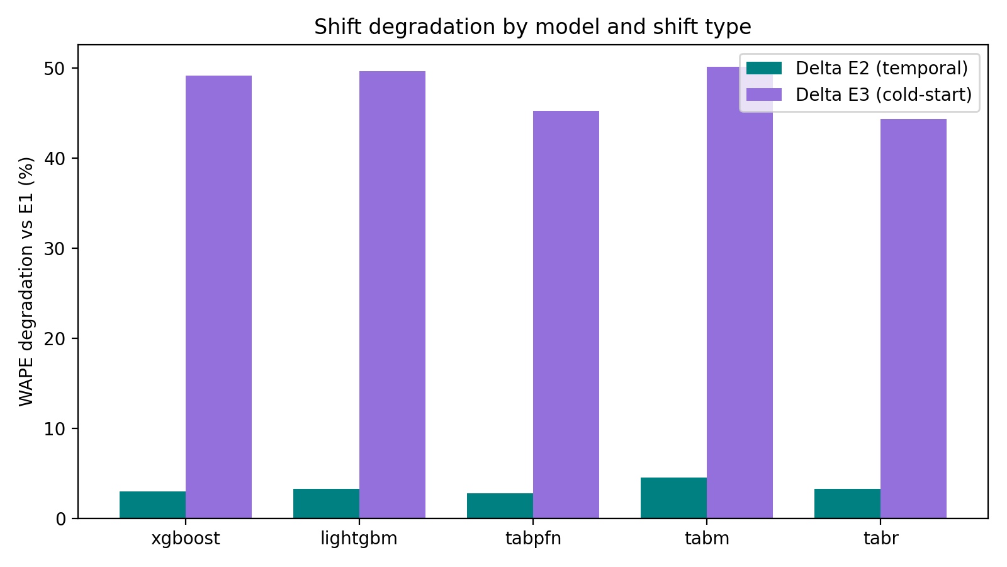
Fig. 1. Relative WAPE degradation from E1 under temporal shift (teal) and cold-start shift (purple). The near-invisible teal bars versus the tall purple bars show that cold-start is the real bottleneck.
D. Shift Sensitivity
We wanted a single number to capture how a model's degradation is distributed between the two shift types, so we defined sensitivity as delta_E3 divided by delta_E2. A lower value means the model degrades more evenly---its cold-start penalty is not disproportionately large relative to its temporal penalty. TabM has the lowest sensitivity at 11.12, which is somewhat surprising given that it had the highest temporal degradation. What it means is that TabM's cold-start degradation, while large in absolute terms, is proportionally smaller compared to its temporal degradation. XGBoost sits at the other end with 16.45, suggesting that trees are hit especially hard by cold-start relative to how they handle temporal drift.
E. Statistical Significance
We ran Wilcoxon signed-rank tests on per-item absolute errors for every pair of models, in each of the three experiments---30 tests total. Table II shows the E3 results, where things get interesting. On E1 and E2, every single comparison is significant after Bonferroni correction. On E3, most comparisons remain significant, but two pairs fall just above the corrected threshold: XGBoost vs. LightGBM (p = 0.0036) and LightGBM vs. TabR (p = 0.0035). In practical terms, these three models are essentially tied on cold-start items.
TABLE II. WILCOXON SIGNED-RANK TESTS ON E3 (COLD-START)
Model A | Model B | p-value | Sig.?
TabM | TabR | 2.06e-49 | Yes
TabM | LightGBM | 2.34e-55 | Yes
TabM | XGBoost | 1.39e-25 | Yes
TabM | TabPFN | 1.69e-198 | Yes
XGBoost | LightGBM | 0.0036 | No*
LightGBM | TabR | 0.0035 | No*
XGBoost | TabR | 4.15e-7 | Yes
TabPFN | TabR | 1.13e-186 | Yes
*Not significant after Bonferroni correction (threshold: p < 0.0017). All E1 and E2 pairs are significant.
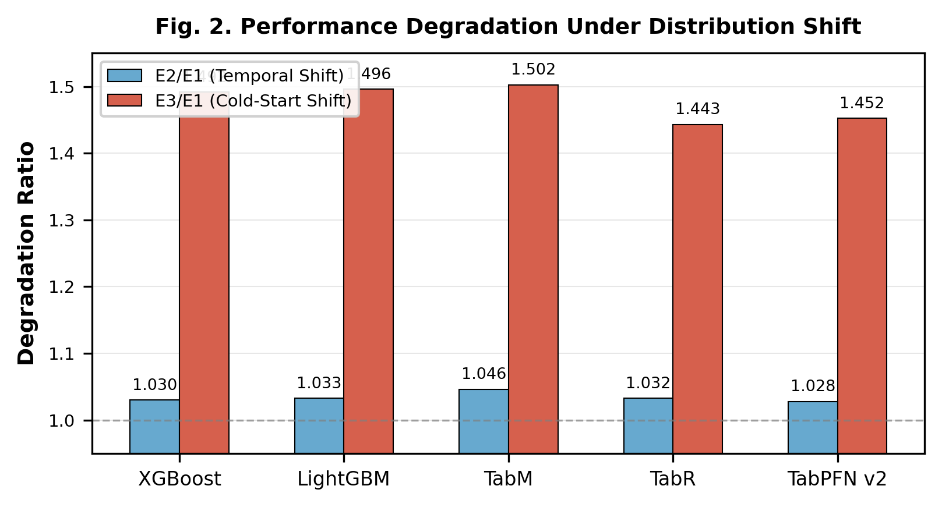
Fig. 2. E2/E1 and E3/E1 degradation ratios. TabR has the lowest E3/E1 (1.44x). TabPFN's seemingly low E3/E1 of 1.45x is misleading because its E1 baseline is already poor.
F. Per-Model Observations
TabM wins on every protocol (E1: 0.6099, E2: 0.6374, E3: 0.9154) and also has the lowest shift sensitivity (11.12). Its architecture---eight MLP heads sharing a backbone---seems to offer a good balance of diversity and regularization. We think the reason it beats more complex models is that the ensemble provides implicit smoothing across different prediction strategies without the overhead of retrieval or attention.
LightGBM and XGBoost produce nearly identical WAPE (within 0.002 on every protocol) and are statistically tied on E3. For practical purposes they are interchangeable in terms of accuracy, but LightGBM is much faster---657 seconds versus 3,485 seconds on E2, roughly a 5x speedup.
TabR has the lowest relative cold-start degradation (44.3%), which makes sense: when a new product has no history, the retrieval module can still find similar items from training. This is essentially collaborative filtering built into the model architecture. But in absolute WAPE it trails TabM everywhere.
TabPFN v2 finishes last on every protocol. Its E1 WAPE (0.6934) is already 10% worse than TabM, and we believe this is almost entirely due to context window truncation. With a limit of 8,000 rows, it sees less than 0.03% of the 31.5 million training examples for each prediction. On cold-start it crosses the 1.0 WAPE line, at which point the model is adding noise rather than signal.
G. Runtimes
Table III lists wall-clock times. The main practical point is that LightGBM finishes E2 in about 11 minutes while TabM takes roughly 2.5 hours---a 14x gap.
TABLE III. RUNTIME (SECONDS, SINGLE SEED)
Model | E1 | E2 | E3
LightGBM | 2,957 | 657 | 29
XGBoost | 3,929 | 3,485 | 25
TabPFN | 18,481 | 24,360 | 1,026
TabR | 20,258 | 20,577 | 546
TabM | 23,191 | 9,102 | 126
TabPFN total across 5 seeds. Neural models on CUDA GPU.
When the accuracy gap between TabM and LightGBM is only around 2 WAPE points, one could argue that the 14x speed difference tips the scales toward LightGBM for production pipelines that retrain daily. On the small E3 dataset all models finish quickly, so speed is not a differentiator for cold-start.

V. DISCUSSION
A. Cold-Start as the Real Challenge
The most striking result is the sheer asymmetry between our two shift types. Cold-start produces 10 to 18 times more degradation than temporal drift, across all five models. This reframes the problem. TabReD [6] focused attention on temporal shift as the key pitfall in tabular evaluation, and that is a valid concern. But our decomposition shows that for retail forecasting specifically, temporal drift is actually quite mild (under 5% for every model we tested). The hard part is predicting demand for items the model has barely seen. Organizations worried about distribution shift in their forecasting pipelines should probably be investing more effort in cold-start robustness than in temporal drift handling. To put it concretely: a major retailer introducing 2,000 new SKUs per year faces a much bigger accuracy hit from those new items than from the gradual evolution of demand patterns on its 30,000 established products. The standard industry practice of using "analogous items" for new product forecasting is, in a sense, trying to solve the same problem that TabR's retrieval mechanism addresses architecturally.
B. Making Sense of TabPFN v2 and TabReD Together
On the surface, TabPFN v2 [5] and TabReD [6] seem to tell opposite stories. TabPFN v2 says neural models can dominate; TabReD says trees win under realistic conditions. Our results suggest both are right within their own domains. TabPFN v2 works well when the dataset is small enough to fit in its context window. On M5, even the random split gives it a poor WAPE of 0.6934 because it can only see 8,000 of 31.5 million training rows. The bottleneck is dataset scale, not shift type. This means the two findings are not really contradictory---they just apply to different regimes.
C. Practical Recommendations
Based on what we observed, our suggestions for practitioners are: (1) If you have GPU access and can afford to retrain weekly or less often, use TabM. It wins everywhere and has the most balanced degradation profile. (2) If you need daily retraining or lack GPU hardware, LightGBM gets you within 2 WAPE points of TabM at a fraction of the compute cost. (3) If your product catalog has heavy cold-start turnover (think fast fashion or seasonal items), it is worth looking at TabR for its lower relative cold-start degradation, even though TabM still wins in absolute terms. (4) Do not use TabPFN v2 on datasets bigger than about 10,000 rows. The context window limitation is crippling at scale.
D. Limitations
We should be upfront about what this study does not cover. We used one dataset (M5), so we cannot claim these patterns will replicate in, say, grocery versus electronics versus pharmaceuticals. TabPFN v2 was run with 5 seeds but the other models used a single seed, and we have observed that TabM E3 can vary by roughly 0.01 WAPE across runs due to GPU non-determinism. We picked 30 days as the cold-start threshold, and different thresholds might change the picture. Finally, we did not test other interesting shift types like promotional changes or macro-economic shocks, which remain open questions for future work. We also note that our feature engineering follows standard M5 practice, and different feature sets could potentially change the relative ordering of models. The lag features we use are particularly important for tree models, so one might wonder whether the trees' cold-start disadvantage is partly an artifact of feature choice. We believe this is actually the point: lag-based features are the standard in production forecasting, and any model deployed in this setting will face the same feature landscape.

VI. CONCLUSION
We set out to understand how different types of temporal distribution shift affect tabular ML models, and the answer turned out to be quite clear. Cold-start is the hard problem---it causes 44--50% WAPE degradation, dwarfing the 2.8--4.5% from temporal drift. This holds for every model we tested, from simple tree ensembles to pretrained foundation models.
The practical upshot is straightforward. TabM is the best model we tested, winning on all three protocols with WAPE of 0.610, 0.637, and 0.915, and it has the most balanced shift sensitivity profile (11.12). TabPFN v2 came last everywhere and failed catastrophically on cold-start with a WAPE above 1.0. XGBoost and LightGBM are statistically tied on cold-start and can be treated as interchangeable, though LightGBM is considerably faster.
One broader point worth making is about tabular foundation models in general. The appeal of TabPFN is obvious---train once, predict anything---but our results expose a hard tradeoff. In-context learning requires fitting the training data into a fixed-size window, and for production datasets that window captures a vanishingly small fraction of available signal. Until someone figures out how to compress or hierarchically summarize millions of training rows into a useful context, these models will remain limited to small-data settings. The recent TabICL [12] and TabPFN Unleashed [13] papers are steps in that direction, pushing to 60,000 rows, but M5 has 31 million. That is a three-orders-of-magnitude gap. Going forward, we plan to extend this decomposition to other types of shift---promotional changes, trend reversals, and demand shocks---and to explore hybrid approaches that route predictions through different models depending on whether a product is new or established.

ACKNOWLEDGMENT
We are grateful to the Department of Artificial Intelligence and Machine Learning at Kongu Engineering College, Perundurai, for providing the compute resources and supervision that made this work possible.

REFERENCES
[1] S. Shwartz-Ziv and A. Armon, "Tabular data: Deep learning is not all you need," Information Fusion, vol. 81, pp. 84-90, 2022.
[2] T. Chen and C. Guestrin, "XGBoost: A scalable tree boosting system," in Proc. ACM SIGKDD, 2016, pp. 785-794.
[3] G. Ke et al., "LightGBM: A highly efficient gradient boosting decision tree," in Advances in NeurIPS, vol. 30, 2017.
[4] L. Grinsztajn, E. Oyallon, and G. Varoquaux, "Why do tree-based models still outperform deep learning on typical tabular data?" in Advances in NeurIPS, vol. 35, 2022.
[5] N. Hollmann, S. Muller, and F. Hutter, "Accurate predictions on small data with a tabular foundation model," Nature, vol. 637, pp. 319-326, Jan. 2025.
[6] I. Rubachev, N. Kartashev, Y. Gorishniy, and A. Babenko, "TabReD: Analyzing pitfalls and filling the gaps in tabular deep learning benchmarks," in Proc. ICLR, 2025.
[7] S. Makridakis, E. Spiliotis, and V. Assimakopoulos, "M5 accuracy competition: Results, findings, and conclusions," Int. J. Forecasting, vol. 38, no. 4, pp. 1346-1364, 2022.
[8] Y. Gorishniy, A. Kotelnikov, and A. Babenko, "TabM: Advancing tabular deep learning with parameter-efficient ensembling," in Proc. ICLR, 2025.
[9] Y. Gorishniy et al., "TabR: Tabular deep learning meets nearest neighbors," in Proc. ICLR, 2024.
[10] Y. Gorishniy, I. Rubachev, V. Khrulkov, and A. Babenko, "Revisiting deep learning models for tabular data," in Advances in NeurIPS, vol. 34, 2021.
[11] N. Hollmann et al., "TabPFN: A transformer that solves small tabular classification problems in a second," in Proc. ICLR, 2023.
[12] A. Qu, J. Allard, and G. Varoquaux, "TabICL: A tabular foundation model for in-context learning on large data," in Proc. ICML, 2025.
[13] S.-Y. Liu and H.-J. Ye, "TabPFN unleashed: A scalable and effective solution to tabular classification," in Proc. ICML, 2025.
[14] C. H. Hoo, S. Muller, V. Salinas, and F. Hutter, "The tabular foundation model TabPFN outperforms specialized time series forecasting models," arXiv:2501.02945, 2025.
[15] J. Quinonero-Candela et al., Dataset Shift in Machine Learning. MIT Press, 2009.

