TEMPORAL DISTRIBUTION SHIFT IN TABULAR DEEP LEARNING: A COMPARATIVE STUDY ON M5 WALMART DEMAND FORECASTING
A PROJECT REPORT
Submitted by
NAME OF THE CANDIDATE(s): ______________________
Register Number: ______________________
in partial fulfilment of the requirements
for the award of the degree of
BACHELOR OF ENGINEERING
IN
______________________
DEPARTMENT OF ______________________

(Autonomous)
PERUNDURAI ERODE – 638 060
MONTH YEAR (__________)

DEPARTMENT OF ______________________
KONGU ENGINEERING COLLEGE
(Autonomous)
PERUNDURAI ERODE – 638060
MONTH YEAR
BONAFIDE CERTIFICATE
This is to certify that the project report entitled TEMPORAL DISTRIBUTION SHIFT IN TABULAR DEEP LEARNING: A COMPARATIVE STUDY ON M5 WALMART DEMAND FORECASTING is the bonafide record of project work done by ______________________ (name of the candidate) (Register no: ____________) in partial fulfilment of the requirements for the award of the Degree of Bachelor of Engineering in ______________________ of Anna University Chennai during the year 20__ – 20__.

SUPERVISOR HEAD OF THE DEPARTMENT
(Signature with seal)
Date:

Submitted for the end semester viva voce examination held on ______________

INTERNAL EXAMINER EXTERNAL EXAMINER

DEPARTMENT OF ______________________
KONGU ENGINEERING COLLEGE
(Autonomous)
PERUNDURAI ERODE – 638060
MONTH YEAR
DECLARATION
We affirm that the Project Report titled TEMPORAL DISTRIBUTION SHIFT IN TABULAR DEEP LEARNING: A COMPARATIVE STUDY ON M5 WALMART DEMAND FORECASTING being submitted in partial fulfilment of the requirements for the award of Bachelor of Engineering is the original work carried out by us. It has not formed the part of any other project report or dissertation on the basis of which a degree or award was conferred on an earlier occasion on this or any other candidate.

(Signature of the candidate)
Date: NAME OF THE CANDIDATE(S)
(Reg. No.: ____________)

I certify that the declaration made by the above candidates is true to the best of my knowledge.

Date: Name and Signature of the Supervisor with seal

ABSTRACT
Gradient-boosted decision trees have long been regarded as the state of the art for tabular prediction, but it is not well understood under which circumstances this holds, especially when the future differs from the past. This project presents an empirical comparison of five tabular models, namely XGBoost, LightGBM, TabM, TabR and TabPFN v2, on the M5 Walmart demand forecasting dataset, which contains about 42 million rows for 30,490 item-store series.
To investigate how models degrade under different kinds of temporal distribution shift, three evaluation protocols were defined: a standard random split (E1), a time-based split in which the models are trained on the first four years and tested on the fifth (E2), and a cold-start setting in which the test items have fewer than 30 non-zero sales days of history (E3). A leakage-safe feature pipeline with lag, rolling, calendar and price features is shared by all models, and a common interface, resumable experiment runner and unit tests make the study reproducible. Performance is measured by the weighted absolute percentage error (WAPE), the relative degradation against E1, a shift sensitivity ratio and pairwise Wilcoxon signed-rank tests with Bonferroni correction.
The results show that temporal drift alone causes only a small degradation of 2.8 to 4.5 percent in WAPE, whereas cold-start is far more harmful, with all models degrading by 44 to 50 percent. TabM obtained the best results under all three protocols (WAPE 0.610, 0.637 and 0.915) and the most balanced shift sensitivity. LightGBM and XGBoost performed almost identically and were statistically indistinguishable on cold-start items, with LightGBM running much faster. TabR showed the smallest relative cold-start degradation. The pretrained foundation model TabPFN v2 performed worst, and its WAPE on cold-start items exceeded 1.0 because its context window can hold only a tiny fraction of the training data. The main finding is that cold-start, not temporal drift, is the limiting factor in retail forecasting, so the choice of model should depend on which of the two conditions prevails in the application.

ACKNOWLEDGEMENT
We express our sincere thanks and gratitude to ______________ our beloved Correspondent and all other philanthropic trust members of Kongu Vellalar Institute of Technology Trust who have always encouraged us in the academic and co-curricular activities.
We express our sincere thanks to ______________, Principal, and ______________, Head of the Department of ______________, for providing the necessary facilities. We are grateful to our supervisor ______________ for the guidance, encouragement and continuous support given throughout this project.
We are grateful to the Department for giving us an opportunity to learn new skills and technologies, and for enhancing our knowledge by providing the necessary computing infrastructure.

TABLE OF CONTENTS
CHAPTER No. TITLE PAGE No.
ABSTRACT iv
LIST OF TABLES viii
LIST OF FIGURES ix
LIST OF ABBREVIATIONS x

1 INTRODUCTION 1
1.1 GENERAL 1
1.2 MOTIVATION 1
1.3 PROBLEM STATEMENT 2
1.4 OBJECTIVES 2
1.5 SCOPE OF THE PROJECT 2
1.6 CONTRIBUTIONS 3
1.7 ORGANISATION OF THE REPORT 3
2 LITERATURE REVIEW 4
2.1 GENERAL 4
2.2 GRADIENT-BOOSTED DECISION TREES 4
2.3 TABULAR DEEP LEARNING ARCHITECTURES 4
2.4 TABULAR FOUNDATION MODELS 5
2.5 DISTRIBUTION SHIFT IN TABULAR LEARNING 5
2.6 THE M5 FORECASTING BENCHMARK 5
2.7 RESEARCH GAP 6
3 SYSTEM ANALYSIS 7
3.1 GENERAL 7
3.2 PROBLEM IDENTIFICATION 7
3.3 FEASIBILITY STUDY 7
3.4 SYSTEM REQUIREMENT ANALYSIS 8
4 SYSTEM DESIGN 10
4.1 GENERAL 10
4.2 OVERALL ARCHITECTURE 10
4.3 DATASET 10
4.4 FEATURE ENGINEERING 11
4.5 EVALUATION PROTOCOLS 12
4.6 MODELS 13
4.7 EVALUATION METRICS AND STATISTICAL TESTS 14
4.8 COLD-START CROSSOVER ANALYSIS 15
4.9 DESIGN DECISIONS 15
5 SYSTEM IMPLEMENTATION 16
5.1 GENERAL 16
5.2 PROJECT STRUCTURE 16
5.3 DATA PIPELINE 16
5.4 FEATURE MODULE 17
5.5 SPLIT MODULE 17
5.6 MODEL WRAPPERS 17
5.7 EXPERIMENT RUNNER 18
5.8 CROSSOVER AND REPORT SCRIPTS 18
5.9 HYPERPARAMETER TUNING 19
5.10 INFERENCE ON NEW DATA 19
5.11 EXECUTION WORKFLOW 19
6 SYSTEM TESTING 21
6.1 GENERAL 21
6.2 UNIT TESTING 21
6.3 LEAKAGE AND SANITY CHECKS 21
6.4 SMOKE TESTING 22
6.5 TESTING OF STATISTICAL PROCEDURES 22
7 RESULTS AND DISCUSSION 23
7.1 GENERAL 23
7.2 EXPERIMENTAL SETUP 23
7.3 OVERALL PERFORMANCE 23
7.4 EFFECT OF TEMPORAL SHIFT (E1 TO E2) 23
7.5 EFFECT OF COLD-START (E1 TO E3) 24
7.6 SHIFT SENSITIVITY 25
7.7 STATISTICAL SIGNIFICANCE 25
7.8 RUNTIME ANALYSIS 26
7.9 MODEL-WISE OBSERVATIONS 26
7.10 DISCUSSION 27
8 CONCLUSION AND FUTURE ENHANCEMENT 29
8.1 CONCLUSION 29
8.2 FUTURE ENHANCEMENT 29
APPENDIX 1: MODEL CONFIGURATION FILES 30
APPENDIX 2: COMMANDS TO REPRODUCE THE STUDY 31
REFERENCES 32
MAPPING OF PROJECT GOALS TO SDG 33

LIST OF TABLES
TABLE NO. TABLE NAME PAGE NO.
2.1 Summary of related work and open questions 6
3.1 Hardware requirements 9
3.2 Software requirements 9
4.1 Summary of the M5 Walmart dataset used 11
4.2 Feature groups used by all models 11
4.3 Definition of the evaluation protocols 12
4.4 Hyperparameters of the five models 14
5.1 Modules of the code base and their responsibilities 16
5.2 Expected runtimes of the full study 20
6.1 Unit test modules 21
7.1 WAPE by model and evaluation protocol 23
7.2 Selected Wilcoxon signed-rank tests on E3 (cold-start) 25
7.3 Runtime in seconds for a single seed 26
A1.1 Configuration files of the five models 30

LIST OF FIGURES
FIGURE NO. FIGURE NAME PAGE NO.
4.1 Overall architecture of the tabular shift study 10
4.2 Partition of the day axis for the E1, E2 and E3 protocols 12
7.1 WAPE increase over the E1 baseline for temporal shift and cold-start 24
7.2 Ratio of E2 and E3 WAPE to the E1 baseline 25
7.3 Runtime of each model under the three protocols 26

LIST OF ABBREVIATIONS
AI Artificial Intelligence
CSV Comma-Separated Values
CUDA Compute Unified Device Architecture
E1, E2, E3 Random split, temporal split and cold-start evaluation protocols
GBDT Gradient-Boosted Decision Tree
GPU Graphics Processing Unit
ICL In-Context Learning
JSON JavaScript Object Notation
k-NN k-Nearest Neighbours
L1 Absolute-error (mean absolute error) loss
M5 Fifth Makridakis forecasting competition
MAE Mean Absolute Error
ML Machine Learning
MLP Multilayer Perceptron
SDG Sustainable Development Goal
SKU Stock Keeping Unit
SNAP Supplemental Nutrition Assistance Program
TabM Tabular deep learning with parameter-efficient ensembling
TabPFN Tabular Prior-data Fitted Network
TabR Tabular deep learning with retrieval
WAPE Weighted Absolute Percentage Error
Δ Relative degradation of WAPE with respect to E1
YAML YAML Ain't Markup Language

CHAPTER 1

INTRODUCTION

1.1 GENERAL
Most industrial applications of machine learning operate on tabular data: rows and columns drawn from relational databases, spreadsheets and data warehouses. This kind of data drives demand forecasting, fraud detection, credit scoring and supply chain optimisation. It has been estimated that a large majority of production machine learning systems deal with tabular data (Shwartz-Ziv and Armon, 2022). For most of the past decade, gradient-boosted decision trees (GBDTs) such as XGBoost (Chen and Guestrin, 2016) and LightGBM (Ke et al., 2017) have been the method of choice for such problems, showing remarkable resilience against attempts to replace them with neural networks.
In recent years a new generation of deep learning models has been designed specifically for tables. Some of these models retrieve similar training rows at inference time, some ensemble several lightweight heads that share a common backbone, and some are pretrained on millions of synthetic datasets so that they can predict in a single forward pass. Each of these ideas is promising, but most of them have been evaluated on academic benchmarks that use random train and test splits. Real deployments are different: a model is trained on the past and must predict a future in which the data distribution may have changed, and it must also cope with products that did not exist, or had almost no sales history, when it was trained.
This project studies exactly this situation. It benchmarks five representative tabular models, namely XGBoost, LightGBM, TabPFN v2, TabM and TabR, on the M5 Walmart demand forecasting dataset under three evaluation protocols that isolate different kinds of distribution shift. The study is implemented as a reproducible Python code base, and its findings are used to answer a practical question: which model should be chosen for retail demand forecasting, and under which conditions?

1.2 MOTIVATION
Two recent results appear to contradict each other. TabPFN v2 (Hollmann et al., 2025), published in Nature, showed that a pretrained transformer can outperform well-tuned baselines in seconds on small datasets. TabReD (Rubachev et al., 2025), presented at ICLR 2025, showed that when random splits are replaced by realistic time-based splits, the ranking of tabular models changes substantially, with trees and simple multilayer perceptrons overtaking more elaborate attention-based architectures.
TabReD treats temporal shift as one single phenomenon. In practice it is composed of several different effects: the gradual drift of demand patterns, prices and promotions over time, and the sudden appearance of new items with no history. To the best of our knowledge, no earlier study has separated these effects and measured how strongly each of them hurts tree-based and neural models. Understanding the relative size of each effect tells an organisation where to invest: in handling gradual drift, in handling new products, or in neither.

1.3 PROBLEM STATEMENT
Given daily unit sales, calendar information and selling prices for 30,490 item-store series, the task is to predict the sales of each series for a future period using a model trained on the past. The problem addressed by this project is to determine how three conditions, namely a random split (no shift), a temporal split (time shift) and a cold-start split (time shift together with items that have almost no history), change the forecasting error of five different families of tabular models, and whether the differences between models are statistically significant.

1.4 OBJECTIVES
The objectives of the project are as follows:
- To build a leakage-safe feature pipeline that converts the M5 time series into a single tabular dataset of about 42 million rows that all models consume identically.
- To implement a common interface for XGBoost, LightGBM, TabPFN v2, TabM and TabR so that every model is trained and evaluated by the same experiment runner.
- To define three evaluation protocols, namely E1 (random split), E2 (temporal split) and E3 (cold-start items), and to measure the degradation of each model against the E1 baseline.
- To quantify the results using WAPE, the relative degradation Delta, a shift sensitivity ratio and pairwise Wilcoxon signed-rank tests with Bonferroni correction.
- To record runtimes and per-item errors so that practical deployment recommendations can be derived.

1.5 SCOPE OF THE PROJECT
The study uses a single dataset, the M5 Walmart competition data covering 1,913 days from January 2011 to June 2016. Five models are compared under one fixed feature set. Hyperparameters are taken from published recommended ranges and kept identical across the three experiments, so that differences in results reflect the shift protocol rather than tuning effort. Optional hyperparameter tuning on the validation window, a cold-start crossover experiment comparing TabPFN v2 with LightGBM, and an inference script that applies a trained TabM model to new retail data are provided as extensions. Other shift types, such as promotions or macroeconomic shocks, and hierarchy-level reporting beyond the item level are outside the scope of the present work.

1.6 CONTRIBUTIONS
The main contributions of this work are the following:
- A decomposition framework for distribution shift with three protocols (random, temporal and cold-start) applied to the M5 benchmark.
- To the best of our knowledge, the first comparison of TabPFN v2, TabM and TabR on a large-scale retail dataset with temporal and cold-start splits, supported by Wilcoxon signed-rank significance tests.
- Evidence that cold-start causes a 44 to 50 percent increase in WAPE, compared with only 2.8 to 4.5 percent for temporal drift, which makes cold-start the dominant source of shift in retail forecasting.
- A shift sensitivity ratio that expresses how uniformly a model degrades across shift types, with TabM showing the most balanced profile.
- A reproducible, tested and resumable open code base that can be reused for other tabular shift studies.

1.7 ORGANISATION OF THE REPORT
The remainder of this report is organised as follows. Chapter 2 reviews the literature on tabular learning and distribution shift. Chapter 3 presents the system analysis, including the feasibility study and the requirements. Chapter 4 describes the design of the study: the dataset, features, protocols, models and metrics. Chapter 5 explains the implementation, Chapter 6 the testing strategy, and Chapter 7 the experimental results and their discussion. Chapter 8 concludes the report and proposes future enhancements. The appendices list the model configurations and the commands needed to reproduce the study, followed by the references and the mapping of the project goals to the Sustainable Development Goals.
CHAPTER 2

LITERATURE REVIEW

2.1 GENERAL
This chapter summarises the work that is most relevant to the project: the dominance of gradient-boosted trees on tabular data, the main families of tabular deep learning architectures, tabular foundation models based on in-context learning, and prior work on distribution shift. The chapter ends by identifying the research gap that this project addresses.

2.2 GRADIENT-BOOSTED DECISION TREES
XGBoost (Chen and Guestrin, 2016) introduced a scalable tree boosting system with regularised objectives, sparsity-aware split finding and histogram-based training. LightGBM (Ke et al., 2017) improved training speed and memory use through gradient-based one-side sampling and exclusive feature bundling. Both libraries have won or placed highly in a large number of structured-data competitions, usually in combination with careful feature engineering. Shwartz-Ziv and Armon (2022) compared several deep models with XGBoost on a collection of datasets and found that XGBoost generally outperformed the deep models while requiring far less tuning, and that an ensemble of deep models and XGBoost gave the best results. These reasons explain why GBDTs remain the default choice in industry: they are fast, need little hyperparameter tuning and perform reliably.

2.3 TABULAR DEEP LEARNING ARCHITECTURES
Constructing neural networks that compete with GBDTs on tables has been an active line of research since about 2021. Grinsztajn et al. (2022) compared tree-based and deep models on 45 datasets and concluded that trees still win on typical medium-sized tabular data, particularly when features are heterogeneous and irregularly distributed, because neural networks lack a suitable inductive bias for such data. FT-Transformer (Gorishniy et al., 2021) tokenises each feature and applies self-attention; it performed well on some benchmarks but did not consistently beat tuned trees. Other attention-based and tree-inspired networks such as SAINT and NODE showed a similar pattern of performing well on selected benchmarks but not on diverse ones.
Two recent architectures have gained traction for different reasons. TabR (Gorishniy et al., 2024) takes a retrieval-augmented approach: a feed-forward encoder is combined with a differentiable k-nearest-neighbour lookup that retrieves similar training rows at inference time and uses their labels, giving the network a local inductive bias analogous to the one trees obtain from their splits. TabM (Gorishniy et al., 2025) takes the opposite direction: it shows that an ensemble of simple multilayer perceptrons that share one backbone, with small per-member adapters, outperforms many more complex architectures. The lesson of TabM is that careful engineering of simple components matters more than architectural novelty.

2.4 TABULAR FOUNDATION MODELS
A second line of work is in-context learning. TabPFN (Hollmann et al., 2023) proposed pretraining a transformer on millions of synthetic datasets so that, at inference time, it uses the whole training set as context and predicts in a single forward pass without any gradient-based training. TabPFN v2 (Hollmann et al., 2025) extended this idea to regression and larger inputs and was published in Nature, reporting better results than tuned baselines on datasets with up to about 10,000 rows. Follow-up work such as TabICL (Qu et al., 2025) and TabPFN Unleashed (Liu and Ye, 2025) raised the practical capacity to roughly 60,000 rows. TabPFN-TS (Hoo et al., 2025) encoded temporal structure through lag-style features and showed that TabPFN can outperform specialised forecasting models on small time-series datasets. All of these evaluations, however, used small datasets or random splits.

2.5 DISTRIBUTION SHIFT IN TABULAR LEARNING
Distribution shift occurs when the training and test data follow different distributions, and it has been studied extensively in the machine learning literature (Quinonero-Candela et al., 2009). In tabular machine learning, temporal shift is particularly important because models are trained on historical records and used to predict an uncertain future. Rubachev et al. (2025) observed that almost all academic tabular benchmarks use random splits, which hides temporal effects. When they re-evaluated models on eight industry datasets with proper time-based splits, the ranking of methods changed considerably: trees and simple MLPs outperformed several attention-based models, implying that the reported progress of many tabular deep learning papers may not carry over to deployment.

2.6 THE M5 FORECASTING BENCHMARK
The M5 accuracy competition (Makridakis et al., 2022) was hosted on Kaggle with data supplied by Walmart. It contains daily unit sales of 3,049 products sold in 10 stores in California, Texas and Wisconsin, together with prices, calendar events and SNAP food-assistance indicators, and it attracted more than 5,500 competing teams. The dataset is large, has realistic weekly seasonality, holiday effects and price effects, and contains many intermittent series with long runs of zero sales. These properties make it a suitable stress test for tabular models, and the weighted absolute percentage error (WAPE) used in demand forecasting handles zero-demand days gracefully.

2.7 RESEARCH GAP
Table 2.1 summarises the studies discussed above and what each of them leaves open. Taken together, they show that no earlier work decomposes temporal shift into its components and evaluates their individual effect on trees and neural models, evaluates TabPFN v2 on a dataset of this scale with temporal splits, or tests all five major tabular paradigms against each other in a controlled shift setting with statistical testing. This project is designed to close these three gaps.
Table 2.1 Summary of related work and open questions
Work | Contribution | Limitation addressed here
Grinsztajn et al. (2022) | Trees beat deep models on 45 medium-sized datasets | Random splits; no temporal shift
Gorishniy et al. (2025), TabM | Parameter-efficient MLP ensembling | Not tested under cold-start or temporal shift at M5 scale
Gorishniy et al. (2024), TabR | Retrieval-augmented tabular network | Not compared with TabPFN v2 under shift
Hollmann et al. (2025), TabPFN v2 | In-context foundation model, strong on small data | Limited to small contexts; no temporal split evaluation
Hoo et al. (2025), TabPFN-TS | TabPFN for time series with lag features | Small datasets; no shift decomposition
Rubachev et al. (2025), TabReD | Time-based evaluation of tabular models | Treats shift as one phenomenon

CHAPTER 3

SYSTEM ANALYSIS

3.1 GENERAL
This chapter analyses the problem to be solved, examines the feasibility of the project and lists the functional, non-functional, hardware and software requirements of the system that was built.

3.2 PROBLEM IDENTIFICATION
Retail forecasting systems are normally built with gradient-boosted trees, yet several recent tabular deep learning models claim better accuracy. Published comparisons rely on random splits and on small or medium datasets, so they say little about how models behave when the future differs from the past or when new products are launched. The practical problems identified are the following:
- Random train and test splits allow a model to see data from the same period as the test rows, which hides temporal effects and produces over-optimistic accuracy.
- Temporal drift and cold-start are mixed together in the term temporal shift, so it is not known which of them actually limits forecasting accuracy.
- The newest foundation models have mostly been tested on datasets far smaller than a real retail catalogue.
- There is no controlled, statistically tested comparison of all major tabular paradigms under the same features and the same protocols.

3.3 FEASIBILITY STUDY

3.3.1 Technical feasibility
All five models have maintained open-source implementations or can be implemented in PyTorch from their published descriptions. XGBoost and LightGBM run on CPU, TabPFN v2 is available as a Python package, and TabM and TabR were implemented in PyTorch following the original papers. The M5 data can be downloaded through the Kaggle application programming interface. The full feature table of about 42 million rows fits in memory after dtype downcasting, and a GPU server is available for the neural models. The project is therefore technically feasible.

3.3.2 Economic feasibility
The project uses only free and open-source software and a freely available dataset. The only significant cost is computation time on an institutional GPU server, with a total of roughly one to two days of compute for the complete study (Table 5.2). No licences or paid services are required, apart from a free access token for the TabPFN v2 weights.

3.3.3 Operational feasibility
Every step of the study is driven by command-line scripts that read fixed configuration files, write results to disk immediately after each run, and can be restarted after a crash without repeating completed work. A smoke-test option restricts the data to a few hundred series so that the whole pipeline can be verified within minutes before the long runs are launched. The study can therefore be operated and reproduced by other students without special expertise.

3.4 SYSTEM REQUIREMENT ANALYSIS

3.4.1 Functional requirements
- Download the M5 data and build one feature table that is shared by all models.
- Generate the E1, E2 and E3 splits and verify that no test day precedes a training day in the temporal protocols.
- Train and evaluate each model through a common fit and predict interface and store WAPE, runtime, configuration and per-item errors.
- Run a cold-start crossover experiment that compares TabPFN v2 with LightGBM as a function of training-history size.
- Generate the master results table, the figures and the pairwise Wilcoxon tests automatically.
- Apply a trained TabM model to new retail data supplied in the M5 format or in a simple generic CSV format.

3.4.2 Non-functional requirements
The system must be reproducible, so that seeds, configurations and timestamps are stored with every result. It must be resumable, so that a crash in a multi-hour run does not lose finished work. It must be memory-efficient, because the table has about 42 million rows. It must be extensible, so that a new model can be added by writing one wrapper class, and it must be testable through automated unit tests.

3.4.3 Hardware requirements
Table 3.1 Hardware requirements
Component | Requirement
Processor | Multi-core CPU for XGBoost and LightGBM (all cores used)
Memory | Sufficient RAM to hold the full feature table (about 6 to 8 GB for the 42 million rows after downcasting, plus working memory)
GPU | CUDA-capable GPU for TabPFN v2, TabM and TabR; the 500K-row TabR candidate set must fit in GPU memory
Storage | Space for the raw M5 CSV files, the processed parquet feature table and the results folder
Operating system | Linux server (Windows and macOS are supported for development)

3.4.4 Software requirements
Table 3.2 Software requirements
Software | Purpose
Python 3.10 or later | Programming language of the code base
pandas 2.0 or later, numpy, pyarrow | Data processing and parquet storage
scikit-learn, scipy | Utilities and the Wilcoxon signed-rank test
xgboost 2.0 or later, lightgbm 4.0 or later | Gradient-boosted tree models
tabpfn 2.0 or later | TabPFN v2 regression model
torch 2.1 or later | TabM and TabR neural networks
optuna | Optional hyperparameter tuning
matplotlib, tabulate | Figures and markdown tables for the report
pyyaml, kaggle, pytest | Configuration files, data download and unit testing

CHAPTER 4

SYSTEM DESIGN

4.1 GENERAL
This chapter describes the design of the benchmark: the overall architecture, the dataset, the shared feature set, the three evaluation protocols, the five models with their hyperparameters, and the evaluation metrics and statistical tests. The design follows one guiding principle: everything that is not the object of study is held constant, so that differences in results can be attributed to the model family and to the type of shift.

4.2 OVERALL ARCHITECTURE
Figure 4.1 shows the flow of the system. The raw M5 files are converted into a long table with one row per series per day, enriched with calendar and price information, and then transformed into the feature table. This table is built once and stored as a parquet file. A split module creates the E1, E2 or E3 partitions, and the experiment runner trains one model on the training partition, uses the validation partition for early stopping and evaluates on the test partition. Each run writes its metrics and its per-item errors to the results folder, and a report script finally assembles the master table, the figures and the statistical tests.
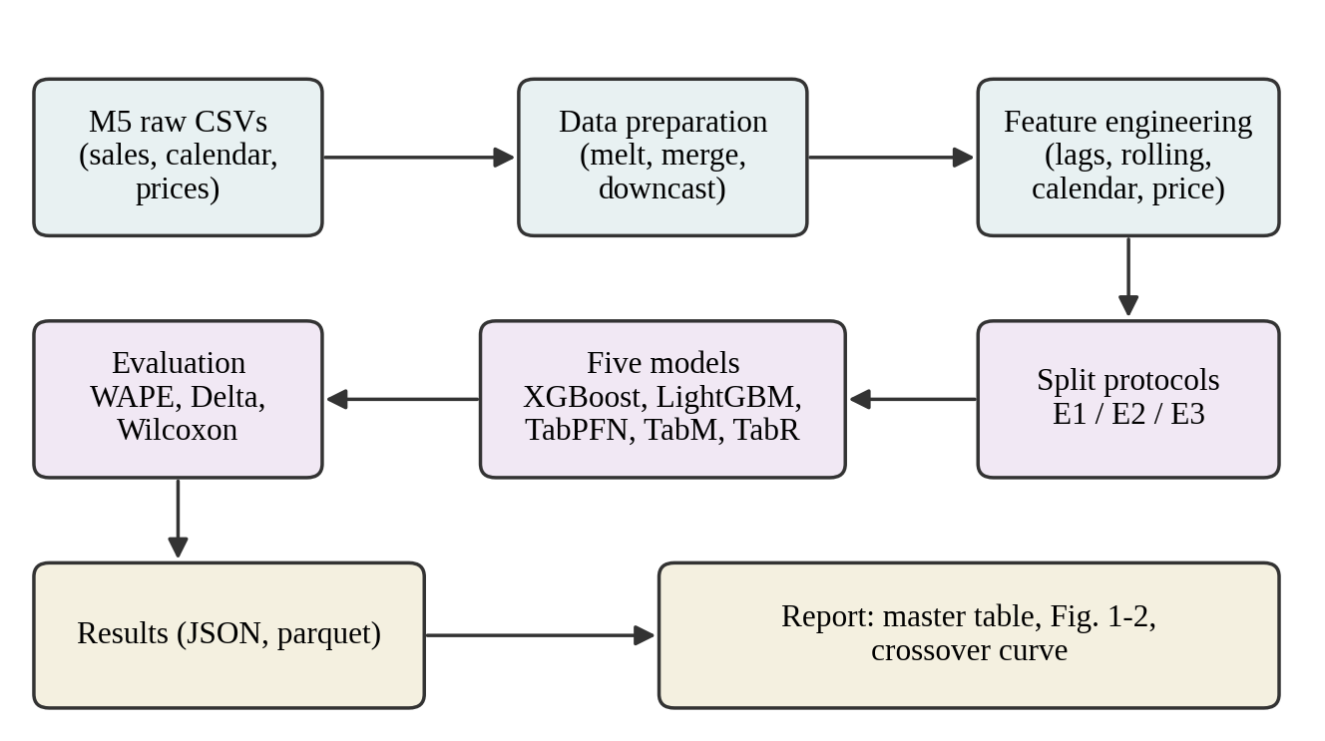
Figure 4.1 Overall architecture of the tabular shift study

4.3 DATASET
The study uses the dataset of the M5 competition (Makridakis et al., 2022). The sales file used is the evaluation file restricted to days 1 to 1,913, which covers the period from 1 January 2011 to 30 June 2016, that is, five years and a half. Table 4.1 summarises its main properties.
Table 4.1 Summary of the M5 Walmart dataset used
Property | Value
Time span | 1,913 days (2011-01-01 to 2016-06-30)
Stores | 10 stores in California, Texas and Wisconsin
Items | 3,049 unique items; 7 departments; 3 categories (Hobbies, Foods, Household)
Series | 30,490 item-store series
Rows after feature construction | About 42 million (long format, one row per series per day)
Additional information | Selling price, SNAP benefit flags, calendar events
Source files | sales_train_evaluation.csv, calendar.csv, sell_prices.csv

Rows that fall before a product was first priced are removed, because the item was not yet on sale. The three state-wise SNAP indicators are collapsed into a single flag that corresponds to the state of the store, and all columns are downcast to compact data types so that the table fits in memory.

4.4 FEATURE ENGINEERING
All five models receive exactly the same input. Instead of formulating the task as sequence modelling, the time dimension is encoded as tabular features, in the spirit of the approach used by TabPFN-TS (Hoo et al., 2025). Table 4.2 lists the feature groups.
Table 4.2 Feature groups used by all models
Group | Features
Lags | lag_7, lag_14, lag_28, lag_35 (sales exactly 7, 14, 28 and 35 days earlier)
Rolling statistics | roll_mean_7, roll_mean_28, roll_std_28, roll_max_28 (windows ending the day before)
Calendar | wday, month, ISO week, is_weekend, snap flag
Price | sell_price, price_change_7d, price_rank_cat, price_momentum_28
Categorical identifiers (label encoded) | item_id, dept_id, cat_id, store_id, state_id, event_type_1

Leakage rule. Every lag feature for day D uses only the single day D minus k, and every rolling feature uses a window that ends at day D minus 1. This is implemented by shifting the series within each item-store group before any rolling window is computed, so that the value of day D can never enter its own features. Rows at the start of a series for which a lag is undefined are dropped, consistently for all models. The code base produces 23 model input columns in total; the categorical identifiers are integer codes, which the neural models embed and the tree models and TabPFN consume as numbers.

4.5 EVALUATION PROTOCOLS
Three protocols are defined. Each one corresponds to a different type of shift between the training data and the test data, and Figure 4.2 shows how the day axis is partitioned.
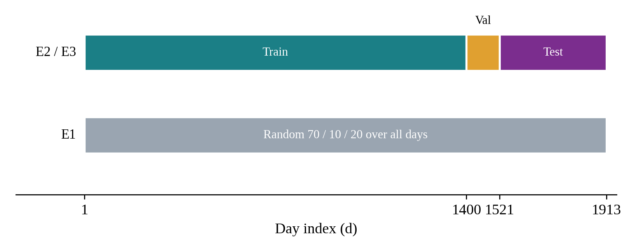
Figure 4.2 Partition of the day axis for the E1, E2 and E3 protocols
Table 4.3 Definition of the evaluation protocols
Protocol | Training data | Test data | Type of shift
E1: random split | Random rows from all days (31.5 M rows) | Random rows from all days (9.0 M rows) | None; baseline that contains temporal leakage by design
E2: temporal split | Days before 1400 (29.5 M rows); days 1400 to 1521 for validation | Days 1522 to 1913 (11.9 M rows) | Temporal drift of demand, prices and events
E3: cold-start | E2 training rows of cold-start items only (245 K rows) | Year-5 rows of the same items (495 K rows, 1,263 series) | Temporal drift plus items with fewer than 30 non-zero sales days in training

E1 (random split). The rows are shuffled and divided at random into training, validation and test parts, ignoring the order of days. This is the usual practice in academic benchmarks. Because rows from the same period occur in both parts, E1 measures the accuracy of a model without distribution shift and acts as the denominator of the degradation metric.
E2 (temporal split). Following the evaluation protocol of TabReD (Rubachev et al., 2025), the model is trained on the first four years and tested on the fifth year (days 1522 to 1913). The window from day 1400 to day 1521 is held out for early stopping and tuning only. The code asserts that the first test day is later than the last training day. E2 measures what would naturally happen when a model trained on past data is used on the future.
E3 (cold-start). Testing is restricted to items with fewer than 30 non-zero sales days in the training period (days up to 1521), which simulates a newly launched product. The temporal split of E2 is applied to this subset. E3 is the hardest of the three settings, because no meaningful history is available for the item and the model must rely on patterns shared across items.

4.6 MODELS
Five models were selected to represent the major paradigms of tabular learning. Their hyperparameters are fixed, taken from recommended ranges, and reused unchanged for E1, E2 and E3 (Table 4.4).

4.6.1 XGBoost
XGBoost (Chen and Guestrin, 2016) is the first gradient-boosted tree baseline. It is trained with the histogram method and an absolute-error objective, with up to 1,000 trees, a maximum depth of 7 and a learning rate of 0.05, with early stopping on the validation window after 50 rounds without improvement.

4.6.2 LightGBM
LightGBM (Ke et al., 2017) is the second tree baseline, trained with an L1 objective, up to 1,500 trees, 127 leaves per tree, a learning rate of 0.05, feature and bagging fractions of 0.8 and L2 regularisation of 1.0, with early stopping after 75 rounds.

4.6.3 TabPFN v2
TabPFN v2 (Hollmann et al., 2025) is a pretrained transformer that needs no training loop. For each run, a context window of 8,000 training rows is sampled at random and passed to the model, and predictions for the test rows are produced in chunks of 50,000 rows. Because different seeds sample different contexts, five seeds are run and averaged.

4.6.4 TabM
TabM (Gorishniy et al., 2025) is a parameter-efficient ensemble of k multilayer perceptrons that share one backbone. Each linear layer holds one shared weight matrix and, for each of the k members, small rank-one multiplicative adapters and a bias. Categorical identifiers are passed through embedding tables, and the prediction is the mean over the k members. The model uses 3 blocks of width 512, k equal to 8, the AdamW optimiser with learning rate 0.001 and batch size 4,096, and early stopping with patience 20 on the validation error for up to 200 epochs.

4.6.5 TabR
TabR (Gorishniy et al., 2024) combines a feed-forward encoder with differentiable retrieval. For each query row, the encoder produces a representation and a key, the most similar training rows are retrieved by their key distance, and a weighted sum of their label embeddings and key differences is added to the representation before the prediction head. At M5 scale, the candidate set is a random subsample of 500,000 training rows, the candidate keys are frozen after four epochs, the nearest-neighbour search is performed in chunks, and a training row is prevented from retrieving itself. The model has width 96, a context size of 96 retrieved rows and dropout of 0.1.
Table 4.4 Hyperparameters of the five models
Model | Main hyperparameters | Seeds
XGBoost | hist; reg:absoluteerror; 1000 trees; depth 7; lr 0.05; subsample 0.8; colsample 0.8; min child weight 10; early stop 50 | 42
LightGBM | regression_l1; 1500 trees; 127 leaves; lr 0.05; min child samples 50; feature and bagging fraction 0.8; L2 1.0; early stop 75 | 42
TabPFN v2 | Context 8,000 rows; prediction chunk 50,000; GPU | 0 to 4
TabM | d = 512; k = 8; 3 blocks; dropout 0; AdamW lr 1e-3, wd 1e-5; batch 4096; patience 20; max 200 epochs | 42
TabR | d = 96; context 96; dropout 0.1; AdamW lr 5e-4; batch 1024; 500K candidates; freeze after 4 epochs; patience 10 | 42

4.7 EVALUATION METRICS AND STATISTICAL TESTS

4.7.1 Weighted absolute percentage error
The main metric is the weighted absolute percentage error (WAPE), the ratio of the total absolute error to the total actual sales. It is standard in demand forecasting because, unlike the mean absolute percentage error, it remains defined on days with zero demand (Makridakis et al., 2022):
WAPE = Σ | y − ŷ | / Σ | y | (4.1)
where y is the actual sales and ŷ the prediction, summed over all test rows.

4.7.2 Relative degradation and shift sensitivity
The degradation caused by a shift is measured relative to the E1 baseline of the same model:
ΔE2 = [ WAPE(E2) − WAPE(E1) ] / WAPE(E1) (4.2)
ΔE3 = [ WAPE(E3) − WAPE(E1) ] / WAPE(E1) (4.3)
The shift sensitivity ratio S = ΔE3 / ΔE2 expresses how disproportionately the cold-start condition hurts a model compared with temporal drift: the lower the value, the more balanced the model. A non-positive degradation in the experiments is flagged by the report script as a possible sign of data leakage.

4.7.3 Statistical testing
For each experiment, the per-item absolute errors of every pair of models are compared with the two-sided Wilcoxon signed-rank test, which gives 10 model pairs per experiment and 30 hypotheses in total. Pairs with identical item errors and items with zero actual sales are excluded. The Bonferroni correction is applied, so that a comparison is regarded as significant only when p is below 0.05 divided by 30, that is, 0.0017.

4.8 COLD-START CROSSOVER ANALYSIS
An additional experiment examines how the benefit of TabPFN v2 over LightGBM changes with the amount of history available for an item. The cold-start items are grouped into buckets according to their number of training rows, with bucket limits of 10, 20, 35, 50, 75, 100, 150, 200, 300 and 500 rows. LightGBM is trained once on the complete E2 training split, which is the realistic setting, while TabPFN v2 receives a context sampled from the training rows of each bucket and is averaged over five seeds. The WAPE of both models is then computed on the year-5 rows of each bucket, and the first bucket in which LightGBM becomes better than TabPFN v2 defines the crossover point. This analysis motivates a hybrid deployment in which new items are routed to one model and established items to another.

4.9 DESIGN DECISIONS
- One feature pipeline, run once. The table is stored as parquet with compact data types and consumed by all models, which guarantees an identical input and avoids repeated 42-million-row computations.
- A common model interface. Every model implements fit(X, y, X_val, y_val) and predict(X), so that the experiment runner is model-agnostic and a new model needs only one wrapper class.
- Fixed configuration per model. One YAML file per model is reused across the three experiments, so that tuning effort is not a hidden variable.
- Per-item errors are saved. Absolute errors per item are stored for each run, which allows the Wilcoxon tests and any later re-aggregation without retraining.
- Resumable results. Each run writes its result file immediately on completion, and finished runs are skipped on restart.
CHAPTER 5

SYSTEM IMPLEMENTATION

5.1 GENERAL
The study is implemented in Python as an installable package named shift_study together with a set of command-line scripts, configuration files and unit tests. This chapter describes the structure of the code base, the implementation of each module and the way the complete study is executed.

5.2 PROJECT STRUCTURE
Table 5.1 Modules of the code base and their responsibilities
File or folder | Responsibility
configs/*.yaml | One fixed configuration per model (XGBoost, LightGBM, TabPFN, TabM, TabR)
scripts/download_data.py | Downloads the M5 files through the Kaggle application programming interface
scripts/build_features.py | Builds the 42-million-row feature table once and stores it as parquet
scripts/run_experiment.py | Runs one model on one protocol and writes the result and per-item errors
scripts/tune.py | Optional Optuna tuning on the validation window only
scripts/run_crossover.py | Cold-start crossover experiment: TabPFN v2 versus LightGBM
scripts/make_report.py, make_charts.py | Master table, figures, Wilcoxon tests and report
scripts/predict_real.py | Applies a trained TabM model to new retail data
src/shift_study/data.py | Loads the raw CSVs, melts sales to long format, merges calendar and prices
src/shift_study/features.py | Leakage-safe lag, rolling, calendar, price and categorical features
src/shift_study/splits.py | E1, E2 and E3 split logic and cold-start item detection
src/shift_study/metrics.py | WAPE, Delta, shift sensitivity, per-item errors, Wilcoxon test
src/shift_study/models/ | Common base class and one wrapper per model
tests/ | Unit tests for the data, features, splits, metrics, models and scripts
main.py, run.ipynb | Notebook-style runner for executing the complete study in sessions

5.3 DATA PIPELINE
The data module reads the sales, calendar and price files. The wide sales table, which has one column per day, is melted into long format with one row per series per day, and the identifier columns are stored as categories to save memory. The calendar is merged on the day index and the price table is merged on store, item and week. Rows without a selling price are removed. The wide frame is deleted before the merges to release memory, and all numerical columns are downcast to compact types such as 16-bit integers and 32-bit floats. A sampling option keeps a random subset of series, which is used for smoke tests.

5.4 FEATURE MODULE
The feature module sorts the table by series and day and computes the lags through a grouped shift. Rolling statistics are computed on the series shifted by one day, so that every window ends at the day before the prediction day. Calendar features include the ISO week and a weekend flag, and the price features include the ratio of the current price to the price 7 and 28 days earlier and the percentile rank of the price within the store and category in the same week. Categorical columns are label-encoded as 16-bit integers. Rows for which a lag or the rolling standard deviation is undefined are dropped, missing price changes are filled with zero and missing price ranks with 0.5. Garbage collection is invoked between steps because the full table is large. The module assumes gapless daily data for every series, since the shifts are positional.

5.5 SPLIT MODULE
The split module defines the constants of the protocol: the last training day (1521), the start of the validation window (1400) and the first and last test day (1522 and 1913), and the cold-start threshold of 30 non-zero days. The function for E1 shuffles all rows with a fixed seed and divides them into test, validation and training parts. The function for E2 selects training rows before day 1400, validation rows from day 1400 to day 1521 and test rows from day 1522 onward, and raises an error if any test day is not later than the last training day. The function for E3 finds the items with fewer than 30 non-zero sales days up to day 1521 and applies the E2 split to the rows of these items only.

5.6 MODEL WRAPPERS
All models derive from an abstract base class with two methods, fit and predict. The runner always calls fit with the training features, the training target, and the validation features and target, and models that do not use validation data, such as TabPFN, simply ignore it. A factory function creates a model by name and imports its library lazily, so that a missing heavy dependency only breaks the model that needs it.
The XGBoost and LightGBM wrappers pass the configuration parameters to the corresponding regressors, always take the random seed from the runner, use all CPU cores by default and implement early stopping through library callbacks on the validation window. The TabPFN wrapper samples the context rows with the run seed, fits the TabPFN regressor once and predicts the test rows in chunks.
The TabM wrapper implements the shared-backbone ensemble in PyTorch. A batch-ensemble linear layer holds one shared weight matrix and, for each member, two random-sign scaling vectors and a bias, so that the k members are obtained at roughly the cost of one network. The loss is the mean absolute error averaged over the members, numerical features are standardised using training statistics, and categorical codes are embedded with a table size derived from their cardinality. Early stopping restores the best checkpoint, and the trained model can be saved to disk for later inference.
The TabR wrapper subsamples up to 500,000 training rows as retrieval candidates, standardises the features and the target, and recomputes the candidate keys every epoch until they are frozen. For each batch, the top-m candidates are selected by a chunked distance search that runs without gradient and masks the row itself; the attention weights are then recomputed from the selected keys with gradient, so that the encoder and key network are trained through the retrieval path. The labels of the retrieved rows enter through a label embedding, and the prediction head combines the query representation with the retrieved context.

5.7 EXPERIMENT RUNNER
The experiment runner loads the feature parquet, optionally restricts it to a random sample of series, builds the requested split, and verifies that the test period is strictly later than the training period for E2 and E3. For every seed in the model configuration, it fits the model, predicts the test rows and records the WAPE. The mean prediction over seeds is used to compute an ensemble WAPE and the per-item errors, which are written to a parquet file. A JSON result file is written immediately and contains the mean and standard deviation of the WAPE, the per-seed values, the number of rows, the runtime, the full configuration and a timestamp. A skip option makes it safe to re-run the complete study after a crash, because finished cells are not repeated.

5.8 CROSSOVER AND REPORT SCRIPTS
The crossover script buckets the items by the number of training rows, trains LightGBM once, runs TabPFN v2 with five seeds on each bucket, and writes the bucket results and the crossover point to a CSV and a JSON file. The report script reads all result files and produces the master table with WAPE, Delta E2, Delta E3 and the shift sensitivity, the figure of shift degradation, the crossover figure, the pairwise Wilcoxon table and a markdown report, and it prints a warning if any degradation is zero or negative. The Wilcoxon p-values are written uncorrected, and a note in the report reminds the reader to apply the multiple-comparison correction.

5.9 HYPERPARAMETER TUNING
Defaults are shipped for all models, so the experiments run without tuning. The optional tuning script uses Optuna on the validation window of E2 (days 1400 to 1521) only, so that the test period is never touched, and can be run on a sample of series for speed. The fixed configurations used in the reported experiments were not tuned further, which keeps the comparison across protocols controlled.

5.10 INFERENCE ON NEW DATA
The inference script applies a saved TabM model to real data in two modes. In the Walmart mode it rebuilds the base table and features from the raw M5 files. In the generic mode it accepts any retail CSV with the columns date, item_id, store_id, sales and sell_price, creates a series identifier and a day index, fills optional columns such as department, category, state, event type and SNAP with defaults, and builds the same features. It stops with an explanatory message if a series has too few consecutive days for the 35-day lag, and it writes the predictions to a CSV file.

5.11 EXECUTION WORKFLOW
The complete study is run in the following order. All scripts are executed from the repository root so that the relative paths of the configuration files resolve correctly.
- Install the requirements, install the package in editable mode, and provide the Kaggle credentials and the TabPFN access token.
- Download the data and build the feature table once.
- Run the unit tests, then a smoke test of LightGBM on E2 with 500 series.
- Run all five models on E1, E2 and E3 with the skip option, so that the run can be resumed.
- Run the crossover script and the report script.
For long GPU sessions, a notebook-style runner executes the same steps in cells: verification of data and GPU, feature building, a smoke test, a first session with XGBoost, LightGBM and TabM, a dedicated second session for the slow TabR model, and finally the crossover curve and the report. The expected runtimes of the complete study are given in Table 5.2.
Table 5.2 Expected runtimes of the full study
Model | Hardware | Approximate runtime
XGBoost | CPU | 50 to 70 minutes
LightGBM | CPU | 30 to 45 minutes
TabPFN v2 | GPU | Chunked, about 1 to 2 hours
TabM | GPU | 2 to 3 hours
TabR | GPU | 8 to 10 hours (slowest)
Planning estimates from the project documentation; measured runtimes are reported in Chapter 7.

CHAPTER 6

SYSTEM TESTING

6.1 GENERAL
Because the study depends on long computations, the correctness of each component was verified before the expensive runs were started. The testing strategy combines automated unit tests, built-in sanity checks that stop the pipeline when an assumption is violated, and smoke tests that run the whole pipeline on a small sample of series.

6.2 UNIT TESTING
The tests are written with pytest and live in the tests folder, with one test module for each important component (Table 6.1). They are run with a single command before any experiment.
Table 6.1 Unit test modules
Test module | Component verified
test_data.py | Raw data loading, melting to long format, calendar and price merging
test_features.py | Lag and rolling features, calendar and price features, absence of leakage
test_build_features_script.py | The command-line script that builds the feature table
test_splits.py | E1, E2 and E3 partitions and cold-start item detection
test_metrics.py | WAPE, Delta, shift sensitivity, per-item errors and Wilcoxon test
test_models_trees.py | XGBoost and LightGBM wrappers
test_models_torch.py | TabM and TabR wrappers
test_models_tabpfn.py | TabPFN wrapper
test_run_experiment.py | Experiment runner and result files
test_make_report.py | Report generation from result files

6.3 LEAKAGE AND SANITY CHECKS
Data leakage is the main threat to the validity of a temporal study, so several safeguards are built into the code:
- Lag and rolling features are constructed from shifted series, so that the value of the prediction day never enters its own features.
- For E2 and E3 the split function and the runner both check that the first test day is later than the last training day and stop with an error if this is violated.
- The runner stops with a clear message when a split is empty, which can happen when too few series are sampled.
- The report script prints a warning when the degradation Delta of a model is zero or negative, because a shift condition should never be easier than the random baseline; such a result would indicate leakage.
- The validation window used for early stopping and optional tuning lies strictly before the test period, so the test rows are never used for model selection.

6.4 SMOKE TESTING
Every script accepts a sampling option that restricts the data to a few hundred random series. Before the full study, a smoke test of LightGBM on E2 with 500 series is run to check the complete chain from the feature file to the result file. The smoke artefacts are removed before the real runs, so that they cannot be confused with final results.

6.5 TESTING OF STATISTICAL PROCEDURES
The statistical procedures were checked for edge cases. The Wilcoxon test pairs items by identifier, discards items whose actual sales are zero and ties between the two models, and returns undefined values when fewer than two valid pairs remain. Seeds are fixed in every run, and the standard deviation across seeds is stored, so that variation from random initialisation is visible; for TabM, a run-to-run variation of about 0.01 WAPE points was observed on cold-start items because of non-determinism on the GPU.
CHAPTER 7

RESULTS AND DISCUSSION

7.1 GENERAL
This chapter presents the results of the complete benchmark of five models under three protocols, analyses the effect of each type of shift, reports the statistical tests and runtimes, and discusses the practical implications.

7.2 EXPERIMENTAL SETUP
The experiments were executed on a Linux server with a CUDA GPU for the neural models. Under E1 the training part contains 31.5 million rows and the test part 9.0 million rows covering all 30,490 series. Under E2 the model is trained on 29.5 million rows from years 1 to 4 and tested on 11.9 million rows from year 5. Under E3 there are 245 thousand training rows and 495 thousand test rows for 1,263 cold-start series. XGBoost, LightGBM, TabM and TabR were run with seed 42, and TabPFN v2 was averaged over five seeds.

7.3 OVERALL PERFORMANCE
Table 7.1 summarises the WAPE of all models under the three protocols together with the relative degradations and the shift sensitivity. In E1, TabM obtains the lowest WAPE of 0.6099, followed by LightGBM (0.6291), XGBoost (0.6311) and TabR (0.6398), while TabPFN v2 performs worst (0.6934). The same ranking holds in E2. All pairwise comparisons in E1 and E2 are statistically significant after Bonferroni correction.
Table 7.1 WAPE by model and evaluation protocol
Model | E1 | E2 | E3 | ΔE2 % | ΔE3 % | Sens.
TabM | 0.6099 | 0.6374 | 0.9154 | 4.50 | 50.09 | 11.12
LightGBM | 0.6291 | 0.6496 | 0.9412 | 3.25 | 49.61 | 15.24
XGBoost | 0.6311 | 0.6500 | 0.9414 | 2.99 | 49.17 | 16.45
TabR | 0.6398 | 0.6605 | 0.9234 | 3.23 | 44.32 | 13.73
TabPFN v2 | 0.6934 | 0.7127 | 1.0069 | 2.79 | 45.21 | 16.19
ΔE2 and ΔE3 are relative degradations (%) with respect to E1; Sens. = ΔE3 / ΔE2. TabPFN v2: mean over 5 seeds. TabM is best in E1, E2 and E3.

7.4 EFFECT OF TEMPORAL SHIFT (E1 TO E2)
Moving from a random split to a temporal split decreases the performance of every model, but only slightly. The relative degradation ranges from 2.79 percent for TabPFN v2 to 4.50 percent for TabM (Figure 7.1). Although TabM degrades most in relative terms, it still obtains the lowest absolute WAPE in E2, because its starting point is considerably lower. This suggests that M5 demand is fairly stationary around the chosen split point (day 1400), and that gradual temporal drift is not the challenging part of the problem.
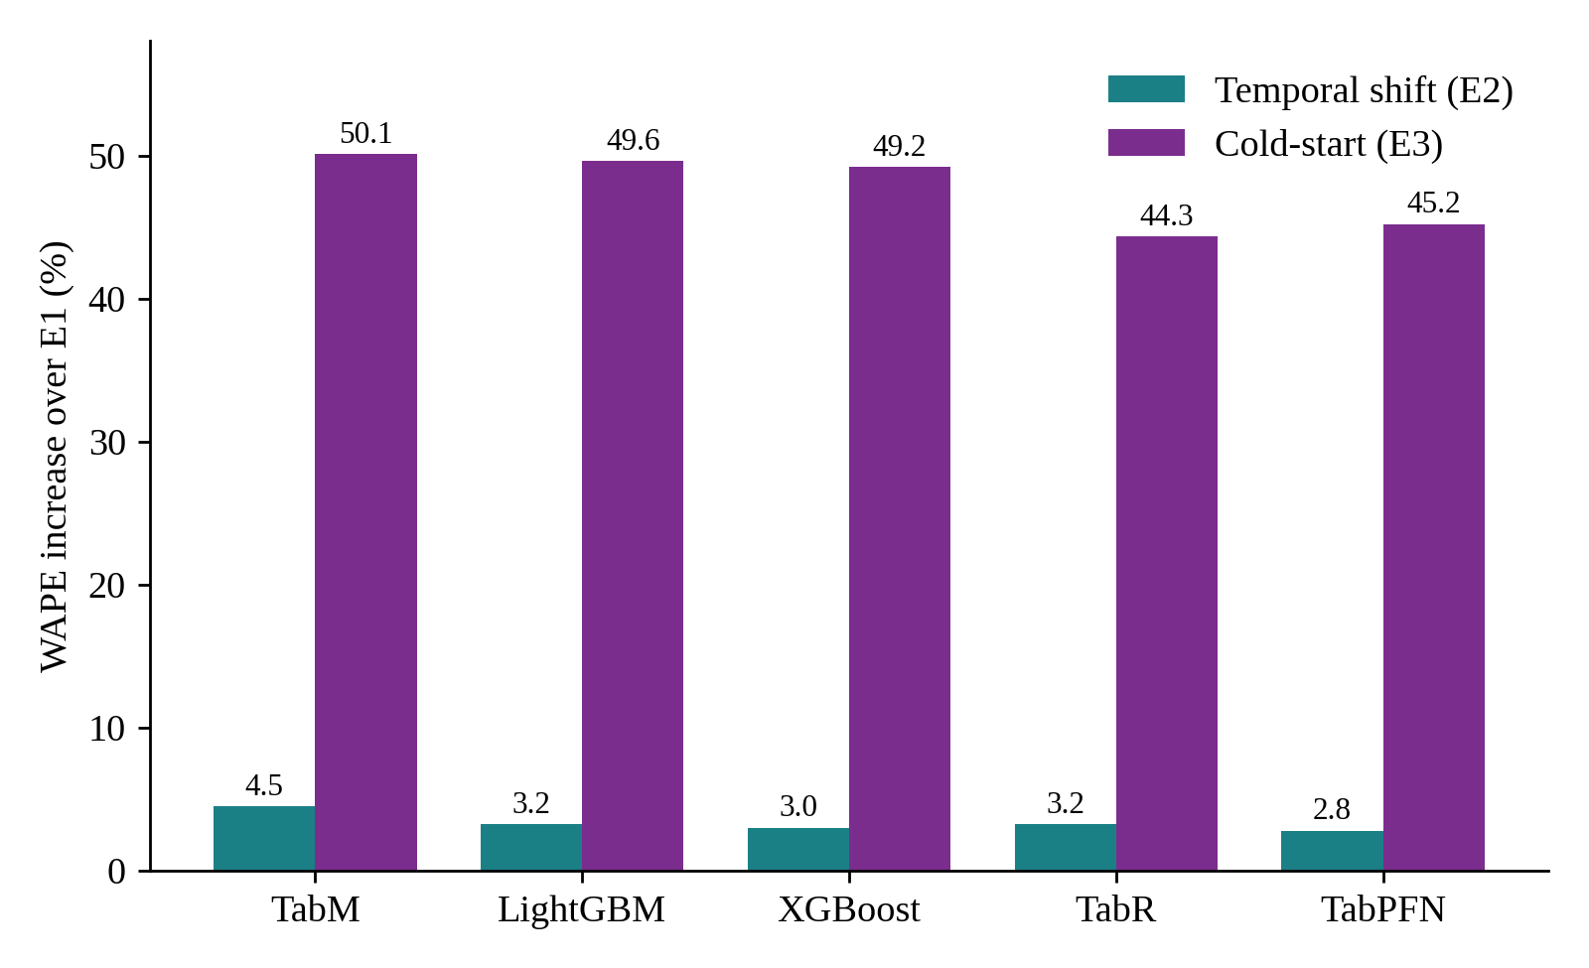
Figure 7.1 WAPE increase over the E1 baseline for temporal shift and cold-start

7.5 EFFECT OF COLD-START (E1 TO E3)
Cold-start is a completely different situation. All models lose between 44 and 50 percent relative to their E1 baseline, more than ten times the degradation caused by temporal shift. The tall cold-start bars compared with the almost invisible temporal bars in Figure 7.1 show that cold-start is the real limiting factor.
In absolute E3 performance TabM is best (0.9154), followed by TabR (0.9234), LightGBM (0.9412), XGBoost (0.9414) and TabPFN v2 (1.0069). A WAPE above 1.0 means that the total absolute error exceeds the total actual sales, so TabPFN v2 is worse than a trivial forecast of zero sales on these items, which is a very poor result for a model published in Nature. In relative terms TabR degrades least (44.3 percent), because its retrieval mechanism allows it to find similar products in the training data even when the target product itself is unseen, which works like collaborative filtering.
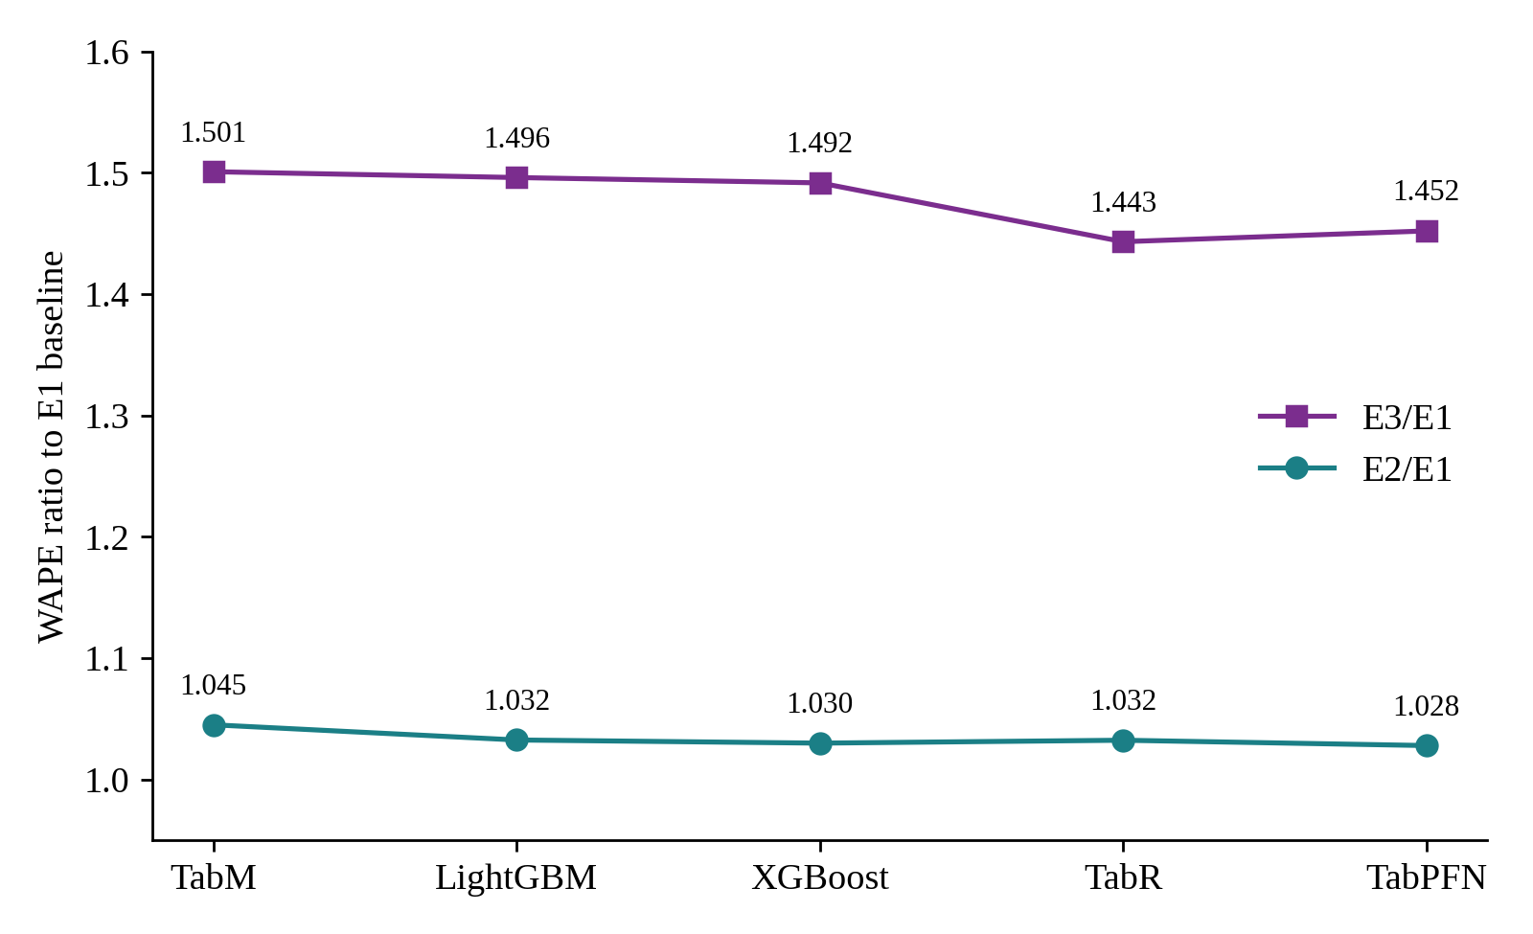
Figure 7.2 Ratio of E2 and E3 WAPE to the E1 baseline

7.6 SHIFT SENSITIVITY
The shift sensitivity ratio ΔE3 / ΔE2 tells how disproportionately cold-start hurts a model compared with temporal drift. TabM has the smallest ratio (11.12), followed by TabR (13.73), LightGBM (15.24), TabPFN v2 (16.19) and XGBoost (16.45). This is somewhat unexpected, because TabM also has the largest temporal degradation: its large denominator makes the ratio small, and its cold-start degradation, although large in absolute terms, is modest compared with its temporal one. XGBoost suffers especially strongly from cold-start relative to temporal shift.

7.7 STATISTICAL SIGNIFICANCE
Wilcoxon signed-rank tests on per-item absolute errors were run for every pair of models in each experiment, 30 tests in total, with a Bonferroni-corrected significance threshold of 0.0017. On E1 and E2 every comparison is significant. On E3 most comparisons remain significant, but two pairs fall just above the corrected threshold: XGBoost versus LightGBM (p = 0.0036) and LightGBM versus TabR (p = 0.0035). In practical terms these models are essentially tied on cold-start items. Table 7.2 shows selected E3 comparisons.
Table 7.2 Selected Wilcoxon signed-rank tests on E3 (cold-start)
Model A | Model B | p-value | Significant?
TabM | TabR | 2.06e-49 | Yes
TabM | LightGBM | 2.34e-55 | Yes
LightGBM | TabR | 0.0035 | No
XGBoost | LightGBM | 0.0036 | No
Significance at the Bonferroni-adjusted level p < 0.0017. All E1 and E2 pairs are significant.

7.8 RUNTIME ANALYSIS
Table 7.3 reports the runtimes of a single seed. LightGBM completes E2 in 11 minutes, whereas TabM needs about 2.5 hours, which is a 14 times speed advantage for LightGBM. LightGBM is also about five times faster than XGBoost on E2 (657 seconds against 3,485 seconds). Since the accuracy gap between TabM and LightGBM is roughly two WAPE points, this speed advantage may make LightGBM preferable for production pipelines that require daily retraining. All models finish the small E3 dataset quickly, so speed is not an important factor for cold-start.
Table 7.3 Runtime in seconds for a single seed
Model | E1 | E2 | E3
LightGBM | 2,957 | 657 | 29
XGBoost | 3,929 | 3,485 | 25
TabPFN v2 | 18,481 | 24,360 | 1,026
TabR | 20,258 | 20,577 | 546
TabM | 23,191 | 9,102 | 126
TabPFN v2: total across 5 seeds. Neural models were run on a CUDA GPU.

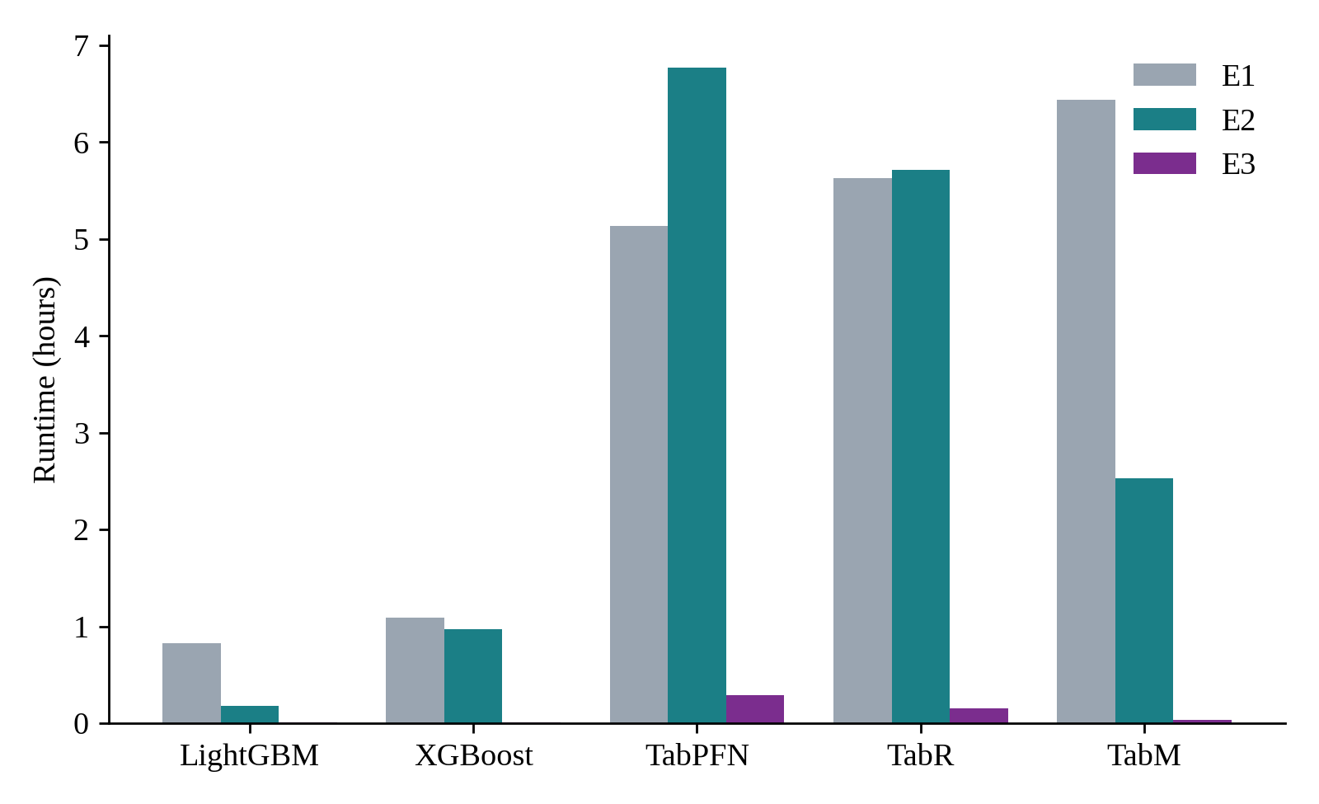
Figure 7.3 Runtime of each model under the three protocols

7.9 MODEL-WISE OBSERVATIONS
TabM performs best under all protocols (E1 0.6099, E2 0.6374, E3 0.9154) and has the lowest shift sensitivity. The most likely reason is the implicit smoothing obtained by averaging eight heads that share a backbone, without any retrieval or attention component.
LightGBM and XGBoost give nearly identical accuracy: the difference does not exceed 0.002 WAPE under any protocol, and they are statistically indistinguishable on E3. LightGBM is much faster and can therefore be regarded as the preferable of the two.
TabR shows the smallest cold-start degradation (44.3 percent), which agrees with its design, since retrieval of similar products acts like collaborative filtering when an item has no history. It is, however, always worse than TabM in absolute WAPE.
TabPFN v2 underperforms under all protocols. Its E1 WAPE of 0.6934 is already about 14 percent worse than TabM, which is attributed to context truncation: with 8,000 context rows it sees less than 0.03 percent of the 31.5 million training rows for each prediction. On cold-start items its WAPE exceeds 1.0, so it effectively produces noise rather than useful forecasts.

7.10 DISCUSSION

7.10.1 Cold-start as the real challenge
The most striking observation is the asymmetry between the two shift types. Temporal drift raises the error by less than 5 percent for every model, while cold-start raises it by 44 to 50 percent, so cold-start degradation is 10 to 18 times larger than temporal degradation. TabReD (Rubachev et al., 2025) was right to concentrate on temporal shift, but the decomposition shows that, for retail forecasting in particular, gradual drift is relatively modest and the real problem lies in items unseen during training. A retailer that adds thousands of new items per year is affected far more by the introduction of those items than by the slow evolution of demand for its existing catalogue. The industry practice of using analogous items for new-product forecasting can be viewed as a manual version of what TabR does automatically.

7.10.2 Reconciling TabPFN v2 and TabReD
TabPFN v2 (Hollmann et al., 2025) and TabReD (Rubachev et al., 2025) appear to contradict each other, since the first suggests that neural models should be preferred while the second suggests the opposite. The experiments show that both are right within their own regime. TabPFN v2 performs well only when the dataset fits within its context window; on M5, even the random split gives a poor WAPE because the model sees only 8,000 of 31.5 million rows. The results do not contradict the earlier findings but apply to a different scenario.

7.10.3 Practical recommendations
- If GPU access is available and models can be retrained weekly or less often, TabM is the best choice, because it performs best overall and has the most balanced degradation pattern.
- If models must be trained daily or no GPU is available, LightGBM achieves nearly the same WAPE as TabM at a much lower computational cost.
- If the catalogue has high cold-start turnover, for example fast fashion or seasonal items, TabR deserves consideration for its lower relative cold-start degradation, although TabM remains better in absolute terms.
- TabPFN v2 should not be used for datasets much larger than about 10,000 rows because of its context-window restriction.

7.10.4 Limitations
Several limitations should be noted. Only one dataset (M5) was used, so the patterns cannot be claimed to generalise to other product domains. TabPFN v2 was run with five seeds whereas the other models used a single seed, and TabM scores on cold-start vary by about 0.01 WAPE points because of GPU non-determinism. The threshold of 30 days that defines a cold-start item was a design choice, and other thresholds may give different results. Other shift types, such as promotions and macroeconomic effects, were not considered. Finally, lag features are crucial for tree models, which raises the question of whether trees suffer from cold-start because of feature engineering; however, lag features are standard in production, and any deployed model must contend with them.
CHAPTER 8

CONCLUSION AND FUTURE ENHANCEMENT

8.1 CONCLUSION
This project benchmarked XGBoost, LightGBM, TabPFN v2, TabM and TabR on the M5 Walmart dataset of about 42 million rows under random, temporal and cold-start protocols. The way the different kinds of shift affect tabular models is fairly consistent across model families: cold-start is the hard case, causing a 44 to 50 percent increase in WAPE, which far outweighs the 2.8 to 4.5 percent caused by temporal drift. This holds for every model analysed, from tree ensembles to a pretrained foundation model.
TabM is the strongest model in the study, with WAPE values of 0.610, 0.637 and 0.915 under the three protocols and the most balanced shift sensitivity (11.12). XGBoost and LightGBM perform almost identically and can be treated as interchangeable on accuracy, with LightGBM being much faster. TabR degrades least under cold-start, and TabPFN v2 performed worst under all protocols, with a WAPE above 1.0 on cold-start items. The results also speak to the promise and the limits of tabular foundation models: in-context learning requires the data to fit in the context window, and on a production-scale dataset this window captures only a tiny fraction of the available signal.
The implemented code base, with its common model interface, leakage-safe features, resumable runs and automatic report generation, is a reusable framework for further tabular shift studies.

8.2 FUTURE ENHANCEMENT
- Apply the same decomposition approach to other shift types such as promotional changes, trend reversals and demand shocks.
- Evaluate additional datasets and product domains to test whether the dominance of cold-start generalises.
- Develop hybrid routing strategies that send new items to one model and established items to another, using the saved per-item errors and the cold-start crossover analysis.
- Investigate methods for compressing or hierarchically summarising millions of training rows into a useful context for in-context learning models.
- Run multiple seeds for all models, apply systematic hyperparameter tuning on the validation window, and test several cold-start thresholds.
APPENDIX 1

MODEL CONFIGURATION FILES
The following settings are stored in the YAML files of the configs folder and were used unchanged for all three experiments.
Table A1.1 Configuration files of the five models
File | Contents
lightgbm.yaml | seeds [42]; early_stopping_rounds 75; objective regression_l1; n_estimators 1500; learning_rate 0.05; num_leaves 127; min_child_samples 50; feature_fraction 0.8; bagging_fraction 0.8; bagging_freq 1; lambda_l2 1.0
xgboost.yaml | seeds [42]; early_stopping_rounds 50; n_estimators 1000; learning_rate 0.05; max_depth 7; subsample 0.8; colsample_bytree 0.8; min_child_weight 10; tree_method hist; objective reg:absoluteerror
tabpfn.yaml | seeds [0, 1, 2, 3, 4]; context_rows 8000; predict_chunk 50000; device cuda
tabm.yaml | seeds [42]; d_main 512; k 8; n_blocks 3; dropout 0.0; lr 1e-3; weight_decay 1e-5; batch_size 4096; max_epochs 200; patience 20; device cuda
tabr.yaml | seeds [42]; d_main 96; context_size 96; dropout 0.1; lr 5e-4; weight_decay 1e-5; batch_size 1024; max_epochs 100; patience 10; context_freeze_epoch 4; train_subsample 500000; candidate_chunk 65536; device cuda

APPENDIX 2

COMMANDS TO REPRODUCE THE STUDY
All commands are run from the repository root.
pip install -r requirements.txt
pip install -e .
python scripts/download_data.py
python scripts/build_features.py
pytest -q
python scripts/run_experiment.py --model lightgbm --experiment e2 --sample 500
python scripts/run_experiment.py --model <model> --experiment <e1|e2|e3> --skip-existing
python scripts/run_crossover.py
python scripts/make_report.py
python scripts/tune.py --model lightgbm --trials 30 --sample 3000
The models are xgboost, lightgbm, tabpfn, tabm and tabr. Kaggle credentials must be placed in the user's kaggle.json file before the data are downloaded, and the environment variable TABPFN_TOKEN must hold the access token of the TabPFN weights before any TabPFN experiment.

REFERENCES
1. Chen T. and Guestrin C. (2016) “XGBoost: A scalable tree boosting system”, Proc. ACM SIGKDD, pp. 785–794.
2. Gorishniy Y., Kotelnikov A. and Babenko A. (2025) “TabM: Advancing tabular deep learning with parameter-efficient ensembling”, Proc. ICLR.
3. Gorishniy Y. et al. (2024) “TabR: Tabular deep learning meets nearest neighbors”, Proc. ICLR.
4. Gorishniy Y., Rubachev I., Khrulkov V. and Babenko A. (2021) “Revisiting deep learning models for tabular data”, Advances in NeurIPS, Vol. 34.
5. Grinsztajn L., Oyallon E. and Varoquaux G. (2022) “Why do tree-based models still outperform deep learning on typical tabular data?”, Advances in NeurIPS, Vol. 35.
6. Hollmann N., Muller S. and Hutter F. (2025) “Accurate predictions on small data with a tabular foundation model”, Nature, Vol. 637, pp. 319–326.
7. Hollmann N. et al. (2023) “TabPFN: A transformer that solves small tabular classification problems in a second”, Proc. ICLR.
8. Hoo C. H., Muller S., Salinas V. and Hutter F. (2025) “The tabular foundation model TabPFN outperforms specialized time series forecasting models”, arXiv:2501.02945.
9. Ke G. et al. (2017) “LightGBM: A highly efficient gradient boosting decision tree”, Advances in NeurIPS, Vol. 30.
10. Liu S.-Y. and Ye H.-J. (2025) “TabPFN unleashed: A scalable and effective solution to tabular classification”, Proc. ICML.
11. Makridakis S., Spiliotis E. and Assimakopoulos V. (2022) “M5 accuracy competition: Results, findings, and conclusions”, Int. J. Forecasting, Vol. 38, No. 4, pp. 1346–1364.
12. Qu A., Allard J. and Varoquaux G. (2025) “TabICL: A tabular foundation model for in-context learning on large data”, Proc. ICML.
13. Quinonero-Candela J. et al. (2009) Dataset Shift in Machine Learning, MIT Press.
14. Rubachev I., Kartashev N., Gorishniy Y. and Babenko A. (2025) “TabReD: Analyzing pitfalls and filling the gaps in tabular deep learning benchmarks”, Proc. ICLR.
15. Shwartz-Ziv R. and Armon A. (2022) “Tabular data: Deep learning is not all you need”, Information Fusion, Vol. 81, pp. 84–90.

MAPPING OF PROJECT GOALS TO SDG
SDG 9: Industry, Innovation and Infrastructure
The project aligns with Sustainable Development Goal 9, which emphasises resilient infrastructure, inclusive industrialisation and the promotion of technological innovation. It builds a reproducible benchmarking platform for comparing modern tabular machine learning models on a production-scale retail dataset of about 42 million rows, and it turns the comparison into practical guidance on model selection. By separating the effect of temporal drift from the effect of new items, the study helps organisations to decide where to invest in their forecasting infrastructure. It also evaluates recent innovations, such as tabular foundation models and retrieval-based networks, under realistic conditions and reports honestly where they fall short, which supports evidence-based innovation instead of benchmark-driven hype. The released code base with standard interfaces, configuration files, automated tests and resumable runs contributes to a reusable digital research infrastructure for the wider community.
SDG 12: Responsible Consumption and Production
The project also supports Sustainable Development Goal 12, which calls for sustainable patterns of production and consumption and for a substantial reduction of waste. Accurate demand forecasting lets retailers stock the right quantity of goods, which reduces overstocking, unsold and expired products, emergency transport and unnecessary production. The study shows that forecast quality drops sharply for newly launched items, which are exactly the products for which over-ordering and waste are most likely, and it recommends models and deployment strategies for this case. The runtime analysis furthermore shows that a gradient-boosted tree model reaches nearly the accuracy of the best neural model in a fraction of the computing time, so that a lower-energy option is available for frequent retraining, which encourages resource-efficient production use of machine learning.

