# Report - CS3205 Assignment 1

## CS18B050 - Aniswar Srivatsa Krishnan

#### Code explanation:

There are two files emailserver.c (which contains the server code) and emailclient.c(which contains the client code). These files give the respective executables when compiled.

In **server**, the function command_processor() is responsible for processing the request from the client, running appropriate system commands and passing the output generated to the NETWORK INTERFACE.

The functions get_message() and send_result() are part of the NETWORK INTERFACE. The protocol for sending messages is as follows. First a 4 byte integer is sent indicating the number of bytes that the subsequent message will contain. Then the actual message is sent. This allows us to receive arbitrary amount of data without any error. This is necessary because TCP/IP socket is a stream socket and hence recv() is not guaranteed to read the number of bytes that send() sends. After creating the socket, binding it to the required port and listening, we run accept() in an infinite loop and handle the client sessions subsequently. Accept() blocks until an incoming connection is made to the listening socket’s port number, and then returns a new socket descriptor, which will be used for the current client session.

In **client**, the function get_user_input() handles the user­input interface which accepts user commands, processes them, and passes appropriate data to the network interface.

The function send_message_and_recv() acts as the NETWORK INTERFACE, which communicates with the server using the protocol described above.

#### Learning Outcome:

This was my first experience in the domain of socket programming. It gave me a good idea as to how TCP/IP sockets actually work and what are the strategies generally adopted for communicating effectively over networks. I also learnt about port forwarding, this was a setting which needed to be enabled in my router so as to accept a connection from a remote machine. This allowed me to connect with a remote machine purely with the help of C programming and not any other software. This assignment also helped me to learn and understand various C functions like sprintf(), send(), recv(), sscanf(), strncmp(), readdir(), fseek(), etc. This would be helpful in order to become a good systems programmer. I hope to understand the topic of networks further and apply my knowledge to build useful products.

#### Sessions Carried Out:

1. Server and Client Running on the Same Machine:

Server:

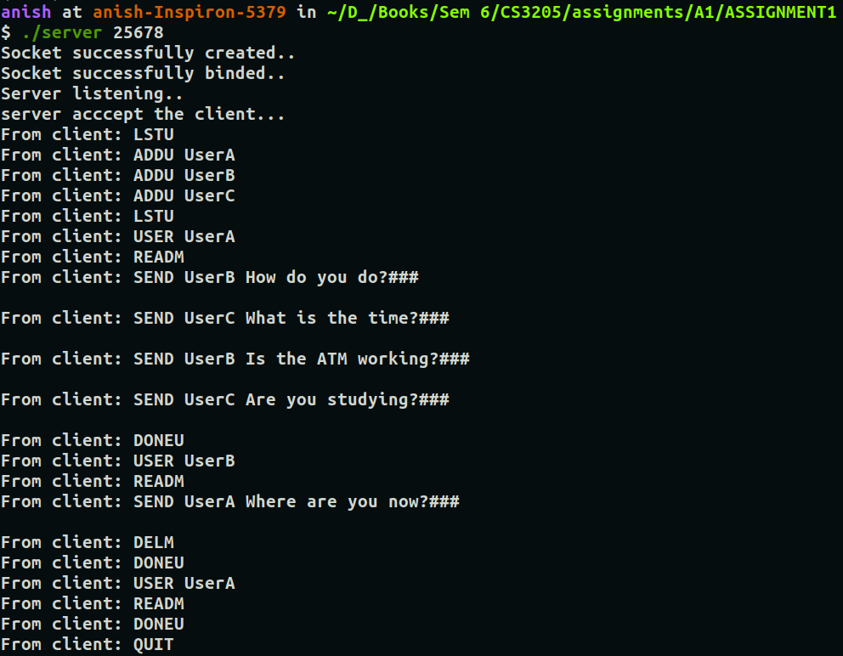

Client:

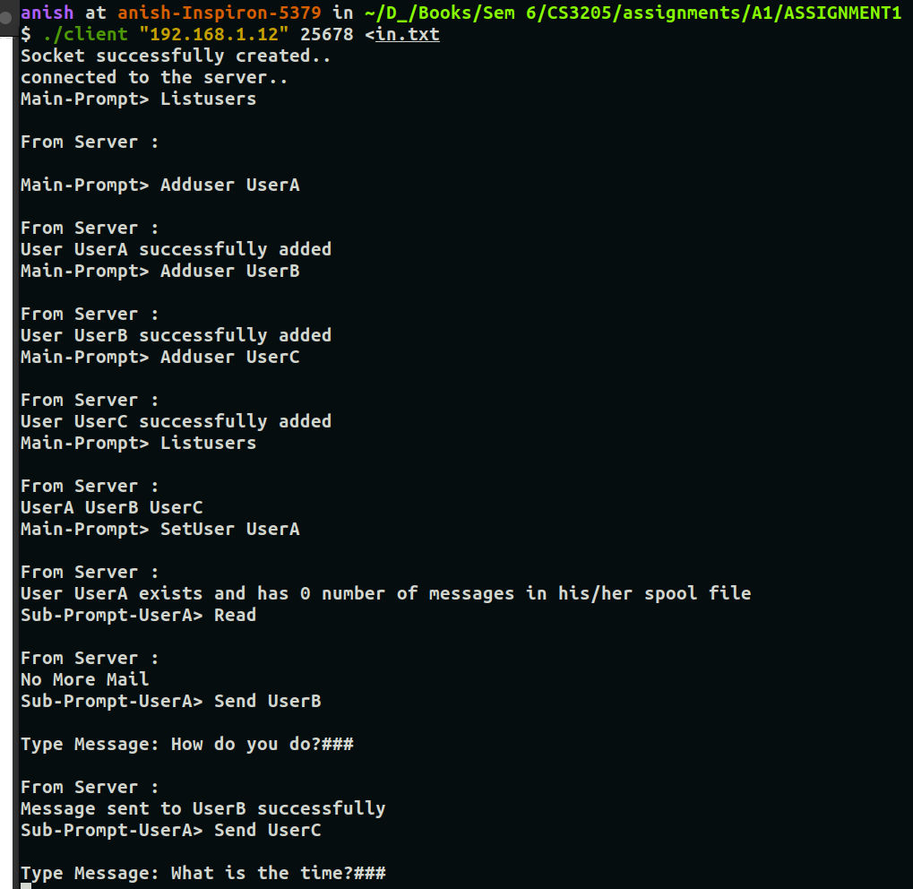

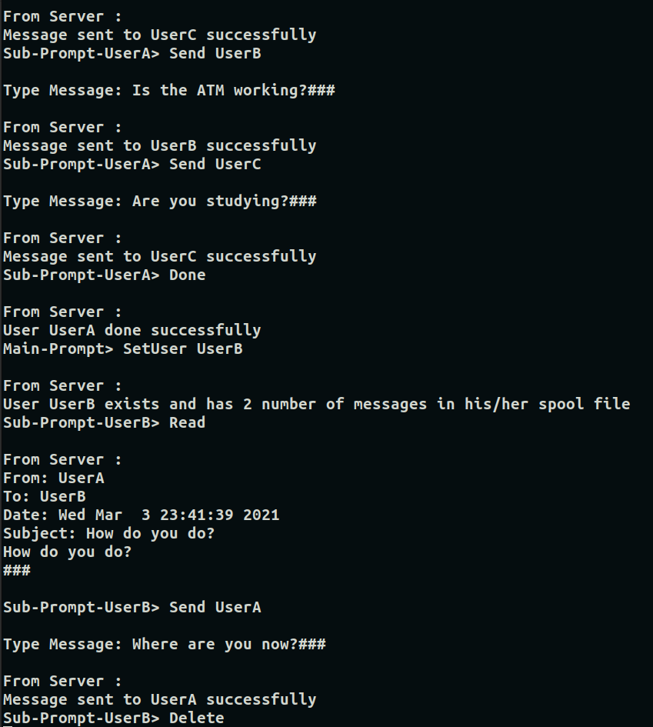

#### 

The Spool files created at the server:

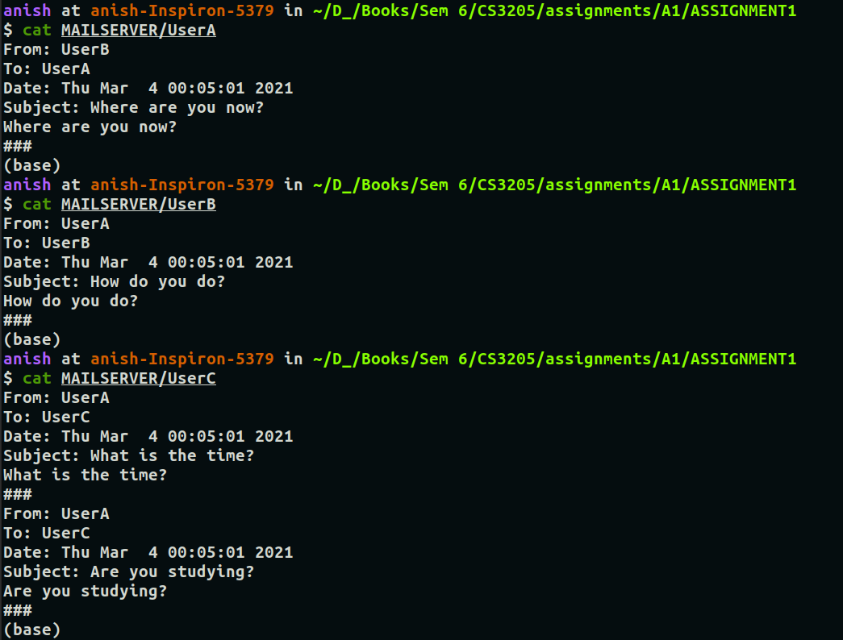

1. Client and server running on different machines

Server: @115.99.48.166

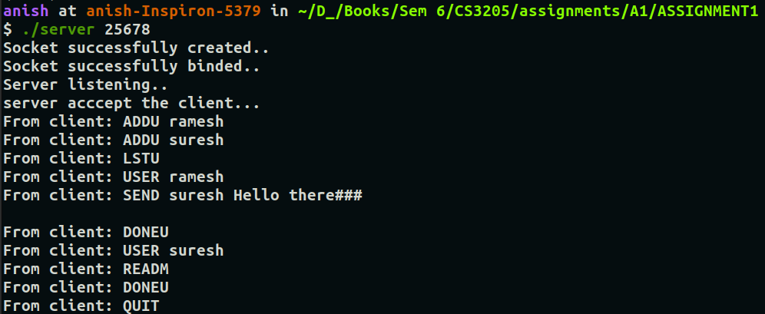

Client: @106.51.241.0

