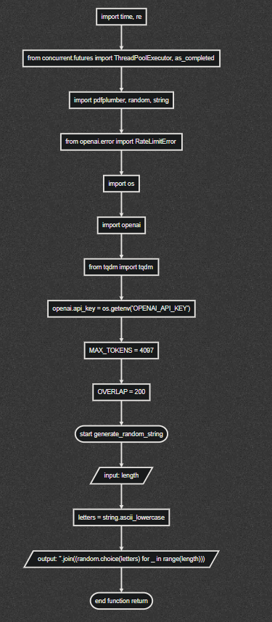

This Python script is designed to extract text from a PDF file, generate a summary of it, and answer questions about its content using the OpenAI GPT-3 model. It also incorporates some level of user interaction, such as asking for a question, and it saves the AI's responses to specific prompts.

Let's go through the main functions of the script:

1. **extract_text(file_path)**: This function opens a given PDF file, extracts text from each page using pdfplumber, and returns all the text joined together.
2. **summarize_chunk(chunk)** and **summarize_text(text)**: These functions use the OpenAI GPT-3 model to summarize chunks of text. The text is divided into chunks to avoid exceeding the maximum token limit of the model.
3. **summarize_pdf(file_path)**: This function first extracts text from a given PDF file and then summarizes the extracted text. It also measures the time it took to perform the summarization.
4. **create_responses(chunk, prompt)** and **answer_prompt(text, prompt)**: These functions use the GPT-3 model to answer a prompt based on chunks of text. The text is divided into chunks, and the model generates a response for each chunk.
5. **generate_filename(prompt)**: This function generates a filename based on a given prompt using the GPT-3 model. It removes any non-alphanumeric characters from the filename, except for underscores and hyphens.
6. **interactive_session(file_path)**: This function creates an interactive session where the user can choose to ask a question about the content of a given PDF file or request a summary of the file. The user's question and the AI's response are saved to a file. The filename is based on the user's question.

In the main part of the script, the **interactive_session** function is called with the path of a PDF file as an argument.

In addition, the script also includes rate limit handling for OpenAI requests and uses a ThreadPoolExecutor for parallel processing of text chunks, which can improve performance when dealing with large amounts of text.