**📄 Introduction:**

FitFlex is a modern fitness web application developed to provide users with a personalized, engaging, and intuitive fitness experience. With a strong emphasis on user-friendliness and a visually appealing interface, FitFlex makes fitness exploration, planning, and engagement accessible to both beginners and experienced fitness enthusiasts.

## By integrating third-party fitness APIs and YouTube video content, FitFlex empowers users to explore various exercises, learn proper workout techniques, and access personalized routines for their fitness goals.

**🎯 Project Objective:**

The primary goal of **FitFlex** is to deliver a fitness discovery platform that blends innovation with practicality. The objectives include:

* ✅ **User-Friendly Experience:** Build an intuitive and responsive UI for easy workout discovery and engagement.
* ✅ **Comprehensive Exercise Management:** Include smart search capabilities and categorized content to support personalized fitness journeys.
* ✅ **Modern Tech Stack:** Use React.js and popular modern libraries/frameworks to ensure high performance and responsiveness.

**⚙️ Technology Stack:**

| **Category** | **Tools/Technologies Used** |
| --- | --- |
| Frontend Framework | **React.js** |
| Routing | **React Router DOM** |
| API Calls | **Axios** |
| Styling | **Tailwind CSS** / Bootstrap |
| Icons | **React Icons** |
| Version Control | **Git** and **GitHub** |
| External APIs | **ExerciseDB API**, **YouTube Data API** via RapidAPI |
| IDE | **Visual Studio Code** |

**🛠️ Project Setup and Configuration:**

**📌 Pre-requisites:**

* **Node.js & npm** – Installed from nodejs.org
* **Basic Web Dev Knowledge** – HTML, CSS, JS
* **Code Editor** – VS Code or equivalent

**📦 Installation Steps:**

1. **Clone or Download the Project**  
   Link: [Download from Google Drive](https://drive.google.com/drive/folders/14f9eBQ5W7VrLdPhP2W6PzOU_HCy8UMex?usp=sharing)
2. **Navigate to the directory**
3. cd fitness-app-react
4. **Install dependencies**
5. npm install
6. **Start development server**
7. npm start
8. **Open app in browser**  
   Visit: http://localhost:3000

**📂 Project Structure:**

fitness-app-react/

│

├── Components/ # Reusable UI components (Navbar, Footer, Hero, etc.)

├── Pages/ # Page-level components (Home, Category, Exercise)

├── Styles/ # CSS or Tailwind classes

├── App.js # App routing and global structure

└── index.js # Entry point

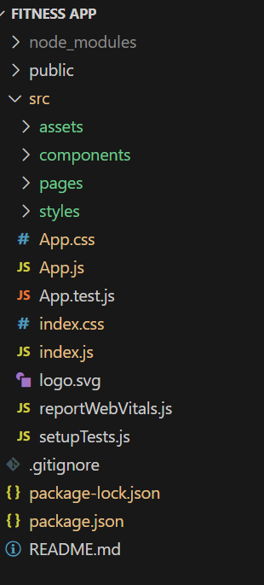    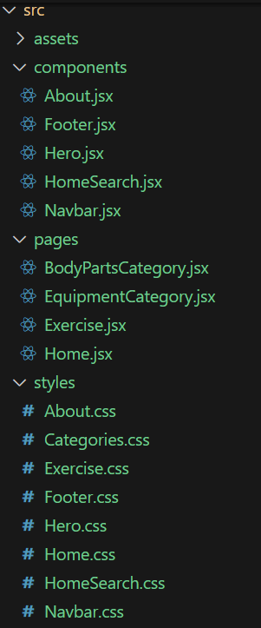

**🔧 Development Overview:**

**🔁 Routing Setup**

* Used react-router-dom to create routes:
  + / – Home page with Hero and Search
  + /category/:name – Exercises under specific category
  + /exercise/:id – Exercise detail page with video

**🧩 Components Built:**

1. **Navbar** – Top navigation
2. **Hero** – Banner for trending workouts
3. **Search Bar** – Smart search powered by RapidAPI
4. **Categories Section** – Grid view of workout types
5. **Exercise Card** – Visual display of workouts
6. **Footer** – Informational links and branding

**🔌 API Integration Details:**

**1. Fetch Body Parts and Equipment**

const bodyPartsOptions = {

method: 'GET',

url: 'https://exercisedb.p.rapidapi.com/exercises/bodyPartList',

headers: {

'X-RapidAPI-Key': 'YOUR_API_KEY',

'X-RapidAPI-Host': 'exercisedb.p.rapidapi.com'

}

};

**2. Fetch Exercises by Category or Equipment**

const options = {

method: 'GET',

url: `https://exercisedb.p.rapidapi.com/exercises/equipment/${id}`,

headers: {

'X-RapidAPI-Key': 'YOUR_API_KEY',

'X-RapidAPI-Host': 'exercisedb.p.rapidapi.com'

}

};

**3. Fetch Exercise Details by ID**

const url = `https://exercisedb.p.rapidapi.com/exercises/exercise/${id}`;

**4. Fetch YouTube Videos Related to Exercise**

const options = {

method: 'GET',

url: 'https://youtube-search-and-download.p.rapidapi.com/search',

params: {

query: `${exerciseName}`,

type: 'v',

sort: 'relevance'

},

headers: {

'X-RapidAPI-Key': 'YOUR_API_KEY',

'X-RapidAPI-Host': 'youtube-search-and-download.p.rapidapi.com'

}

};

**🎨 UI Features and Screenshots Overview:**

**📸 1. Hero Section:**

Displays trending workouts or challenges with CTA buttons.

**🔍 2. Search Functionality:**

Smart search by:

* Muscle group
* Equipment
* Fitness level
* Keywords

**📚 3. Category Page:**

Grid of exercise categories with visual icons. E.g.,:

* Strength
* Cardio
* Yoga
* Full Body

**🏋️‍♀️ 4. Exercise Details Page:**

Each exercise includes:

* Instructions
* Target muscle groups
* Equipment required
* Embedded related YouTube videos

**✅ Key Features Summary:**

| **Feature** | **Description** |
| --- | --- |
| Exercise Discovery | Powered by ExerciseDB API |
| YouTube Integration | Embedded workout demos using YouTube search API |
| Responsive UI | Mobile-friendly and responsive layout |
| Smart Search | Filter by body part, difficulty, equipment |
| Routing & Navigation | Smooth transitions via React Router |
| API-Driven Content | Dynamic fetching and rendering based on user input |
| Component-Based Design | Scalable and reusable component architecture |

**🚀 Project Execution:**

To run the project locally:

npm start

To build the app for production:

npm run build

**🧪 Future Enhancements:**

* ✅ User authentication for saving workouts
* ✅ Workout planner and tracker
* ✅ Personalized recommendations based on usage
* ✅ Social sharing and community features
* ✅ Progressive Web App (PWA) support

**📌 Conclusion:**

FitFlex demonstrates how modern web development technologies can be leveraged to create a rich, interactive, and user-centered fitness platform. With its modular structure, API integrations, and clear UX design, FitFlex is well-positioned to serve users seeking a more engaging and educational workout journey.