DATA STRUCTURES & ALGORITHMS LAB
Capstone Assignment

Smart City Traffic Management and Route Optimization System

Student Name | Anish Chhetri
Roll No. | 2401201086
Course / Semester | BCA / 5th A
Subject | Design and Analysis of Algorithms

1. Introduction

1.1 Smart city concepts
A smart city uses sensors, data and algorithms to run urban services more efficiently. Transportation is one of its most important domains: road networks, signals, public transit and emergency services all depend on timely routing decisions. A road network is naturally a graph, so graph theory gives a precise and well-studied toolkit for these decisions.

1.2 Importance of traffic optimization
Congestion increases travel time, fuel consumption, emissions and emergency response delays. Routing commuters along the cheapest paths, re-planning when a road is congested or closed, checking that every region remains reachable, and planning new roads at minimum cost all reduce these losses. This project implements these tasks as a Streamlit application backed by classical graph algorithms.

1.3 System design
The city is modelled as a weighted undirected graph: intersections are vertices, roads are edges and weights are travel times in minutes. The application has four modules plus a benchmarking component:
- Road Network Modeling - build, load and view the graph as an adjacency list and adjacency matrix.
- Route Planning - Dijkstra shortest route with every distance update displayed.
- Traffic Analysis - congestion/closure simulation and Bellman-Ford re-routing with cost comparison.
- Network Connectivity - BFS and DFS traversals and reachable intersections.
- Infrastructure Planning - minimum spanning tree using Prim and Kruskal.
All algorithms were implemented from scratch in Python (heapq for priority queues, a union-find structure for Kruskal) and verified against NetworkX on 40 random networks of 5 to 60 intersections.

2. Experimental Results

2.1 Sample road network
The sample city has 12 intersections and 18 roads (Airport, Highway Jn, Tech Park, Stadium, University, Central Station, City Hall, Market, Hospital, Old Town, Mall and Harbor).
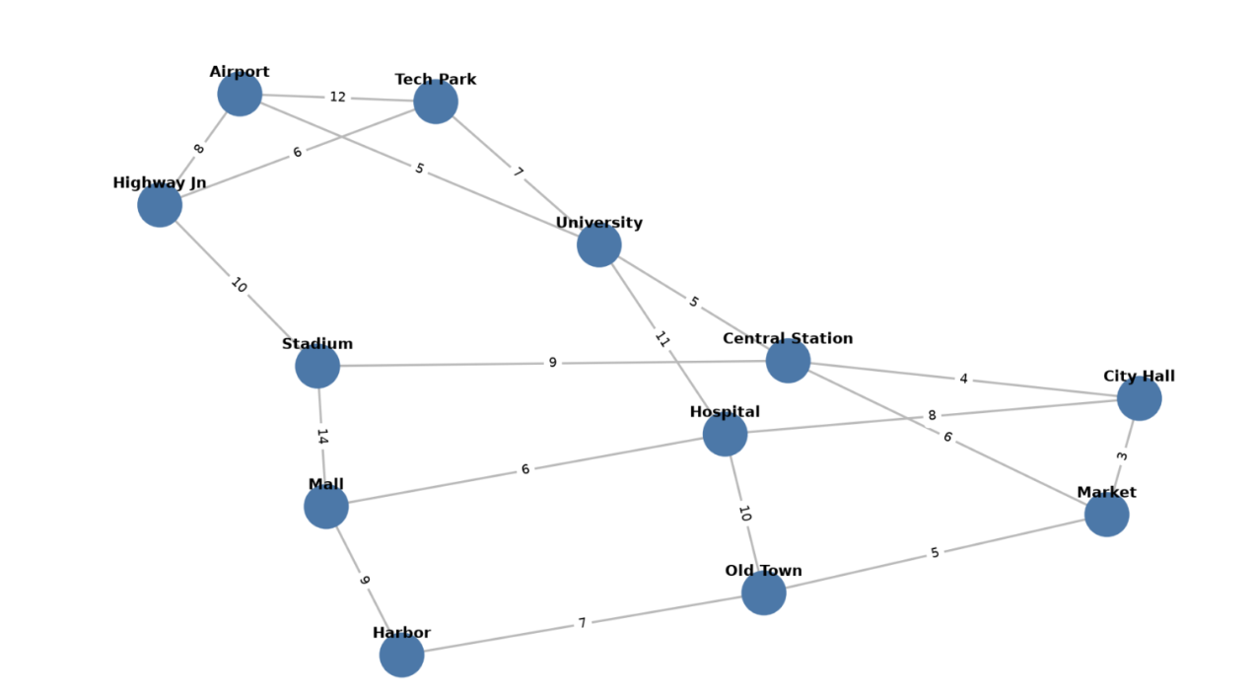
Figure 1: Sample city road network (edge labels are travel minutes)

2.2 Route calculation (Dijkstra)
From Airport to Harbor the shortest route is Airport -> Highway Jn -> Stadium -> Mall -> Harbor with a total cost of 41 minutes. Dijkstra performed 13 distance updates, all of which are listed in the application.
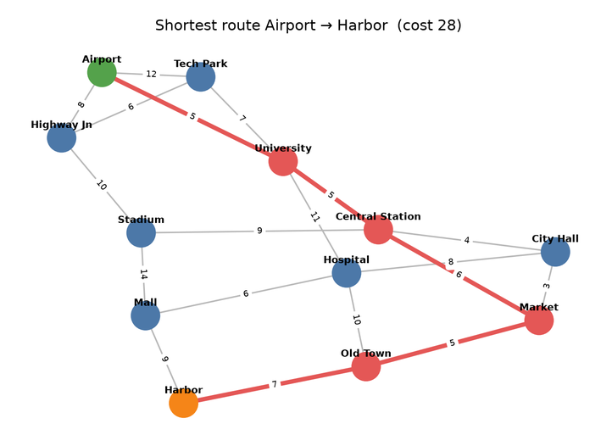
Figure 2: Shortest route found by Dijkstra

2.3 Traffic analysis (Bellman-Ford)
Congestion was simulated by tripling the travel time of the Stadium-Mall road. Bellman-Ford then found the route Airport -> Tech Park -> University -> Central Station -> Market -> Old Town -> Harbor with cost 42 minutes.
Scenario | Route | Cost (min)
Original | Airport -> Highway Jn -> Stadium -> Mall -> Harbor | 41
After congestion | Airport -> Tech Park -> University -> Central Station -> Market -> Old Town -> Harbor | 42
The cost increased by 1 minutes (2.4%) and the route changed, showing that a diversion through Tech Park and Central Station becomes preferable once the Stadium-Mall road is congested. Staying on the original route would have cost 69 minutes (the Stadium-Mall road grows from 14 to 42), so rerouting limits the delay to 1 minute.
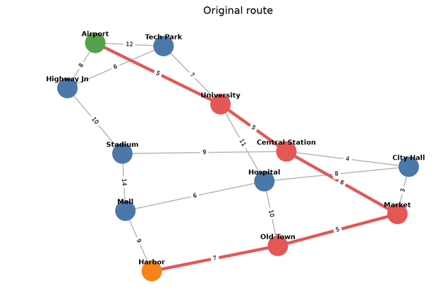
Figure 3a: Original route
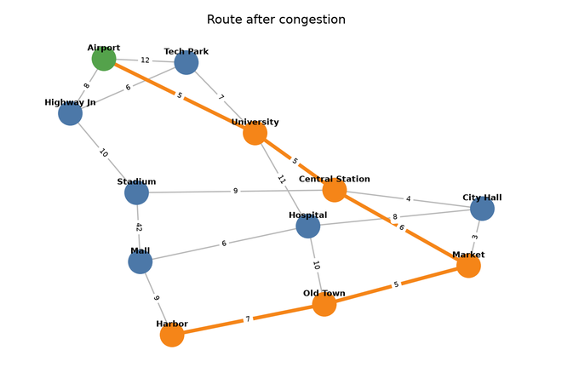
Figure 3b: Route after congestion

2.4 Traversal outputs (starting at Airport)
BFS order: Airport, Highway Jn, Tech Park, Stadium, University, Central Station, Mall, Hospital, City Hall, Market, Harbor, Old Town
DFS order: Airport, Highway Jn, Stadium, Central Station, City Hall, Hospital, Mall, Harbor, Old Town, Market, University, Tech Park
All 12 intersections are reachable, so the network is a single connected region. BFS explores level by level (nearest intersections in terms of number of roads first), while DFS follows one branch as deep as possible before backtracking.

2.5 Minimum spanning tree outputs
Prim's and Kruskal's algorithms both produced a minimum spanning tree with total infrastructure cost 68 (Kruskal: 68). The tree contains 11 roads; the remaining 7 roads form cycles and are not required to keep the network connected.
From | To | Cost
Airport | Highway Jn | 8
Highway Jn | Tech Park | 6
Tech Park | University | 7
University | Central Station | 5
Central Station | City Hall | 4
City Hall | Market | 3
Market | Old Town | 5
Old Town | Harbor | 7
City Hall | Hospital | 8
Hospital | Mall | 6
Central Station | Stadium | 9
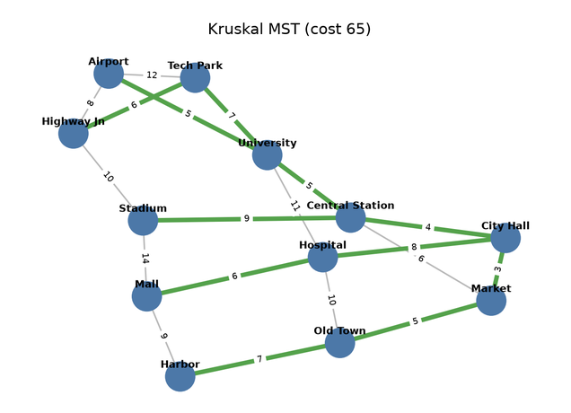
Figure 4: Minimum spanning tree (green roads)

2.6 Comparative experiments
Random connected networks with 10, 25, 50 and 100 intersections (about twice as many roads as intersections) were generated with a fixed seed. Each time is the mean of 50 runs; memory is the peak allocation measured with tracemalloc.
Table 1: BFS vs DFS
Intersections | Roads | BFS (ms) | DFS (ms) | BFS mem (KB) | DFS mem (KB)
10 | 19 | 0.006 | 0.008 | 1.8 | 1.6
25 | 49 | 0.014 | 0.015 | 4.5 | 5.2
50 | 99 | 0.027 | 0.028 | 5.4 | 5.4
100 | 199 | 0.054 | 0.062 | 15.5 | 19.3
Table 2: Dijkstra vs Bellman-Ford
Intersections | Roads | Dijkstra (ms) | Bellman-Ford (ms) | Route cost | Route hops
10 | 19 | 0.006 | 0.016 | 7 | 1
25 | 49 | 0.021 | 0.05 | 22 | 3
50 | 99 | 0.043 | 0.105 | 42 | 5
100 | 199 | 0.097 | 0.173 | 34 | 4
Table 3: Prim vs Kruskal
Intersections | Roads | Prim (ms) | Kruskal (ms) | Prim MST cost | Kruskal MST cost
10 | 19 | 0.026 | 0.028 | 41 | 41
25 | 49 | 0.073 | 0.066 | 149 | 149
50 | 99 | 0.14 | 0.133 | 280 | 280
100 | 199 | 0.321 | 0.29 | 568 | 568

3. Analysis

3.1 Comparison of graph algorithms
- BFS vs DFS: both run in O(V+E) and visited every intersection in all experiments; their running times were nearly identical. BFS additionally gives the minimum number of roads to each intersection, which is useful for coverage analysis, whereas DFS needs less memory on deep, narrow networks.
- Dijkstra vs Bellman-Ford: both returned identical route costs on every network. Dijkstra (O((V+E) log V)) was roughly 1.8 to 2.7 times faster in these experiments because Bellman-Ford (O(VE)) repeatedly scans all roads. The gap would widen on larger networks.
- Prim vs Kruskal: both gave the same MST cost on every network. Run times were very close because road networks are sparse (E is about 2V); Kruskal is simple and efficient here, while Prim is generally preferable for dense graphs.

3.2 Traffic optimization observations
- Dijkstra is the best fit for real-time navigation because travel times are non-negative and queries must be fast.
- Bellman-Ford is slower but simple to run on the full edge list after weights change and would also support negative adjustments (for example, incentive discounts) and detect inconsistent data through negative-cycle checks.
- Congestion on one road does not always change the best route; here it did, and the diversion limited the delay to a few minutes. Cost changes depend on whether a nearby alternative exists.

3.3 Infrastructure planning insights
The MST shows the cheapest way to keep every intersection connected (cost 68). Roads outside the MST are not wasted: they provide redundancy, which is what makes rerouting possible. Planners should treat the MST as a lower bound on construction cost, then add redundant roads where congestion analysis shows heavy dependence on a single link.

4. Conclusion

4.1 Key findings
- All algorithms were implemented correctly and agree with NetworkX on all test networks.
- Dijkstra outperformed Bellman-Ford; BFS/DFS and Prim/Kruskal performed almost identically on sparse city-like graphs.
- Re-computing routes after simulated congestion quantifies the delay and identifies diversions.

4.2 Benefits of graph algorithms in transportation systems
Graph algorithms provide fast, provably correct answers to routing, reachability and network design questions, and they scale to city-sized networks. They form the basis of navigation, ride-sharing, emergency routing and infrastructure planning systems.

4.3 Future improvements
- Use real map data (OpenStreetMap) and live traffic feeds.
- Add A* search, k-shortest paths and time-dependent edge weights.
- Support one-way roads (directed graphs) and road capacities with max-flow analysis.
- Add signal timing optimization and a map-based interface.

