Image-Based Breed Recognition of Indian Cattle and Buffaloes
Anish Tiwari  Department of Computer Science and Engineering  Shri Vaishnav Vidyapeeth Vishwavidyalaya  Indore, Madhya Pradesh, India | Anmol Panchal  Department of Computer Science and Engineering  Shri Vaishnav Vidyapeeth Vishwavidyalaya  Indore, Madhya Pradesh, India | Anirudh Pachori  Department of Computer Science and Engineering  Shri Vaishnav Vidyapeeth Vishwavidyalaya  Indore, Madhya Pradesh, India | Ahishek Singh  Department of Computer Science and Engineering  Shri Vaishnav Vidyapeeth Vishwavidyalaya  Indore, Madhya Pradesh, India

Abstract—Accurate identification of indigenous cattle and buffalo breeds is important for livestock management, breed conservation, dairy operations, and agricultural decision-making. Traditional breed identification generally depends on human observation of morphological characteristics, which can be time-consuming and may be affected by observer experience, environmental conditions, and similarities between closely related breeds. This project proposes an image-based breed recognition system that uses Computer Vision and Deep Learning to automate livestock breed identification from digital images. The proposed system follows a hierarchical two-stage approach. First, YOLOv8 is used to detect and localise the animal within an input image and reduce the influence of complex backgrounds. The detected animal region is then extracted as a Region of Interest and passed to a ResNet50-based transfer-learning classifier for fine-grained breed recognition. The classification stage analyses visual characteristics such as body structure, horn shape, head characteristics, coat appearance, and other breed-related morphological features. A Streamlit-based interface is proposed for image upload and prediction visualisation. The system will be evaluated using appropriate classification and detection metrics including accuracy, precision, recall, F1-score, and confusion matrix analysis. The project focuses on developing a software-based, non-invasive and extensible approach for automated recognition of selected Indian cattle and buffalo breeds.
Keywords—Cattle Breed Recognition, Buffalo Breed Recognition, Computer Vision, Deep Learning, YOLOv8, ResNet50, Transfer Learning, Image Classification, Object Detection, Livestock Management
I. INTRODUCTION
India has a large and diverse livestock population consisting of numerous indigenous cattle and buffalo breeds. Correct breed identification plays an important role in livestock management, dairy production, breeding programmes, genetic conservation, livestock trading, and agricultural research.
Traditional breed identification is generally based on physical and morphological characteristics observed by farmers, veterinarians, livestock experts, or trained personnel. Characteristics such as horn shape, body structure, coat colour, hump, head shape, dewlap, and overall appearance may be considered during identification. However, this process can be subjective and may become difficult when visually similar breeds are involved.
The availability of digital images and advances in Artificial Intelligence, Computer Vision, and Deep Learning create an opportunity to automate this process. A computer vision system can analyse animal images and learn visual patterns associated with different breeds.
The proposed project therefore focuses on developing an integrated image-based breed recognition system rather than relying entirely on manual visual identification. The proposed workflow is:
Image Acquisition → Preprocessing → Animal Detection → ROI Extraction → Breed Classification → Confidence Estimation → Result Display
The project synopsis identifies the system as a fine-grained visual classification problem and proposes YOLOv8 for animal localisation and ResNet50 for breed classification.
II. PROBLEM DOMAIN
Indian cattle and buffalo breeds exhibit significant diversity in their physical characteristics. However, visual identification becomes challenging because individual animals within the same breed may have different appearances while different breeds may share similar characteristics.
A. Breed Identification
Breed identification may involve characteristics such as:
- Horn shape and curvature
- Body structure
- Head and facial characteristics
- Coat colour and appearance
- Hump characteristics
- Dewlap
- Ear shape
- Overall body proportions
B. Importance of Identification
Accurate breed identification can support:
- Livestock management
- Dairy operations
- Breeding programmes
- Livestock documentation
- Breed conservation
- Agricultural research
- Livestock trading
- Insurance-related verification
The project synopsis identifies breed verification, livestock trading, insurance-related verification, livestock census, and conservation as potential application areas.
C. Image-Based Identification Problem
A digital image may contain complex backgrounds such as farms, vegetation, buildings, other animals, fences, or equipment. Therefore, directly classifying the entire image may cause the model to learn irrelevant background information.
The proposed system addresses this issue by separating animal localisation from breed classification.
III. PROBLEM STATEMENT
The project addresses the following problem: how can Indian cattle and buffalo breeds be automatically identified from digital images using Computer Vision and Deep Learning while handling variations in animal appearance, background, lighting, scale, and camera viewpoint?
The system needs to address several aspects simultaneously:
- Animal detection
- Background separation
- ROI extraction
- Fine-grained breed classification
- Confidence estimation
- Multi-breed support
- User-friendly result presentation
- Model performance evaluation
The main challenge is not simply classifying an image. The system must first determine the relevant animal region and then distinguish between visually similar breed categories.
IV. CHALLENGES IN CONVENTIONAL BREED IDENTIFICATION
A. Manual Identification
Traditional identification depends heavily on human observation and domain knowledge. Different observers may reach different conclusions, particularly when breeds have similar visual characteristics.
B. Intra-Class Variation
Animals belonging to the same breed may differ because of:
- Age
- Gender
- Nutrition
- Physical condition
- Environmental conditions
C. Inter-Class Similarity
Some breeds may share similar morphological characteristics. This makes fine-grained classification more difficult than general animal classification.
D. Image Variations
Computer Vision performance may be affected by:
- Lighting conditions
- Camera angle
- Image resolution
- Background clutter
- Occlusion
- Animal pose
- Scale variation
The project synopsis explicitly identifies age, nutrition, gender, lighting, scale, camera angle, and background clutter as important challenges.
V. NEED FOR AN AUTOMATED SYSTEM
Instead of depending completely on manual identification, the proposed project combines object detection and deep learning classification into a unified workflow. The proposed workflow is:
Animal Image → Detection → ROI Extraction → Feature Learning → Breed Classification → Confidence → Result
The detection stage helps isolate the animal from irrelevant background content. The classification stage then concentrates on the visual characteristics of the animal itself.
This separation is particularly useful for fine-grained recognition because the classifier receives a focused representation of the animal rather than the complete scene.
The proposed system also provides a software interface through which users can upload an image and receive the predicted breed.
VI. PROJECT OBJECTIVES
The major objectives of the proposed project are:
A. Automated Breed Recognition
Develop a software system capable of recognising selected Indian cattle and buffalo breeds from images.
B. Animal Detection
Use YOLOv8 to detect and localise the animal before classification.
C. ROI-Based Classification
Extract the detected animal region and use it as input for breed classification.
D. Deep Learning-Based Classification
Use a transfer-learning-based ResNet50 model to perform fine-grained breed classification.
E. User-Friendly Interface
Develop a Streamlit-based interface for image upload and prediction display.
F. Model Evaluation
Evaluate the system using appropriate classification and detection metrics.
G. Extensibility
Design the system so that additional breeds and improved models can be incorporated in future versions.
VII. LITERATURE SURVEY
The literature and technical background for the proposed system can be organised around four major areas:
- Computer Vision for livestock recognition
- Object detection
- Deep learning-based image classification
- Transfer learning
Deep Learning has significantly improved image recognition by allowing models to learn hierarchical visual representations directly from images.
Residual Networks introduced the concept of residual learning to enable deeper neural network architectures. ResNet50 is therefore suitable as a feature extraction and classification backbone for image recognition tasks [1].
Object detection models such as YOLO perform localisation and classification within a single detection framework. YOLO-based approaches are designed for efficient object detection and have been widely used in real-time computer vision applications [2].
Transfer learning allows a model pretrained on a large image dataset to be adapted to a specialised classification problem. This approach is useful when the target dataset is smaller than datasets typically used for training deep neural networks from scratch.
For the proposed system, these concepts are combined into a hierarchical pipeline where object detection and fine-grained classification perform complementary roles.
VIII. COMPUTER VISION FOR LIVESTOCK RECOGNITION
Computer Vision provides a method for automatically analysing livestock images. A general image recognition pipeline can be represented as:
Image → Preprocessing → Feature Extraction → Classification → Prediction
For the proposed project, this pipeline is extended to include an object detection stage:
Image → Preprocessing → Detection → ROI Extraction → Feature Learning → Classification
A. Potentially Useful Visual Characteristics
The system may learn visual information related to:
- Horn structure
- Head shape
- Body proportions
- Coat appearance
- Hump
- Dewlap
- Ear characteristics
- General body morphology
The system does not explicitly measure every characteristic separately. Instead, the deep learning model learns relevant visual representations from labelled training images.
B. Computer Vision Challenges
Model performance can be affected by:
- Variable lighting
- Occlusion
- Camera perspective
- Image quality
- Background objects
- Limited labelled data
- Differences between training and deployment images
Therefore, preprocessing and data augmentation are important components of the proposed training pipeline.
IX. OBJECT DETECTION AND ROI EXTRACTION
The first major stage of the proposed system is animal detection. YOLOv8 is used to identify the cattle or buffalo within the image and generate a bounding box. The workflow is:
Input Image → YOLOv8 → Bounding Box → Animal ROI
The purpose of this stage is to reduce irrelevant information from the image. For example, if an image contains an animal standing in a field, the complete image may contain:
- Grass
- Trees
- Buildings
- Fences
- People
- Other objects
Passing the complete image directly to the classifier may introduce unwanted visual information. By extracting the animal ROI, the classification model can focus more strongly on animal-specific features.
The project synopsis proposes YOLOv8 specifically for localisation and background isolation.
X. FINE-GRAINED BREED CLASSIFICATION
After ROI extraction, the cropped animal image is passed to the ResNet50 classifier. The proposed classification architecture is:
ROI → ResNet50 Backbone → Global Average Pooling → Dropout → Dense Layer → Softmax → Breed
ResNet50 is used as a transfer-learning backbone. The model is pretrained on a large image dataset and adapted to the target cattle and buffalo breed classification problem. The proposed classification stage uses:
- ResNet50
- Transfer learning
- Global Average Pooling
- Dropout
- Dense classification layer
- Softmax output
The project synopsis specifies a dropout value of 0.5 and a softmax-based classification head for the target breed classes.
XI. DATA PREPROCESSING AND AUGMENTATION
The quality and diversity of training data are important for fine-grained breed recognition. The proposed preprocessing pipeline includes:
Image → Resize → Normalisation → Tensor Conversion → Model Input
For the classification stage, the project synopsis proposes a 224 × 224 pixel input size. During training, augmentation techniques may include:
- Horizontal flipping
- Affine transformations
- Brightness variation
- Gaussian blur
These transformations are intended to expose the model to different image conditions and improve robustness to variations in illumination, scale, and camera viewpoint.
The dataset should contain representative images for the supported cattle and buffalo breeds and should include sufficient visual variation.
XII. COMPARATIVE ANALYSIS
Different approaches can be used for livestock breed identification, as summarised in Table I.
TABLE I. COMPARISON OF IDENTIFICATION APPROACHES
Approach | Main Function | Limitation
Manual Identification | Human visual identification | Subjective and time-consuming
Direct Image Classification | Predict breed from complete image | Background may influence prediction
Object Detection | Localise animal | Does not itself provide detailed breed classification
Deep Learning Classification | Learn breed-specific visual patterns | Requires representative labelled data
Proposed Two-Stage Approach | Detection + ROI + classification | Requires training and integration of two stages

The proposed approach combines the strengths of object detection and image classification rather than treating them as independent tasks.
XIII. RESEARCH GAP
Existing computer vision approaches can perform object detection and image classification, but the proposed project focuses specifically on integrating these capabilities for fine-grained recognition of Indian cattle and buffalo breeds. The primary gap addressed by the project is the development of a unified workflow that combines:
- Animal localisation
- Background reduction
- ROI extraction
- Deep feature learning
- Fine-grained breed classification
- Confidence estimation
- User-facing prediction
The contribution is therefore primarily focused on applying and integrating established Computer Vision and Deep Learning techniques to the Indian livestock breed recognition problem rather than claiming a completely new object detection or classification algorithm.
XIV. PROPOSED INTEGRATED APPROACH
The complete proposed system is:
Image Acquisition → Preprocessing → YOLOv8 Detection → ROI Extraction → ResNet50 Classification → Confidence Estimation → Streamlit Result
A. Data Sources
The system may use:
- Public livestock image datasets
- Curated project images
- Research datasets
- Images collected for the project
- Properly labelled training images
B. Detection Stage
YOLOv8 identifies the animal and provides the bounding box.
C. Classification Stage
The ROI is resized and passed to the ResNet50 model.
D. Prediction Stage
The classification model produces class probabilities and selects the predicted breed.
E. Application Stage
The prediction is displayed through a Streamlit interface.
XV. PROPOSED SYSTEM ARCHITECTURE
The overall architecture of the proposed system is shown in Fig. 1.
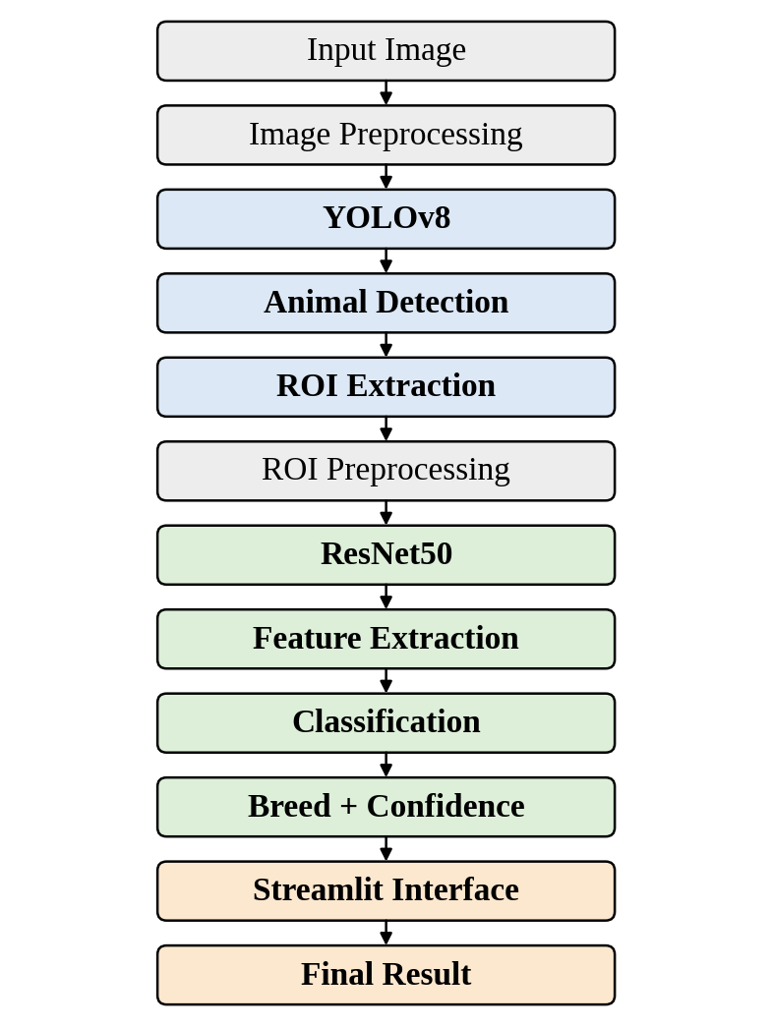
Fig. 1. Proposed architecture for image-based breed recognition.
The hierarchical architecture follows the project synopsis, where YOLOv8 performs localisation and ResNet50 performs fine-grained classification.
XVI. TECHNICAL FEASIBILITY
The proposed system is technically feasible because its primary components can be implemented using established open-source technologies, as shown in Table II.
TABLE II. PROPOSED TECHNOLOGY STACK
Component | Proposed Technology | Function
Programming | Python | Application development
Object Detection | YOLOv8 | Animal localisation
Deep Learning | PyTorch / TensorFlow | Model development
Classification | ResNet50 | Breed recognition
Image Processing | OpenCV | Image preprocessing
Data Processing | NumPy / Pandas | Dataset handling
Evaluation | Scikit-learn | Performance analysis
Interface | Streamlit | Web application
Training | GPU / Google Colab | Model training

The project synopsis proposes Python, TensorFlow/PyTorch, OpenCV, Streamlit and GPU/Google Colab as the primary engineering stack. The main technical challenge is expected to be the availability and quality of representative labelled livestock images rather than the availability of the software technologies themselves.
XVII. ECONOMIC FEASIBILITY
The proposed system is economically feasible as a software-centric project.
A. Cost-Minimising Approach
The project can make use of:
- Open-source software
- Public datasets
- Existing computing resources
- Google Colab or similar environments
- Existing development tools
- Streamlit for prototype deployment
B. Hardware Boundary
The proposed implementation does not require development of:
- Custom livestock sensors
- RFID hardware
- Custom cameras
- Robotic inspection systems
The primary requirement is computational infrastructure suitable for model training and inference.
XVIII. OPERATIONAL FEASIBILITY
The proposed system can be used by different categories of livestock-related users. The operational workflow is:
User → Upload Animal Image → AI Analysis → Breed Prediction → Confidence → Result
Potential users include:
- Farmers
- Livestock owners
- Dairy cooperative staff
- Researchers
- Veterinary/livestock experts
A. Expected Operational Benefits
- Faster preliminary breed identification
- Reduced dependence on manual visual inspection
- Consistent software-based prediction
- Centralised digital workflow
- Easy demonstration through a web interface
- Potential support for livestock documentation
The system is intended to support human decision-making rather than completely replace expert verification.
XIX. REQUIREMENT TO SOLUTION MAPPING
Table III maps the major project requirements to the corresponding software solutions.
TABLE III. REQUIREMENT TO SOLUTION MAPPING
Project Requirement | Proposed Software Solution
Image-based breed identification | Deep Learning classification
Animal localisation | YOLOv8 object detection
Background reduction | ROI extraction
Breed classification | ResNet50
Multi-breed recognition | Multi-class classification
Prediction confidence | Softmax class scores
Image preprocessing | Resize and normalisation
Robust training | Data augmentation
User interaction | Streamlit interface
Model evaluation | Accuracy, precision, recall and F1-score
Error analysis | Confusion matrix
Future deployment | Mobile/API integration

XX. EXPECTED CONTRIBUTION
The proposed project aims to provide an integrated software workflow for image-based recognition of Indian cattle and buffalo breeds. The expected contribution includes:
- Automated animal localisation
- ROI-based breed classification
- Deep learning-based feature extraction
- Multi-class breed prediction
- Confidence estimation
- User-friendly web interface
- Evaluation framework for model performance
The contribution is primarily the integration of these components into a complete end-to-end breed recognition workflow. The system is intended to convert an unstructured animal image into a structured prediction that can support livestock-related applications.
XXI. LIMITATIONS
At the current development stage, the following limitations are recognised:
- Real-world labelled livestock images may be limited.
- Model performance depends on dataset quality and diversity.
- Similar breeds may be difficult to distinguish visually.
- Lighting and background variations may affect predictions.
- Occlusion may hide important breed characteristics.
- Camera angle and animal pose may influence classification.
- An unsupported breed may not be correctly identified.
- Genetic breed purity cannot be determined from an image alone.
- Model confidence does not guarantee biological correctness.
- Real-world performance requires testing on unseen field images.
- The system should not replace expert livestock or veterinary verification.
These limitations are consistent with the challenges identified in the project synopsis, particularly intra-class variation and low inter-class variation.
XXII. NEXT STEPS
The immediate development plan is divided into the following phases.
A. Phase 1 — Dataset Preparation
- Collect suitable cattle and buffalo images.
- Organise images according to breed.
- Verify labels.
- Prepare detection annotations where required.
- Divide the dataset into training, validation and testing subsets.
B. Phase 2 — Object Detection
- Prepare YOLOv8 dataset.
- Train/fine-tune the detection model.
- Evaluate detection performance.
- Generate animal bounding boxes.
C. Phase 3 — Classification
- Prepare extracted ROI images.
- Configure ResNet50 transfer learning.
- Train the breed classifier.
- Evaluate classification performance.
D. Phase 4 — System Integration
- Connect YOLOv8 and ResNet50.
- Implement preprocessing pipeline.
- Develop Streamlit interface.
- Display breed and confidence.
E. Phase 5 — Evaluation
- Test the complete pipeline on unseen images.
- Generate confusion matrix.
- Calculate precision, recall and F1-score.
- Analyse incorrect predictions.
- Identify areas for future improvement.
XXIII. CONCLUSION
The proposed project addresses the challenge of automatically recognising Indian cattle and buffalo breeds from digital images.
Traditional visual identification can be difficult because of human subjectivity, intra-class variation, inter-class similarity, environmental conditions, and image quality. The proposed system addresses these challenges through a hierarchical Computer Vision pipeline.
YOLOv8 is used to detect and localise the animal, after which the detected region is extracted as an ROI. A ResNet50-based transfer-learning model then performs fine-grained breed classification. The final prediction and confidence are presented through a Streamlit-based interface.
The proposed system is technically and economically feasible as a software-centric project because it can be implemented using established Deep Learning and Computer Vision technologies without requiring custom physical identification hardware.
The expected contribution is an integrated and extensible workflow for image-based breed recognition that can support livestock management, breed verification, documentation, research, and conservation-oriented applications.
Future development will focus on dataset preparation, model training, system integration, evaluation on unseen images, and potential deployment through mobile or cloud-based platforms.
REFERENCES
[1] K. He, X. Zhang, S. Ren, and J. Sun, “Deep residual learning for image recognition,” in Proc. IEEE Conf. Computer Vision and Pattern Recognition (CVPR), 2016.
[2] J. Redmon, S. Divvala, R. Girshick, and A. Farhadi, “You only look once: Unified, real-time object detection,” in Proc. IEEE Conf. Computer Vision and Pattern Recognition (CVPR), 2016.
[3] ICAR-NBAGR, “Registered Indigenous Cattle Breeds of India,” ICAR-National Bureau of Animal Genetic Resources.
[4] ICAR-NBAGR, “Registered Indigenous Buffalo Breeds of India,” ICAR-National Bureau of Animal Genetic Resources.
[5] A. Dosovitskiy et al., “An image is worth 16×16 words: Transformers for image recognition at scale,” in Proc. International Conference on Learning Representations (ICLR), 2021.
[6] T.-Y. Lin et al., “Microsoft COCO: Common objects in context,” in Proc. European Conference on Computer Vision (ECCV), 2014.
[7] M. Tan and Q. V. Le, “EfficientNet: Rethinking model scaling for convolutional neural networks,” in Proc. International Conference on Machine Learning (ICML), 2019.
[8] O. Ronneberger, P. Fischer, and T. Brox, “U-Net: Convolutional networks for biomedical image segmentation,” in Proc. International Conference on Medical Image Computing and Computer-Assisted Intervention (MICCAI), 2015.
[9] Project Synopsis, “Image-Based Breed Recognition of Indian Cattle and Buffaloes,” Shri Vaishnav Vidyapeeth Vishwavidyalaya, Indore, 2026.

