SmartCare v0.4 - Domain Implementation Workbook
Student name: Anish Atmakur Student ID: U3319971 Tutorial group: 4483

1. UML-to-Code Trace
UML element | Python element | Implemented? | Notes
Patient | class Patient | Yes | Private state, read-only properties, validation in the constructor.
Patient attributes | _patient_id: str, _name: str | Yes | Both validated by require_text() - BR-01, FR-11.
Patient.details() | details() -> str | Yes | FR-02. The only operation carried over from v0.3.
Practitioner | class Practitioner | Yes | No database logic, as Lab Part C requires.
Practitioner attributes | _practitioner_id, _name, _specialty | Yes | practitioner_id and specialty are new in v0.4 - see section 5.
Practitioner operations | none | n/a | Stage 4 Part C asks for the three fields and no database logic. No operation is required, so none is implemented.
Appointment | class Appointment | Yes | Holds a Patient and a Practitioner by reference.
Appointment attributes | _appointment_id, _patient, _practitioner, _time, _status | Yes | status is now an AppointmentStatus enum, not a string.
Appointment.is_scheduled() | is_scheduled() -> bool | Yes | Reads the private status.
Appointment.cancel() | cancel() -> None | Yes | BR-04. Raises InvalidStatusTransitionError if not SCHEDULED.
Appointment.clashes_with() | clashes_with(other) -> bool | Yes | BR-02 for one pair. Collection-wide check still deferred to a service.
Patient 1 - 0..* Appointment | Appointment holds patient: Patient | Yes | Association. Constructor rejects a non-Patient.
Practitioner 1 - 0..* Appointment | Appointment holds practitioner: Practitioner | Yes | Association. Constructor rejects a non-Practitioner.
AppointmentStatus | class AppointmentStatus(Enum) | Yes | SCHEDULED, CANCELLED, COMPLETED declared. No transition into COMPLETED - OQ-01 is still open.
InvalidStatusTransitionError | class InvalidStatusTransitionError | Yes | The only custom exception. See section 4.

2. Domain Invariants
Class | Invariant / rule | How protected
Patient | patient_id and name always contain real text (BR-01, FR-11) | Validated in __init__ by require_text(), which raises ValueError. No setters, so the value cannot be replaced later.
Patient | A patient's identity does not change once created | Private attributes exposed only through read-only properties.
Practitioner | practitioner_id, name and specialty always contain real text | Same pattern: validated in __init__, exposed read-only.
Appointment | An appointment always starts SCHEDULED (BR-03) | Set in __init__ and never taken from the caller, so it cannot be created in any other state.
Appointment | Status only ever changes SCHEDULED -> CANCELLED, once (BR-04) | _status is private with no setter. cancel() is the only route, and it raises InvalidStatusTransitionError if the current status is not SCHEDULED. Verified by Checks 5 and 7.
Appointment | A cancelled appointment is kept, not deleted (FR-09) | cancel() changes state only. The object and all its data remain readable, which Check 6 verifies.
Appointment | Status can only be one of the declared domain states | AppointmentStatus enum instead of a string, so a typo cannot create a state that does not exist.
Appointment | An appointment always refers to a real Patient and Practitioner | The constructor checks the types and raises ValueError otherwise. Verified by Check 4.

3. Composition / Inheritance Decisions
Relationship | Decision | Rationale
Appointment - Patient | Association | Not inheritance - an appointment is not a kind of patient. Appointment holds a reference to a Patient and does not own its lifecycle, because FR-09 and BR-04 require cancelled appointments to be retained.
Appointment - Practitioner | Association | Not inheritance. Exactly one Practitioner held by reference, without lifecycle ownership. This is what makes BR-02 expressible.
Doctor - Practitioner (hypothetical) | Inheritance would be correct, but not implemented | A genuine is-a relationship that would pass the substitution test. SmartCare has never asked for different practitioner types with different behaviour, so building the hierarchy would be inheritance for its own sake.
Clinic - Appointment | Not implemented | Clinic was rejected in Stage 3 as a god class. If it existed it would hold appointments rather than be one, so it would be association, never inheritance.
Any inheritance in the implementation | None used | No is-a relationship exists among the three domain classes. The lecture warns against inheritance used only for reuse, and the Activity 4 example shows the failure mode: Appointment inheriting from PatientRecord.

4. AI Pair-Programming Record
AI tool used: Microsoft Copilot. Prompt: the handout's pair-programmer prompt, supplied with the approved UML, the five business rules and the explicit list of things not to add.
AI contribution | Conforms? | Decision | Reason | Verification
Appointment class structure holding a Patient and a Practitioner by reference | Yes | Accepted | Matches the approved UML associations exactly, and uses association rather than inheritance. | UML-to-code trace in section 1; Check 4.
AppointmentStatus enum instead of string statuses | Yes | Accepted | Removes magic strings so only declared domain states can exist, as the lecture asks. | Checks 1, 6 and 7 all read the enum.
status exposed as a public writable attribute | No | Rejected and replaced | Any caller could bypass cancel() and set an arbitrary status, so BR-03 and BR-04 would not be protected. The rule existed but nothing enforced it. | Check 5 - assignment now raises AttributeError.
Generic ValueError raised on an illegal status transition | Partly | Modified | Works, but does not communicate a domain failure. Replaced with InvalidStatusTransitionError so a caller can tell a broken rule from a broken program. | Check 7 - the custom exception is raised with a message naming the status.
Type hints throughout the generated class | Yes | Accepted | Communicates design intent and matches the lecture's guidance. Does not replace runtime validation, which is still done in the constructor. | Checks 2, 3 and 4 show validation still runs.
A details() method on Appointment | No | Rejected | Not in the approved model, which has is_scheduled(), cancel() and clashes_with() only, and not asked for by Stage 4. Convenience is not a design justification. | UML-to-code trace reports no undocumented members.
No database, UI, notification or service class generated | Yes | Accepted | The explicit constraints in the prompt held. This is the over-design the lecture predicts and it did not occur. | Section 1 - only the three classes plus the enum and exception exist.

5. Updated UML
Change | Evidence | Effect on the model
Practitioner gains practitioner_id | Stage 4 Lab Part C: "Implement Practitioner with identifier, name and specialty". Also the Week 7 lecture. | New private attribute with a read-only property. No relationship changes.
Practitioner gains specialty | Same. In Stage 3 specialty was rejected as unsupported, because only the lecture mentioned it and no requirement did. The Stage 4 handout is a direct instruction, so it is now supported. | New private attribute with a read-only property.
Appointment status becomes AppointmentStatus instead of str | Week 7 lecture: use enumerations for finite domain states instead of magic strings. Handout prompt requires an AppointmentStatus enum. | Attribute type changes. The three status values are now explicit.
All state becomes private with read-only properties | Week 7 lecture on encapsulation and information hiding, and "tell, don't ask". | Operations gain the properties. The invariants in section 2 are now enforced rather than assumed.
InvalidStatusTransitionError added | Week 7 lecture on domain exceptions; handout asks for an agreed enum and exception. | A new exception class, raised by cancel().
is_valid() removed from Patient and Practitioner | Stage 4 Lab Part G - remove unnecessary code and make the implementation simpler. | Validation now occurs in each constructor, so an invalid object cannot be created through the normal constructors. A separate is_valid() operation is therefore not needed, and no Week 7 requirement requires it.
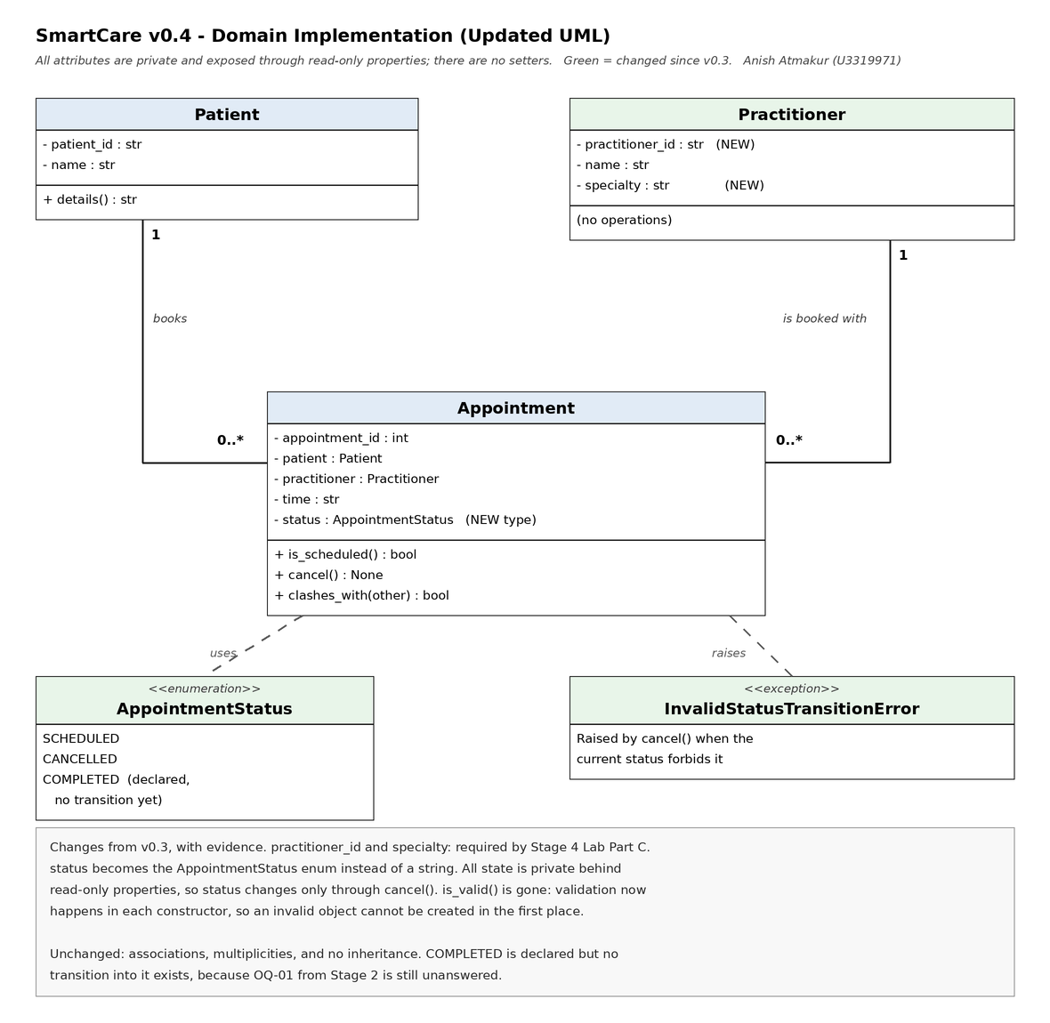
Note on COMPLETED: the Week 7 lecture lists it as an AppointmentStatus value, so it is declared. No transition into it is implemented, because the clinic has still not said when or by whom an appointment becomes completed. That is open question OQ-01, raised in Stage 2 and still unanswered.

