SmartCare v0.3 - Domain Model Workbook
Week 6 student resource
Student name: Anish Atmakur Student ID: U3319971 Tutorial group: 4483

Requirement-to-Concept Trace
Requirement | Concept | State / behaviour | Decision
FR-01 Register a patient with a unique ID and name | Patient | patient_id, name | Class - has identity, state and its own validation
FR-02 Display patient details | Patient | details() | Behaviour on Patient - the object that holds the data reports it
FR-03 Find a patient by ID | Collection query | - | Deferred - no single Patient can search the others. Repository, later stage
FR-04 Register a practitioner | Practitioner | name | Class - every appointment is booked with exactly one
FR-05 List a practitioner's appointments | Collection query | - | Deferred - a view over stored appointments, not a single object's job
FR-06 Create an appointment | Appointment | appointment_id, patient, practitioner, time, status | Class - has its own state and its own legal state changes
FR-07 Reject a clashing appointment (BR-02) | Appointment | clashes_with(other) | Split - one pair handled on Appointment; collection-wide check deferred to a service
FR-08 Cancel an appointment (BR-04) | Appointment | cancel() | Behaviour on Appointment - the object owning the state controls the change
FR-09 Retain cancelled appointments | Appointment | status = CANCELLED | Behaviour - the record is marked, never deleted
FR-10 List a patient's appointment history | Collection query | - | Deferred - a view over stored appointments
FR-11 Reject blank required fields (BR-01) | Patient, Practitioner | is_valid() | Behaviour on each class - each object validates its own fields. Appointment is not given this responsibility on its CRC card, so blank-field checking for an appointment is deferred to where appointments are created
FR-12 Persistence | Storage concern | - | Deferred - not a domain class. The lecture says keep database concerns out of the model

CRC Cards
Patient
Responsibilities | Collaborators
Know its own patient ID and name (FR-01) | Appointment
Validate that its own required fields are not blank (BR-01, FR-11)  Report its own stored details (FR-02) | Appointment
Practitioner
Responsibilities | Collaborators
Know its own name (FR-04) | Appointment
Validate that its own name is not blank (BR-01, FR-11) | Appointment
Appointment
Responsibilities | Collaborators
Know its own patient, practitioner, time and status (FR-06)  Start life with status SCHEDULED (BR-03) | Patient  Practitioner
Cancel itself, keeping the record (BR-04, FR-08, FR-09)  Say whether it clashes with one other appointment (BR-02, FR-07) | Patient  Practitioner
Optional class - Clinic (considered and rejected)
Responsibilities | Collaborators
None allocated. Clinic was considered as a root class owning every patient, practitioner and appointment. | Would have collaborated with every other class - which is the problem.
Rejected: it has no responsibility that another class cannot hold, and owning everything would make it the god class the lecture warns about. Coordinating work across objects belongs to a service, and storing them to a repository, both in later stages. | -

UML Class Diagram
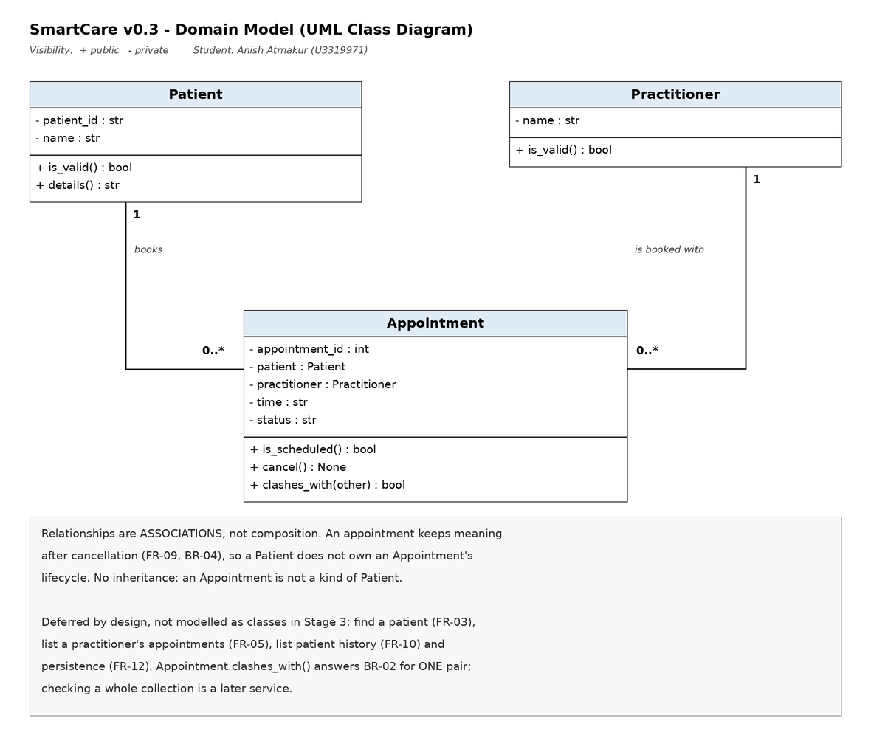
Visibility: + public, - private. Attributes are shown as private and operations as public, following the UML convention from the lecture. Python does not enforce this; the diagram communicates design intent.

Design Rationale
Class selection
Eight candidate concepts were considered and three became classes. Patient, Practitioner and Appointment each have their own identity, their own state and behaviour that belongs with that state. Name, Status and Cancellation were rejected because they are attributes or an operation rather than things: Cancellation in particular is modelled as Appointment.cancel() together with the status value CANCELLED. Clinic and Database were rejected because they are the scope of the system and a storage concern, neither of which is a domain concept. The guiding rule was the one from the lecture: a good model is the simplest model that accurately represents the confirmed problem.
Responsibility allocation
Patient and Practitioner each validate their own required fields, because the object holding the data is the one that knows whether it is complete. Appointment is deliberately not given that responsibility: its CRC card allocates it state, cancellation and clash detection only, so blank-field checking for an appointment happens where appointments are created rather than inside the object. Appointment does own its own status and its own state change, so a cancellation happens through cancel() rather than something outside reaching in and setting a value. That keeps BR-03 and BR-04 in one place.
The hardest allocation was BR-02. A clash is a rule about appointments, but no single Appointment can see the others, so putting the whole check there would force it to know about every stored appointment and create exactly the wide coupling the lecture warns about. The responsibility was therefore split: Appointment.clashes_with(other) answers the question for one pair, which is genuinely a single object's job, and checking a new booking against the whole collection is recorded as deferred to a service in a later stage.
Key relationships
Patient 1 to 0..* Appointment and Practitioner 1 to 0..* Appointment, both associations. A patient or practitioner may have no appointments or many, and each appointment involves exactly one of each, which is what makes BR-02 expressible at all.
Comparing practitioners in clashes_with()
BR-02 depends on deciding whether two appointments involve the same practitioner. The association in the UML says an Appointment holds a Practitioner object, not a practitioner name, so the comparison is made between the objects themselves rather than reaching through to the name attribute. This keeps the dependency narrow, as the lecture asks, and it relies on the system storing one Practitioner object per real practitioner, which is how registering and finding a practitioner already works. Value-based equality through a __eq__ method is a Week 7 topic and is deliberately not added here.
Association rather than composition: composition means the whole owns the part's lifecycle, and FR-09 and BR-04 require a cancelled appointment to be retained in the history. The appointment record therefore has meaning in its own right and is not simply part of a patient. No inheritance is used anywhere, because no genuine is-a relationship exists - an appointment is not a kind of patient, and inheriting would only be a way of reusing fields.
What is deliberately not in the model
- No Manager, Controller or Engine classes - none is supported by a requirement, and they would leave the domain classes with no behaviour of their own.
- No Clinic root class - it would be a god class with low cohesion and high coupling.
- No persistence or UI concerns - FR-12 belongs to a repository in a later stage.
- No specialty attribute on Practitioner - the lecture mentions it as a possibility, but the SmartCare client has never asked for it.
- No COMPLETED status - still an open question from Stage 2 (OQ-01), so only SCHEDULED and CANCELLED are modelled.
Note on requirement numbering
The Week 6 lecture cites FR-04 for creating an appointment and FR-06 for cancelling one. Those are the lecture's own example numbers. This workbook uses the numbering from my SmartCare v0.2 specification, where creating is FR-06 and cancelling is FR-08, so that Weeks 5 and 6 stay consistent.

AI Design Review Record
AI tool used: Microsoft Copilot. The human model was created first, then the AI was asked for an alternative using the engineering prompt from the lecture, which required a supporting requirement ID for every proposed element.
AI suggestion | Evidence | Decision | Reason | Model change
Appointment should own its own status and state change | BR-03, BR-04 | Accepted | Matches responsibility-driven design - the object holding the state controls how it changes. | None - it confirmed the placement already chosen. Implemented as cancel().
Add an AppointmentManager to hold all appointments and check clashes | BR-02 is real; no requirement asks for a manager class | Modified | The need is genuine but a manager class now is premature and would leave Appointment with little behaviour. | clashes_with(other) added to Appointment for one pair. Collection-wide check recorded as deferred.
Add Clinic as a root class owning everything | None | Rejected | God class - low cohesion, high coupling, and no requirement supports it. | None. Recorded on the optional CRC card as considered and rejected.
Add a NotificationManager for appointment reminders | None | Rejected | No supporting requirement. SMS reminders were already Unsupported in Stage 2. | None.
Give Practitioner a specialty attribute | None from the client | Rejected | Mentioned in the lecture as a possibility, but the SmartCare client has never asked for it. | None.
One accepted, one modified, three rejected. The AI did not invent new client requirements when asked not to, but it did propose classes with no requirement support, which is the over-design pattern the lecture predicts.

