Organization
Organization module contains all the information and operation related to a organization. From basic organization information like logo, name, website etc to advance features like organization polices, subscriptions, locations, departments, designations, etc.

Basic fields:
- Logo: Image upload field.
- Name: Text field. Contains name of the organization.
- Website: Url field. Contains the website url of the organization.
- Type of organization. Select/Dropdown field. Contains options for type of the organization like production, marketing, IT etc.
- Contact person: Text field. Name of the contact person.
- Contact number: Text field. Contact number of the organizaton.
- Contact email: email field. Email of the organization.
- Primary address: This field is a field set rather than being a single input. This includes:
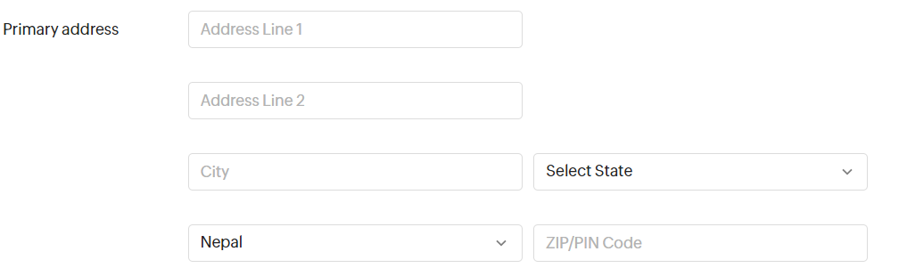
Figure 1: Primary address fieldset

Organization Type
Organization Type is a module that handles the type of organization. It contains data about organization categories. This module is used under Organization module to determine the type of organization.
DB Fields:
- Name: Text field that holds the name of the type. E.g. Information technology, manufacturing and production, etc
- Slug: This field stores auto generated slugs for the organization types. This field must be unique. This field is derived after an instance is saved to database. This field is generated using instances name and id.

Department
Department module features adding/updating/deleting/managing department members of new organization department.

DB fields
- Department name: Text field. Contains name of the department
- Department lead: Select/Dropdown field. Foreign key to the members of the organization. This fields describes the lead of the department.
- Parent department: Select/Dropdown field. If the department has any parent department than the parent department should be selected from the list.

Post
This module consist posts/designations for a specific department.

DB fields
- Department: Foreign key to Department. Denotes which department the Post belongs to.
- Title: Char field that stores the name of the post.

Employee
The employee module is actually a derived module. The main objective of this module is to isolate the relation between user and an organization by assigning the user to a post of an organization. Instead of adding a foreign key field to the main Auth User model making it tighly coupled, this module insures loosly coupled or decoupled architecture for associating User to an organization.

DB fields
- User: Foreign key to the auth user model
- Post: Foreign key to the Post of a specific organization

Announcements
Annoucements modules features adding new annoucements that can be annouced to all the members of the organization or specific members/department.

DB Fields:
- Content/body: The main announcement details and descriptions are included here. This has to be a text editor field.
- Attachments: A file upload field. Any documents or files that are related to the announcements are uploaded via this field.
- Category: Dropdown/select field. It describes the type of announcement.
- Expiry: A datetime field. The expiry date of annoucement.
- Pin announcements: Check box. If checked the announcement will be pinned to the members’ (those who are related to the annoucement) dashboard annoucement section.
- Notify all employees: Check box. If checked the announcement will be notified to all the users either via email/in-app notification.
- Notify any others: Text field. Multiple Email addresses can be placed using comma to seperate each email address. Announcement emails will be sent to the provided emails.

