Contents

Bootstrap 1

Intro 1

Prerequisites 2

Post-this 3

How to use 3

Layout 4

Things you can do 5

Buttons 5

Dropdowns 5

Carousel 6

Jumbotron 7

# Bootstrap

## Intro

Bootstrap is another frame work(just like 960 was) which eases a lot of things about web development. It was so tough to design those navigation bars and buttons. What if a team of hardworking people have created a frame work so you don't need to worry about spending hours just to design these things and focus on the functionality.

Bootstrap4 is the latest version of that framework and we will be working on it only. Let's see what the bootstrap 4 is capable of doing.

* 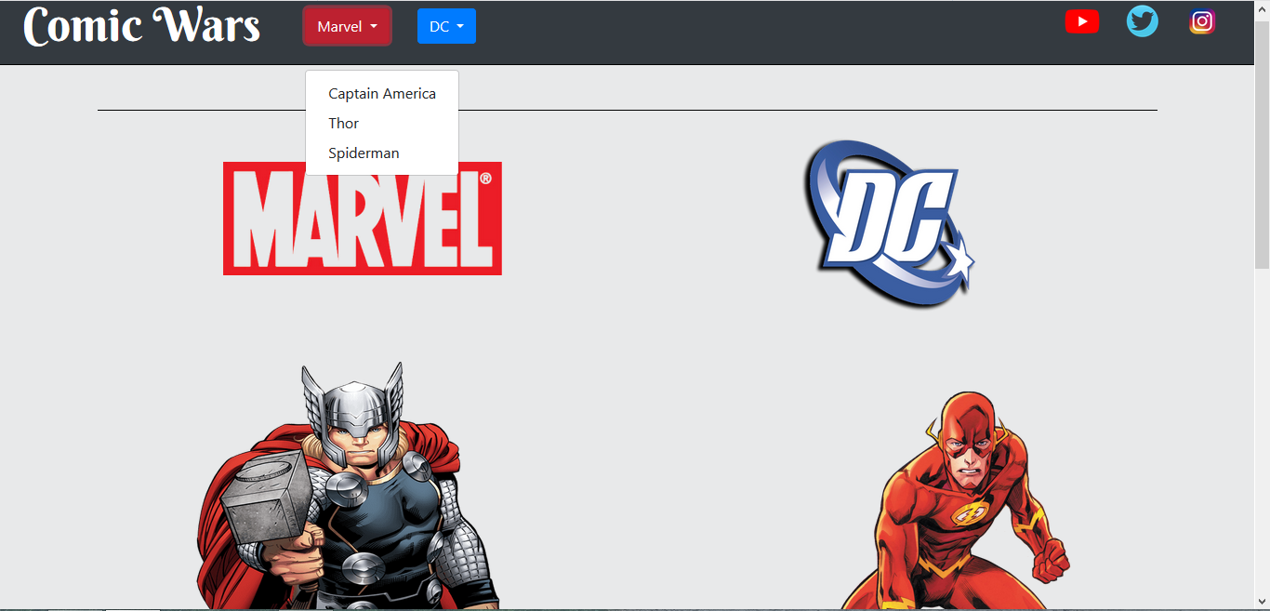The navigation bar
* Drop downs
* Moving pictures

All of this was made in bootstrap and if it were to be implemented without it, would have taken a lot of time. That's how powerful bootstrap is and that's exactly why we need it.

But, before diving in the framework we need to have a decent knowledge about the fundamentals. So, following are the prerequisites.

## Prerequisites

* Knowledge about HTML
* Knowledge about CSS
* Know how to link CSS files
* Have some experience making websites.
* Motivation
* Appetite to learn

The last two are mandatory to learn anything.

## Post-this

* Will be able to design buttons, dropdowns, navigation bars, carousel, jumbotrons and many more.
* Will be able to position elements easily using bootstrap's row-column system
* Websites will look more beautiful

## How to use

There are a number of way to use bootstrap.

* Bootstrap CDN : The fastest way to use bootstrap in your file is this. All you have to do is paste this in the head of your html file :-

<link rel="stylesheet"href="https://maxcdn.bootstrapcdn.com/bootstrap/4.0.0/css/bootstrap.min.css"integrity="sha384-Gn5384xqQ1aoWXA+058RXPxPg6fy4IWvTNh0E263XmFcJlSAwiGgFAW/dAiS6JXm" crossorigin="anonymous">

This you can find on official bootstrap website too.

* Downloading the whole package and using files accordingly.

from this link : -

https://getbootstrap.com/

After using any one of those methods, you are ready to go through bootstrap. Let's start by looking how to align the elements.(Similar as 960)

## Layout

Bootstrap uses a 12 column system and whenever a column fills up it moves to the next row. There are two classes container and container-fluid which needs to be defined first. Container fluid takes up the whole width.

<div class="container">

<div class="row">

<div class="col-sm">

One of three columns

</div>

<div class="col-sm">

One of three columns

</div>

<div class="col-sm">

One of three columns

</div>

</div>

</div>

Now, if you see this code, in a container, a row is defined. The width of this row gets increased till we close that particular tag. Three columns are defined : by default each of them will have the same width

If you want a particular column to have more width than the other one. You can change the class of that column to col-1 to col-12 and the other columns will have an equal width. That's why its so handy to use bootstrap. For eg: this code

<div class="container">

<div class="row">

<div class="col">

1 of 3

</div>

<div class="col-6">

2 of 3 (wider)

</div>

<div class="col">

3 of 3

</div>

</div>

</div>

This will create 3 columns and the middle will be taking 6 columns.

## Things you can do

### Buttons

Inserting buttons have never been this easy. Have a look :

<button type="button" class="btn btn-primary">Primary</button>

That's it .. now you have made a button with blue color. Don't believe me? Look at the output.

The primary button gets created. To create other buttons just change their class to btn-dark or btn-lin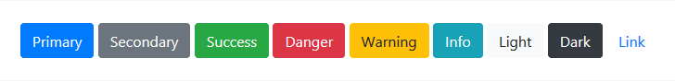k.

### Dropdowns

I can't recall a website which doesn't use dropdown menus and this is one of the main components required to create.

Let's see how the code is :

<div class="dropdown">

<button class="btn btn-secondary dropdown-toggle" type="button" id="dropdownMenuButton" data-toggle="dropdown" aria-haspopup="true" aria-expanded="false">

Dropdown button

</button>

<div class="dropdown-menu" aria-labelledby="dropdownMenuButton">

<a class="dropdown-item" href="#">Action</a>

<a class="dropdown-item" href="#">Another action</a>

<a class="dropdown-item" href="#">Something else here</a>

</div>

</div>

This will create a drop down with links to Action, Another action and Something else. You can customize to make it view on any page.

### Carousel

This makes a slideshow and you can have it on your webpage too. It's really nice and looks great too.

<div id="carouselExampleSlidesOnly" class="carousel slide" data-ride="carousel">

<div class="carousel-inner">

<div class="carousel-item active">

<img class="d-block w-100" src="..." alt="First slide">

</div>

<div class="carousel-item">

<img class="d-block w-100" src="..." alt="Second slide">

</div>

<div class="carousel-item">

<img class="d-block w-100" src="..." alt="Third slide">

</div>

</div>

</div>

### Jumbotron

<div class="jumbotron">

<h1 class="display-4">Hello, world!</h1>

<p class="lead">This is a simple hero unit, a simple jumbotron-style component for calling extra attention to featured content or information.</p>

<hr class="my-4">

<p>It uses utility classes for typography and spacing to space content out within the larger container.</p>

<p class="lead">

<a class="btn btn-primary btn-lg" href="#" role="button">Learn more</a>

</p>

</div>

Those huge banners can be inserted just by using this bit of code. Make sure you give them a class of container-fluid if you want them to take up the whole width.

## Components

While there are so many things bootstrap can do, it is not necessary that you will use all of them in your site. You can make many things like - forms, navbar, progress bar, collapse etc, There's no end. Just check them out on **https://getbootstrap.com/docs/4.0/components** and all you have to do is copy paste the code. That's just how it is.

## Media Query

While there are many things you can do with bootstrap. Please check them out on the official website. I believe that we have practiced/studied enough that we can now go exploring on our own. Because that's the real way of learning.

Just before we close this article, there's a really important concept which I would like to address know as the media query.

While we make a website we should also think about how many different users with different devices are going to be using that. We should always keep that in mind. The content displayed should be good.

We use media queries to do that. That's how :

// Extra small devices (portrait phones, less than 576px)

// No media query since this is the default in Bootstrap

// Small devices (landscape phones, 576px and up)

@media (min-width: 576px) { ... }

// Medium devices (tablets, 768px and up)

@media (min-width: 768px) { ... }

// Large devices (desktops, 992px and up)

@media (min-width: 992px) { ... }

// Extra large devices (large desktops, 1200px and up)

@media (min-width: 1200px) { ... }

With these lines of code in your CSS file, inside of this, you can write inside what width you would want of your elements so that your website is displayed correctly.

## Conclusion

Bootstrap4 is really vast and not all of it can be learned. You need to know how to put the code and where to put it which I think have demonstrated successfully here. So, go on explore all there is in this wonderful world of bootstrap and make your websites a lot more beautiful than they already are.

Thank you