**World war 3**

Recently a leading daily of UK, The Express have been seen covering World War 3. But wait a minute, I haven’t heard any war going around. Have you? Maybe not. Then, What the hell are these guys reporting? Let me clear the illusion.

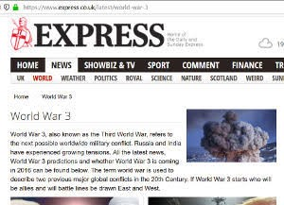

“Colonel Santosh Babu among 19 soldiers martyred on Monday night at Galwan Valley in Ladakh.”

*Ouch! It hurts deep, I’m sure it may’ve aroused a slight discomfort in your hurt too.*

India-China Faceoff has been a high level of engrossment for nations around the globe. Why wouldn’t it be?

As this ongoing CoVID-19 pandemic has destroyed the backbone of every nation’s economy. Even the so called World Superpower United States is helpless in this scenario.

Turning the table back to the Galwan. This is the first time after 1967 that such clashes have been witnessed on Indo-China front and quite similar to the 1962 War if the intensity of situation is accounted. What has been the major concern is that all these including the 1975 Chinese assault on Assam Rifles Brigade in Arunachal Pradesh happened before the pacts were signed between the nations in 1996 & 2005 to respect each other’s sovereignty.

Maybe you are not aware of the pact as demonstrated by *Our Honourable Ex-Congress Chief Mr. Rahul Gandhi,* Mr Gandhi inquired about the soldiers being unarmed. Who was soon informed by The External Affairs Minister, who was forced to resolve this internal issue, that all the soldiers were armed but the pact’s article limits the use of firepower by both sides on LAC.

But soon the issue heated up, *just like my old unresponsive phone*, as more and more dignitaries started questioning on violation of pact from the Chinese side. The objection was flamed up even more due to the centre's silence on the border situation.

More and more people are demanding centre’s response on the situation as foreign media has started to publish news about India acceding land measuring 60 km2 to China.

Center’s Silence has given the Media houses license to hype the current situation to World War 3. We also took the opportunity to *Make hay while the sun is shining.* Let’s look what’s the global equation is on the World War.

As of now, everybody has been aware of rising tensions between the US and China over the trade war. CoVID-19 has only exaggerated the matter. US President has even referred CoVID as China Virus not just once and that too on the global stage. Recent developments have seen US involvement in the regression of Uighur Muslims in Xinjiang Province of China. On June 17 just a couple of days back US Senate approved a bill to Sanction Chinese Officials on Uighurs human rights violation. Several News reports have even claimed Chinese building Concentration Camps for Uighurs in Xinjiang.

Moving towards the other Giant in the Asia- Pacific region, Australia, who has been stern on its stand on China’s role in spreading Corona to the world. Even after threats from China on stopping the bilateral trade. Australia stood still on its demand. Amid the escalating Indo-China tensions Australia signed a pact with India for regional Coperation in Asia Pacific region against the growing Chinese Aggression.

*So yes we can count the Aussies on our side. Now after touring the whole Pacific Let’s move back to China’s own backyard.*

*Yes, you guessed it right.* Taiwan has clearly been opposing China against its two Nation system, demanding its independence from China. Recently Taiwanese Netizens have appealed to India to support its freedom Movement. *Is it due to India's dominance in the 1971 war, resulting in formation of the new nation-Bangladesh. Well its on you to decide.* Recently an Illustration made by a Taiwanese national depicting Lord Rama went viral on social media.

*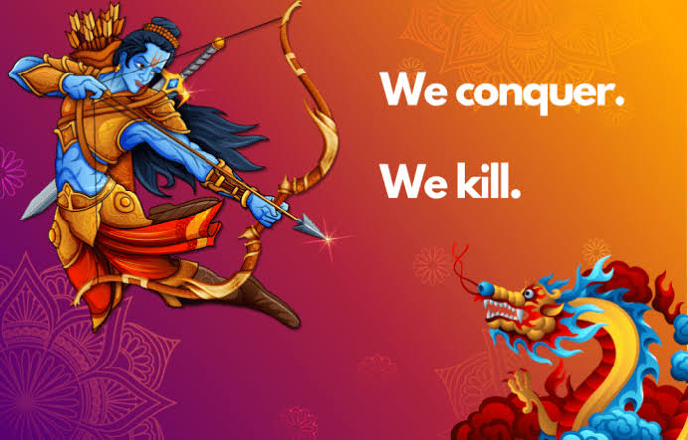I*

*f everybody's on our side then who the hell is supporting China in this World War? Well in this Corona period I don’t think anyone’s willing to support China in this war. So in short China is all alone in this so called World War.*

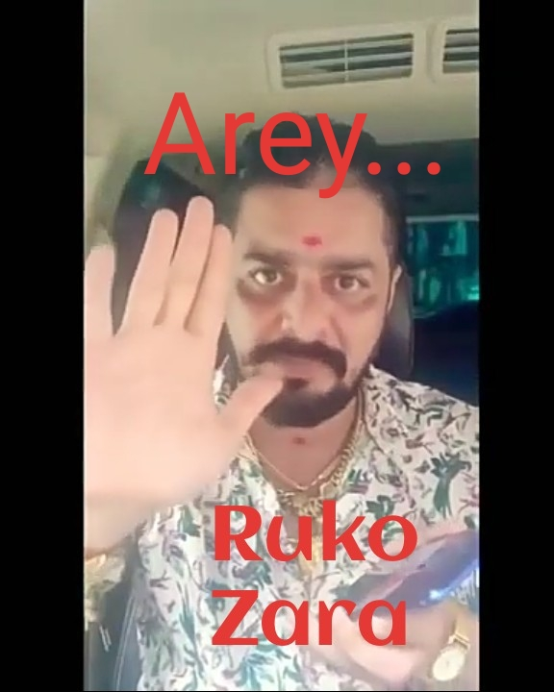*Ahh! I’m extremely sorry, I forgot to mention a couple of nations on China's side.*

Recent development have witnessed Nepal’s inclination towards China partly due to dwindling India-Nepal ties and partly due to increasing Communism in Nepal.

Then there’s China's *puppet, Oh sorry! I once again misspelled for,* partner Pakistan. I don’t think there exist any more nation who support China.

*OMG! How can I forget him, The Big B? How can I even assume a World War without him? God’s not going to forgive me for this sin.*

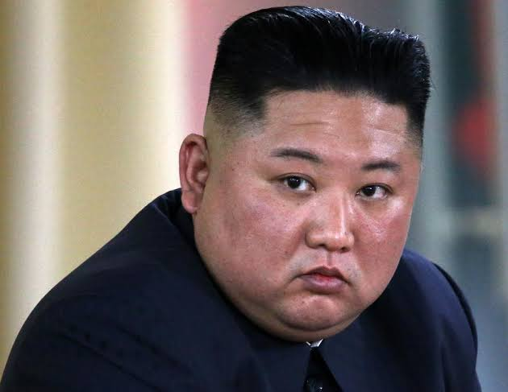

*Yes , North Korea. Well I can’t say much about this guy. I don’t even need to tell you about him to you guys , this guys enjoys immense popularity across all seven continents and if Atlantic exist that this guy will be famous even there. He’s insane, there’s no fuckin' States that can stop him from launching Missiles, conducting Nuclear tests or participating in a World War.*

