PBJ Documentation

**Abstract**

This process document throws light on the steps involved in making a common American delicacy – ‘The Peanut Butter and Jelly Sandwich’. The steps in the document should be followed sequentially unless stated otherwise. The document also elucidates several ways to deviate from the traditional recipe in an attempt to tweak it to suit the reader’s taste buds.

**The Process**

**Step 1**

Make sure that you collect the following list of ingredients and apparatus before proceeding to the next few steps. You will need the following –

* 2 Bread Slices
* Peanut Butter
* Jam or Jelly
* A Knife
* A cutting board
* A napkin or paper towel
* A Plate (to serve the sandwich) or packing material (in case you intend on eating the sandwich later)

**Step 2**

Place two slices of bread side by side on the cutting board. The choice of bread to make the sandwich is up to you. Brown bread or whole wheat bread usually serve as healthier options. However, the use of white bread is also acceptable. You can view and compare the nutritional aspect of breads[1] before making a decision.

**Step 3**

Open the jar of Peanut Butter by twisting the lid of the jar counter-clockwise. If the jar has just been removed from the refrigerator, ensure that it reaches room temperature before using it. This is to ensure that the slice of bread does not tear when you apply and spread cold Peanut Butter onto it. Using the knife, stir the Peanut Butter in the jar till it attains a creamy texture. Now dip the knife in the jar and spread the Peanut Butter evenly onto the first slice of bread. Ensure that you spread less Peanut Butter near the edges so that it doesn’t spill over when the two slices of bread are combined.

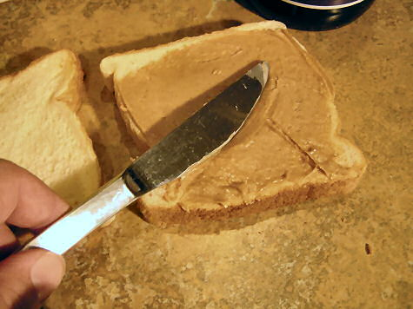

**Step 4**

To proceed with this step, you need to decide which Jam or Jelly you are going to use. Open the chosen Jam or Jelly jar by turning the lid of the jar counter-clockwise. Before dipping the knife into the jar ensure that you clean it thoroughly using a napkin. This will ensure that the peanut butter on the knife does not mix with the contents of the Jam/Jelly jar. Now dip the knife into the jar and spread the jam evenly onto the second slice of bread. As in step 3, ensure that you do not spread too much of jam near the edges to avoid spilling. After Step 4 you will have two slices of bread on the cutting board like the one’s shown in the image below.

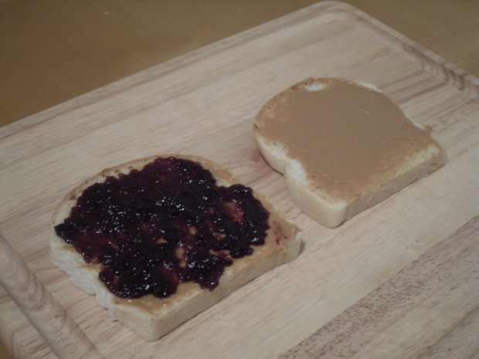

**Step 5**

Now combine the two slices by overturning the slice which contains the Jam spread over the slice which contains the Peanut Butter spread or vice versa. Press the two slices of bread together. Ensure that there is no spillage.

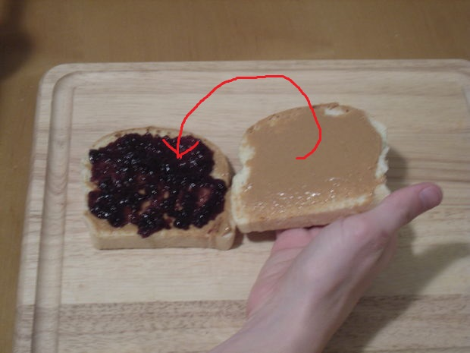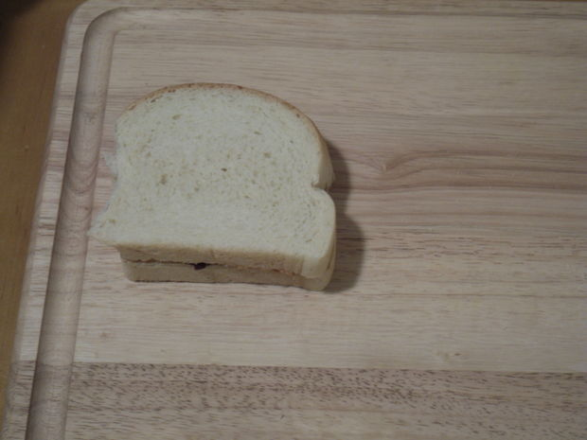

**Step 6**

Using the knife, cut the sandwich diagonally from end to end to obtain two triangular pieces. You can also cut the sandwich along the center to obtain two rectangular pieces. Serve the sandwich using a plate or pack the same using the packing material. The Peanut Butter and Jelly sandwich is now ready to be devoured!

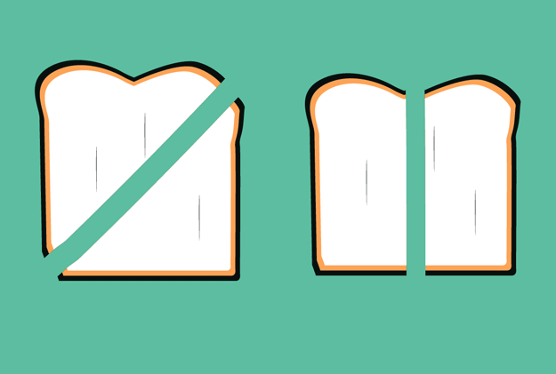

**Some additional tips to modernize the recipe**

**Tip 1 – Increase the crunch**

In order to increase the crunchiness of the sandwich, the bread can be toasted before using it in Step 1. The remaining steps can then be followed as given above. Another alternative would be to toast the sandwich after all steps have been followed (i.e. toast the entire sandwich after ‘Step 6’)

**Tip 2 – Getting creative!**

Before combining the two slices of bread in ‘Step 6’, you can add fruits, nuts or berries to either slice.

**Tip 3 – Defying the traditional sandwich**

The Peanut Butter and Jelly sandwich can also be tweaked in a host of other ways. Other ingredients can be used to compliment/replace Peanut Butter, Jelly or bread in the sandwich. Refer to the link[2] in the footnote to know more.

Word Count: 711

1. Kristin Kirkpatrick. The Healthiest Breads: 6 Types Explained. (Nov 6, 2011). Retrieved October 27, 2016, from The Huffington Post, http://www.huffingtonpost.com/2011/11/06/healthiest-breads_n_1078520.html
2. 14 Ways to Instantly Upgrade Your Peanut Butter and Jelly (RECIPES). (Feb 26, 2014). Retrieved October 27, 2016, from The Huffington Post, http://www.huffingtonpost.com/2014/02/26/peanut-butter-and-jelly-upgrade_n_4854550.html