Data Analysis of Traffic Violations across Montgomery County

**Audience**

Our target audience is Chief J. Thomas Manger who is the Chief of Police in Montgomery County, Maryland. He is interested in expanding and reorganizing the Police Department’s Community Policing efforts to ensure safety of the public. Our data set describes about traffic violation information from all electronic traffic violations issued in Montgomery County. It gives information regarding the district which has encountered highest traffic violations over a period of 3 years, most common race that has received citations, season of the year that has experienced maximum traffic violations and number of resulting fatalities. Since traffic safety has more potential to cause injury and deaths among citizens in the county, the Chief will be able to make better decisions to enforce laws in Montgomery County.

**Data Set Description**

The Montgomery County traffic violations dataset is being used for this project. The dataset is intended for public access and use and can be accessed from the link - <https://data.montgomerycountymd.gov/Public-Safety/Traffic-Violations/4mse-ku6q>. It has been obtained from the Montgomery County government website and the dataset has been updated on a daily basis since January 1st, 2013.

**Data Processing**

We decided to use data from 2013 – 2015 since this provides a complete and equally comparable set of data for our analysis. Records from 2016 were removed since the year is still in progress and data is still being recorded. Some new columns were added such as Index, Season, Rush Hour, Year of Stop, Month of Stop to efficiently aid our analysis. Data was cleaned using Excel and analyzed using R Studio.

**Plot**

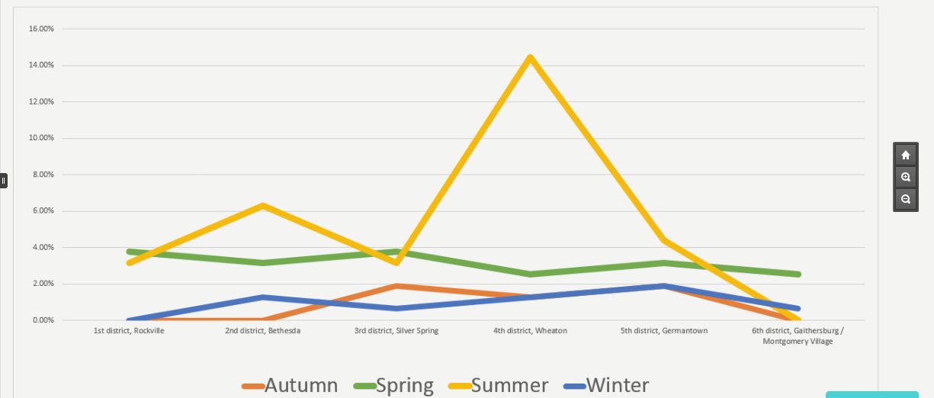

**Interpretation**

One of our plots as mentioned above is a line chart that provides information about the fatalities that have occurred in the 6 districts of Montgomery County during different seasons of the year. It can be observed that Wheaton records the highest percent of fatalities in Montgomery County during the summer season. It is also worth noting that highest percent (47%) of fatalities due to traffic violations is recorded during summer. The season of summer is from June to August. While 26% of fatalities are reported during spring, followed by autumn (16%) and winter accounts for 10% of the total fatalities due to traffic violations.

**Argument**

The Chief of Police could probably understand the reason for a spike in fatalities during summer and a considerable drop during winter as winter is usually the holiday season and due to snow not many vehicles would be plying. Moreover, since many of the county residents must have taken a break from work (especially during December) and schools close down for Winter break, there is a drop in the fatalities during that time of the year. However, a considerable increase in the percent of fatalities in Wheaton compared to other districts will definitely make the Police department and the Chief of Police wonder for an explanation. Our analysis will thus help the Chief and the police department to identify significant disparities among the 6 districts and provide opportunities for training and improvement in districts like Wheaton that account for 25% of traffic violations in Montgomery County.

Word count: 522