**Data Analysis of Traffic Violations across Montgomery County**

Our target audience is Chief J. Thomas Manger, the Chief of Police in Montgomery County, Maryland. He is interested in expanding and re-organizing the Police Department’s community policing efforts to ensure safety of the public. Our analysis aims at drawing a district wise comparison of the number of traffic violations issued, the race with the most citations, traffic violations by season and the number of resulting fatalities and alcohol related incidents. An analysis of these factors can influence major policing decisions such as carrying out awareness drives for citizens, imparting additional knowledge during motor vehicle training and trigger data backed investigations to improve the overall safety of the county.

Our assigned dataset is *Traffic Violations in Montgomery County, Maryland* obtained from the Montgomery County government website. It contains information on electronic traffic violations issued (over a period of three years i.e. 2013 – 2015) within the county as of January 1st, 2013 and is updated daily. The dataset contains thirty-five attributes and 823,129 rows as of October 6th, 2016 when the dataset was downloaded. The dataset is intended for public access and use and can be accessed from the link - <https://data.montgomerycountymd.gov/Public-Safety/Traffic-Violations/4mse-ku6q>.

We decided to use data from 2013 – 2015 since this provides a complete and equally comparable set of data for our analysis. Records from 2016 were removed since the year is still in progress and data is still being recorded. Some new columns were added such as Index, Season, Rush Hour, Year of Stop and Month of Stop to efficiently aid our analysis. Data was cleaned using Excel and SQL querying in MS Access database. Analysis was performed using R Studio and Excel.

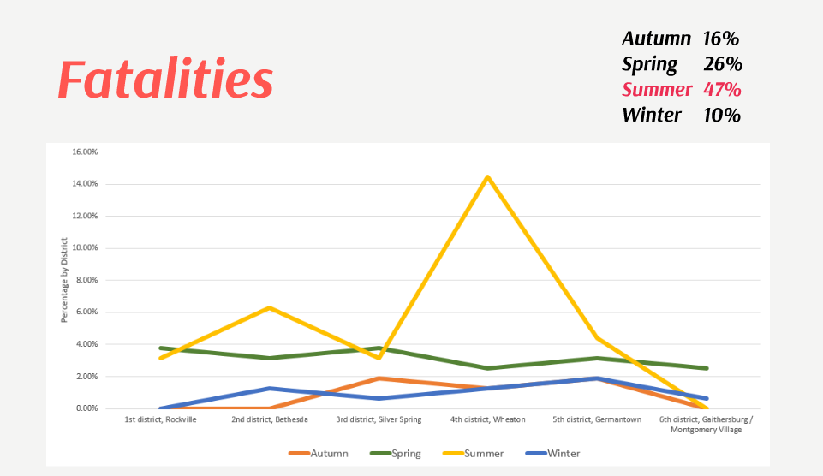

One of our plots as shown above is a line chart that provides information about the fatalities that have occurred in the 6 districts of Montgomery County during different seasons of the year. It can be observed that Wheaton records the highest percentage of fatalities during summer. It is also worth noting that the highest percentage of fatalities due to traffic violations is recorded during summer (June – August, 47%). As much as 26% of fatalities are reported during spring (March – May), followed by autumn (September – October, 16%) and winter (December – February, 10%).

The Chief of Police can use the information provided to conduct an assessment of the spike in violations in Wheaton during summer. The considerable drop during winter can be attributed to the holiday season and the reduced number of vehicles plying on the roads due to snow. Moreover, since many of the county residents must have taken a break from work (especially during December) and schools close down for Winter break, there is a drop in fatalities during that time of the year. Our analysis will thus help the Chief and the police department to identify significant disparities among the 6 districts and provide opportunities for training and improvement in districts like Wheaton that accounts for 25% of traffic violations in Montgomery County.

Word count: 500