Air pollution

The addition of undesirable substances in undesirable concentration into the atmosphere that may cause various harmful effects to the living beings is known as air pollution. And these undesirable substances are known as air pollutants.

Air pollutants can be classified as either primary or secondary. Primary pollutants are any substances directly emitted from a process, such as ash from volcanic eruption, the carbon monoxide gas from a motor vehicle exhaust or sulfur dioxide released from factories.

Secondary pollutants are not emitted directly, rather they are formed in the atmosphere when primary pollutants react or interact. E.g. peroxy acetyl nitrate (PAN),peroxy benzoyl nitrate(PBN),ground level ozone.

Types of pollutants:

1. Gaseous pollutants:

* Carbon compounds: CO2 and CO; the former released by complete combustion of fossil fuels and the latter by automobiles.
* Sulfur compounds:SO2, H2S, H2SO4etc; mostly these are released from the industrial units and thermal power n plants.
* Nitrogen compounds: NO, NO2, and HNO3; mostly these are released from automobiles and industries.
* Hydrocarbons: Benzene and methane are the hydrocarbons chiefly emitted from the industries and automobiles.
* Ozone: Its level rise in troposphere due to human activities.

2.Particulate Matters(PM): They are tiny particles of solid or liquid suspended in a gas i.e. dust, fly ash, smoke, and other suspended particles such as metals, biotic particulates(e.g., pollen grains and spores. Increased level of particulates in air leads to health hazards such as heart disease, altered lung function and lung cancer.

Different types of particulates are:

* **Dust**: Sources: mines, quarries, furnaces, house cleaning, ceramic factory, agricultural, forest fires, natural winds, engine exhausts etc.

Effects: allergic and respiratory diseases, it also causes corrosion.

* **Fly ash**: Sources: mainly emitted from burning coal in thermal power plants.
* **Smoke**: Sources: industries, open fires, diesel engines, furnaces etc.

Effects: It is carcinogenic. It causes dull appearance of buildings and spoiling of the clothes. It also causes imperfect combustion of fuels and hence loses its fuel value.

* **Smog**: It is the mixture of smoke and fog in suspended droplet form .i.e. Smoke + Fog = Smog. Classic smog results from large amounts of coal burning in an area caused by mixture of sulfur dioxide and smoke. Modern smog does not usually come from coal but from vehicular and industrial emissions that are acted on in atmosphere by sunlight to form secondary pollutants (PAN, PBN) that also combine with primary emissions to form photochemical smog.

Effects: It causes irritation to eyes and

lungs. It also affects the plant growth

**and visibility in the road track.**

* **Asbestos**: It is the fibrous silicate mineral. It is used in industry for its high mechanical strength and heat resistance.

Effects: Suspension of asbestos fibers in the atmosphere is found more health hazardous. Tiny asbestos fibers readily penetrate the lung tissues and the digestive tissues and remain their permanently resulting asbestosis (a lung’s disease) and cancer.

* **Lead**: Tetraethyl lead is used as an antiknocking agent used for improving the performance of gasolines in automobiles. This may be released in atmosphere in its original state or elemental form; both are found harmful for our health.

It may be inhaled and injected into the blood as Pb2+. This has tendency to react with sulphydryl group (-SH) of the proteins.

Protein-SH+Pb2++HS-Protein

**↓**

Protein-S-Pb-S-Protein + 2H+

It inhibits the biosynthesis of haemoglobin and results anemia. On the other hand, it also affects the central nervous system and impairs kidneys.

* **Mercury**: It is more dangerous in its vapour state. It causes irritation and destruction of lung’s tissues. The Hg2+ ions concentrate chiefly in the liver and kidneys. Mercury poisoning can cause brain damage to unborn infants.
* **Cadmium**: It is mainly released from the industrial processes. It is toxic to living organism even in low concentration (<1ppm).

3.Radioactive pollutants:

These include all the radioactive elements released from the nuclear power plants and by nuclear experiments.

**PAN and PBN:**

**Peroxy benzoyl nitrate** is the secondary pollutants that is formed by photochemical reaction between NO2and aromatic hydrocarbon.

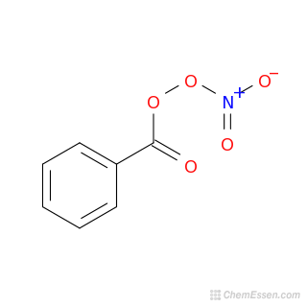

**PAN and PBN:**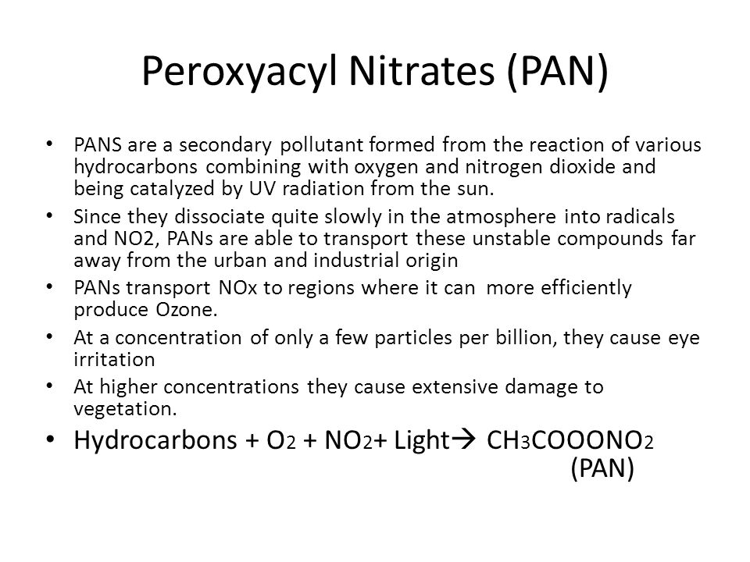

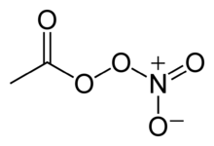

Structure of PAN

The major pollutants and their adverse effect are discussed below:

1. Carbon dioxide:

Source:

* Complete combustion of fossil fuel (coal, oil etc.), fire woods.
* Decomposition of limestone during manufacture of cement.

Effects:

* Responsible for greenhouse effect and global warming.

1. Carbon monoxide:

Source:

* Incomplete combustion of fuel in automobiles, industries and oil-refineries.
* Volcanic eruption.

Effects:

* It causes difficulty in breathing, headache, and irritation of mucus membranes in the respiratory tract.
* Other than these, the most dangerous effect of CO in our body is, it causes great disturbance in the transportation of oxygen from lungs to body cells because CO is far (~210 times) more reactive to hemoglobin than oxygen . More number of carboxy haemoglobin is formed instead of oxyhaemoglobin, which drastically reduces the transportation of oxygen into the body parts.

Hb + O2 ⟶HbO2⟶Hb + O2

Haemoglobin oxyhaemoglobin

Hb + CO⟶COHb

Carboxy haemoglobin

Thus it causes serious deficiency of oxygen in our body leading to headache and suffocation leading to death.

1. **Sulfur oxides (SOx):**

**Sources:**

* It is produced by volcanoes and in various industrial processes.
* It is produced from burning of coal and petroleum.
* Volcanic eruption.

**SO2 + H2O SO2 + oxidizing agent**

↓ **↓**

**H2SO3  SO3**

**SO2 + H2O**

**↓**

**H2SO4**

**Effects:**

* Causes eye irritation, throat problems, respiratory and heart diseases.
* Causes acid rain.
* Increases rate of corrosion of the metals so it can damage the architectural figures (monuments, railings etc.).

1. **Nitrogen oxides (NOx):**

**Sources:**

* Released into atmosphere from explosive industry, automobiles etc.
* Combustion of fossil fuels.
* Due to lightning.

**Effects:**

Nitric oxide (NO) does not harm us directly but forms the other harmful gases by its oxidation, so it is called pivot compound.

* NO is responsible for several photochemical reactions in the atmosphere, particularly in the formation of several secondary pollutants like peroxy acetyl nitrate (PAN), O3, carbonyl compounds etc. in the presence of other organic compounds.
* It growth of plants are suppressed by NO2.
* The prolonged exposure of NO2 causes lung inflammation; this may be followed by oedema and final death.
* In the presence of sunlight, nitrogen oxide and hydrocarbons interact to form smog which causes eye irritation, difficulty in breathing and hence lung’s asthma, bronchitis etc.

1. **Hydrocarbons:**

**Sources:**

* Burning of woods, oils etc.
* From motor vehicle exhaust and industries.

**Effects:**

* Responsible for greenhouse effect.
* Responsible for photochemical smog.
* Effects lungs and cause respiratory problems.

**Control measures for air pollution:**

Air pollution can be minimized by following methods:

* Using low sulfur coal in industries.
* Removing sulfur from coal (by washing or with the help of bacteria).
* Removing particulate from stack exhaust gases by employing electrostatic precipitators, bag-house filters, cyclone separators etc.
* Shifting to less polluting fuels (hydrogen gas).
* By planting more trees.

**Methods for controlling air pollution:**

1. **By cyclone collector:**

It is mostly used as pre-cleaner of air. It works on the principle of centrifuging. In this method, gas containing particles is allowed to flow into a tight circular spiral-fitted chamber. The centrifugal force exerts great inertial effect on the dispersed particulates, thereby forcing the particulates to move away from the gas and towards the wall of the chamber. Then they are settled due to the force of gravity. The particulates so collected at the bottom of the chamber are removed periodically. The schematic representation of this process is shown below:

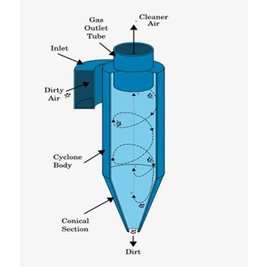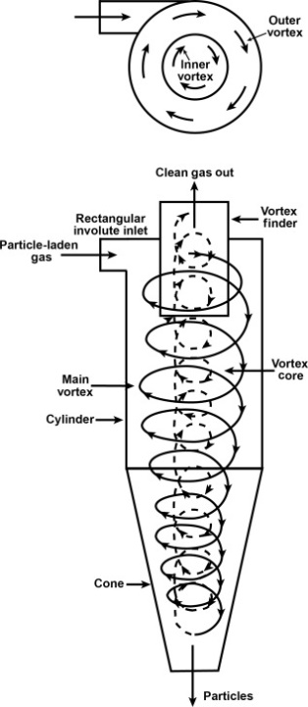

1. **By using gravity settlers;**

Typical gravity settlers are used to collect fairly coarse dusts and may be used as pre-filters. In particular, the gravity settler works only for the large particles of size more than 50𝛍m. a simple schematic representation of gravity settler is shown below:

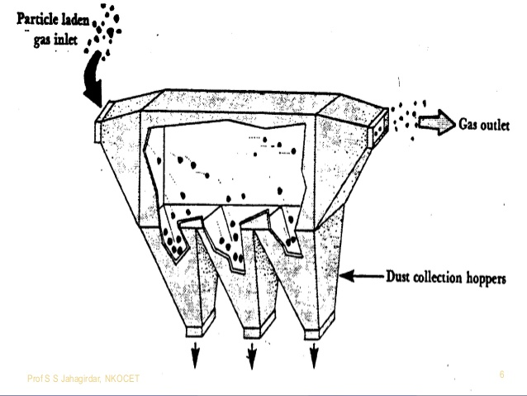

Fig: gravity settler

1. **Electrostatic precipitator (ESP):**

An electrostatic precipitator is air pollution control device used to separate solid particulate matter from a contaminated air stream. Contaminated air flows into an ESP chamber and is ionized by electron emitting electrodes; also known as the corona chamber. The suspended particles are changed by the electro field and migrate to a collection plate. Accumulate particulate matter is removed from the collection plates at periodic intervals by rapping or hitting the plates with rappers (mallets type hammers). Heavy particles fall to the base of the ESP where hoppers hold the removed particles for disposal.

Smoke is a colloidal solution of negatively charged carbon particles in air. Before passing the smoke to chimney, it is sent through a chamber provided with a high potential of 30,000 volts or more. Under the influence of strong electric field, the smoke particles get robbed of their negative charge, there by the smoke particles precipitate out and settle at the bottom of the chamber.

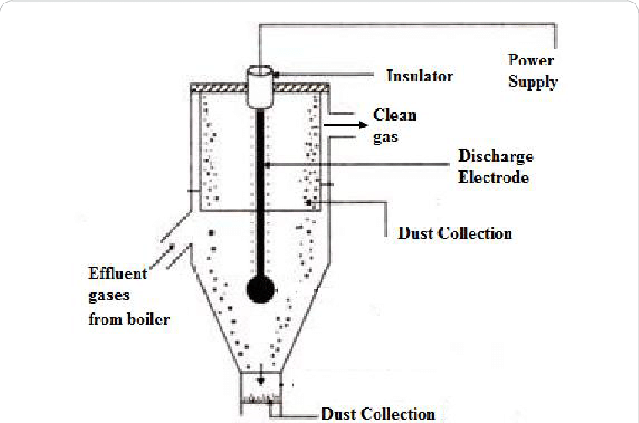

Fig: Electrostatic precipitator (ESP)