**Website Traffic Analysis**

**Overview:**

The goal of this project is to create a web application that provides detailed analytics on the traffic of a website. This includes metrics such as page views, unique visitors, referral sources, popular pages, and more. The application will be built using Python for backend development and will use various libraries for data analysis and visualization.

**Objectives**:

1**. Collect Data**: Implement a data collection mechanism to gather information about website traffic. This can be achieved by integrating with tools like Google Analytics or by creating a custom tracking system.

2. **Data Processing**: Process the collected data to extract relevant information. This may involve tasks such as filtering out bot traffic, aggregating data over time intervals, and identifying unique visitors.

3. **Analytics Dashboard**: Create a user-friendly dashboard where website owners can view the collected analytics data. The dashboard should provide various visualizations and reports to help users understand their website's performance.

4. **Key Metrics:**

- Page Views

- Unique Visitors

- Bounce Rate

- Referral Sources

- Popular Pages

- User Demographics (if available)

- Conversion Rates (if applicable)

5. **User Authentication and Authorization**: Implement a secure login system to ensure that only authorized users have access to the analytics dashboard.

6. **Alerting Mechanism (Optional)**: Implement an alerting system to notify website owners of unusual spikes or drops in traffic.

**Design Thinking**:

1. **Architecture:**

- Backend: Python with a web framework (e.g., Flask or Django)

- Database: PostgreSQL or a NoSQL database for storing processed data

- Frontend: HTML, CSS, JavaScript for the dashboard UI

2. **Data Collection:**

- Utilize APIs provided by services like Google Analytics or set up custom tracking scripts on the website.

3. **Data Processing:**

- Use Python libraries such as pandas for data manipulation and cleaning.

- Apply algorithms for filtering out bot traffic and aggregating data.

4. **Analytics Dashboard**:

- Use a web framework like Flask to create routes for different analytics views.

- Utilize visualization libraries like Matplotlib, Plotly, or D3.js for creating charts and graphs.

5. **User Authentication and Authorization:**

- Implement a user authentication system using Flask-Login or similar libraries.

- Define user roles (admin, regular user) and permissions.

6. **Alerting Mechanism (Optional):**

- Set up periodic checks on the analytics data for unusual patterns.

- Send alerts via email or in-app notifications.

Innovation

Website Traffic Prediction with Time Series Forecasting

Idea : Build a predictive model using time series forecasting techniques to predict future website traffic patterns.

Implementation:

1. Collect historical website traffic data, including metrics like page views, unique visitors, and time intervals (e.g., daily, hourly).

2. Preprocess and clean the data using Python libraries like Pandas and NumPy.

3. Utilize time series forecasting methods such as ARIMA (AutoRegressive Integrated Moving Average) or Prophet (developed by Facebook) to build a predictive model.

4. Train the model on historical data and validate its accuracy.

5. Create a web-based dashboard using a Python web framework (e.g., Flask or Django) to display real-time and predicted website traffic data.

6. Implement automation to periodically update predictions and visualize them on the dashboard.

Benefits:

- Provides website administrators and marketing teams with insights into expected future traffic trends.

- Helps in resource allocation, content planning, and ad campaign scheduling based on predicted traffic.

**DATA VISUALIZATION**

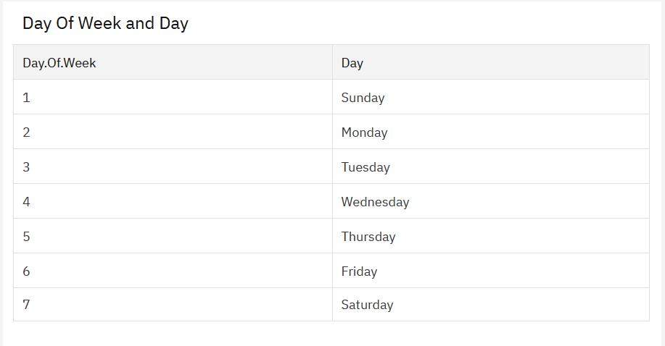

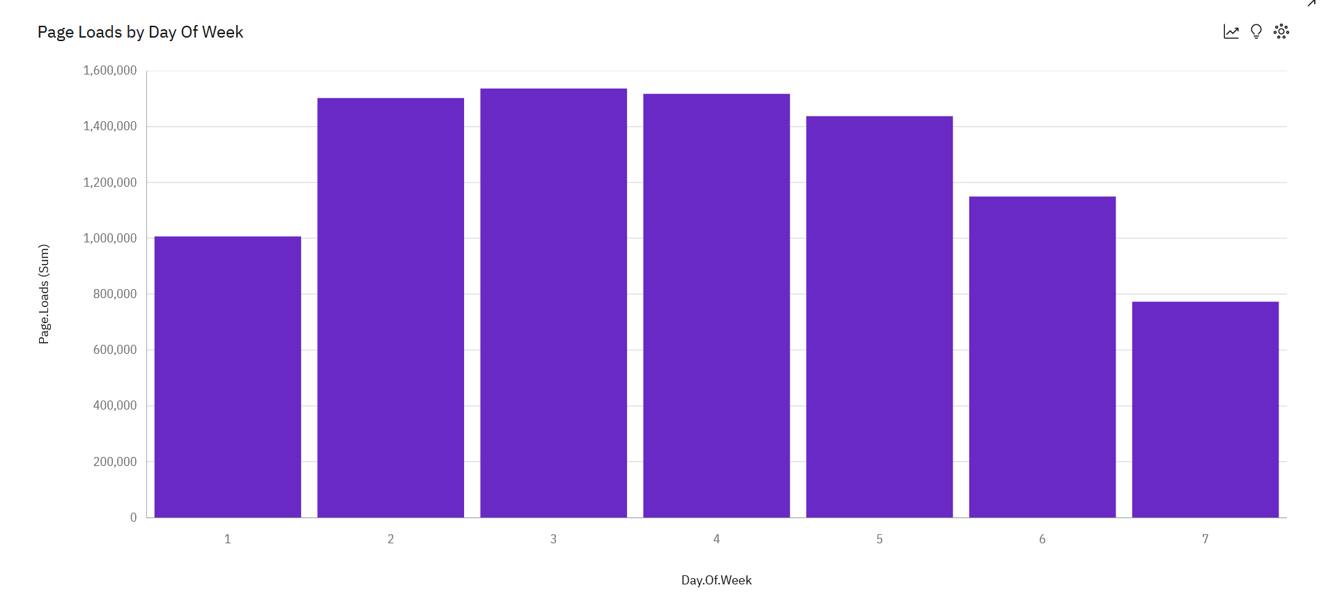

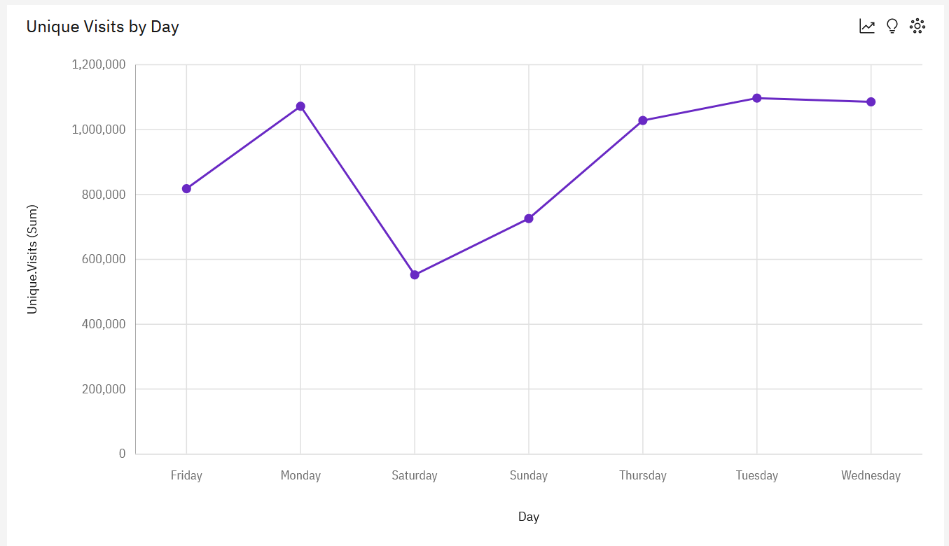

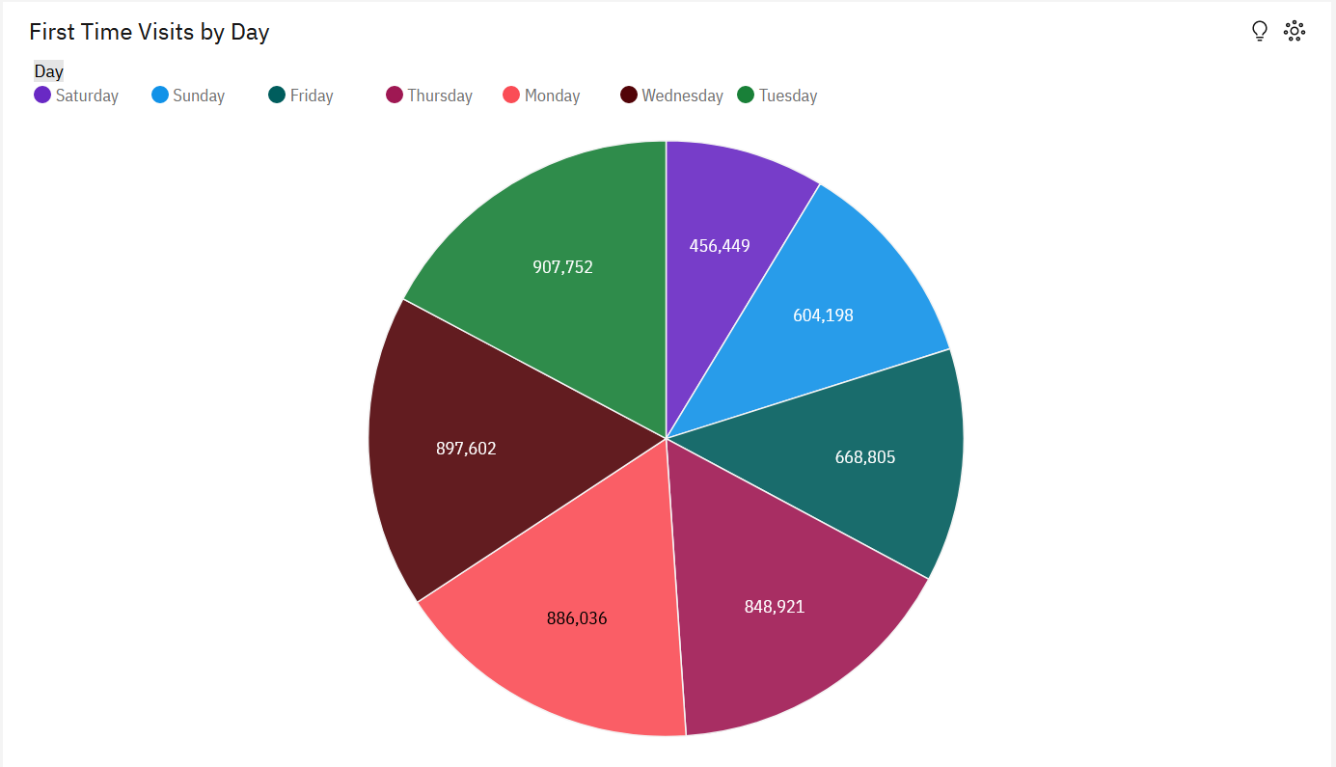

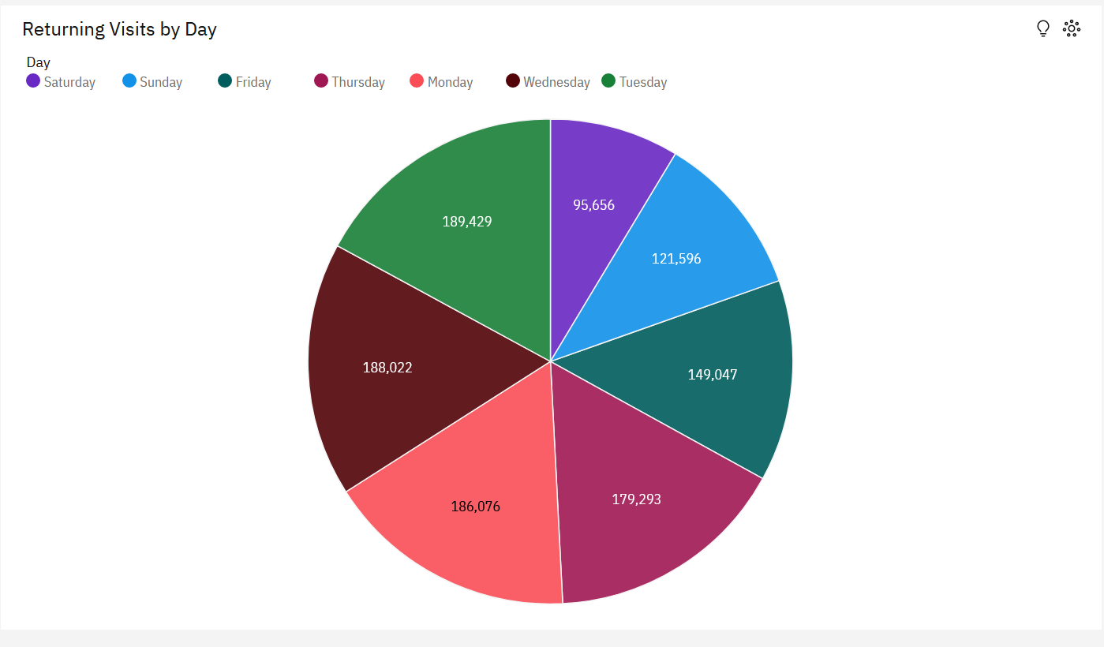

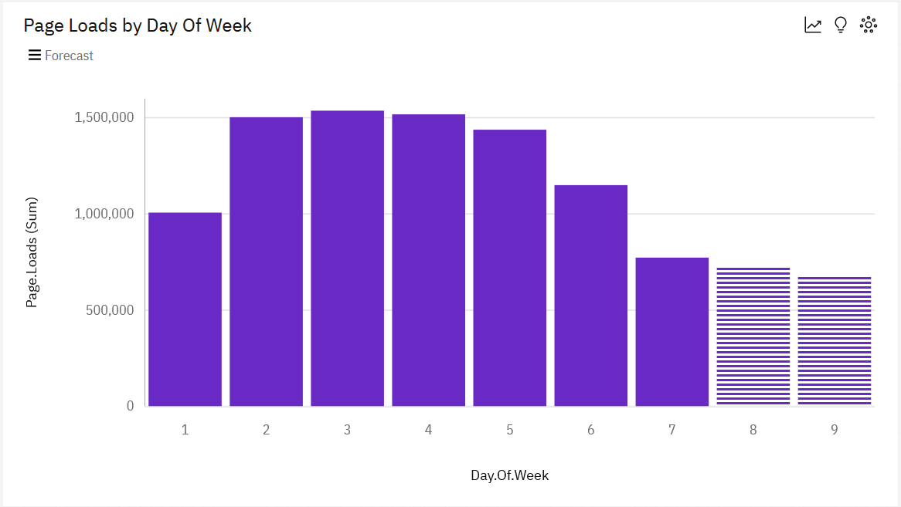

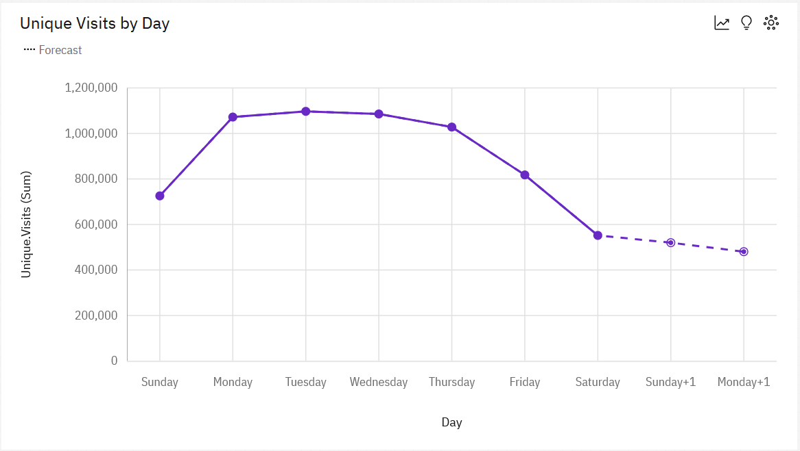

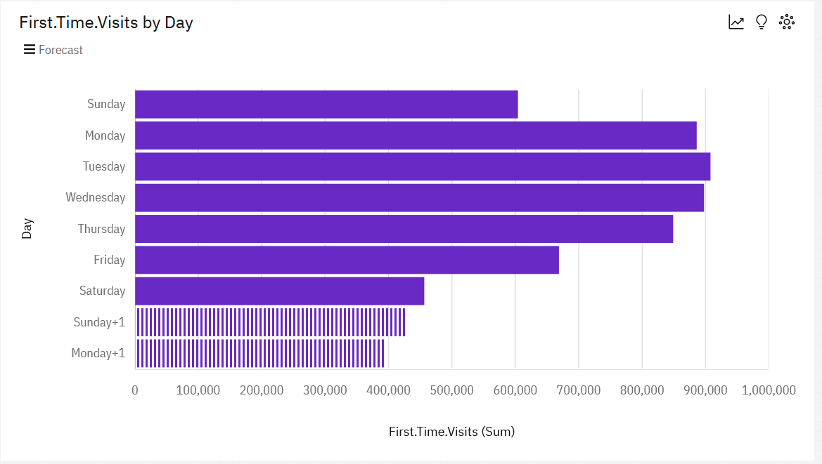

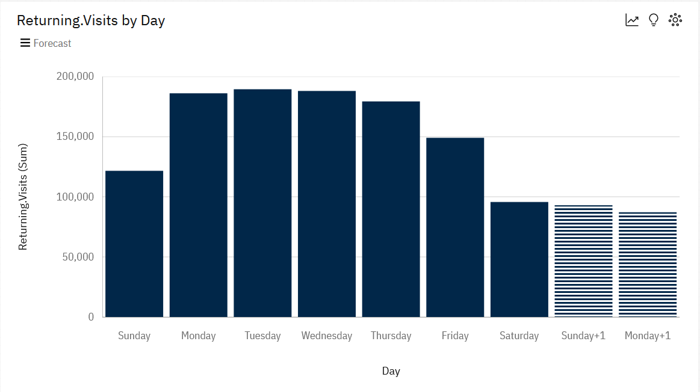

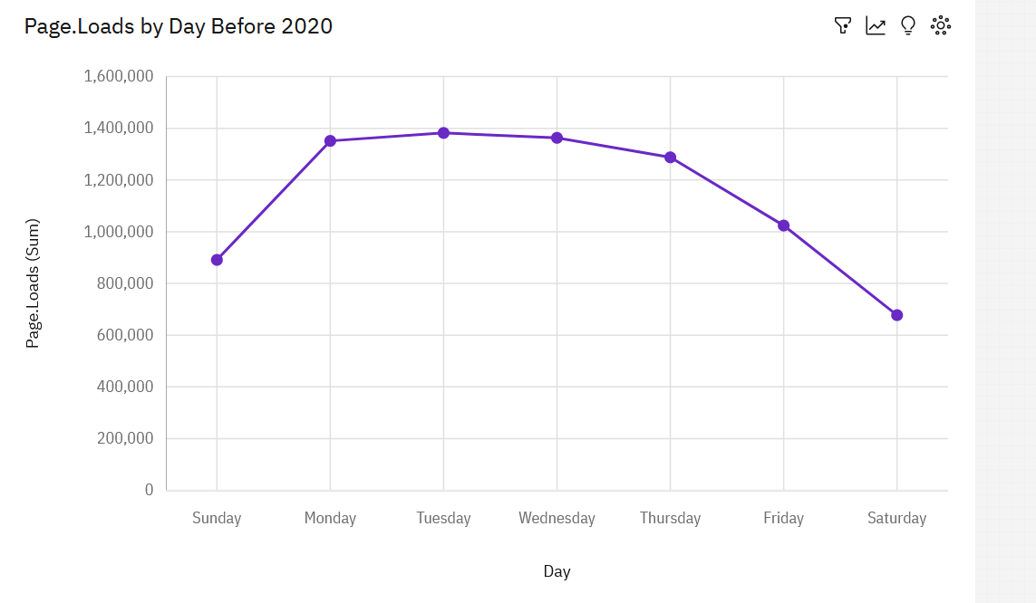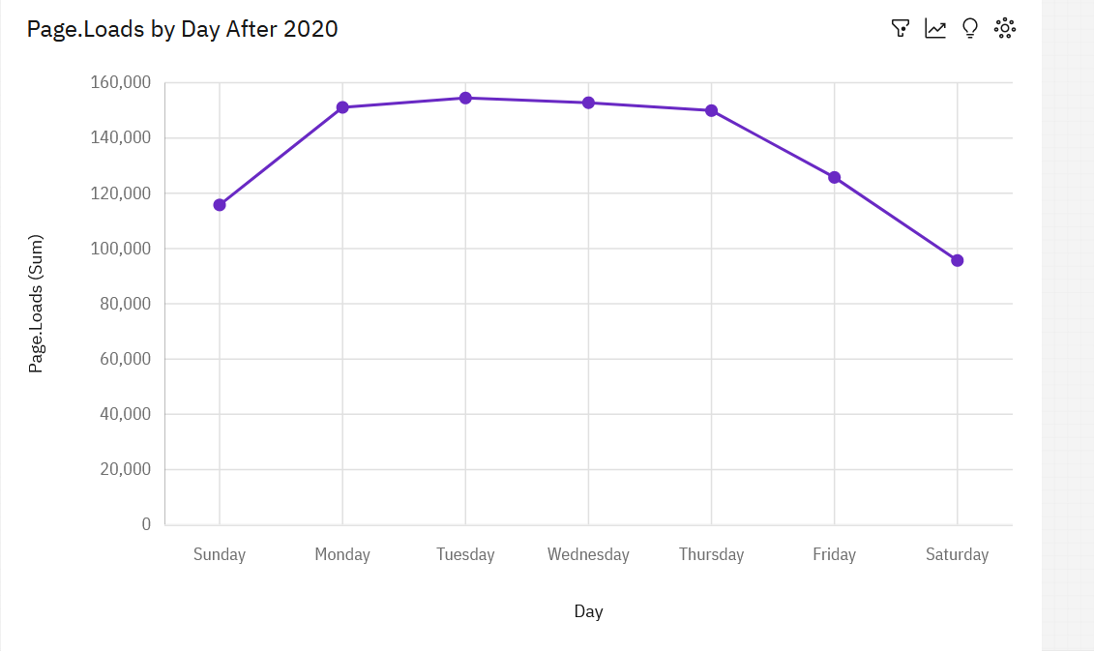

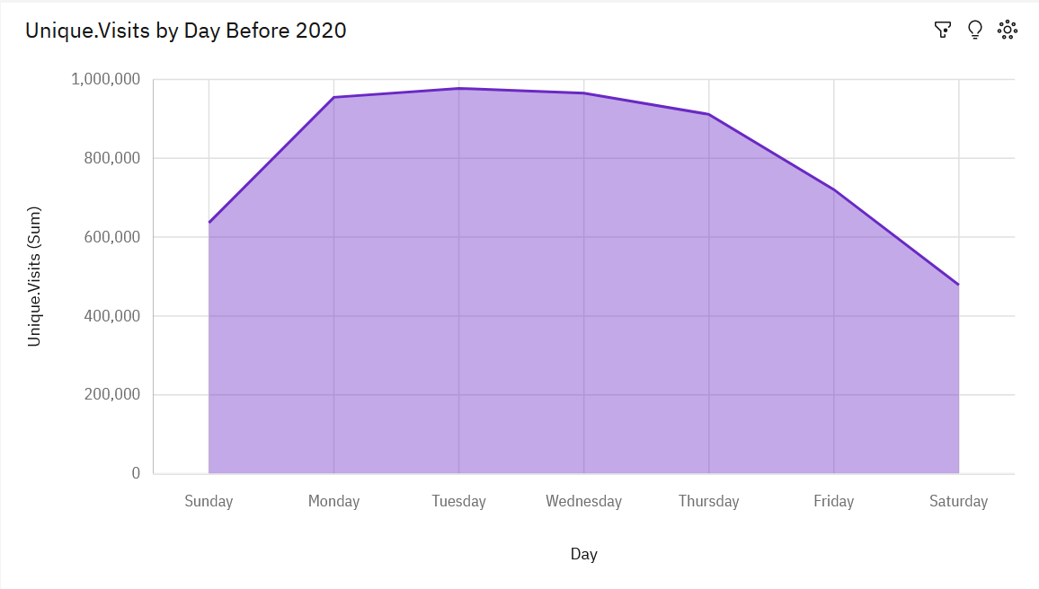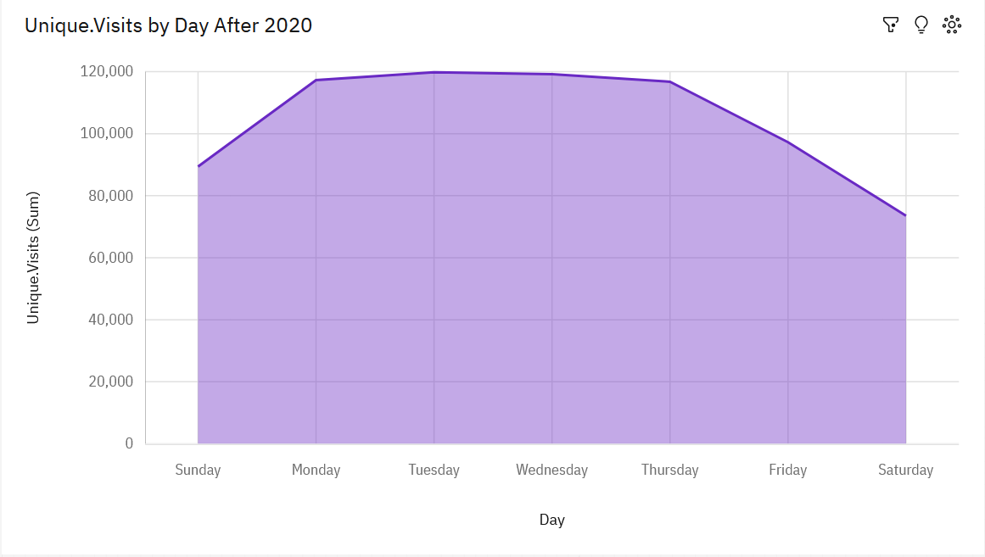

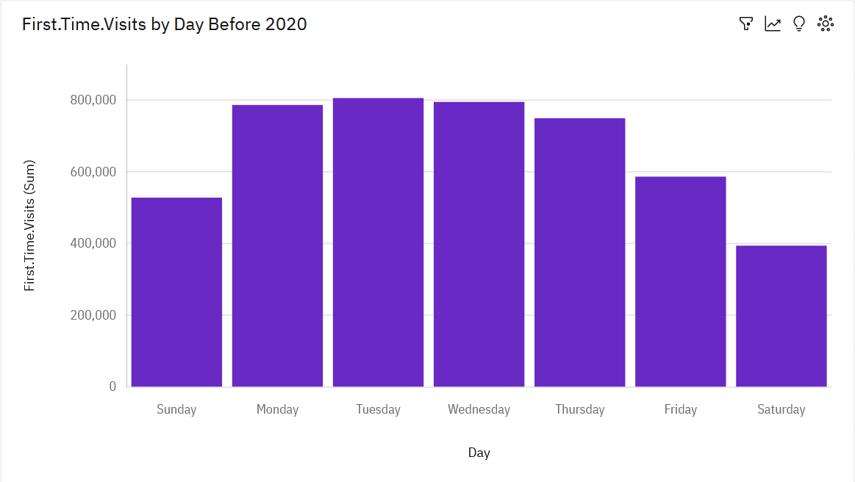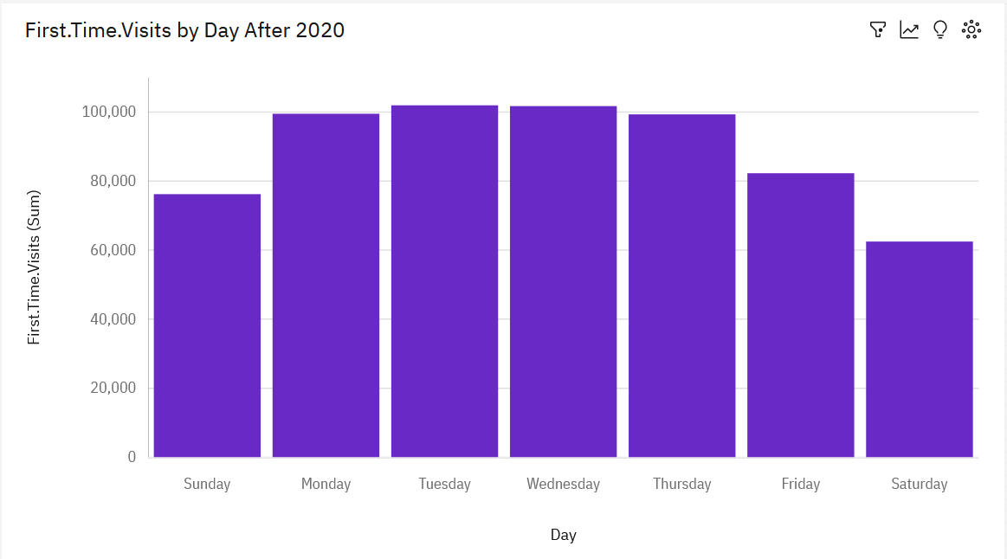

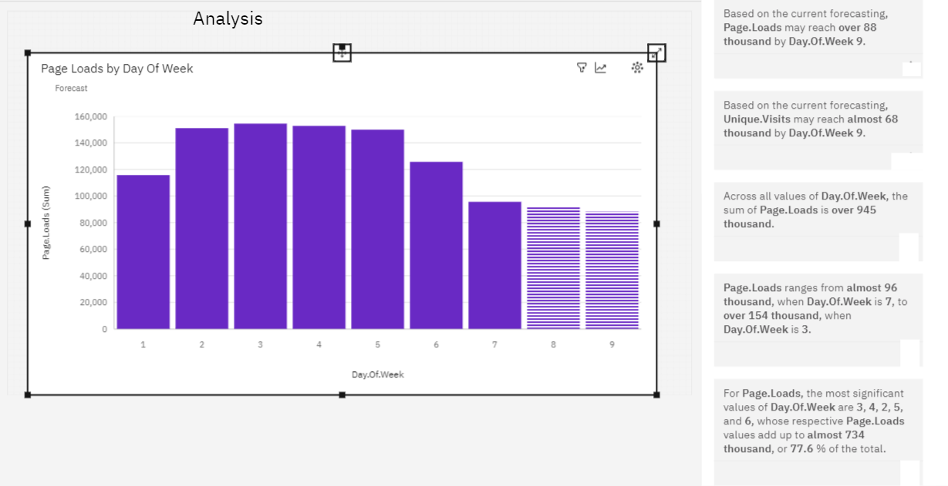

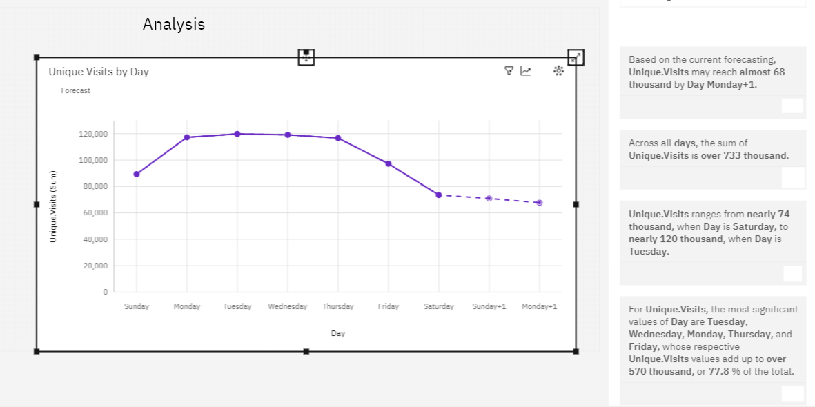

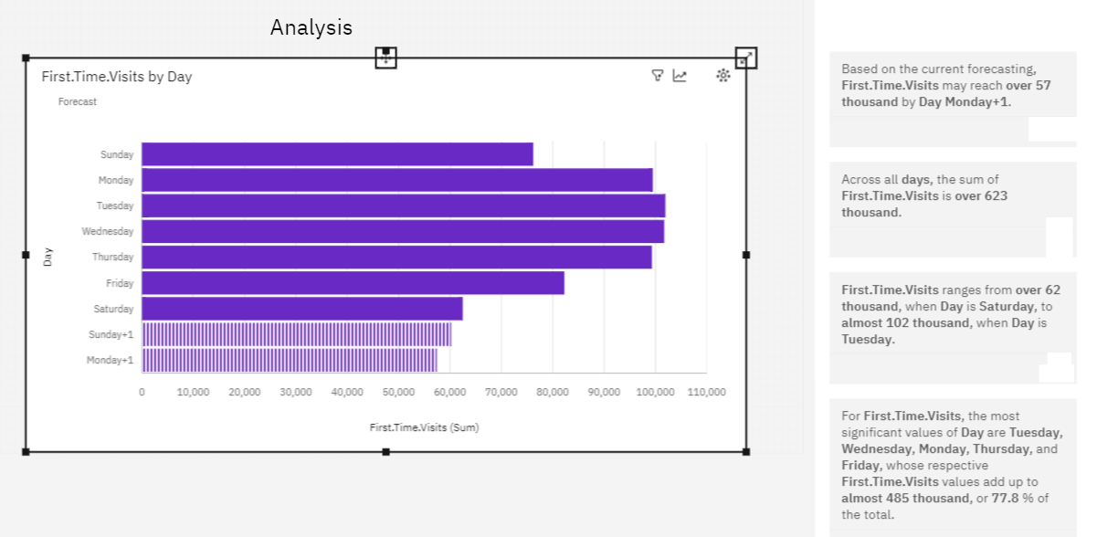

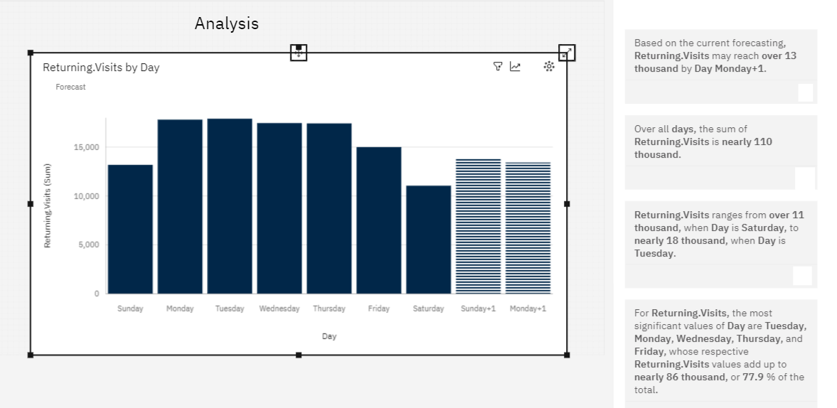

**Conclusion:**

This project aims to provide a comprehensive solution for website owners to track and analyze their website's traffic. By integrating Python, we leverage its powerful data processing capabilities and a wide range of libraries for analytics and visualization. The dashboard will empower users with actionable insights into their website's performance, helping them make informed decisions to improve user experience and engagement. The optional alerting mechanism adds an extra layer of proactive monitoring.

By implementing this project, website owners can gain a deeper understanding of their audience and optimize their content and marketing strategies accordingly. Additionally, the modular design allows for future enhancements and integrations with other analytics platforms.