

***B9DA101 Statistics for Data Analytics: CA_TWO***

*January 2025*

Submitted by:

Anish Rao: 20066423

Lecturer: Dr. Muhammad Alli

**Index**

**Introduction** 2

**Purpose of the Analysis** 2

**Dataset Overview** 2

**Q1. Consider a relational dataset and specify your input and output variables** 3

**(a) Logistic model trained using 80% of the dataset** 4

**(b) Significant variables and estimated parameters** 4

**(c) Predict outcomes for test data and model equation** 5

**(d) Confusion matrix and accuracy** 6

**Q2. Let x_1,…,x_10 are identically independently distributed (iid) with Poisson(λ)** 7

**(a) Likelihood function for a given λ** 7

**(b) Gamma prior for λ using chosen hyperparameters** 8

**(c) Posterior distribution of λ** 8

**(d) Bayesian estimator of λ** 9

**Q3. Use a particular stock market dataset to accomplish the time series analysis** 10

**(a) Check if mean and variance are stationary** 11

**(b) Plot acf() and pacf()** 12

**(c) Best ARIMA model** 13

**(d) 10 step Forecast** 14

# **Introduction**

### **Purpose of the Analysis**

This analysis explores the application of statistical techniques across three different problem domains: regression modeling, Bayesian estimation, and time series forecasting.

The report is divided into three main questions:

* **Question 1:** Applying a Generalized Linear Model (GLM).
* **Question 2:** Constructing a Bayesian estimation framework with Poisson-distributed data.
* **Question 3:** Analyzing a financial time series and forecasting future trends.

### **Dataset Overview**

Three datasets were used in this analysis:

* **mtcars (Q1):**
  + A built-in dataset in R with 32 observations on fuel consumption and 10 design aspects of cars.
  + Used to model transmission type (am) based on variables like mpg, hp, wt, and cyl.
* **Simulated Poisson Data (Q2):**
  + A sample of 10 values generated from a Poisson(λ=3) distribution.
  + Used to demonstrate likelihood computation and Bayesian inference using a Gamma prior.
* **EuStockMarkets (Q3):**
  + Time series dataset of daily closing prices of four major European stock indices.
  + The DAX index was used to perform stationarity checks, ARIMA modeling, and forecasting.

Google Colab Notebook link-

<https://colab.research.google.com/drive/18wMC0CFy5MYsx3ItcEJew90EmbEyLf7C?usp=sharing>

# **Q1. Consider a relational dataset and specify your input and output variables**

The dataset used is **mtcars** which is inbuilt in RStudio.

Input variables - **mpg**, **hp**, **wt**, **cyl**

Output variable - **am**

data("mtcars")  
head(mtcars)

## mpg cyl disp hp drat wt qsec vs am gear carb  
## Mazda RX4 21.0 6 160 110 3.90 2.620 16.46 0 1 4 4  
## Mazda RX4 Wag 21.0 6 160 110 3.90 2.875 17.02 0 1 4 4  
## Datsun 710 22.8 4 108 93 3.85 2.320 18.61 1 1 4 1  
## Hornet 4 Drive 21.4 6 258 110 3.08 3.215 19.44 1 0 3 1  
## Hornet Sportabout 18.7 8 360 175 3.15 3.440 17.02 0 0 3 2  
## Valiant 18.1 6 225 105 2.76 3.460 20.22 1 0 3 1

str(mtcars)

## 'data.frame': 32 obs. of 11 variables:  
## $ mpg : num 21 21 22.8 21.4 18.7 18.1 14.3 24.4 22.8 19.2 ...  
## $ cyl : num 6 6 4 6 8 6 8 4 4 6 ...  
## $ disp: num 160 160 108 258 360 ...  
## $ hp : num 110 110 93 110 175 105 245 62 95 123 ...  
## $ drat: num 3.9 3.9 3.85 3.08 3.15 2.76 3.21 3.69 3.92 3.92 ...  
## $ wt : num 2.62 2.88 2.32 3.21 3.44 ...  
## $ qsec: num 16.5 17 18.6 19.4 17 ...  
## $ vs : num 0 0 1 1 0 1 0 1 1 1 ...  
## $ am : num 1 1 1 0 0 0 0 0 0 0 ...  
## $ gear: num 4 4 4 3 3 3 3 4 4 4 ...  
## $ carb: num 4 4 1 1 2 1 4 2 2 4 ...

summary(mtcars)

## mpg cyl disp hp   
## Min. :10.40 Min. :4.000 Min. : 71.1 Min. : 52.0   
## 1st Qu.:15.43 1st Qu.:4.000 1st Qu.:120.8 1st Qu.: 96.5   
## Median :19.20 Median :6.000 Median :196.3 Median :123.0   
## Mean :20.09 Mean :6.188 Mean :230.7 Mean :146.7   
## 3rd Qu.:22.80 3rd Qu.:8.000 3rd Qu.:326.0 3rd Qu.:180.0   
## Max. :33.90 Max. :8.000 Max. :472.0 Max. :335.0   
## drat wt qsec vs   
## Min. :2.760 Min. :1.513 Min. :14.50 Min. :0.0000   
## 1st Qu.:3.080 1st Qu.:2.581 1st Qu.:16.89 1st Qu.:0.0000   
## Median :3.695 Median :3.325 Median :17.71 Median :0.0000   
## Mean :3.597 Mean :3.217 Mean :17.85 Mean :0.4375   
## 3rd Qu.:3.920 3rd Qu.:3.610 3rd Qu.:18.90 3rd Qu.:1.0000   
## Max. :4.930 Max. :5.424 Max. :22.90 Max. :1.0000   
## am gear carb   
## Min. :0.0000 Min. :3.000 Min. :1.000   
## 1st Qu.:0.0000 1st Qu.:3.000 1st Qu.:2.000   
## Median :0.0000 Median :4.000 Median :2.000   
## Mean :0.4062 Mean :3.688 Mean :2.812   
## 3rd Qu.:1.0000 3rd Qu.:4.000 3rd Qu.:4.000   
## Max. :1.0000 Max. :5.000 Max. :8.000

### **(a) Logistic model trained using 80% of the dataset**

Train the model using 80% of this dataset and suggest an appropriate GLM to model output to input variables. (10)

**Code -**

mtcars$am = as.factor(mtcars$am)  
mtcars$cyl = as.factor(mtcars$cyl)  
  
data_split = createDataPartition(mtcars$am, p = 0.8, list = FALSE)  
train_data = mtcars[data_split, ]  
test_data = mtcars[-data_split, ]

model = glm(am ~ mpg + hp + wt + cyl, data = train_data, family = binomial)

The variables **am** and **cyl** are converted to factors. The dataset is split into training (80%) and testing (20%) sets. A Binomial regression model is then trained to predict the transmission type (**am**).

### **(b) Significant variables and estimated parameters**

Specify the significant variables on the output variable at the level of 𝛼=0.05 and explore the related hypotheses test. Estimate the parameters of your model. (10)

**Code –**

summary(model)

**Output –**

## Call:  
## glm(formula = am ~ mpg + hp + wt + cyl, family = binomial, data = train_data)  
##   
## Coefficients:  
## Estimate Std. Error z value Pr(>|z|)  
## (Intercept) -1280.950 809723.749 -0.002 0.999  
## mpg 40.998 28196.890 0.001 0.999  
## hp 6.413 3310.121 0.002 0.998  
## wt -98.671 58606.465 -0.002 0.999  
## cyl6 -5.707 30697.754 0.000 1.000  
## cyl8 -480.280 345022.731 -0.001 0.999  
##   
## (Dispersion parameter for binomial family taken to be 1)  
##   
## Null deviance: 3.6499e+01 on 26 degrees of freedom  
## Residual deviance: 7.3221e-09 on 21 degrees of freedom  
## AIC: 12  
##   
## Number of Fisher Scoring iterations: 25

**Insights -**

At the 𝛼 = 0.05 level, none of the variables are statistically significant as all p-values are greater than 0.05.

Hypotheses:

* Null hypothesis (H₀): The variable has no effect on the output (**am**)
* Alternative hypothesis (H₁): The variable does affect the output (**am**)

As all p- values > 0.05, we fail to reject the null hypothesis for all variables.

Estimated parameters:

| Variable | Coefficient |
| --- | --- |
| Intercept | -1280.950 |
| mpg | 40.998 |
| hp | 6.413 |
| wt | -98.671 |
| cyl6 | -5.707 |
| cyl8 | -480.280 |

### **(c) Predict outcomes for test data and model equation**

Predict the output of the test dataset using the trained model. Provide the functional form of the optimal predictive model. (10)

**Code -**

predicted_prob = predict(model, newdata = test_data, type = "response")  
  
predicted_class = ifelse(predicted_prob > 0.5, 1, 0)  
actual_class = test_data$am

The model predicts probabilities on the test set and converts them into class labels using a 0.5 threshold.

**Output -**

print(data.frame(Actual = actual_class, Predicted = predicted_class))

## Actual Predicted  
## Mazda RX4 Wag 1 0  
## Duster 360 0 1  
## Merc 280C 0 0  
## Dodge Challenger 0 0  
## Porsche 914-2 1 1

**Insights -**

The model output returns the predicted transmission class (0 or 1) for each test data point.

Functional Form:

$$log\left(\frac{p}{1-p}\right)=-1280.95+40.998⋅mpg+6.413⋅hp-98.671⋅wt-5.707⋅cyl_{6}-480.280⋅cyl_{8}$$

Here, $p$ = probability that the car has a manual transmission (**am** = 1).

### **(d) Confusion matrix and accuracy**

Provide the confusion matrix and obtain the probability of correctness of predictions. (5)

**Code -**

predicted_class = as.factor(predicted_class)  
actual_class = as.factor(actual_class)  
  
confusion_matrix = confusionMatrix(predicted_class, actual_class)

A confusion matrix is created to compare predicted and actual classes for the test data.

**Output -**

print(confusion_matrix)

## Confusion Matrix and Statistics  
##   
## Reference  
## Prediction 0 1  
## 0 2 1  
## 1 1 1  
## Accuracy : 0.6   
## 95% CI : (0.1466, 0.9473)  
## No Information Rate : 0.6   
## P-Value [Acc > NIR] : 0.6826   
##   
## Kappa : 0.1667   
##   
## Mcnemar's Test P-Value : 1.0000   
##   
## Sensitivity : 0.6667   
## Specificity : 0.5000   
## Pos Pred Value : 0.6667   
## Neg Pred Value : 0.5000   
## Prevalence : 0.6000   
## Detection Rate : 0.4000   
## Detection Prevalence : 0.6000   
## Balanced Accuracy : 0.5833   
##   
## 'Positive' Class : 0

**Insights -**

The model got 3 correct out of 5 and has **60%** accuracy.

# **Q2. Let x_1,…,x_10 are identically independently distributed (iid) with Poisson(λ)**

Generated 10 independent values from a Poisson distribution with λ = 3.

x = rpois(10, lambda = 3)  
print(x)

## [1] 4 4 2 1 4 5 1 3 3 3

### **(a) Likelihood function for a given λ**

Compute the likelihood function (LF). (10)

**Code -**

likelihood = function(lambda, data) {  
 n = length(data)  
 sum_x = sum(data)  
 return((lambda ^ sum_x) * exp(-n * lambda))  
}  
  
lambda_values = seq(1, 6, by = 0.1)  
likelihood_values = sapply(lambda_values, likelihood, data = x)  
  
plot(lambda_values, likelihood_values,  
 type = "l",  
 col = "red",  
 main = "Likelihood Function",  
 xlab = "Lambda", ylab = "Likelihood")

The function calculates the likelihood of observing the data for different λ values.

**Output -**

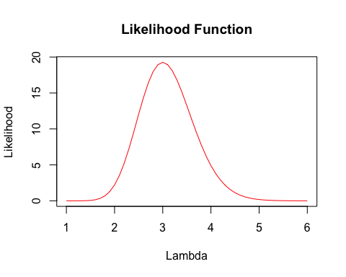

**Insights -**

The likelihood function shows how likely different values of λ are, given the observed data. In this case, the likelihood peaks around λ = 3.

### **(b) Gamma prior for λ using chosen hyperparameters**

Adopt the appropriate conjugate prior to the parameter λ (Hint: Choose hyperparameters optionally within the support of distribution). (10)

**Code -**

alpha = 2  
beta = 1  
lambda_vals = seq(0, 10, by = 0.1)  
  
prior_density = dgamma(lambda_vals, shape = alpha, rate = beta)  
  
plot(lambda_vals, prior_density,  
 type = "l",  
 col = "red",  
 main = "Gamma Prior for λ (α = 2, β = 1)",  
 xlab = "Lambda", ylab = "Density")

A Gamma distribution with shape α = 2 and rate β = 1 is used to represent prior for λ.

**Output -**

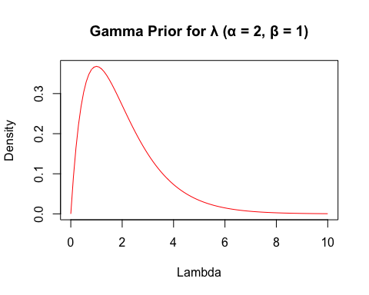

**Insights -**

The Gamma distribution is a natural conjugate prior for Poisson(λ).

### **(c) Posterior distribution of λ**

Using (a) and (b), find the posterior distribution of λ. (10)

**Code -**

sum_x = sum(x)  
n = length(x)  
  
posterior_alpha = alpha + sum_x  
posterior_beta = beta + n

The posterior parameters are calculated by updating the prior with the observed data: α = α + sum(x), and β = β + n.

**Output -**

cat("Posterior: \nGamma (",posterior_alpha,",",posterior_beta,")\n")

## Posterior:   
## Gamma ( 32 , 11 )

**Insights -**

Based on the observed data and the prior (Gamma(2, 1)), the posterior distribution for λ is Gamma(32, 11)

### **(d) Bayesian estimator of λ**

Compute the minimum Bayesian risk estimator of λ. (5)

**Code -**

lambda_bayes = posterior_alpha / posterior_beta

The posterior mean (α / β) is used as the Bayesian estimator of λ.

**Output -**

cat("Bayesian Estimator:", lambda_bayes)

## Bayesian Estimator: 2.909091

**Insights -**

The Bayesian estimator represents the expected value of λ based on the posterior distribution.

For Gamma(32, 11), this gives an estimate ~ 2.91.

# **Q3. Use a particular stock market dataset to accomplish the time series analysis**

The dataset used is **EuStockMarkets** which is inbuilt in RStudio.

data("EuStockMarkets")  
head(EuStockMarkets)

## Time Series:  
## Start = c(1991, 130)   
## End = c(1991, 135)   
## Frequency = 260   
## DAX SMI CAC FTSE  
## 1991.496 1628.75 1678.1 1772.8 2443.6  
## 1991.500 1613.63 1688.5 1750.5 2460.2  
## 1991.504 1606.51 1678.6 1718.0 2448.2  
## 1991.508 1621.04 1684.1 1708.1 2470.4  
## 1991.512 1618.16 1686.6 1723.1 2484.7  
## 1991.515 1610.61 1671.6 1714.3 2466.8

str(EuStockMarkets)

## Time-Series [1:1860, 1:4] from 1991 to 1999: 1629 1614 1607 1621 1618 ...  
## - attr(*, "dimnames")=List of 2  
## ..$ : NULL  
## ..$ : chr [1:4] "DAX" "SMI" "CAC" "FTSE"

summary(EuStockMarkets)

## DAX SMI CAC FTSE   
## Min. :1402 Min. :1587 Min. :1611 Min. :2281   
## 1st Qu.:1744 1st Qu.:2166 1st Qu.:1875 1st Qu.:2843   
## Median :2141 Median :2796 Median :1992 Median :3247   
## Mean :2531 Mean :3376 Mean :2228 Mean :3566   
## 3rd Qu.:2722 3rd Qu.:3812 3rd Qu.:2274 3rd Qu.:3994   
## Max. :6186 Max. :8412 Max. :4388 Max. :6179

dax = EuStockMarkets[, "DAX"]  
plot(dax,  
 type = "l",   
 col = "red",  
 main = "DAX Index Time Series",   
 xlab = "Time", ylab = "Price")

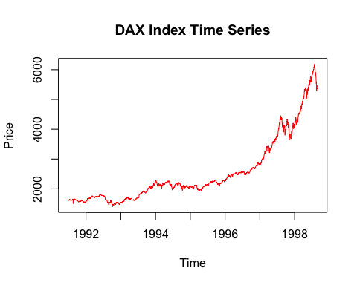

### **(a) Check if mean and variance are stationary**

Check whether the time series is stationary in mean and variance. (5)

**Code -**

adf_test = adf.test(dax)  
print(adf_test)

sd_full = sd(dax)  
sd_first_half = sd(dax[1:(length(dax)/2)])  
sd_second_half = sd(dax[((length(dax)/2) + 1):length(dax)])  
  
cat("Full SD:", sd_full, "\n")

cat("First Half SD:", sd_first_half, "\n")

cat("Second Half SD:", sd_second_half, "\n")

The adf.test() checks for stationarity in mean, while standard deviations for the full series and each half are calculated to check difference in variance.

**Output -**

## Augmented Dickey-Fuller Test  
##   
## data: dax  
## Dickey-Fuller = -0.82073, Lag order = 12, p-value = 0.9598  
## alternative hypothesis: stationary

## Full SD: 1084.793

## First Half SD: 241.1517

## Second Half SD: 1137.395

**Insights -**

Hypotheses:

* Null hypothesis (H₀): Series mean is non-stationary.
* Alternative hypothesis (H₁): Series mean is stationary.

As p- value (0.96) > 0.05, we fail to reject the null hypothesis , therefore the series is not stationary in mean.

Standard Deviation also changes a lot between the first and second half, therefore the series is not stationary in variance.

### **(b) Plot acf() and pacf()**

Use acf() and pacf() functions to identify the order of AR and MA. (10)

**Code -**

dax_diff = diff(dax)  
  
plot(dax_diff,   
 type = "l",   
 col = "red",  
 main = "Differenced DAX Series",   
 xlab = "Time", ylab = "Diff Price")

acf(dax_diff, main = "ACF")

pacf(dax_diff, main = "PACF")

The series is first differenced using diff() to stabilize the mean. The acf() and pacf() plots are then used to examine autocorrelation and partial autocorrelation patterns.

**Output -**

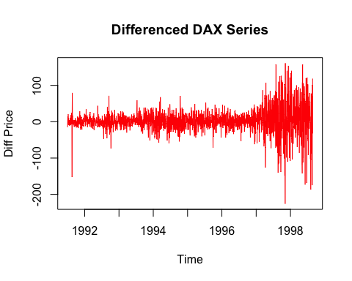

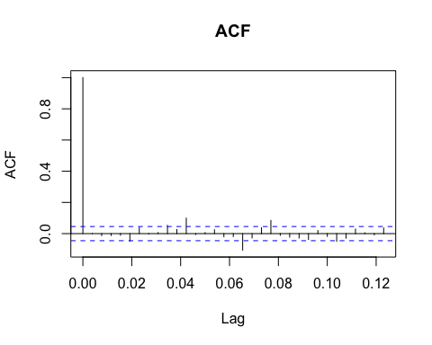

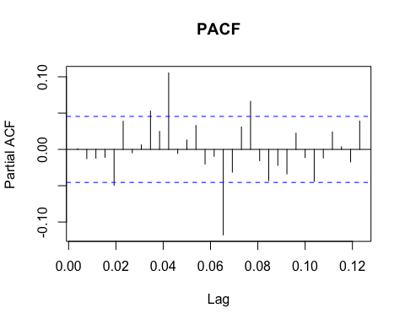

**Insights -**

The ACF drops sharply after lag 1 and PACF shows a few significant spikes.

### **(c) Best ARIMA model**

Use auto.arima() to learn the best ARIMA model. (5)

**Code -**

best_model = auto.arima(dax)  
print(best_model)

The auto.arima() function automatically selects the best-fitting ARIMA model for the DAX time series based on information criteria like AIC and BIC.

**Output -**

## Series: dax   
## ARIMA(5,2,0)   
##   
## Coefficients:  
## ar1 ar2 ar3 ar4 ar5  
## -0.8187 -0.6631 -0.5053 -0.3444 -0.2231  
## s.e. 0.0228 0.0287 0.0306 0.0289 0.0231  
##   
## sigma^2 = 1235: log likelihood = -9248  
## AIC=18507.99 AICc=18508.04 BIC=18541.15

**Insights -**

The chosen model is ARIMA(5,2,0), which means the series was differenced twice to achieve stationarity and includes five autoregressive terms.

### **(d) 10 step Forecast**

Forecast h=10 step ahead prediction of the time series variable and plot it with the original time series. (10)

**Code -**

forecast_result = forecast(best_model, h = 10)  
  
plot(forecast_result,  
 main = "10 step Forecast",  
 xlab = "Time", ylab = "DAX Value")

The forecast() function generates a 10-step ahead prediction using the selected ARIMA model. The results are plotted to visualize future values alongside the original time series.

**Output -**

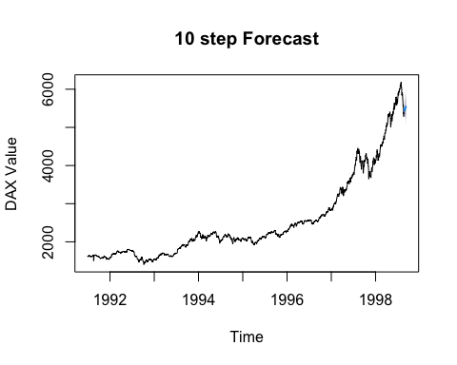

**Insights -**

The forecast shows a continued upward trend in DAX values. The confidence intervals widen over time, indicating increasing uncertainty in long-term predictions.