Amazon Sales Data Analysis

Wireframe documentation

**Hypothetical data record – 100 records**

**Time Period: 2010-2017**



**Problem Statement:**

Find ways to check the need for improved methods of distribution to reduce cost and to increase profits.

As per the problem statement, the data has been divided into 4 sections:

1. Sales analysis
2. Product analysis
3. Price analysis
4. Global Outlook

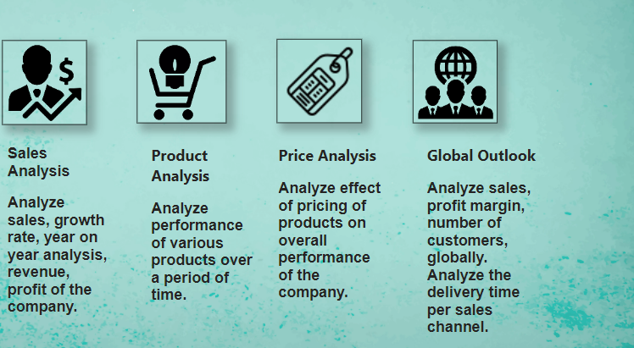

1. **Sales Analysis dashboard:** Designed to view

* Overall sales growth
* Sales per year
* Change in sales with respect to last year
* Sales growth over the last year
* Yearly, monthly trend
* Total orders and Count of Products over a period of time
* KPIs for this dashboard: total sales and profit%

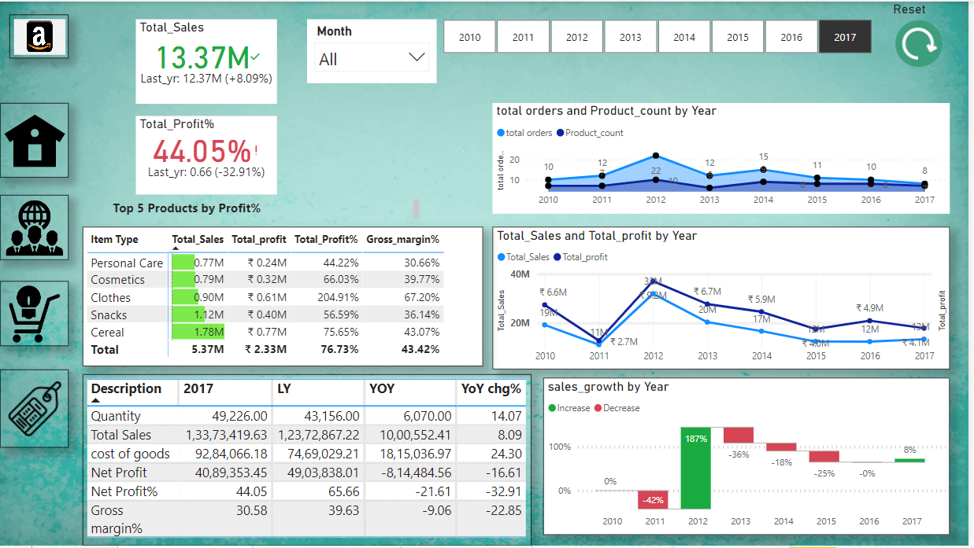

First, we look at the total sales and profit year-wise:

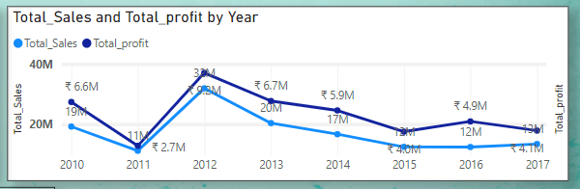

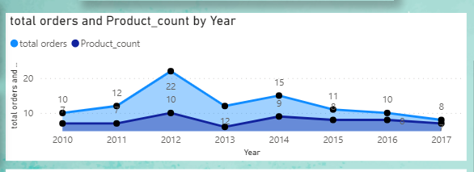

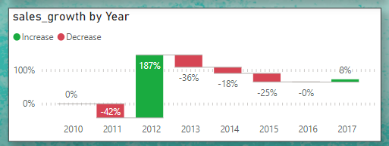

Insights:

* Year 2012- sales and profit very high
* Sales and profit decline from 2012 to 2015 and then take an upward trend after 2015
* Product count and total orders were maximum in year 2012
* Total orders and products make a sharp decline after 2012 and then make some improvement after 2013 for an year.
* Sales growth maximum in 2012, declines till 2015 and then shows positive change in 2017

So, we analyze the top products bringing the sales

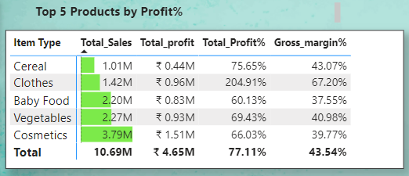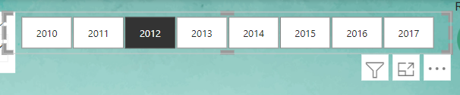

Then, We try to analyze change in various measures like total sales, profit, gross margin% per year with respect to the previous year and its growth rate.

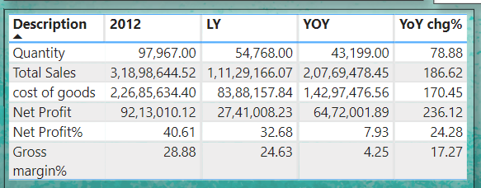

1. **Product analysis dashboard:** Designed to view
   * Product segmentation region wise
   * Performance of each of the products of the company compared to previous year, their demand in the market, total orders received per product per year
   * Performance of the products in terms of profit% and gross percentage.
   * Product Sales through various distribution channels
   * Product order priority and changes.

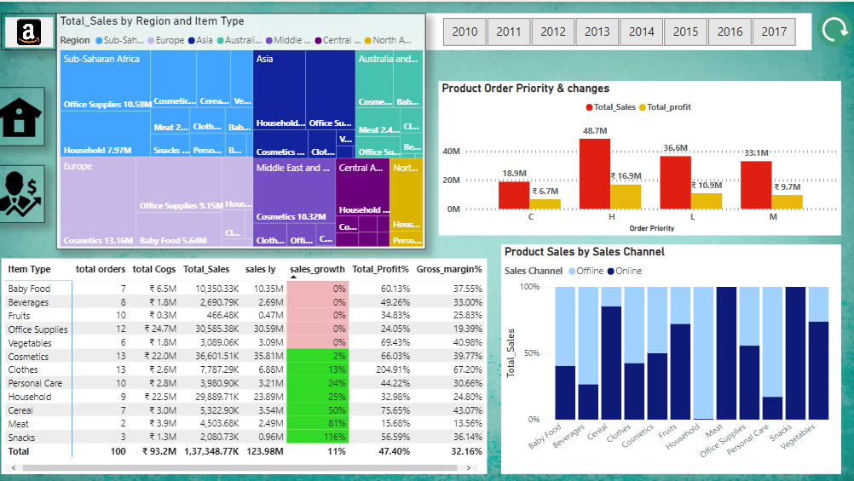

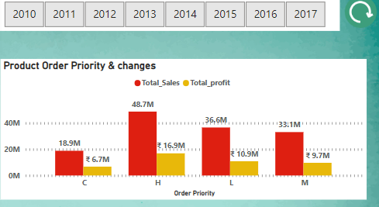

Insights:

* High,low and medium category products do well overall.

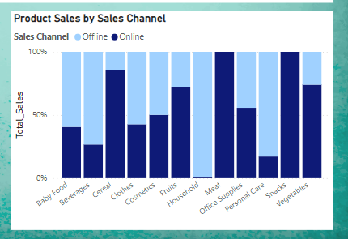

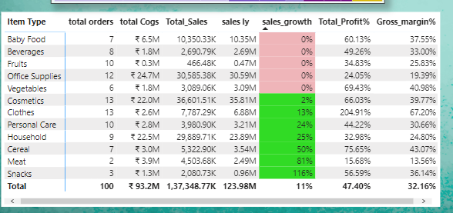

Insights:

* Some products are performing well according to the sales growth values. These values have been compared to the previous year.

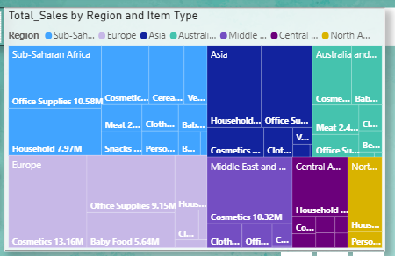

Insights:

* The Heat map shows the size of market region wise and size of the market product wise
* Clearly, Household items are a rogue in most of the regions followed by office supplies and cosmetics.
* Overall, there are some products which have a good market demand, show good sales growth, have good profit% and gross margin%.

1. **Price analysis dashboard:** Designed to view:
   * Impact of prices on different products
   * Impact of Prices on sales and profits.
   * Impact of prices on the number of customers.

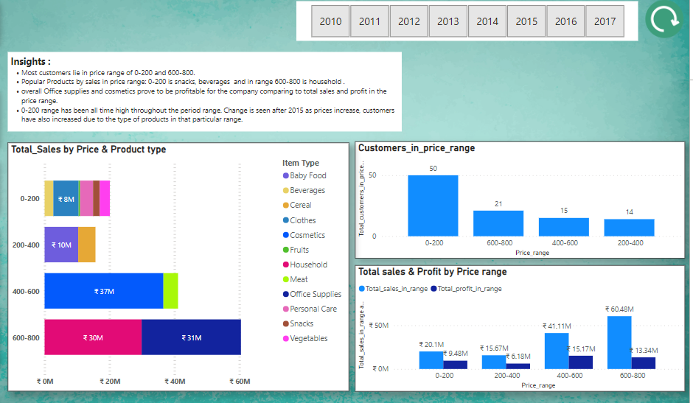

Impact of prices on customers and Sales,Profit

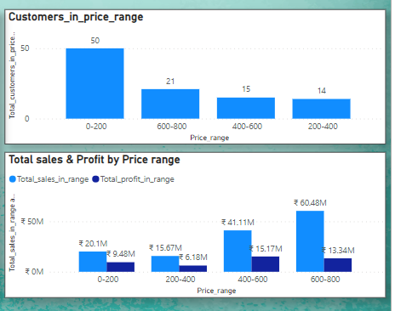

Visualize the Products which fall under different price ranges

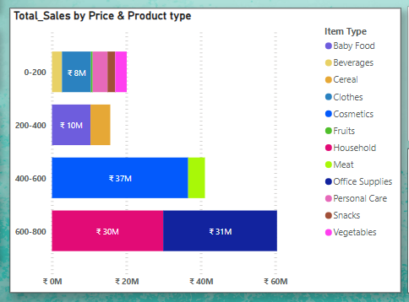

1. **Global Outlook dashboard:** Designed to view:
   * Customers served globally region wise and then country wise.
   * Analyze sales through different distribution channels.
   * Analyze the demand region wise, average delivery time to each region, average purchase price and order size per region.
   * Analyze the profit% per sales channel
   * Analyze sales metrics region wise.

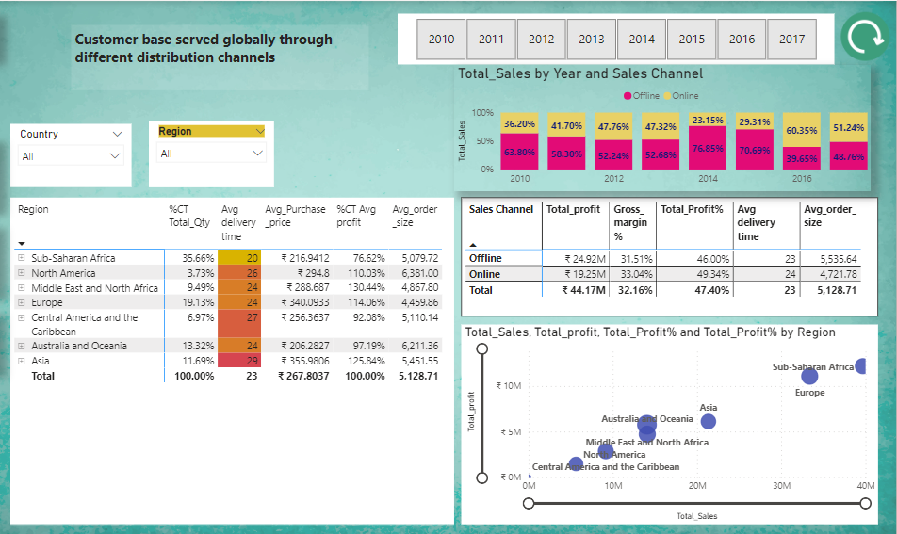

Analyze the metrics region wise and then country wise to figure out the issues at the base level.

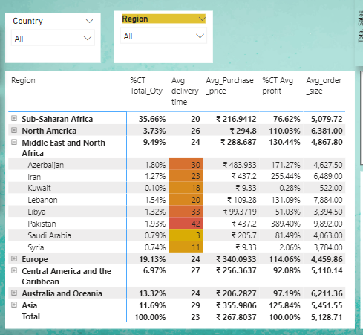

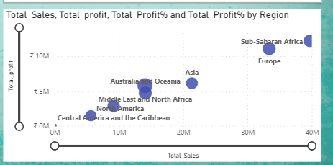

Analyze metrics through sales channel perspective

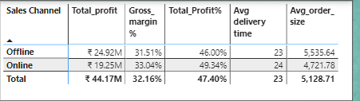

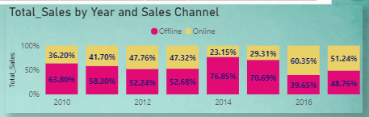

Overall:

Suggested Measures to increase profits and reduce the cost distribution channels is:

1. Through offline channels – order size is far more than online channels and since profits are more than online channels, the company must try ways to optimise its marketing strategies to attract the offline customers.
2. There are more customers in price range 0-200 and 600-800, so the company can increase its prices of products falling under the range to increase its profits.
3. As average order size is more in offline channel, the company must try to focus more on the demands of offline customers than online customers.
4. Focus on office supplies, household, cosmetics to increase profits.