# **Bungee Coding Round**

### **Problem Statement:-**

You are provided with a file "main.csv" in the input folder. Following operation needs to be provided on the file:-

1. Create an output file "filteredCountry.csv" inside a folder named "output". This file should contain only those records where country contains the word USA.

Expected output:-



1. Now consider "filteredCountry.csv" as the input file. For each group of "SKU" find 2 minimum prices and store this result in "lowestPrice.csv" inside a folder named "output"

Expected output:-

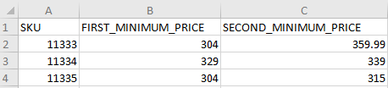

## Solution by Anisha Gupta

### The input file:

Main.csv in input foder

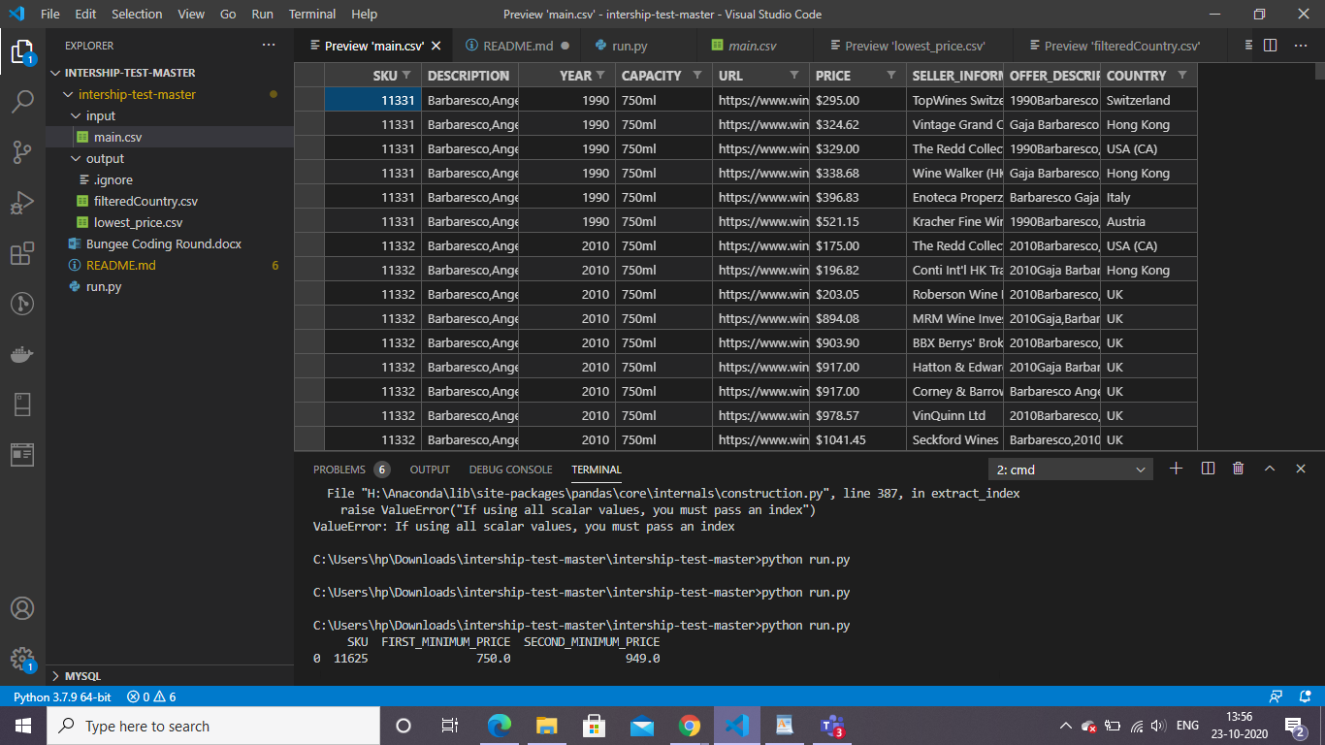

## Ques1.

# 1.Create an output file "filteredCountry.csv" inside a folder named "output".

# This file should contain only those records where country contains the word USA.

Soln :

Considering the Country column,have checked if country is USA and have made changes to price column as:

Removed “,” , “ ? “ , “$” from the string and have converted it to numeric value and saved it in output folder as “filtered_country.csv”

### Filtered_country.csv in output folder:

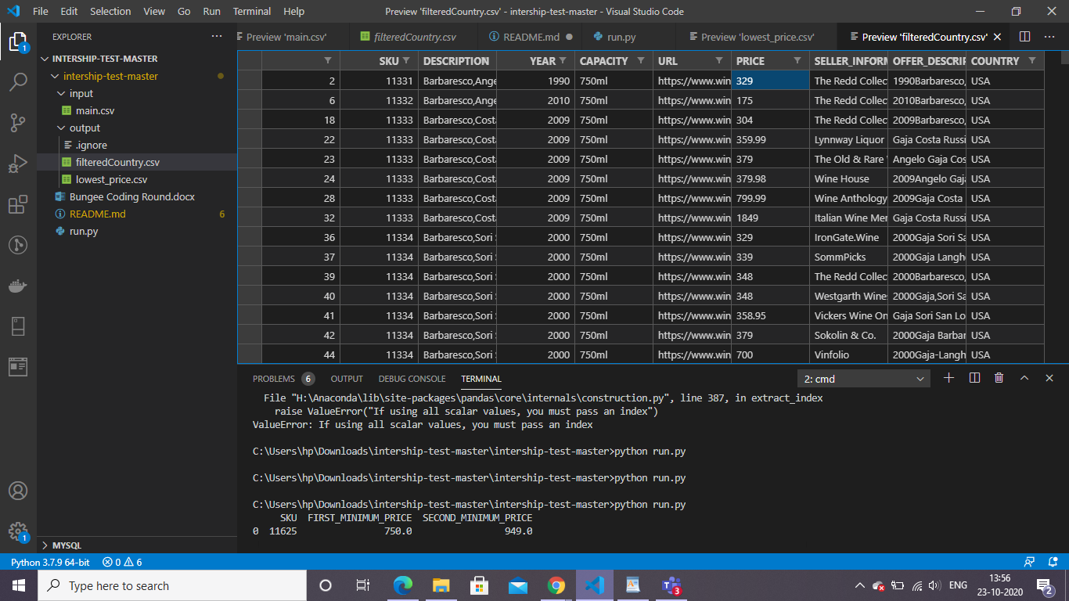

## Ques 2.

# 1. Now consider "filteredCountry.csv" as the input file.

# For each group of "SKU" find 2 minimum prices and store this result in "lowestPrice.csv" inside a folder named "output"

1. Made a dictionary that holds “SKU” as key and Prices as list of values.
2. Then sorted the list.
3. Made a dictionary for 'SKU','FIRST_MINIMUM_PRICE','SECOND_MINIMUM_PRICE'
4. Converted the dictionary into csv and saved it as :

### Lowest_price.csv in output folder:

