A

PROJECT REPORT ON

**E-LEARNING SYSTEM**

SUBMITTED BY

**Ms. ANISHA BAJIRAO GAIKWAD**

SUBMITED TO

# **SAVITRIBAI PHULE PUNE UNIVERSITY, PUNE**

# IN FULFILLMENT OF DEGREE

# **MASTER OF COMPUTER APPLICATION (SEM – I)**

# UNDER THE GUIDANCE OF

# **Dr. Samiksha Yeola**

# Through,



**Sadhu Vaswani Institute of Management Studies for Girls,**

**Koregaon Park, Pune – 411001**

**2024-25**

**DECLARATION BY STUDENT**

To,  
The Director,   
SVIMS, Koregaon Park Pune

I hereby declare that the project titled **“E-Learning System”** has been created by me to provide an effective online learning platform as per the requirements of modern educational systems. This project was completed under the guidance of Dr. **Samiksha Yeola** and is my original work.

I further declare that to the best of my knowledge and belief, this project has not been submitted to this or any other University or Institution for the award of any Degree.

**Place:** Pune  
**Date:** 5/12/2024

**[Anisha Bajirao Gaikwad]**



Mini Project Progress Report

**Class: MCA – I Semester – I (Academic Year 2024-25)**

**Student Name:**

**Project Title:**

**Project Guide:(Institute)**

|  |  |  |  |  |  |
| --- | --- | --- | --- | --- | --- |
| **Sr.**  **No.** | **Activity to be completed** | **Date of Completion** | | **Suggestions if any** | **Guide Sign** |
| **Expected** | **Actual** |
| 1. | **Preliminary discussion & project title finalization** | 13/09/2024 |  |  |  |
| 2. | **Synopsis submission & presentation** | 23/09/2024 |  |  |  |
| 3. | **CHAPTER 1: INTRODUCTION**   * 1. Client/Organization Profile   2. Need for System   3. Scope & Feasibility of Work   4. Operating Environment – H/w & S/w   5. Architecture of system   6. Detail Description of Technology Used | 4/10/2024 |  |  |  |
| 4. | **CHAPTER 2 : PROPOSED SYSTEM**   * 1. Proposed System   2. Objectives of System   3. User Requirements | 11/10/2024 |  |  |  |
| 5. | **CHAPTER 3 : ANALYSIS & DESIGN**   * 1. DFD   2. Table specifications (Database)   3. ERD | 21/10/2024 |  |  |  |
| 6. | * 1. Object Diagram   2. Class Diagram   3. Use Case Diagrams   4. Web Site Map Diagram (if Website ) | 31/10/2024 |  |  |  |
| 7. | **CHAPTER 4: USER MANUAL**   * 1. User Interface Design (Screens etc.)   2. Limitations   3. Future enhancement   **BIBLIOGRAPHY**  **ANNEXURE:** Sample program code | 8/11/2024 |  |  |  |
| 8. | **Review / Presentation** | 14/11/2024 |  |  |  |
| 9. | **Project soft copy checkup** | 21/11/2024 |  |  |  |
| 10. | **Final Submission** | 25/11/2024 |  |  |  |

**INDEX**

|  |  |  |
| --- | --- | --- |
| CHAPTER | DETAILS | PAGE NO |
| 1 | **CHAPTER 1: INTRODUCTION**   * 1. Client/Organization Profile   2. Need for System   3. Scope & Feasibility of Work   4. Operating Environment – H/w & S/w   5. Architecture of system   6. Detail Description of Technology Used | 5 |
| 2 | **CHAPTER 2: PROPOSED SYSTEM**   * 1. Proposed System   2. Objectives of System   3. User Requirements | 20 |
| 3 | **CHAPTER 3: ANALYSIS & DESIGN**   * 1. DFD   2. Table specifications (Database)   3. ERD   4. Object Diagram   5. Class Diagram   6. Use Case Diagrams   7. Web Site Map Diagram (if Website) | 24 |
| 4 | **CHAPTER 4: USER MANUAL**   * 1. User Interface Design (Screens etc.)   2. Limitations   3. Future enhancement   **BIBLIOGRAPHY**  **ANNEXURE:** Sample program code | 34 |

ACKNOWLEDGEMENT

**ACKNOWLEDGEMENT**

I extend my sincere gratitude to Dr. B.H.Nanwani, Dr. Rajesh Kashyap for allowing me to work on the project "E-Learning System" and for their constant encouragement, valuable suggestions, and guidance throughout.

I extend my special thanks to Prof. Samiksha Yeola and Dr. Shveti Chandan for their kind cooperation and inspiration.

I extend my special gratitude to my dearest family members and friends who encouraged and motivated me to complete the project successfully.

**Place:** [PUNE]  
**Date: 3/12/2024**  
 **[ [ANISHA BAJIRAO GAIKWAD]**

**CHAPTER-1 INTRODUCTION**

**1.1 Client/Organization Profile:**

**Name:** E-Learning System  
**Location:** Online Platform

**About Organization:**

The E-Learning System is an advanced online platform designed to provide flexible and accessible education for students and professionals. It offers a wide range of features such as online courses, tutorials, lessons allowing users to learn at their own pace and convenience.

One of the main advantages of the E-Learning System is its ability to eliminate geographical barriers, enabling users from different locations to access quality education. The platform is cost-effective, saving users the expenses associated with traditional classroom learning, such as travel and accommodation. It also provides a personalized learning experience, allowing learners to choose courses that suit their individual interests and career goals.

Additionally, the platform integrates features such as progress tracking and instant feedback, helping learners identify their strengths and areas for improvement. The E-Learning System supports a diverse range of subjects and skill levels, making it suitable for school students, college graduates, and working professionals. By using interactive tools and multimedia content, it ensures a rich and engaging learning experience.

This system promotes lifelong learning, empowering users to acquire new skills and knowledge that are essential in today’s fast-changing world. It is especially beneficial for those who wish to balance education with work, family, or other commitments.

**1.2 Need for System:**

An E-Learning System is crucial for modern education and professional training, offering convenience, flexibility, and a wide reach. Here are several reasons why implementing an E-Learning System is essential:

1. **Accessibility:** An E-Learning System allows learners to access educational materials anytime and anywhere, breaking geographical and time constraints. This is particularly beneficial for remote learners or those with limited access to traditional education.
2. **Cost-Effective:** Online learning reduces the costs associated with physical classrooms, including travel, accommodation, and printed materials. It provides an affordable alternative to traditional learning without compromising quality.
3. **Personalized Learning:** The system enables users to choose courses that match their interests and pace, ensuring a tailored learning experience. Features like progress tracking and adaptive content further enhance individual growth.
4. **Engagement:** With interactive tools such as videos, quizzes, and multimedia presentations, the platform keeps learners engaged and motivated, making education more effective and enjoyable.
5. **Scalability:** An E-Learning System can accommodate a large number of users at once, making it ideal for organizations, schools, and universities aiming to educate multiple learners simultaneously.
6. **Skill Development:** The platform supports a wide range of subjects and skill-based courses, helping users upgrade their knowledge and stay competitive in their fields.
7. **Sustainability:** By reducing the need for physical resources like paper and infrastructure, an E-Learning System contributes to a more eco-friendly and sustainable learning approach.
8. **Lifelong Learning:** It fosters a culture of continuous learning, enabling professionals to gain new skills and certifications while balancing work and personal commitments.

**Scope of Work**

The scope of the E-Learning System includes:

* **Course Management:** Allowing the admin to add, edit, delete, and organize courses effectively.
* **User Registration:** Managing student registrations and maintaining their profiles.
* **Content Delivery:** Providing access to various learning materials, including video tutorials, assignments, and quizzes.
* **Progress Tracking:** Enabling students to monitor their learning progress through detailed reports.
* **Feedback System:** Allowing students to provide feedback on courses for continuous improvement.
* **Security:** Ensuring secure access to data and protecting user information.

**Users of the System**

Users of the E-Learning System will include:

1. **Students:**
   * Registering for courses.
   * Accessing course materials like videos, quizzes, and assignments.
   * Tracking their progress and performance.
2. **Admin:**
   * Managing courses by adding, editing, and deleting content.
   * Handling student registrations and maintaining the system.
   * Monitoring system usage and generating reports for analysis.

In conclusion, the E-Learning System simplifies the learning process by offering a user-friendly platform for students and a robust management system for administrators. It ensures a streamlined and efficient online learning experience while promoting flexible education opportunities.

### **Feasibility of Work**

#### **Technical Feasibility**:

The technical feasibility evaluates the current computer hardware, software, and personnel required for the e-learning system. The available hardware and software must be compatible with the system. It also considers the necessity for any additional hardware or software and potentially training staff to ensure smooth operations. In this system, the front end is developed using HTML, CSS, and JavaScript, while PHP and MySQL handle the backend.

The e-learning system is designed to be user-friendly, ensuring that students and administrators can easily interact with the system. Existing technology is upgraded as needed, and personnel skills are considered for efficient system management.

#### **Operational Feasibility**:

Operational feasibility determines the system's ease of use and acceptance by students and administrators. The project is considered feasible if the system is intuitive, efficient, and user-friendly. The e-learning system allows administrators to manage courses, set prices, and update content seamlessly, ensuring the system can handle student queries and data without technical issues.

The platform operates effectively in different environments. Its straightforward design ensures that both students and administrators can manage and navigate the platform efficiently, even with large amounts of data.

#### **Economic Feasibility**:

Economic feasibility involves a cost-benefit analysis of the e-learning system. The benefit should exceed the cost. Costs related to software acquisition, hardware compatibility, and maintenance are evaluated. Given that the required hardware aligns with project needs, additional hardware costs are minimized, focusing the investment primarily on software and training.

### **1.3 Operating Environment – Hardware & Software:**

#### **Client-Side System Specification:**

**Hardware:**

|  |  |
| --- | --- |
| Item Name | Specification |
| Laptop | Minimum Intel Core i3 or Above Minimum RAM: 4 GB or above Minimum Hard disk: 10 GB free space |

**Software:**

|  |  |
| --- | --- |
| Particular | Specification |
| Operating System | Minimum Windows 10 or above Minimum Linux Mac OS X 10.12 or above |
| Browser(s) | Google Chrome 90.0 or higher  Firefox 85.0 or higher |
| Internet | High-speed internet connection |

#### **Server-Side System Specification:**

|  |  |
| --- | --- |
| Server | Specification |
| Server | XAMPP 8.1.2 |
| Database | MySQL 8.0.33 |
| Browser(s) | Google Chrome |

### **Developer-Side System Specification:**

### **Hardware:**

|  |  |
| --- | --- |
| Item Name | Specification |
| Laptop/Desktop | Intel Core i5, 11th Gen  RAM: 8 GB  Hard Disk: 256 GB SSD |

**Software:**

|  |  |
| --- | --- |
| Particular | Specification |
| Operating System | Windows 10 or above, Intel Core i5 |
| Documentation | Microsoft Office 2016 or higher |
| Browser(s) | Google Chrome 90.0 or higher |
| Text Editor(s) | Visual Studio Code (1.78) |
| Server | XAMPP 8.1.2 |
| Database | MySQL 8.0.33 |

### **1.4. Detail Description of Technology Used:**

**1. HTML (Version: HTML5)**

HTML stands for Hypertext Markup Language, which is utilized to create the basic structure of web pages in the e-learning system. It serves as the foundational element for webpage development, providing the essential building blocks of each page. HTML is crucial for constructing and linking multiple pages within the system, allowing seamless navigation. The language employs mark-up to annotate text, images, and other content, enhancing the user experience. HTML tags are essential for constructing the webpage layout, ensuring that the e-learning platform is user-friendly and visually appealing.

### **Advantages of HTML:**

* **Accessibility**: HTML provides features that make it possible to create web pages accessible to users with disabilities. For example, HTML allows the addition of text to images, enabling screen readers to describe the image content to visually impaired users.
* **Easy to Learn and Use**: HTML has a straightforward syntax and structure, making it easy for beginners to learn and implement. This simplicity allows developers to build pages quickly and efficiently.
* **Wide Range of Tools and Resources**: There are numerous tools and resources available for HTML development, including editors, validators, and libraries. These tools help developers to create and maintain web pages effectively, ensuring quality content for the e-learning platform.

### 2. **CSS (Version: CSS3)**

CSS stands for Cascading Style Sheets, and it is used to make web pages visually appealing and more interactive. It is essential in designing the look and feel of the e-learning platform, providing a polished and professional appearance. CSS is used to style the pages and create animations, adding aesthetic value. It also controls the presentation of documents written in markup languages like HTML or XHTML. As a core technology of the World Wide Web alongside HTML and JavaScript, CSS, developed by the World Wide Web Consortium (W3C), offers greater flexibility and control over HTML elements.

### **Advantages of CSS:**

* **Compatibility**: CSS is supported by all modern web browsers, making it a dependable and widely used technology for web design. This ensures that the e-learning platform will work consistently across different browsers.
* **Responsive Design**: CSS allows developers to create responsive designs that adapt to various screen sizes and devices. This flexibility ensures that the e-learning system looks and functions well on desktops, tablets, and smartphones, enhancing user accessibility.

### **3.JavaScript (Version: ES2023)**

JavaScript is a scripting language developed by Brendan Eich of Netscape. It has become one of the most popular languages in 2022, playing a key role in making web pages more interactive. JavaScript is used not only to enhance web pages but also to create applications for websites, desktop, and mobile devices. It helps define the behavior of a webpage, allowing dynamic content updates and interactive features. All major web browsers have dedicated JavaScript engines to execute the code directly on the user's device, improving the overall functionality of the e-learning platform.

### **Advantages of JavaScript:**

* **Improved Performance**: JavaScript allows for dynamic updates to web pages without the need for a complete page reload, improving the performance of web applications. This results in a smoother and more responsive experience for users, especially in interactive sections of the e-learning platform.
* **Platform Independence**: JavaScript runs on all major web browsers and can be used across various platforms, including desktop and mobile devices. This flexibility makes it a powerful tool for web development, ensuring that the e-learning system works seamlessly across different devices and browsers.
* **Easy to Learn**: JavaScript is considered a relatively easy language to learn, with a simple syntax and a large community of developers offering support and resources. This makes it accessible to new developers, contributing to faster development and integration of interactive features in the e-learning platform.

### **4.PHP (Version: 8.0 and above)**

PHP (Hypertext Pre-processor) is a widely-used open-source server-side scripting language designed for web development. It is especially effective for building dynamic web pages and interacting with databases. PHP is used extensively in your e-learning system for server-side processing, handling user inputs, managing session data, and interacting with the MySQL database to store and retrieve course and student information. It allows the platform to function interactively by processing data submitted through forms, managing login sessions, and dynamically generating content based on user roles (students or admins).

### **Advantages of PHP:**

* **Server-Side Processing**: PHP is a server-side language, which means it can handle complex operations like form submission, user authentication, and database interaction securely on the server, ensuring that the front end of the e-learning platform remains efficient and responsive.
* **Open Source and Free**: PHP is open-source software, meaning it's free to use and widely supported. This helps reduce the overall development costs and allows for extensive community support and resources, which can be especially helpful when troubleshooting or adding features to the e-learning system.
* **Database Integration**: PHP works seamlessly with MySQL and other databases, making it ideal for building database-driven applications like your e-learning platform. It is used to manage course data, student details, and payment records, ensuring smooth functionality and data integrity.
* **Scalability and Flexibility**: PHP is highly scalable, allowing the e-learning system to expand as more features or users are added. Whether it's adding new courses, integrating additional services, or increasing user load, PHP is flexible enough to accommodate these needs without significant rework.

### 5.**XAMPP (Version: 8.1.12)**

XAMPP is an open-source, cross-platform web server package developed by Apache Friends. It combines a web server (Apache), MySQL database, and PHP/Perl scripting languages into one easy-to-install package. XAMPP is primarily used as a local server for developers to build, test, and debug web applications in a controlled environment before deploying them to a live server. It enables developers to simulate a real-world server environment on their personal computers, which is essential for developing and testing the e-learning system efficiently.

### **Advantages of XAMPP:**

* **Easy Installation**: XAMPP is easy to install and configure, making it ideal for developers who need a quick and hassle-free setup for local development. This allows developers to focus on building the e-learning platform without worrying about complicated server configurations.
* **Cross-Platform Compatibility**: XAMPP is available for Windows, macOS, and Linux, allowing developers to work on the e-learning system across different platforms without needing to install different software for each operating system.
* **Complete Web Server Solution**: XAMPP includes all the necessary components for building and testing a web application, including Apache (web server), MySQL (database), PHP (scripting language), and Perl (for additional scripting). This makes it a comprehensive tool for local development, enabling developers to test the e-learning platform in a real-world server environment before deployment.

### **6.MySQL (Version: 8.0.35)**

MySQL is a Relational Database Management System (RDBMS) used to store and manage data in the form of tables, which are organized into rows and columns. It is an open-source database system that is freely available, making it a popular choice for web development. MySQL uses Structured Query Language (SQL) to define, manipulate, and control data by executing SQL queries. In your e-learning system, MySQL is used to store crucial data such as user information, course details, lesson content, and student payment records. It works seamlessly with XAMPP to provide a local database environment for development and testing.

### **Advantages of MySQL:**

* **Reliability and Stability**: MySQL is a stable and reliable database system that can handle large volumes of data and support high-traffic websites without compromising performance. This is essential for ensuring the e-learning platform functions smoothly even as the number of users and data grows.
* **Speed**: MySQL is known for its fast performance, efficiently handling complex queries and transactions. This speed is crucial for web applications like the e-learning platform, where quick data retrieval and updates are necessary to provide a seamless user experience.
* **Scalability**: MySQL is highly scalable, allowing the database to handle the growing data needs of the e-learning system as it expands. Whether adding more courses, users, or features, MySQL can support the evolution of the platform without sacrificing performance.

### **CHAPTER-2: PROPOSED SYSTEM**

#### **Proposed System:**

The proposed **E-Learning System** aims to offer a robust, user-friendly platform for students and administrators to manage courses, lessons, payments, and user interactions effectively. This system will offer an automated and efficient solution to the challenges faced by educational institutions in providing online learning. The system will incorporate the following features:

* **User-Friendly Interface**: An intuitive and easy-to-navigate interface for both students and admins, ensuring a smooth user experience. Students can easily access and complete courses, while administrators can manage content and user data with ease.
* **Course Management**: Admins can create, edit, and remove courses, assign categories, and set prices. This feature ensures that the courses remain updated and relevant to student needs.
* **Lesson Management**: Admins can add, update, or delete lessons for each course, allowing for dynamic course structure modification. Additionally, admins can include YouTube video links and notes for lessons, especially for paid courses.
* **Student Management**: The system allows admins to manage student registrations, view student progress, and track course completion. Students can register, log in, and access their enrolled courses, view lessons, and track their learning progress.
* **Payment Management**: For paid courses, the system supports a payment gateway integration (such as a pop-up window to collect payment information) to securely handle transactions. Admins can set different payment methods and track all payment-related data in the system.
* **Security**: The system includes user authentication (login and sign-up) and role-based authorization to ensure that only authorized users can access specific functionalities. This protects sensitive student and course data.
* **Mobile Responsiveness**: The system is built to be fully responsive, ensuring that students can access courses and lessons on a variety of devices, including smartphones and tablets.

**User Requirements:**

* **Account Creation and Login**: Users (students and admins) should be able to create accounts with unique usernames and passwords. The system should support secure login and account recovery features.
* **Course CatLog**: A comprehensive catalogue of courses should be available, including detailed information for each course such as course name, description, pricing, and prerequisites (if any).
* **Course Enrolment**: Students should be able to enroll in available courses. The system should display a clear list of active and upcoming courses for easy navigation.
* **Lesson Access**: Once enrolled, students should be able to access lessons, videos, and other course materials. The system should allow students to track their progress and resume lessons where they left off.
* **Payment Management**: The system should support a secure payment process for paid courses. Students should be able to view the total price of their course and proceed with payment using various payment methods.
* **Account Management**: Users should be able to manage their account information, such as updating personal details, changing passwords, managing payment methods, and adjusting notification preferences (e.g., course updates or promotions).
* **Feedback and Suggestions**: The system should allow students to provide feedback on courses and the overall learning experience. They can also suggest improvements for courses or the platform itself.
* **Admin Management**: Admins should have full control over course creation, modification, deletion, and pricing. They should also be able to manage user accounts, track payment history, and generate performance reports.

CHPTER 3

ANALYSIS DESIGN

DFD

**LEVEL 1 DIAGRAM:**

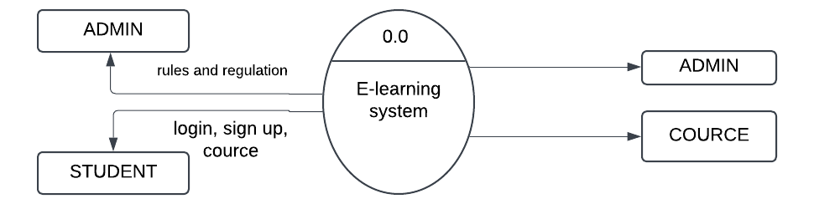

LEVEL 2 DIAGRAM

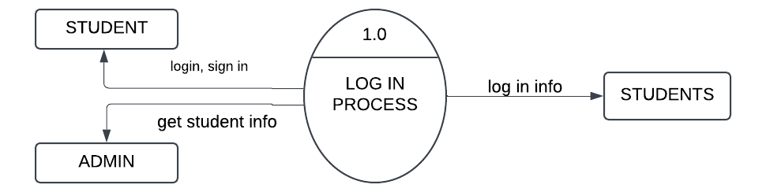

LEVEL 3 DIAGRAM

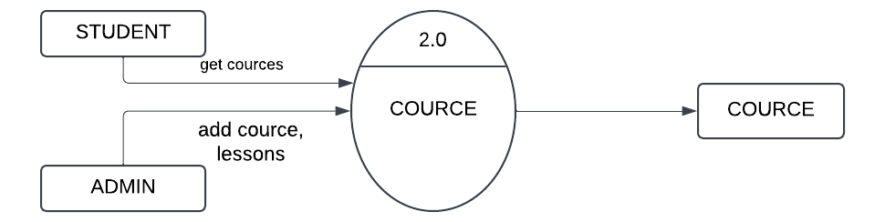

LEVEL 4 DIAGRAM:

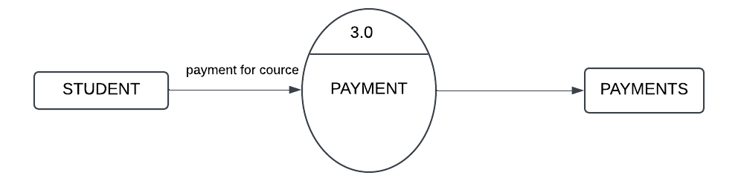

LEVEL 5 DIAGRAM:

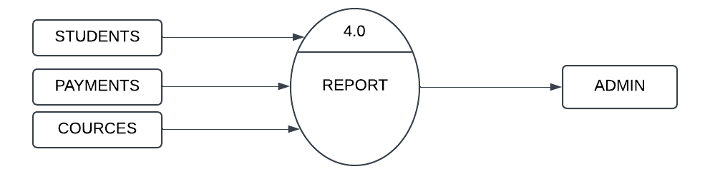

ER DIAGRAM :

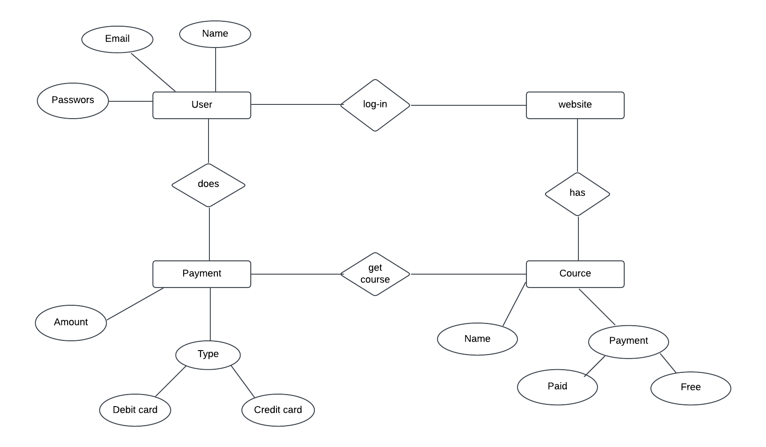

CLASS DIAGRAM:

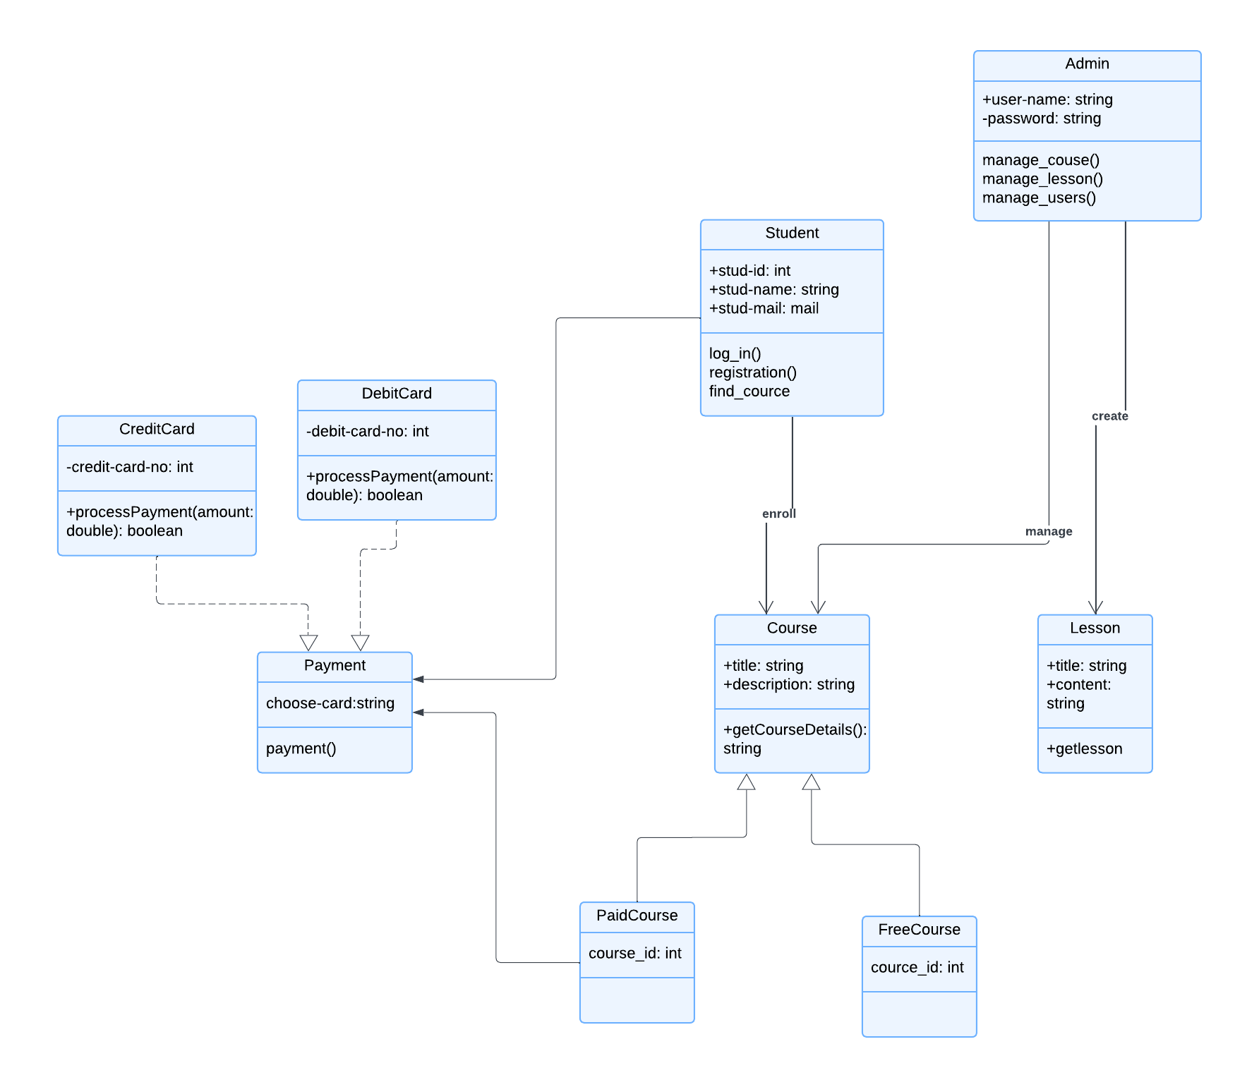

ACTIVITY DIAGRAM

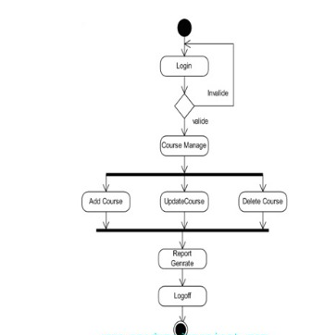

USE CASE DIAGRAM :

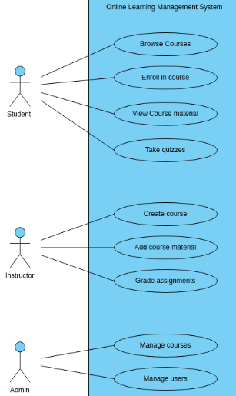

TABLE SPECIFICATION:

|  |  |  |  |  |
| --- | --- | --- | --- | --- |
| Table name | courses | | | |
| Primary key | Course_id | | | |
| Foreign key |  | | | |
| Table description | Details of courses | | | |
| Sr.no | Field name | Data type | Constraint | Description |
| 1 | Course_id | Number(3) | Auto increment | To store id |
| 2 | Title | String(20) | Not null | Store title |
| 3 | Description | String(20) | Not null | Store description |
| 4 | Price | Number(5) | Not null | Stores price |
| 5 | Created_at | date | - | Stores date |

|  |  |  |  |  |
| --- | --- | --- | --- | --- |
| Table name | lessons | | | |
| Primary key | lesson_id | | | |
| Foreign key | course_id | | | |
| Table description | Details of lessons | | | |
| Sr.no | Field name | Data type | Constraint | Description |
| 1 | lesson_id | Number(3) | Auto increment | To store id |
| 2 | course_id | String(20) | Not null | Stores cource id |
| 3 | lesson_title | Varchar(20) | Not null | Store title |
| 4 | video_url | Varchar(20) | Not null | Stores URL |
| 5 | notes | Varchar(20) | Not null | Stores notes |

|  |  |  |  |  |
| --- | --- | --- | --- | --- |
| Table name | students | | | |
| Primary key | id | | | |
| Foreign key |  | | | |
| Table description | Details of student | | | |
| Sr.no | Field name | Data type | Constraint | Description |
| 1 | id | Number(3) | Auto increment | To store id |
| 2 | name | String(20) | Not null | Stores name |
| 3 | email | Varchar(20) | Not null | Store email id |
| 4 | created_at | Date | Not null | Stores date |
| 5 | password | Varchar(20) | Not null | Stores password |

|  |  |  |  |  |
| --- | --- | --- | --- | --- |
| Table name | payments | | | |
| Primary key | id | | | |
| Foreign key |  | | | |
| Table description | Details of payments | | | |
| Sr.no | Field name | Data type | Constraint | Description |
| 1 | user_id | Number(3) | Auto increment | To store id |
| 2 | course_id | Number(3) | Not null | Stores id |
| 3 | status | Varchar(20) | Not null | Store status |
| 4 | card_number | Number(3) | Not null | Stores card no |
| 5 | payment_date | date | Not null | Stores date |
| 6 | expiry_date | date | Not null | Stores date |
| 7 | cvv | Number(3) | Not null | Stores cvv |
| 8 | cardholder_name | Varchar(20) | Not null | Stores name |

|  |  |  |  |  |
| --- | --- | --- | --- | --- |
| Table name | users | | | |
| Primary key | id | | | |
| Foreign key | - | | | |
| Table description | Details of user | | | |
| Sr.no | Field name | Data type | Constraint | Description |
| 1 | id | Number(3) | Auto increment | To store id |
| 2 | User_name | String(20) | Not null | Stores username |
| 3 | password | Varchar(20) | Not null | Store password |
| 4 | role | Varchar(20) | Not null | Stores role |

HOME PAGE :

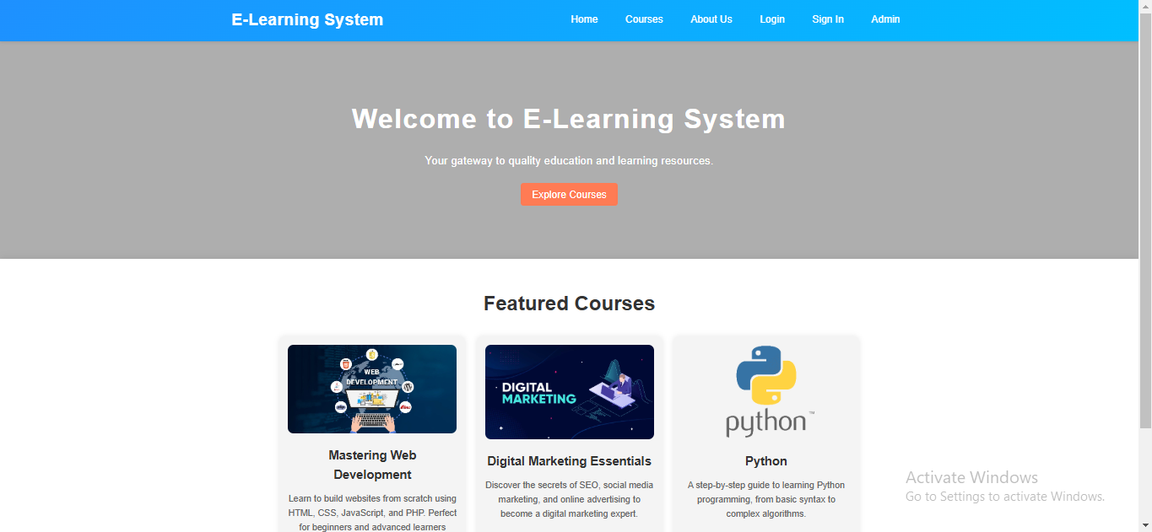

LOG IN (ADMIN)

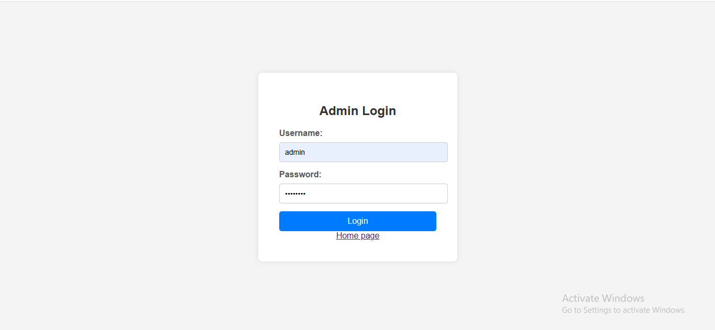

ADMIN DASHBOARD:

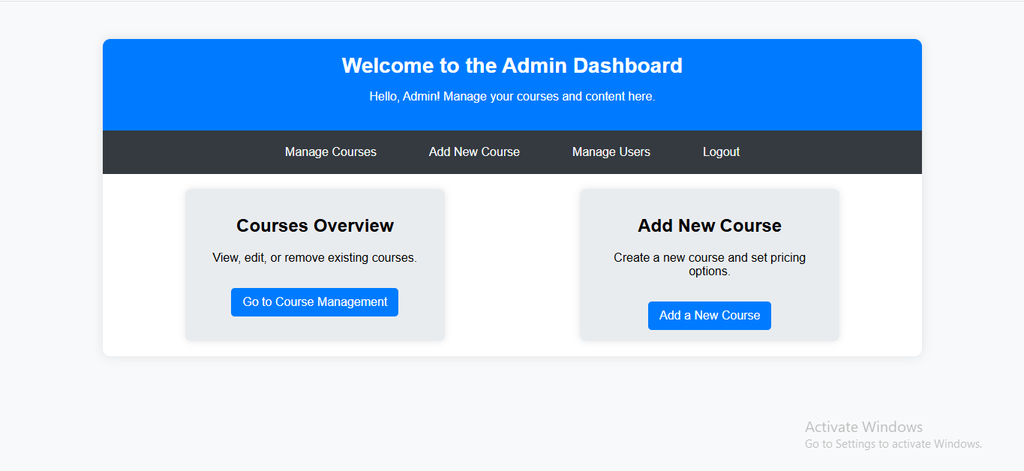

ADD COURSE PAGE:

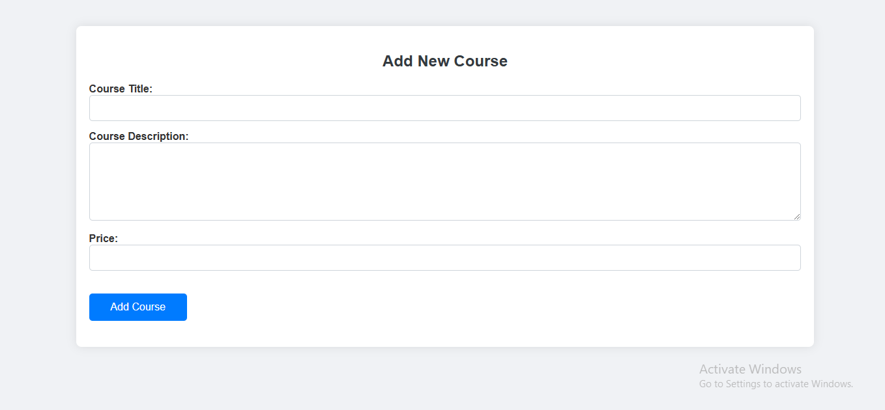

MANAGE COURSE

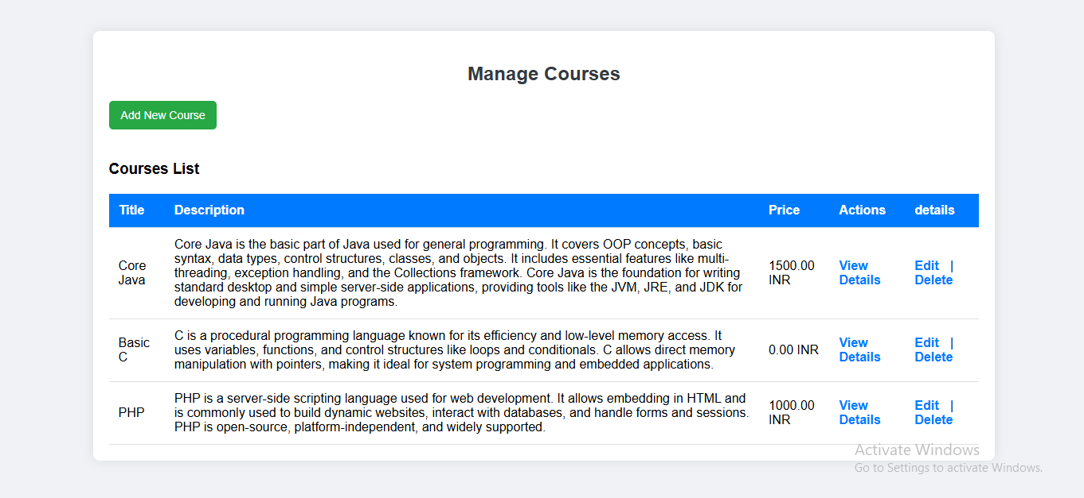

MANAGE USER

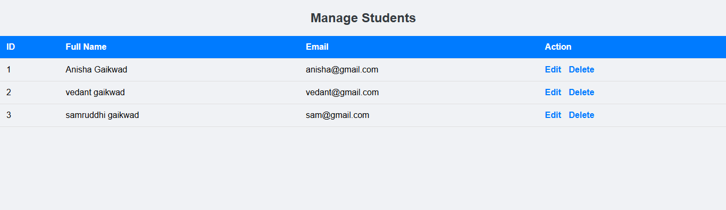

COUCE DETAILS:

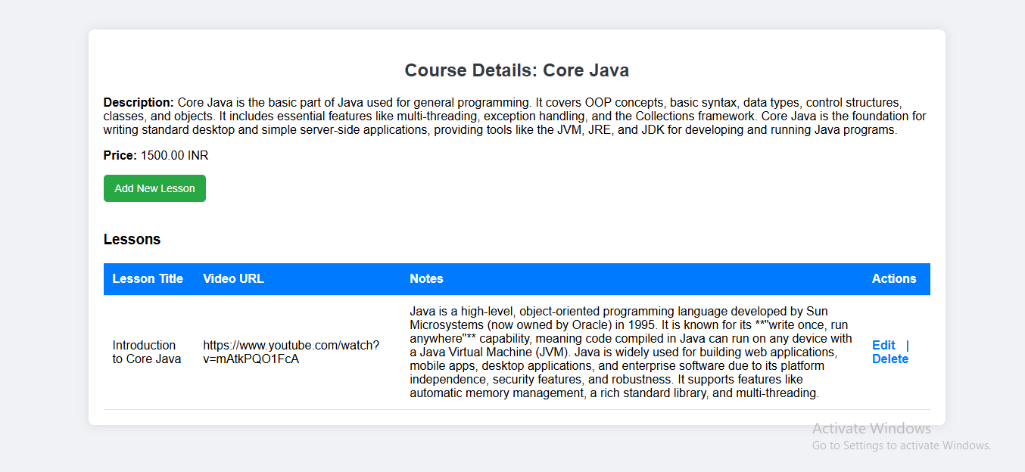

STUDENT LOG IN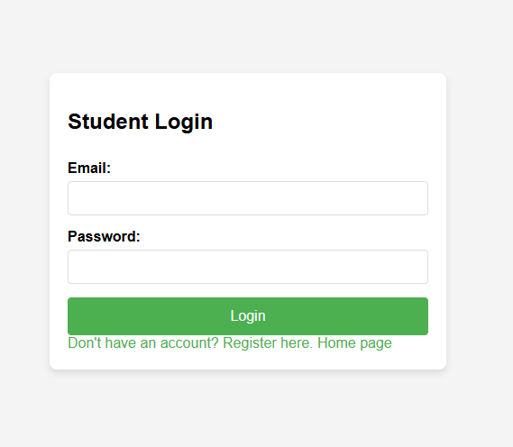

STUDENT DASHBOARD

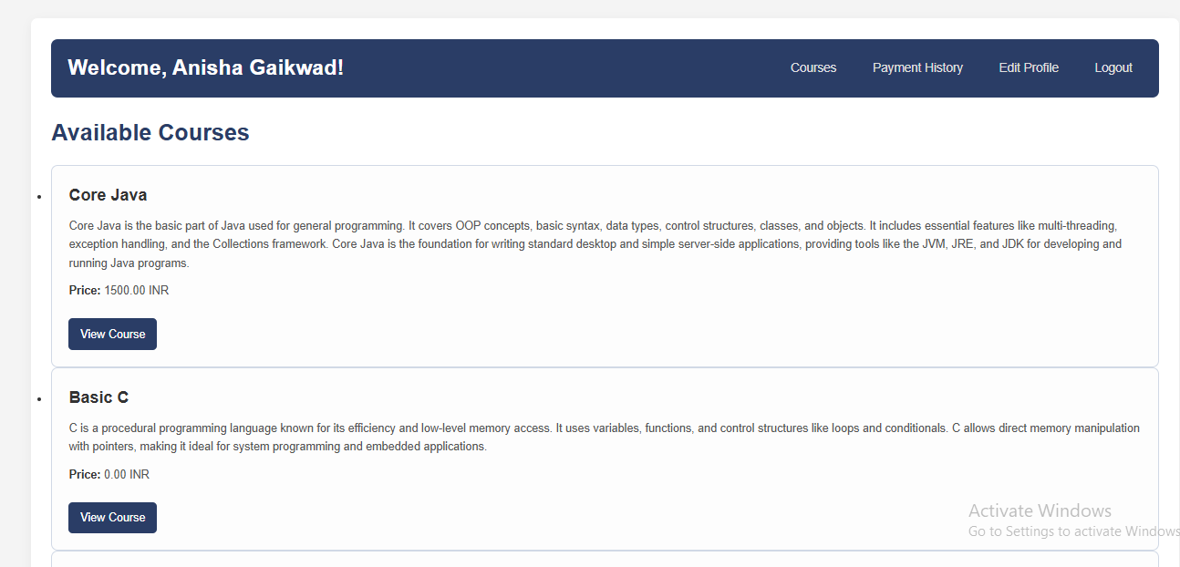

PYMENT HISTORY

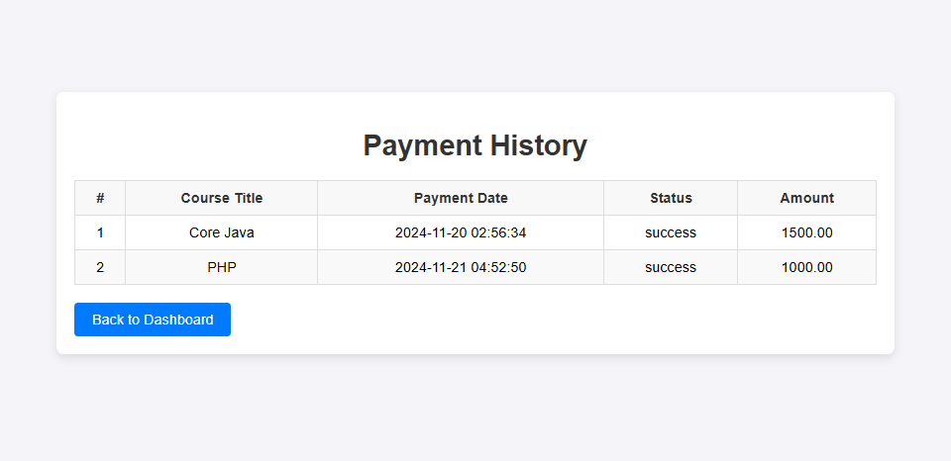

EDIT PROFILE:

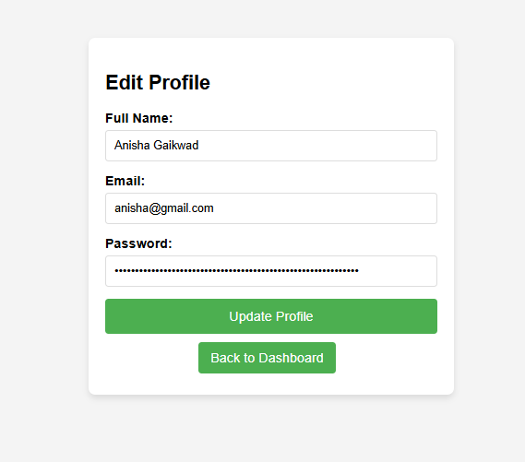

VIEW COURCE:

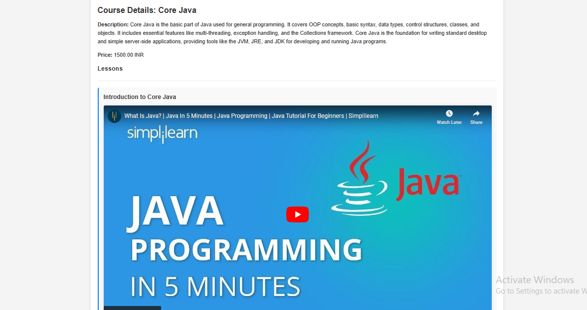

CODE:

<?php

session_start();

include '../includes/db-config.php';

if (isset($_POST['login'])) {

$username = $_POST['username'];

$password = $_POST['password'];

// Query to check if username exists

$query = "SELECT * FROM users WHERE username = '$username'";

$result = mysqli_query($conn, $query);

if ($result && mysqli_num_rows($result) == 1) {

$row = mysqli_fetch_assoc($result);

$hashedPassword = $row['password'];

// Verify the password

if (password_verify($password, $hashedPassword)) {

// Successful login, set session variable

$_SESSION['admin_logged_in'] = true;

$_SESSION['admin_username'] = $username;

// Redirect to admin dashboard

header("Location: admin-dashboard.php");

exit();

} else {

echo "Incorrect username or password!";

}

} else {

echo "Incorrect username or password!";

}

}

?>

<!DOCTYPE html>

<html lang="en">

<head>

<meta charset="UTF-8">

<meta name="viewport" content="width=device-width, initial-scale=1.0">

<title>Admin Login - E-Learning System</title>

<link rel="stylesheet" href="admin-styles.css">

</head>

<body>

<div class="login-container">

<h2>Admin Login</h2>

<?php if (isset($error)): ?>

<div class="error-message"><?php echo $error; ?></div>

<?php endif; ?>

<form action="admin-login.php" method="POST">

<label for="username">Username:</label>

<input type="text" id="username" name="username" required>

<label for="password">Password:</label>

<input type="password" id="password" name="password" required>

<button type="submit" name="login">Login</button>

</form>

<a href="../index.php">Home page</a>

</div>

</body>

</html>