DevOps Assignment

Docker

Anisha S

22BCS008

1. Download and Install Docker App.

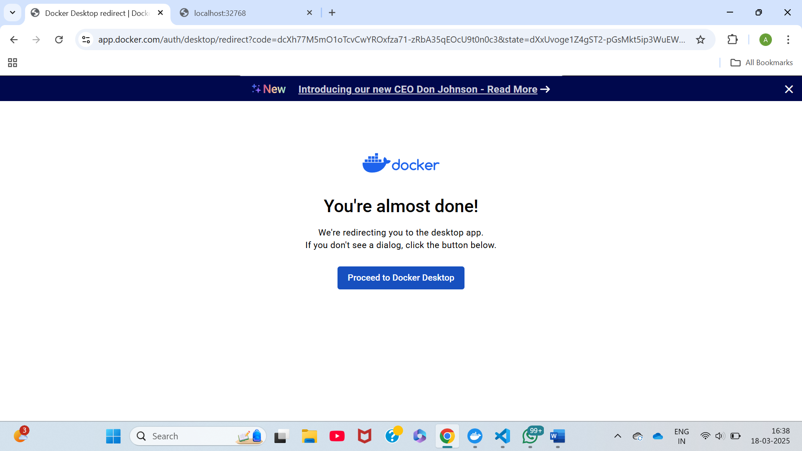

1. Create a Html File.

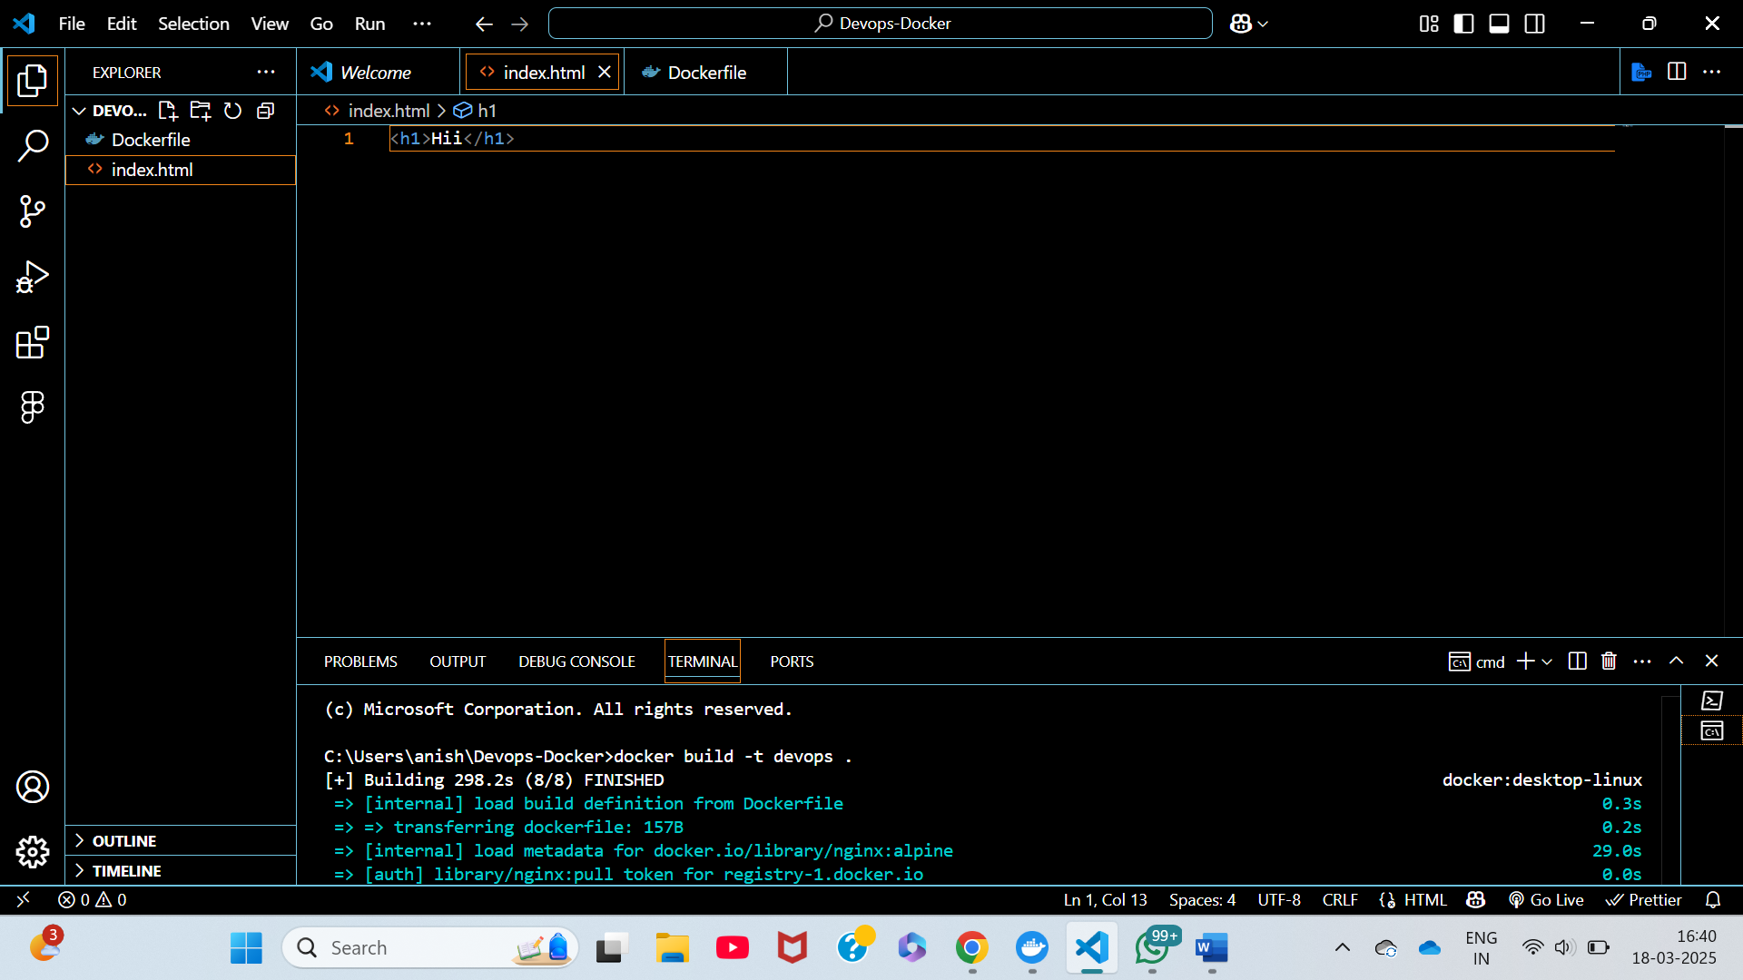

1. Create a docker File and have the following code:

FROM nginx:alpine

COPY index.html /usr/share/nginx/html/index.html

EXPOSE 80

CMD ["nginx", "-g", "daemon off;"]

1. Run the Following Command:

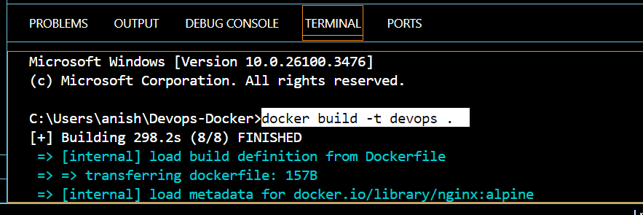

1. Open Docker App and navigate to Images

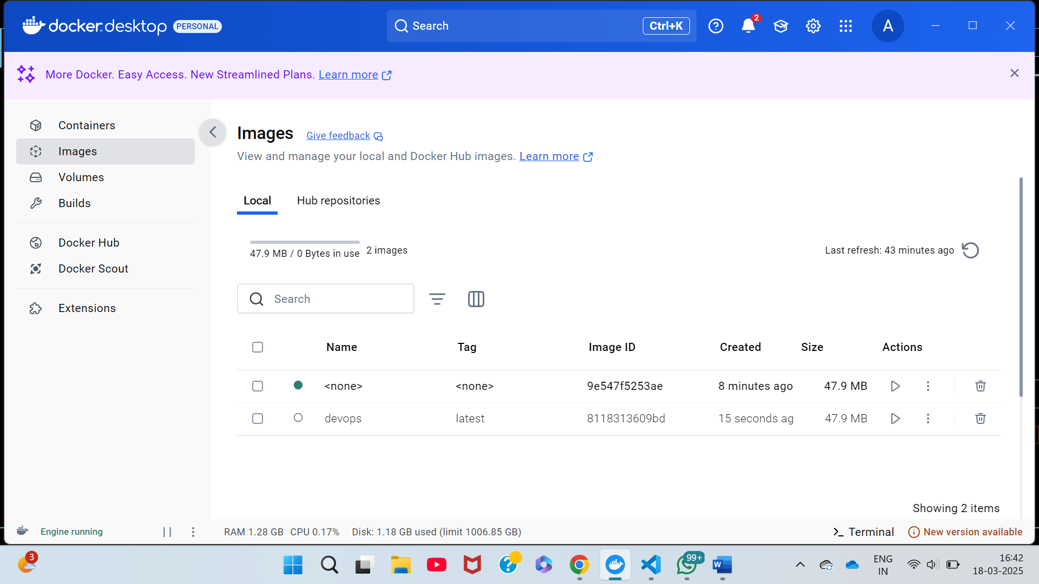

1. Click on run button and Choose the Optional Settings

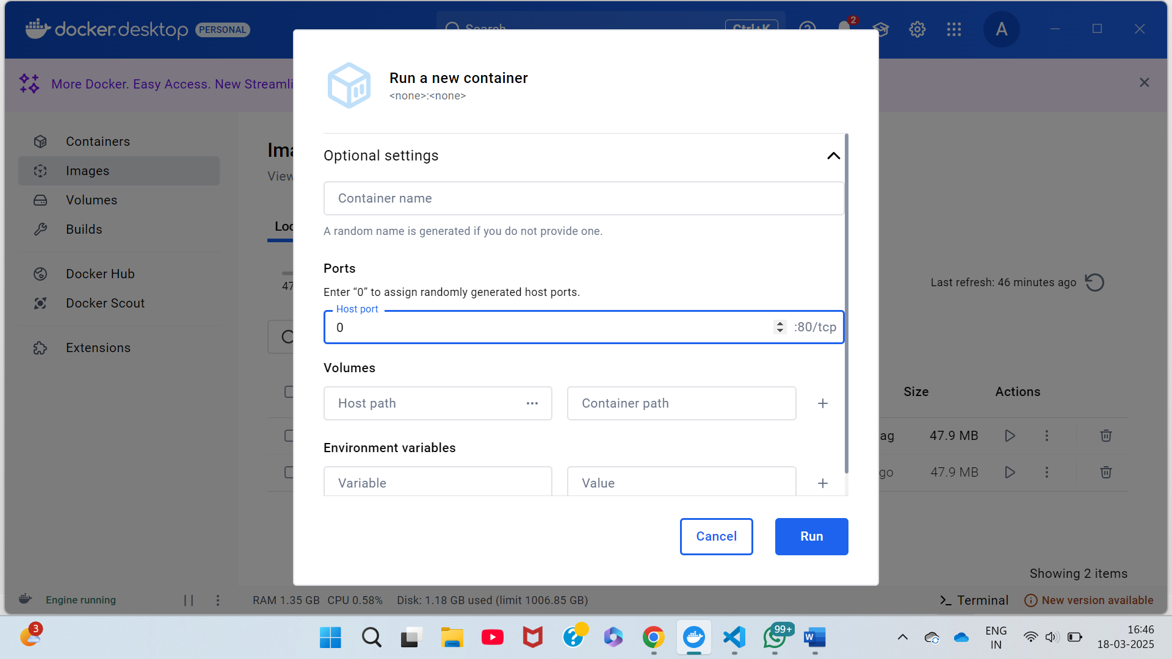

1. Run the IP Address



1. The content of the HTML file will be shown



