Principle of DevOps – Lab 2

Anisha S

22BCS008

**Experiment Steps:**

**Step 1: Cloning a Repository**

* Sign in to your GitHub account.
* Find a repository to clone (you can use a repository of your own or any public repository).

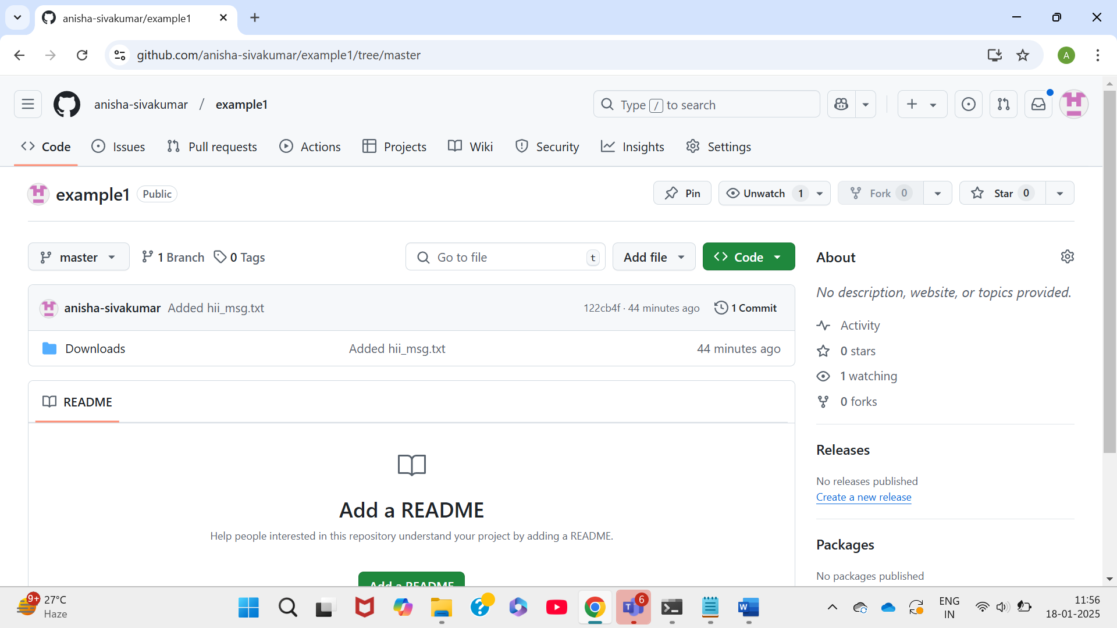

* Click the "Code" button and copy the repository URL.

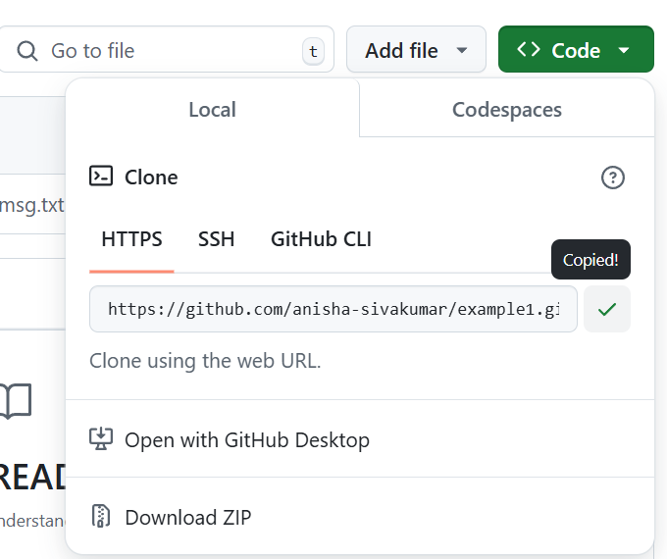

* Open your terminal or command prompt.
* Navigate to the directory where you want to clone the repository.

* Run the following command:

***git clone <repository_url>***

* Replace <repository_url> with the URL you copied from GitHub.
* This will clone the repository to your local machine.

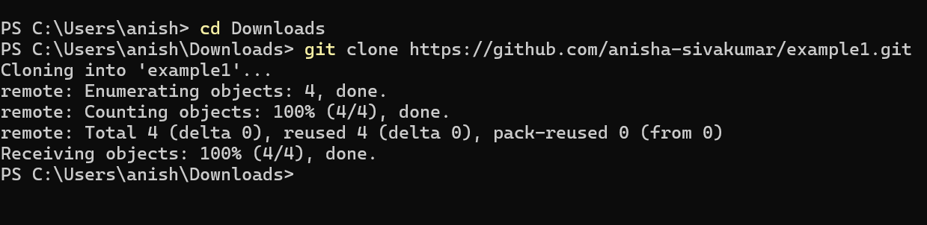

**Step 2: Making Changes and Creating a Branch**

Navigate into the cloned repository:

**cd <repository_name>**

* Create a new text file named "example.txt" using a text editor.
* Add some content to the "example.txt" file.

* Save the file and return to the command line.
* Check the status of the repository:

***git status***

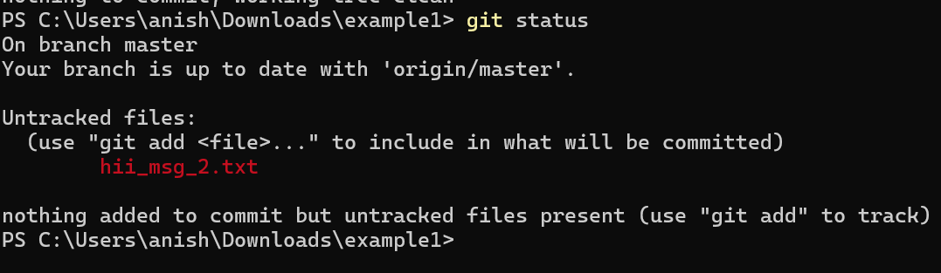

* Stage the changes for commit:

**git add example.txt**



* Commit the changes with a descriptive message:

***git commit -m "Add content to example.txt"***

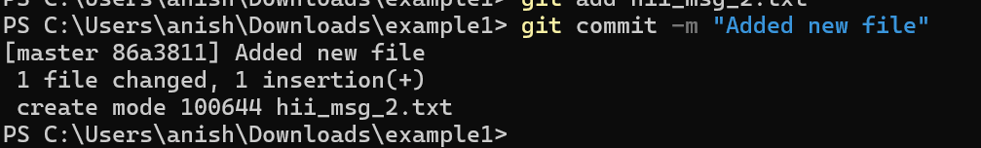

* Create a new branch named "feature":

***git branch feature***

* Switch to the "feature" branch:

***git checkout feature***

**Step 3: Pushing Changes to GitHub**

* Add Repository URL in a variable

***git remote add origin  <repository_url>***

* Replace <repository_url> with the URL you copied from GitHub.

* Push the "feature" branch to GitHub:

***git push origin feature***

* Check your GitHub repository to confirm that the new branch "feature" is available.

**Step 4: Collaborating through Pull Requests**

* Create a pull request on GitHub:
* Go to the repository on GitHub.
* Click on "Pull Requests" and then "New Pull Request."
* 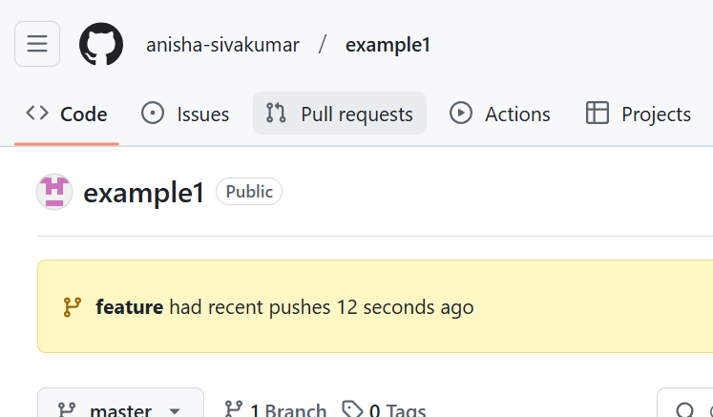

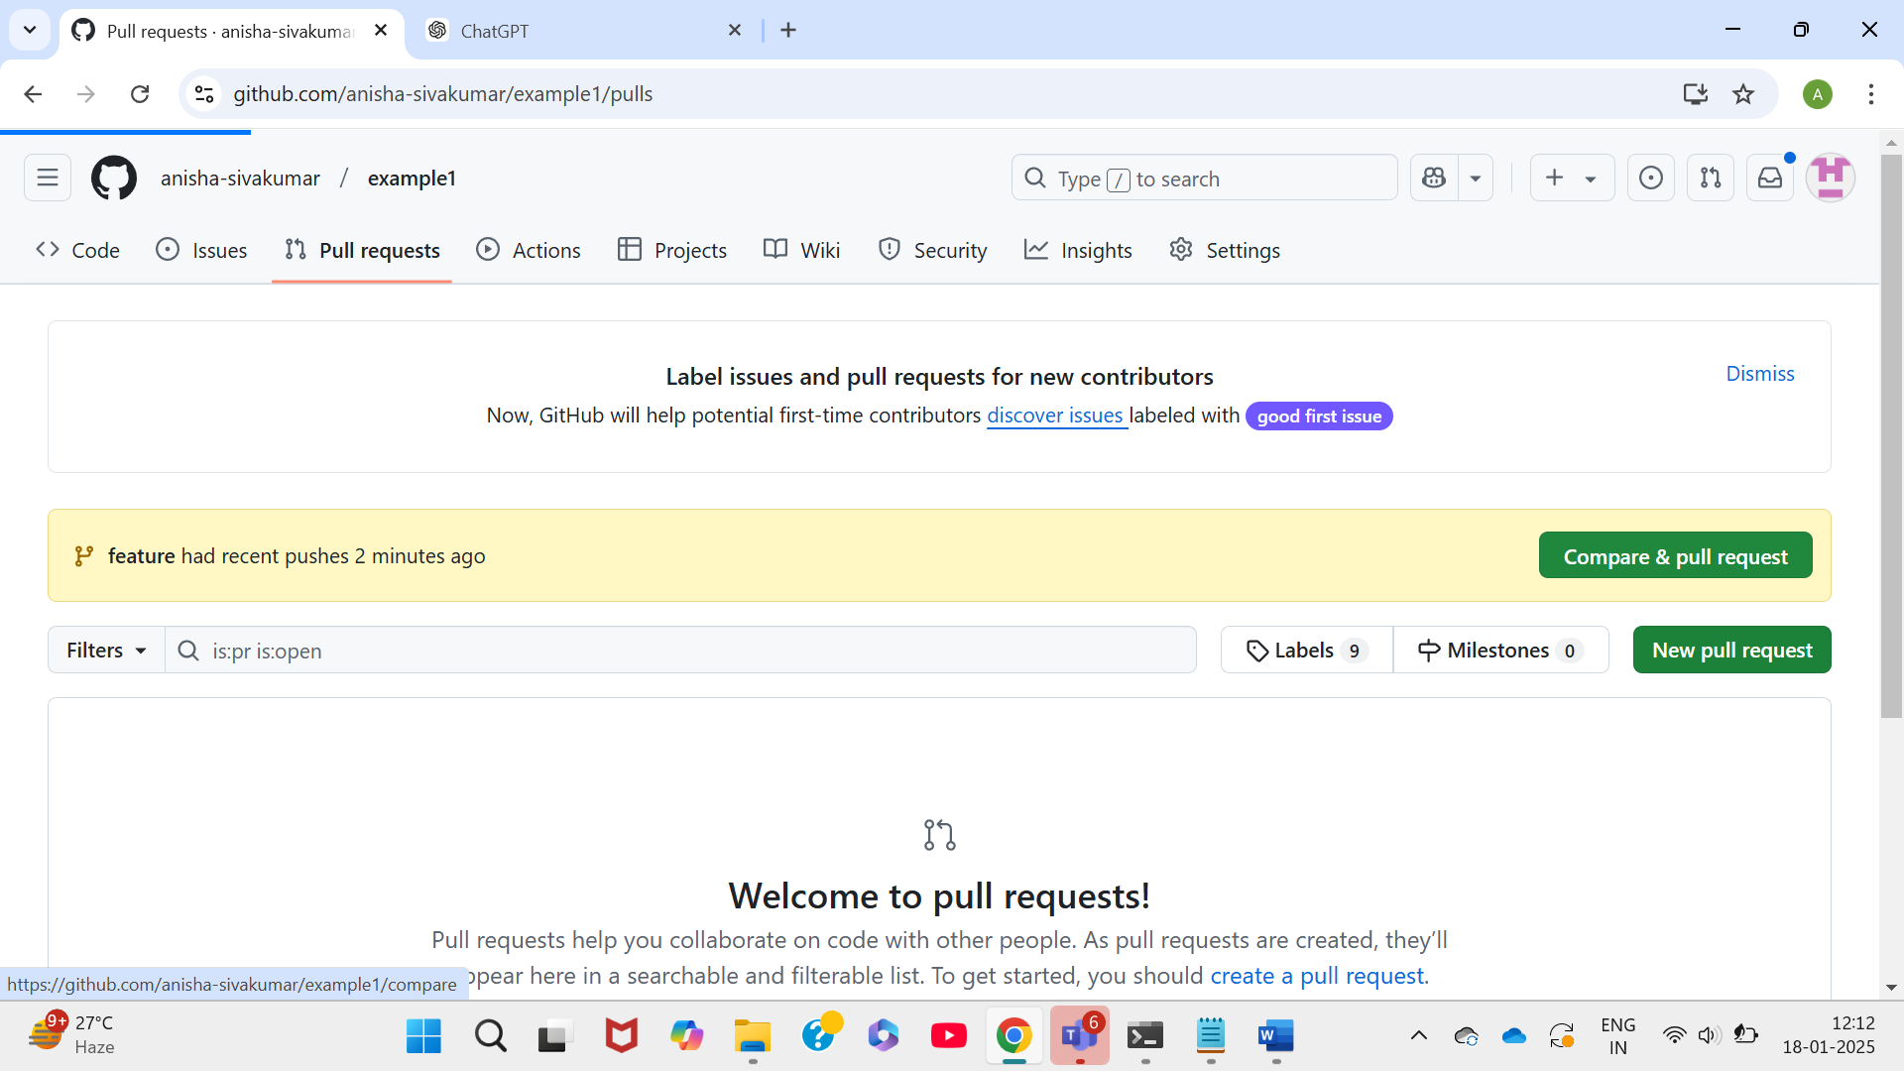

* Choose the base branch (usually "main" or "master") and the compare branch ("feature").

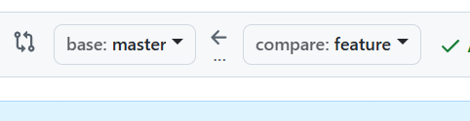

* Review the changes and click "Create Pull Request."

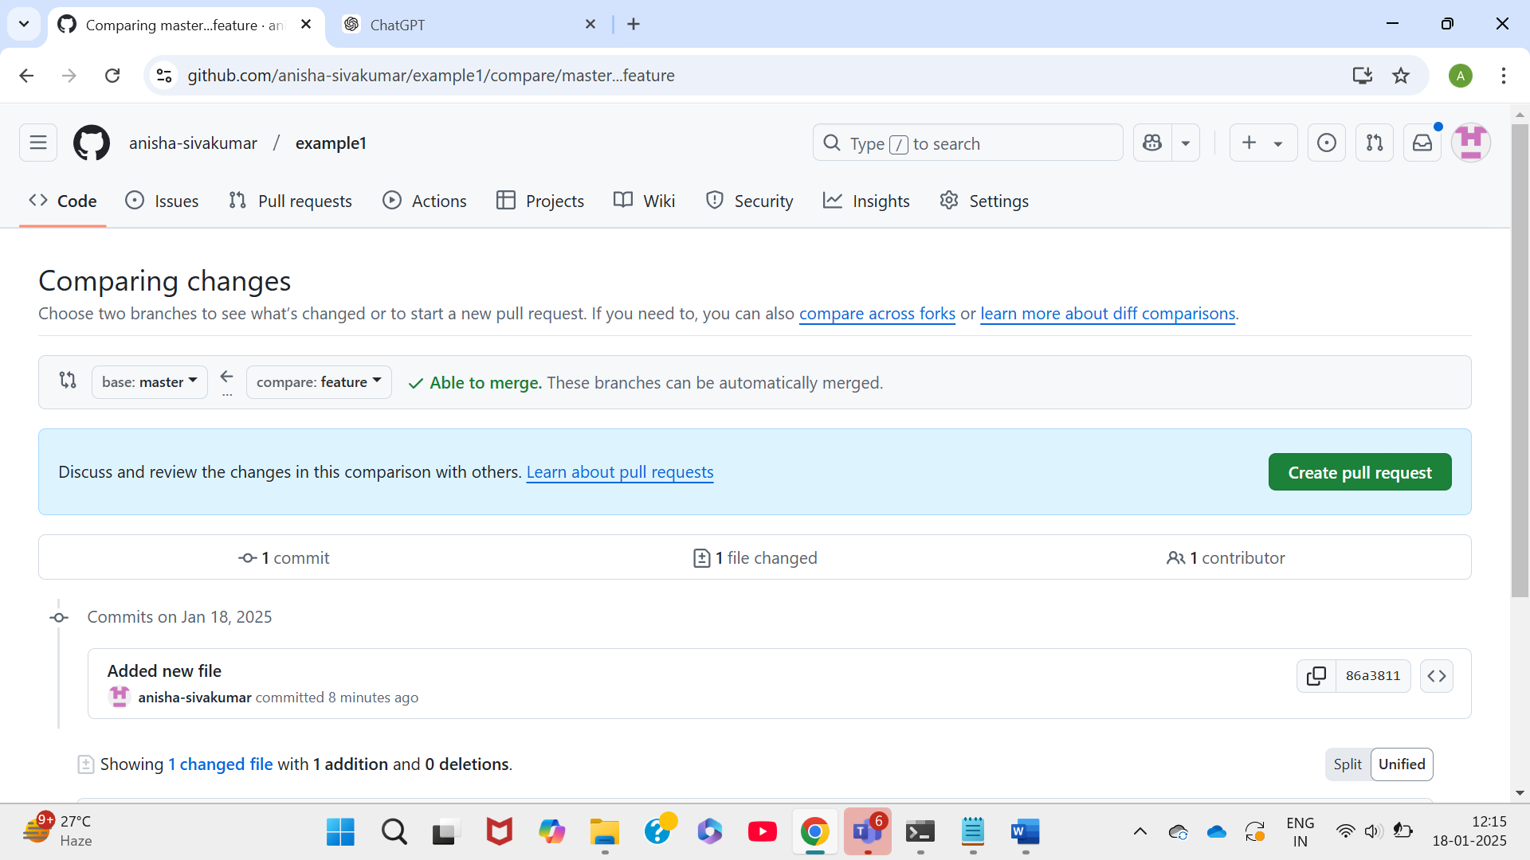

* Review and merge the pull request:
* Add a title and description for the pull request.

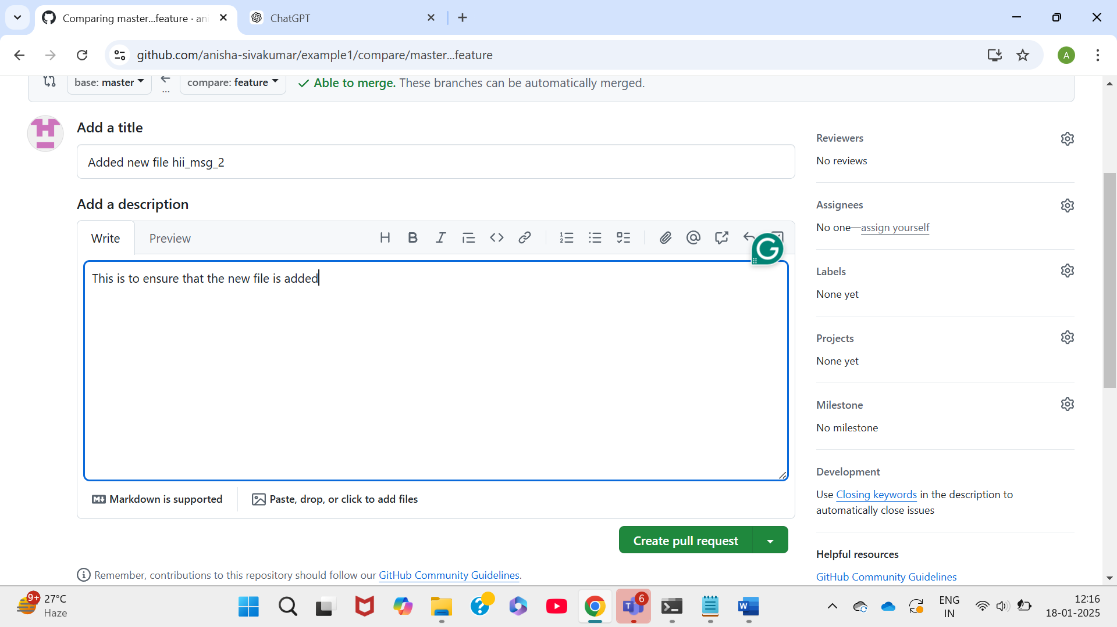

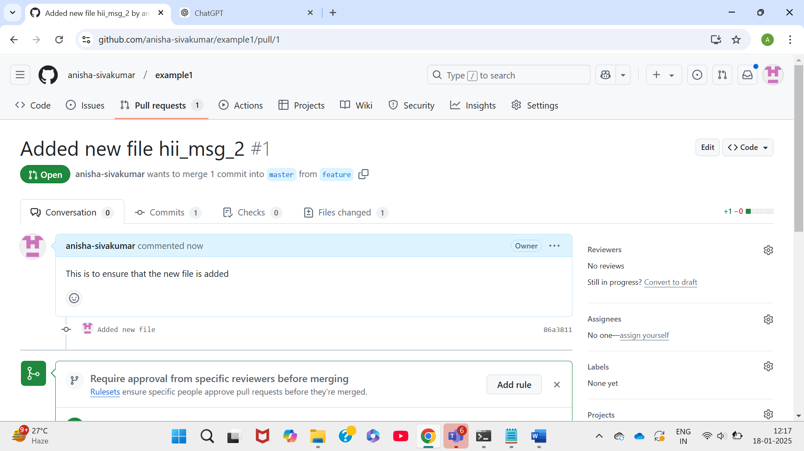

* Assign reviewers if needed.
* Once the pull request is approved, merge it into the base branch.

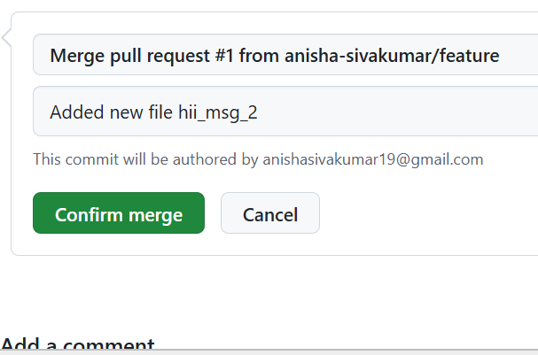

**Step 5: Syncing Changes**

* After the pull request is merged, update your local repository:

***git checkout main***

***git pull origin main***

