**Issues faced while testing**

No work order is displayed to create a PO as mentioned in the note.

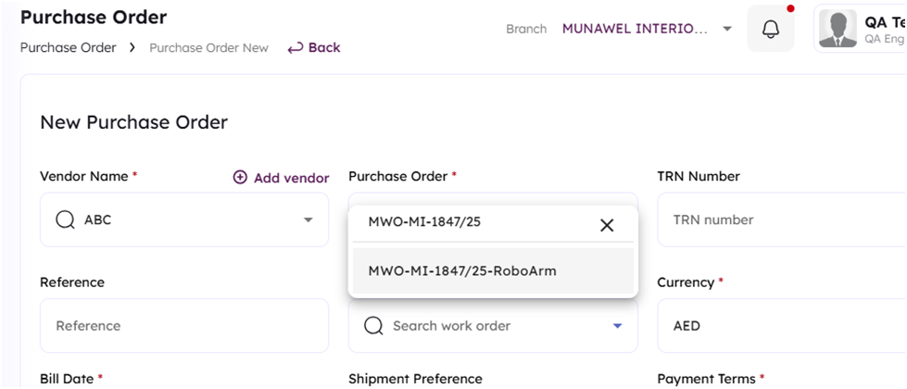

And while generating a new invoice, an invoice number is provided in the task note. However, when I enter that as the vendor invoice number, it shows that it already exists, even after deleting the existing invoice with the same number.

