**Suggestions for Improvement**

* The Vendor **Invoice table headers are not fully visible**, making it difficult to read the column names. Users need to zoom out to see them properly. Consider **enabling horizontal scrolling** or adjusting the column width for better visibility.

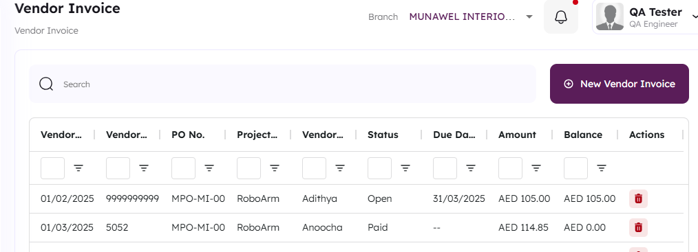

* The munawel **site logs out too quickly**, disrupting user workflow and causing inconvenience. **Consider extending the session timeout** or providing a warning before auto-logout to improve user experience.

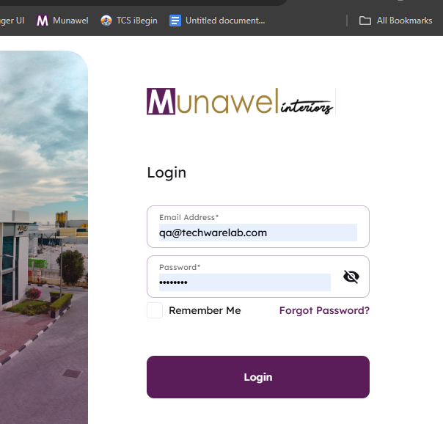

* Error message format – Remove **"ApolloError"** to keep it clean and user-friendly.
* Exposing **"ApolloError"** to users is unnecessary and should be replaced with a clearer, more user-friendly message.

