**Church management system**

**1.Context level DFD for church management system**

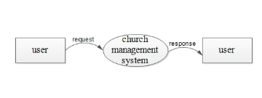

**2.first level DFD for church management system admin**

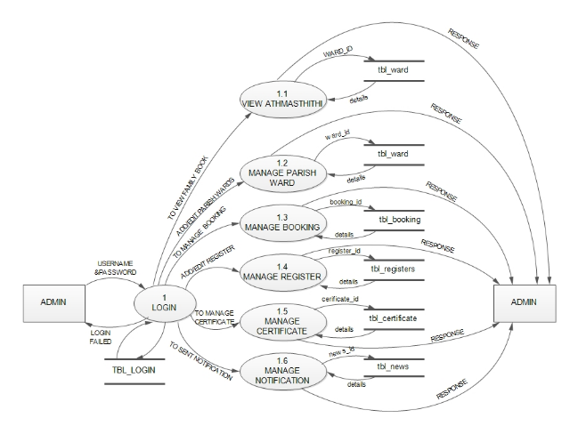

**3.first level DFD for church management system:user**

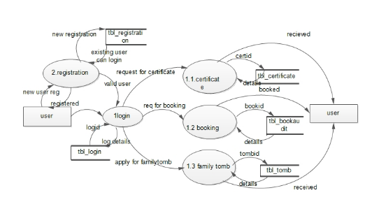

**4.second level DFD for church management system:user**

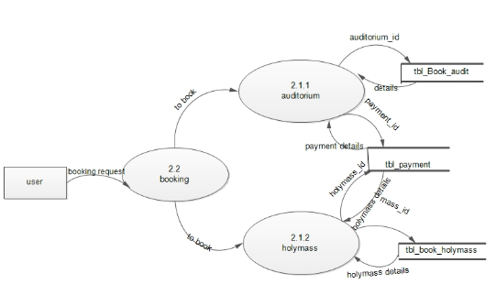

**5. second level DFD for church management system:user**

