Computer and Network System
IP-Wireshark




Submitted by:
Full Name: Anish Adhikari
Orbund ID: 11147
Student ID: 24071101
Kathmandu, Nepal

Questions

- Select the first UDP segment sent by your computer via the traceroute command to gaia.cs.umass.edu. (Hint: this is 44th packet in the trace file in the ip-wireshark- trace1-1.pcapng file in footnote 2). Expand the Internet Protocol part of the packet in the packet details window. What is the IP address of your computer? [Marks: 5]
Answer:
In the first UDP segment sent by my computer (packet 44), the Source Address shown in the Internet Protocol section is 192.168.86.61, which corresponds to my computer. The Destination Address (128.119.245.12) is the IP address of gaia.cs.umass.edu.

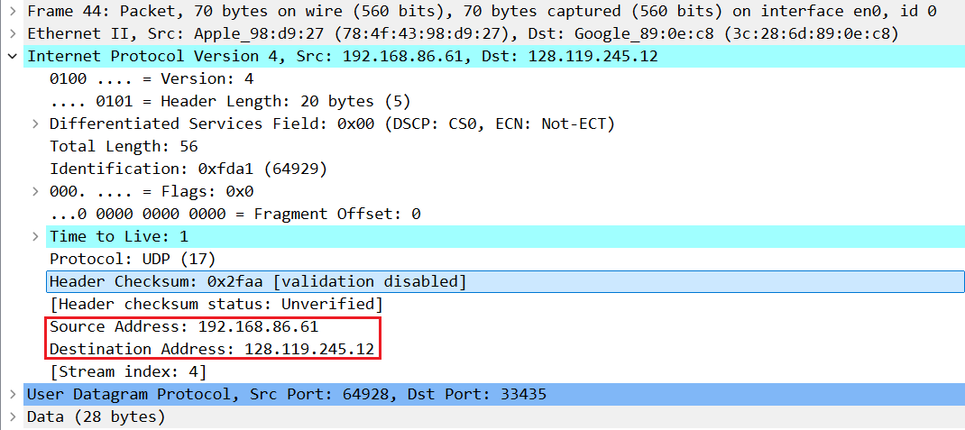
Fig: Ip addresses

- What is the value in the time-to-live (TTL) field in this IPv4 datagram’s header? [Marks: 5]
Answer:
In packet 44, under the Internet Protocol Version 4 header, the Time to Live field clearly shows a value of 1, indicating that the packet is allowed to pass through only one router before being discarded.

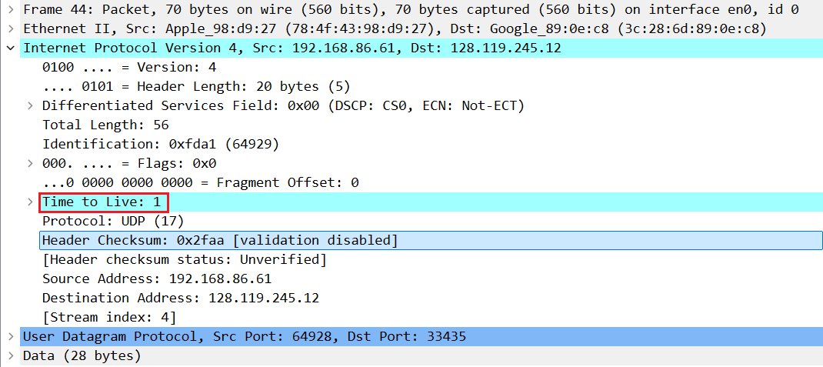
Fig: Time to Live

- What is the value in the upper layer protocol field in this IPv4 datagram’s header? ( hint: you should look at protocol field in IP4 datagram ) [Marks: 5]
Answer:
In the IPv4 header, the Protocol field indicates which upper-layer protocol is used. For this packet, the Protocol field shows UDP, which has a numeric value of 17.

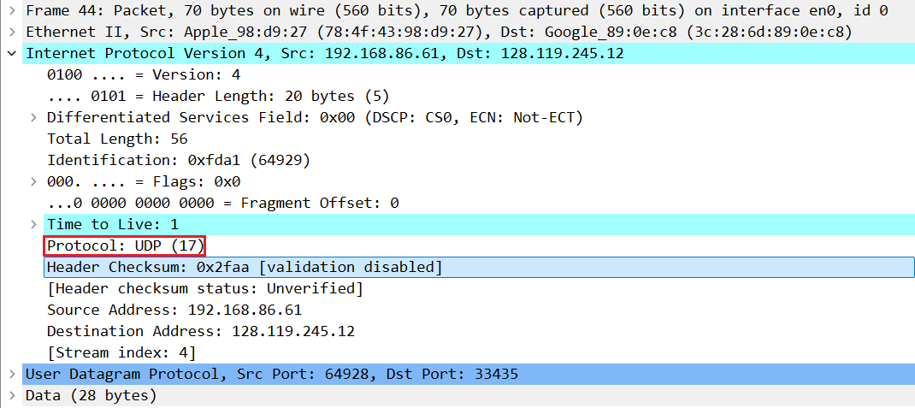
Fig: Protocol Field

- How many bytes are in the IP header? [Marks: 5]
Answer:
In the IPv4 header, the Header Length field is shown as 20 bytes (5).

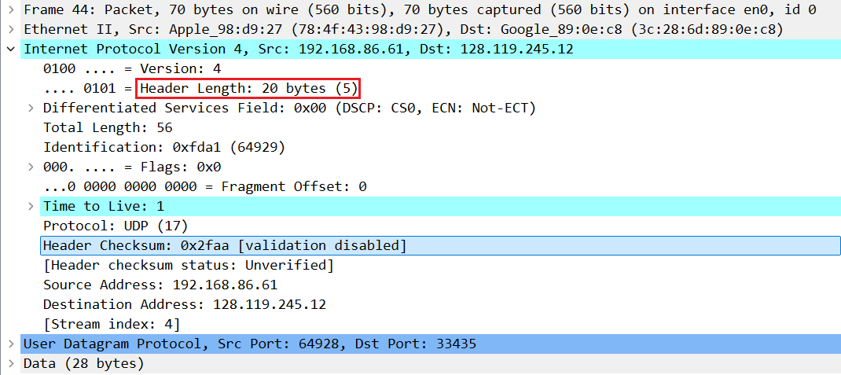
Fig: Header Length

- How many bytes are in the payload of the IP datagram? Explain how you determined the number of payload bytes. [Marks: 5]
Answer:
From the IPv4 header, the Total Length of the IP datagram is 56 bytes, and the IP Header Length is 20 bytes.
So, the payload size is calculated as:
IP payload = Total Length − IP Header Length
= 56 − 20
= 36 bytes
So, the IP payload is 36 bytes.

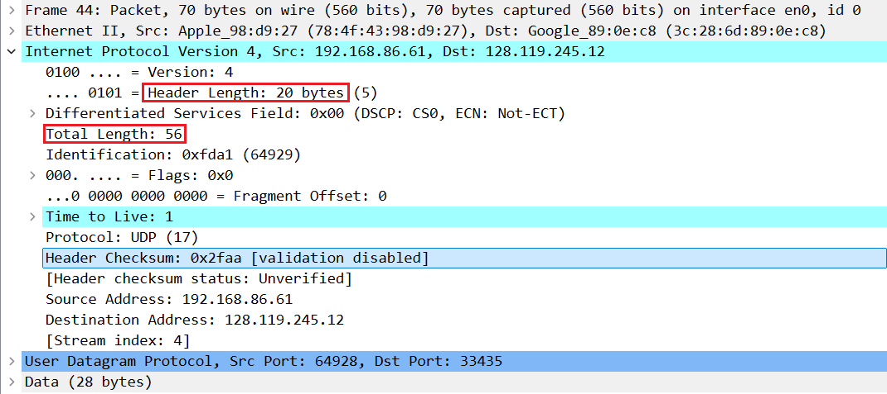
Fig: IP Payload

- Has this IP datagram been fragmented? Explain how you determined whether or not the datagram has been fragmented. [Marks: 5]
Answer:
No, this IP datagram has not been fragmented. The Flags field is 0x0 and the Fragment Offset is 0. If fragmentation had happened, the fragment offset would be non-zero or the More Fragments flag would be set. Since neither is present, the packet was not fragmented.

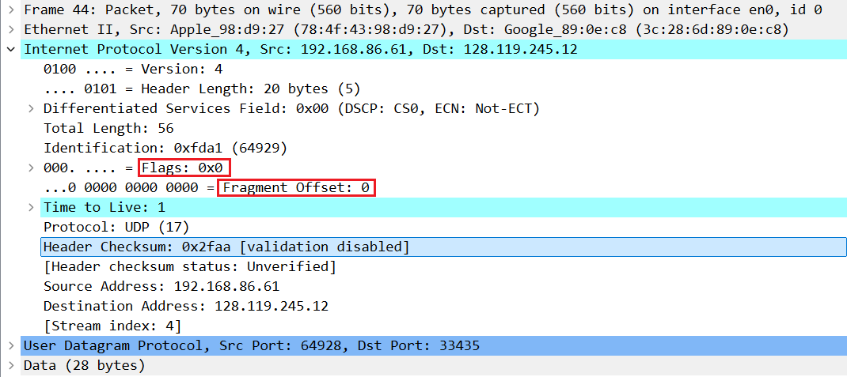
Fig: Fragment Offset

- Which fields in the IP datagram always change from one datagram to the next within this series of UDP segments sent by your computer destined to 128.119.245.12, via traceroute? Why? [Marks: 5]

Answer:

The IP fields that change in the traceroute UDP datagrams are the TTL and the Identification field. TTL changes because traceroute sends probes with TTL = 1, 2, 3, … to discover each hop. Identification changes because each probe is a new IP datagram and is given a different IP ID.

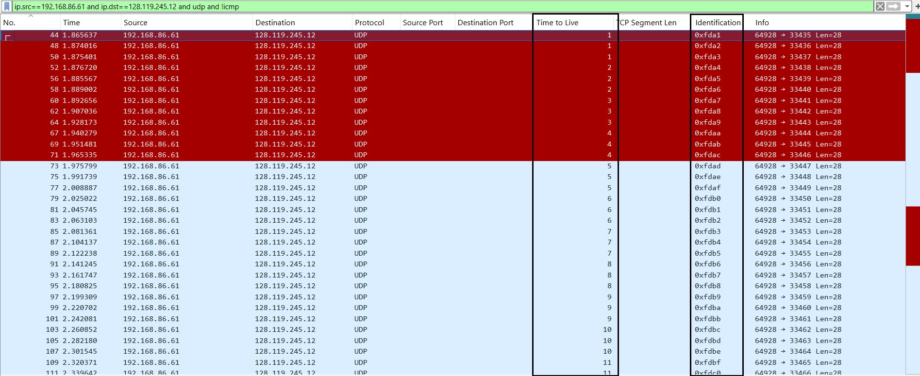
Fig: Changing IP Datagrams

- Which fields in this sequence of IP datagrams (containing UDP segments) ﻿﻿﻿﻿﻿﻿﻿﻿﻿﻿﻿stay constant? Why? [Marks: 5]

Answer:

The IP datagram fields that stay constant are the Source IP address, Destination IP
address, IP version, Header Length, Protocol field, and Total Length. The Source IP address remains the same because all UDP packets are sent from the same computer. The Destination IP address (128.119.245.12) stays the same since all packets are sent to the same host. The IP version and Header Length do not change because all packets use IPv4 with no IP options. The Protocol field stays constant because all packets carry UDP segments. The Total Length remains the same because each UDP packet is the same size.

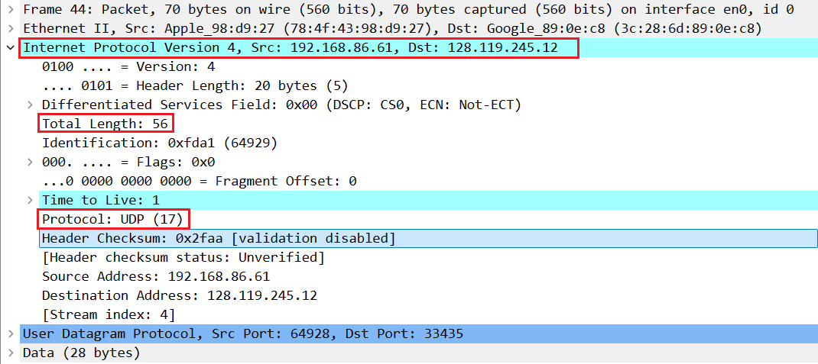
Fig: Constant IP Datagrams

- Describe the pattern you see in the values in the Identification field of the IP datagrams being sent by your computer. [Marks: 5]

Answer:

The Identification field values of the IP datagrams sent by my computer show a
sequentially increasing pattern.

Each IP datagram is assigned a unique Identification value by the operating system.
For the traceroute UDP packets, this value increases by one for each successive
datagram. This allows each IP packet to be uniquely identified, especially if
fragmentation was to occur.

Packet 44 → 0xfda1(64929)
Packet 48 → 0xfda2(64930)
Packet 50 → 0xfda3(64931)
Packet 52 → 0xfda4(64932)
Packet 56 → 0xfda5(64933)
Packet 58 → 0xfda6(64934)
Packet 60 → 0xfda7(64935)

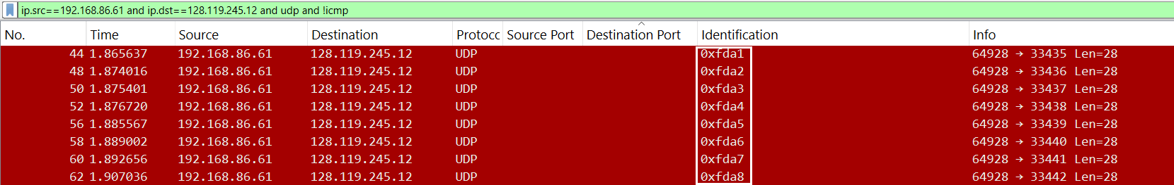Fig: Identification Field

- What is the upper layer protocol specified in the IP datagrams returned from the
routers? [Marks: 5]

Answer:

The upper-layer protocol specified in the IP datagrams returned from the routers is
ICMP (Protocol number = 1).

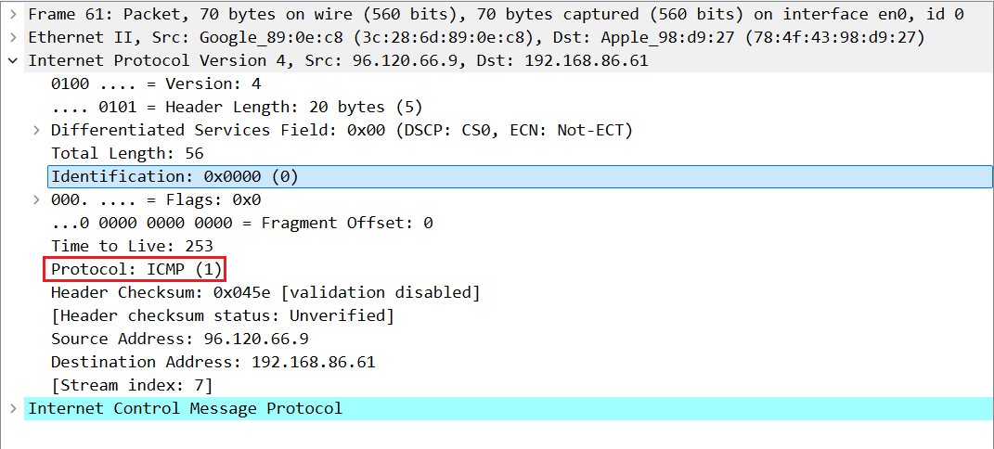
Fig: Protocol

- Are the values in the Identification fields (across the sequence of all of ICMP packets from all of the routers) similar in behavior to your answer to question 9 above? [Marks: 5]

Answer:

No, the Identification field values are not the same as in Question 9. In Question 9, the packets came from one device, so the Identification values increased in order. Here, the ICMP packets come from different routers, and each router uses its own Identification values, so the numbers do not follow one single sequence.

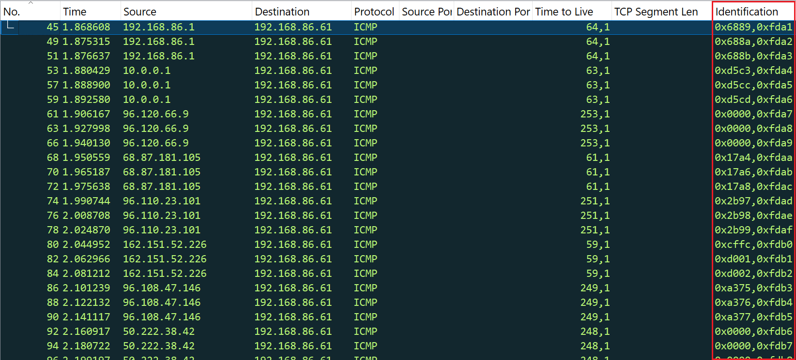
Fig: Identification Field

- Are the values of the TTL fields similar, across all of ICMP packets from all of the routers? [Marks: 5]

Answer:

No, the TTL values are not all the same. Each router generates the ICMP packet with its own default TTL value. Since different routers use different default TTL settings, the TTL values across all ICMP packets are different.
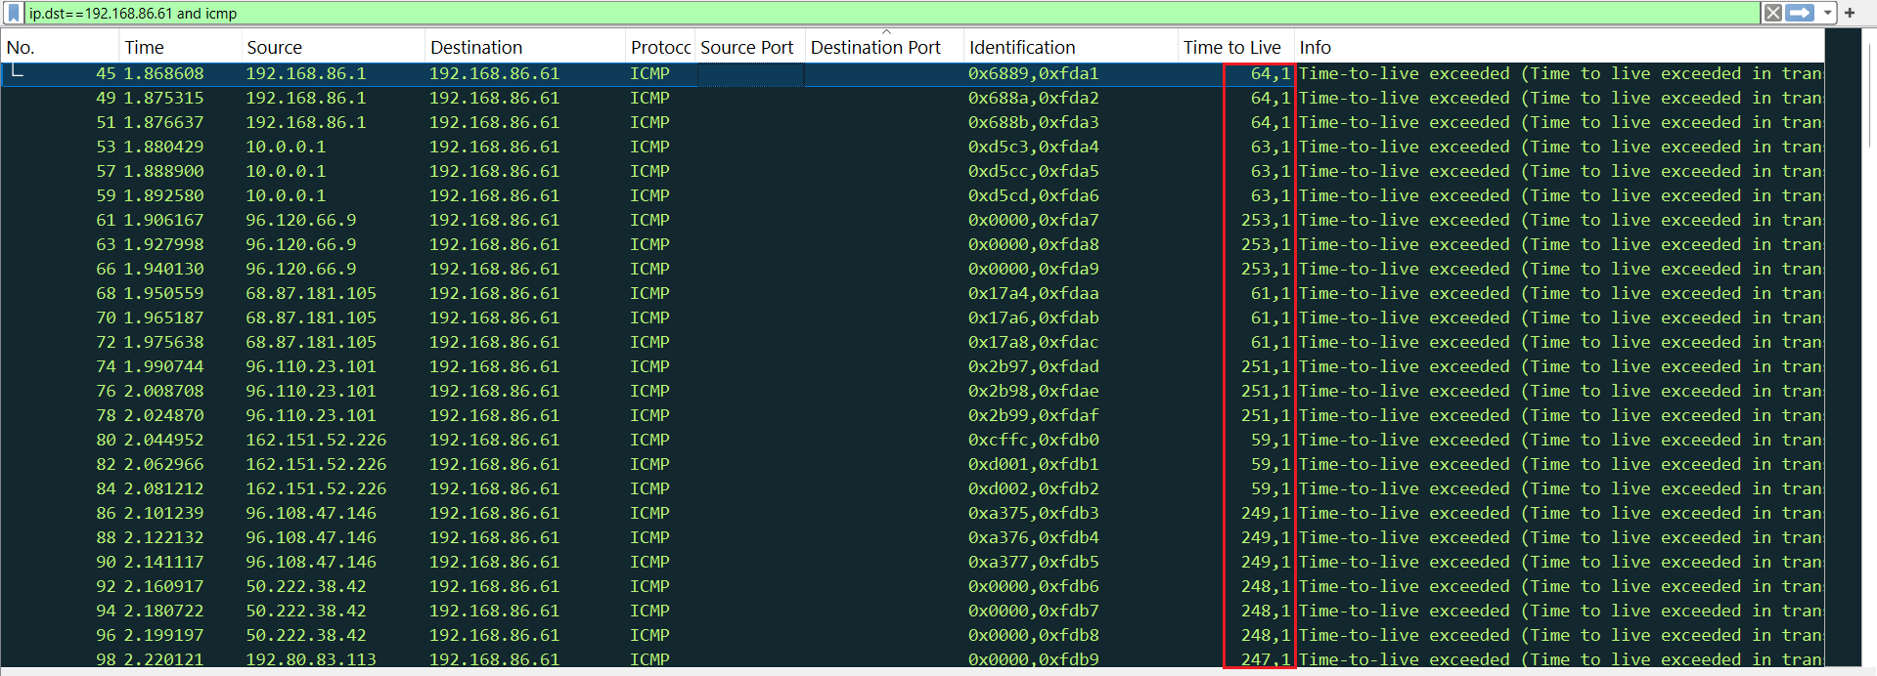
Fig: TTL value of different ICMP packets

- What is the IPv6 address of the computer making the DNS AAAA request? This is the source address of the 20th packet in the trace. Give the IPv6 source address for this datagram in the exact same form as displayed in the Wireshark window . [Marks: 6]

Answer:

The IPv6 address of the computer making the DNS AAAA request (the source address of the 20th packet) is 2601:193:8302:4620:215c:f5ae:8b40:a27a.

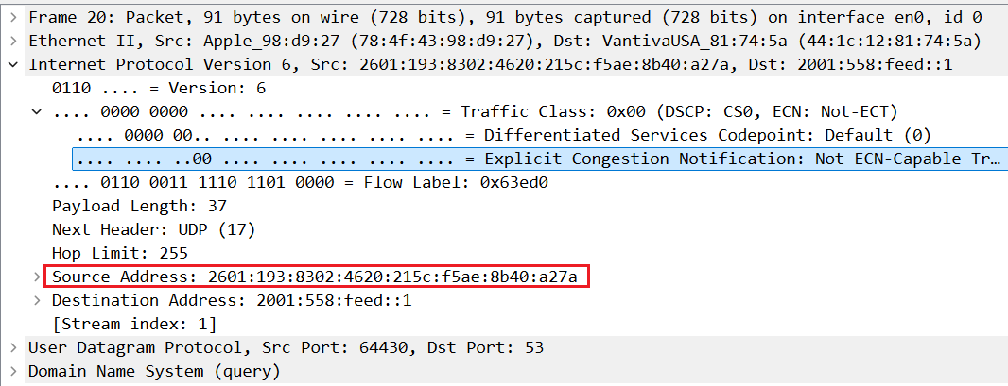Fig: Source IPV6 Address
- What is the IPv6 destination address for this datagram? Give this IPv6 address in the exact same form as displayed in the Wireshark window. [Marks: 6]

Answer:

The IPv6 destination address for this datagram is 2001:558:feed::1.
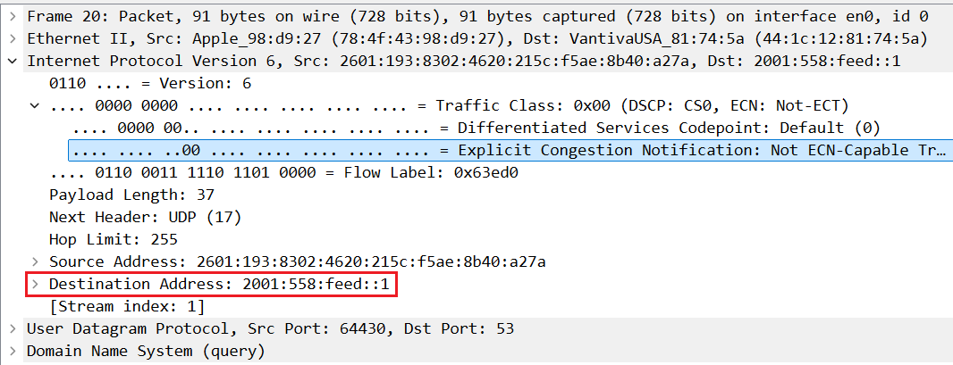Fig: Destination Address

- What is the value of the flow label for this datagram? [Marks: 6]

Answer:

The value of Flow Label for the datagram is 0x63ed0.

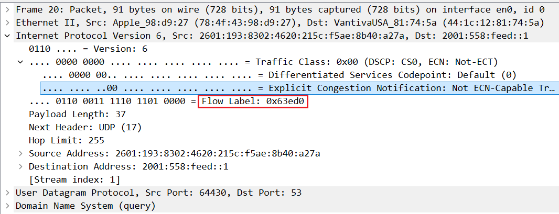
Fig: Flow Label

- How much payload data is carried in this datagram? [Marks: 6]

Answer:

The amount of payload data carried in this datagram is 37 bytes.

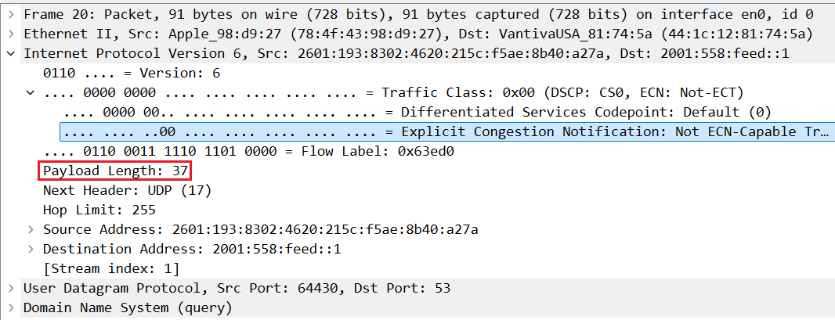
Fig: Payload Length

- What is the upper layer protocol to which this datagram’s payload will be delivered at the destination? [Marks: 6]

Answer:

The payload of this datagram is passed to the UDP protocol at the destination, as indicated by the Next Header value of 17.

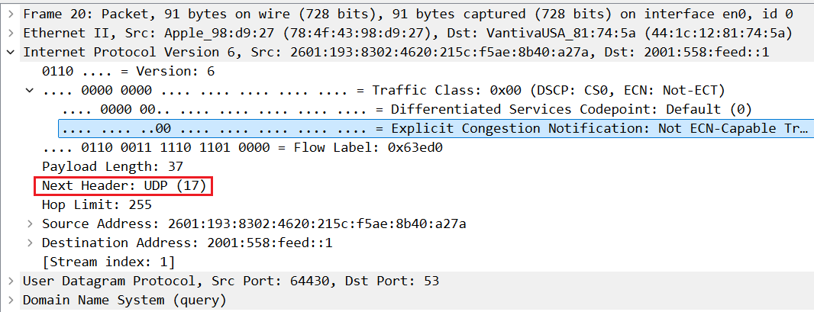
Fig: Next Header value

- How many IPv6 addresses are returned in the response to this AAAA request? [Marks: 5]

Answer:

The DNS AAAA response returns 1 IPv6 address. The DNS response shows Answer RRs: 1, indicating that a single AAAA record (IPv6 address) was returned for youtube.com.

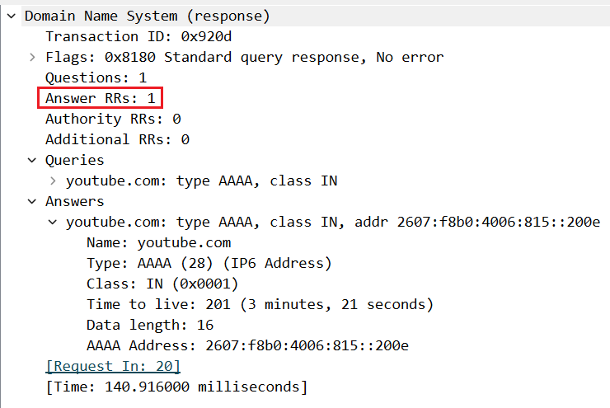Fig: Returned IPV6 addresses

- What is the first of the IPv6 addresses returned by the DNS for youtube.com (in the ip-wireshark-trace2-1.pcapng trace file, this is also the address that is numerically the smallest)? Give this IPv6 address in the exact same shorthand form as displayed in the Wireshark window. [Marks: 5]

Answer:

The first (and numerically smallest) IPv6 address returned by the DNS for youtube.com is 2607:f8b0:4006:815::200e.
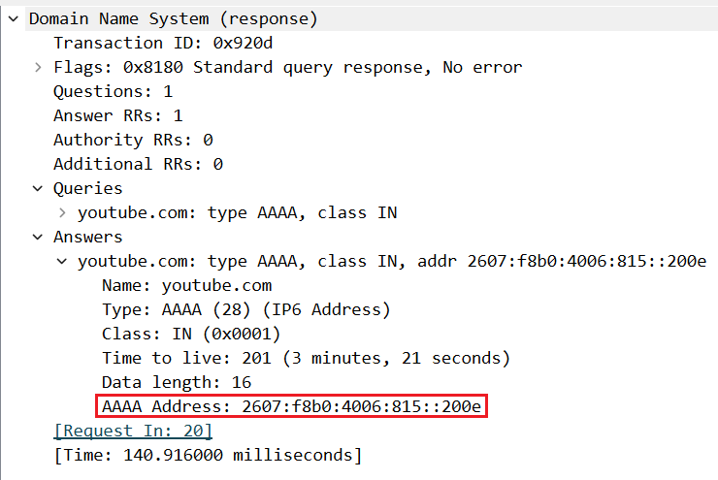
Fig: AAAA Address

