Computer System and Network
Ethernet-ARP



Submitted by:
Full Name: Anish Adhikari
Orbund ID: 11147
Student ID: 24071101
Kathmandu, Nepal

Questions

- What is the 48-bit Ethernet address of the host computer? [Marks: 5]

Answer:

The 48-bit Ethernet address of the host computer is c4:41:1e:75:b1:52.This address is
taken from the Source field of the Ethernet II header in the frame carrying the HTTP
request.

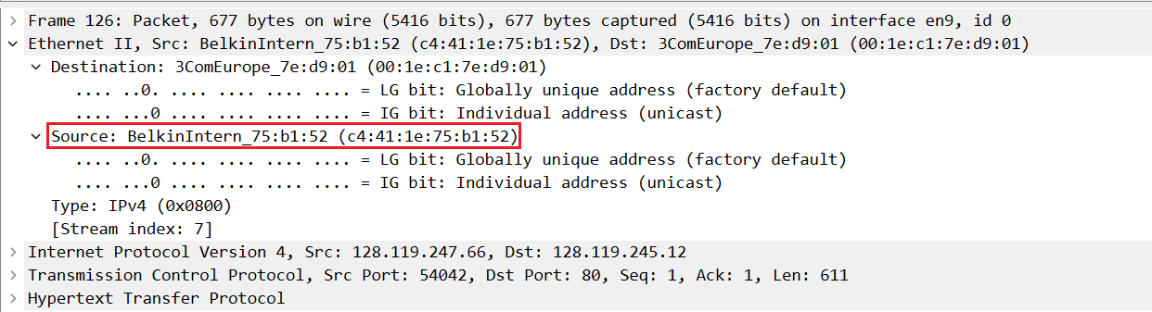
Fig: Source Address

- What is the 48-bit destination address in the Ethernet frame? Is this the Ethernet address of gaia.cs.umass.edu? (Hint: the answer is no). What device has this as its Ethernet address? [Note: this is an important question, and one that students sometimes get wrong. Re-read pages 483-484 in the text and make sure you understand the answer here.] [Marks: 5]

Answer:

The 48-bit destination Ethernet address in frame 126 is 00:1e:c1:7e:d9:01. This is not
the Ethernet address of gaia.cs.umass.edu, because Ethernet addresses are only used
within the local network. This destination address belongs to the local router (default
gateway), which forwards the packet toward the remote server.

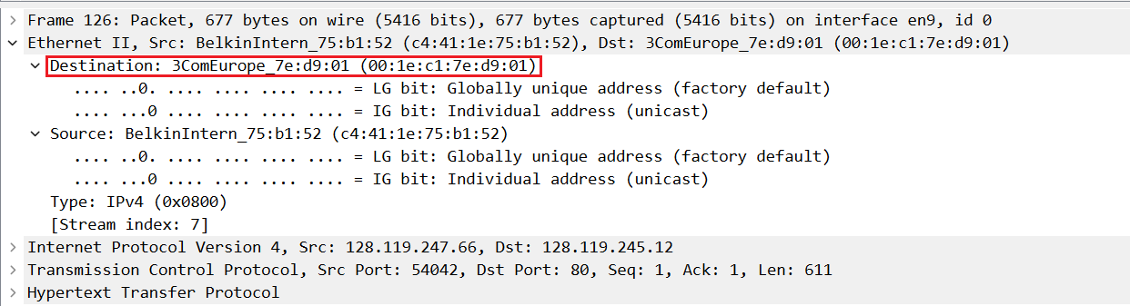
Fig: Destination Address

- What is the hexadecimal value for the two-byte Frame type field in the Ethernet frame carrying the HTTP GET request? What upper layer protocol does this correspond to? [Marks: 5]

Answer:

The hexadecimal value for two-byte Frame Type field value is 0x0800. This corresponds
to the upper-layer protocol IPv4.

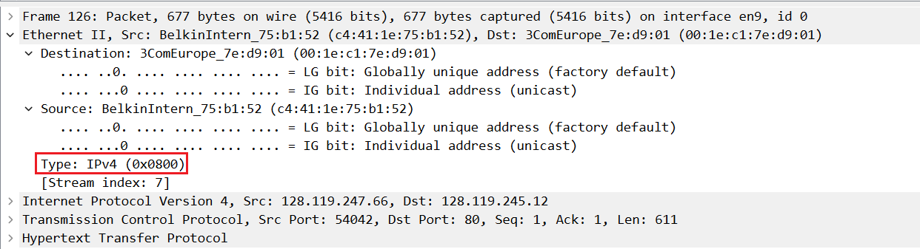
Fig: Type Field

Next, answer the following questions, based on the contents of the Ethernet frame containing the first byte of the HTTP response message.

- What is the value of the Ethernet source address? Is this the address of the host computer, or of gaia.cs.umass.edu (Hint: the answer is no). What device has this as its Ethernet address? [Marks: 5]

Answer:

The Ethernet source address is 00:1e:c1:7e:d9:01. This is not the Ethernet address of the host computer and not the Ethernet address of gaia.cs.umass.edu. This address belongs to the local router (default gateway), which forwarded the HTTP response onto the local network toward the host.

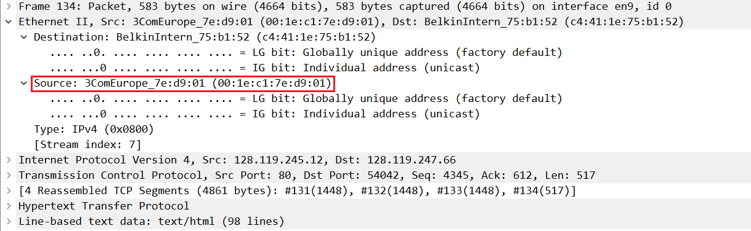
Fig: Source Address

- What is the destination address in the Ethernet frame? Is this the Ethernet address of your computer? [Marks: 5]

Answer:

The destination Ethernet address is c4:41:1e:75:b1:52. Yes, this is my computer’s
Ethernet (MAC) address. Ethernet frames use MAC addresses to deliver data within the
local network. Since this data was meant for my computer, the destination MAC
address is my computer’s own Ethernet (MAC) address. This is why the destination
address shown in the frame matches my device’s MAC address.

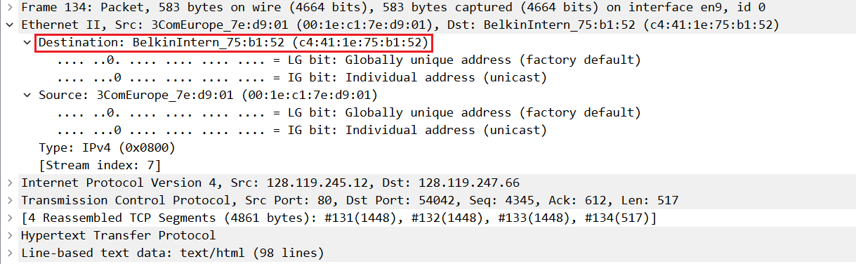
Fig: Destination Address

- Give the hexadecimal value for the two-byte Frame type field. What upper layer protocol does this correspond to? [Marks: 5]

Answer:
The Frame Type field is 0x0800, which corresponds to IPv4.

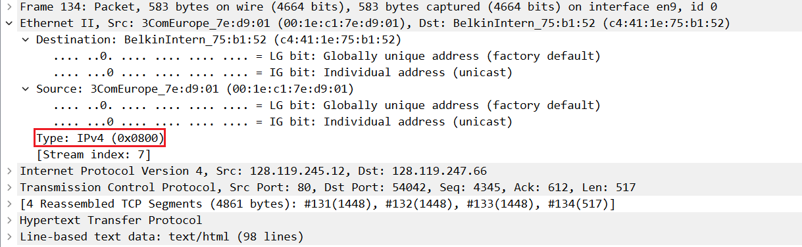
Fig: Type Field

- How many Ethernet frames (each containing an IP datagram, each containing a TCP segment) carry data that is part of the complete HTTP “OK 200 ...” reply message. ( hint: check number of TCP segements ) [Marks: 5]

Answer:

4 Ethernet frames carry data for the complete HTTP “200 OK” reply. I checked the
“Reassembled TCP Segments” list, which shows the response is split across 4 TCP
segments (#131–#134), and each segment is carried in its own Ethernet frame.

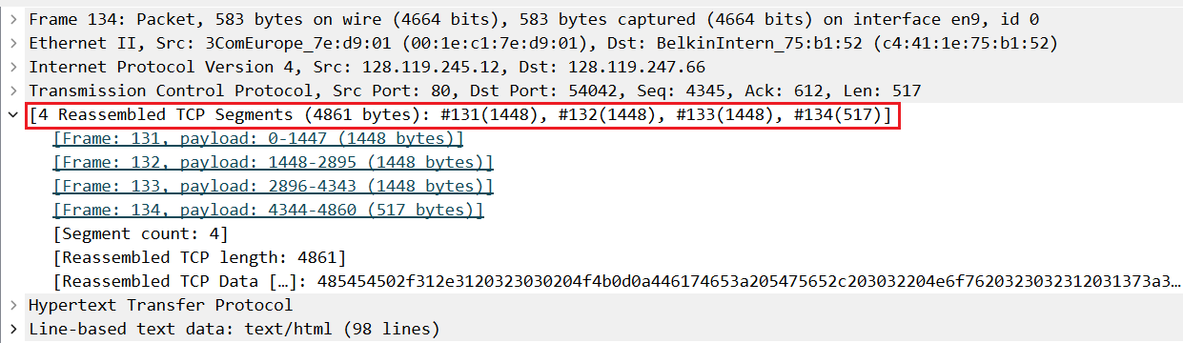
Fig: 4 reassembled TCP Segments

- How many entries are stored in your ARP cache? [Marks: 5]

Answer:

There are three (3) entries stored in the ARP cache. This is determined by counting the
three IP-to-Ethernet address mappings displayed in the output of the arp -a command
shown in Figure 3. The three entries are:

1) gw-vlan-2471.cs.umass.edu (128.119.247.1) at 0:1e:c1:7e:d9:1
2) sammac.cs.umass.edu (128.119.247.19) at (incomplete)
3) romobac.cs.umass.edu (128.119.247.79) at 78:7b:8a:ac:ad:e1

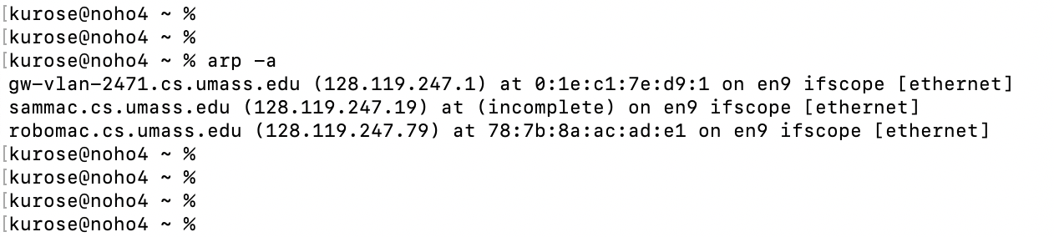
Fig: ARP Cache

- What is contained in each displayed entry of the ARP cache? [Marks: 5]

Answer:

Each displayed entry in the ARP cache contains an IP address and its corresponding 48-bit Ethernet (MAC) address. The entry may also include the hostname and the network interface on which the mapping applies. If address resolution has not yet completed, the MAC address field may be shown as incomplete.

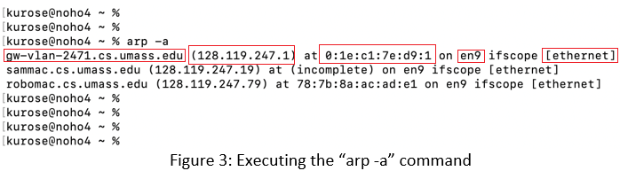

- What is the hexadecimal value of the source address in the Ethernet frame containing the ARP request message sent out by the host computer? ( hint: you need to look at packet number 108 in wireshark) [Marks: 5]
Answer:
The hexadecimal value of the source address in the Ethernet frame containing the ARP request (packet 108) is c4:41:1e:75:b1:52.
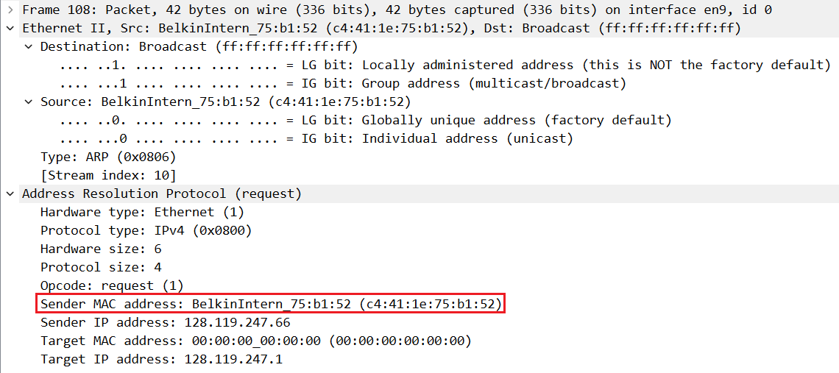Fig: Sender MAC address

- What is the hexadecimal value of the destination addresses in the Ethernet frame containing the ARP request message sent out by the host computer? And what device(if any) corresponds to that address (e.g,, client, server, router, switch or otherwise...)? [Marks: 5]

Answer:

The destination Ethernet address in the ARP request frame (packet 108) is ff:ff:ff:ff:ff:ff. This is the Ethernet broadcast address, so it does not correspond to a single device: it is received by all devices on the local network (LAN).
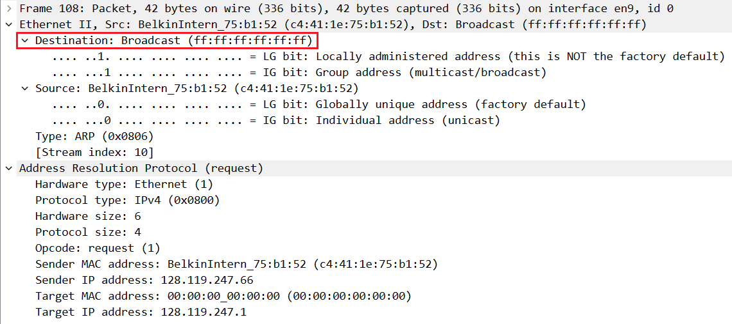
Fig: Destination Address

- What is the hexadecimal value for the two-byte Ethernet Frame type field. What upper layer protocol does this correspond to? [Marks: 5]

Answer:

The hexadecimal value of the two-byte Ethernet Frame Type field is 0x0806. This corresponds to the Address Resolution Protocol (ARP).

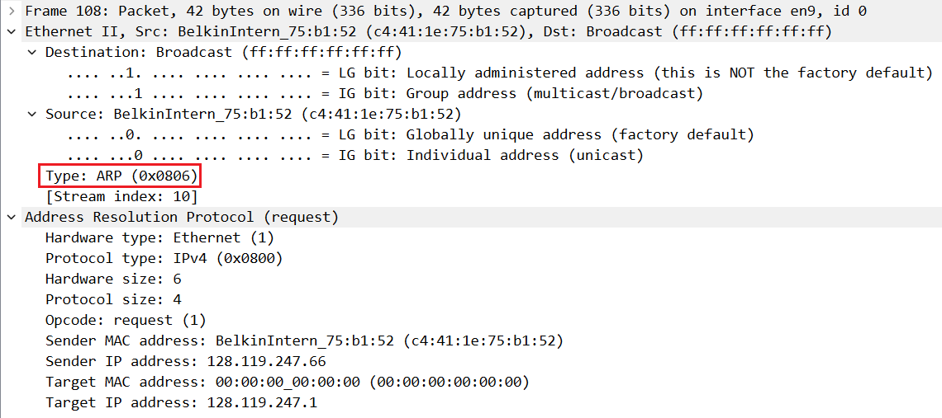
Fig: Frame Type

- How many bytes from the very beginning of the Ethernet frame does the ARP opcode field begin? ( hint: you need to count from start of Ethernet to opcode field in ARP) [Marks: 5]

Answer:

The ARP opcode field begins 20 bytes from the start of the Ethernet frame. This includes 14 bytes for the Ethernet header and 6 bytes for the initial fields of the ARP header before the opcode field.

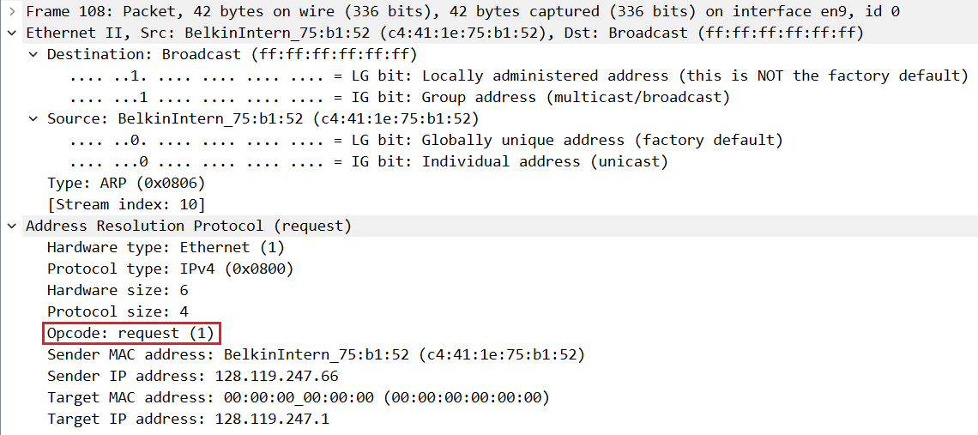
Fig: Opcode

- What is the value of the opcode field within the ARP request message sent by your computer? [Marks: 5]

Answer:

The value of the opcode field in the ARP request message is 1, which indicates an ARP request.
Fig: Opcode

- Does the ARP request message contain the IP address of the sender? If the answer is yes, what is that value? [Marks: 5]

Answer:

Yes, the ARP request message contains the IP address of the sender. The sender’s IP address is 128.119.247.66.

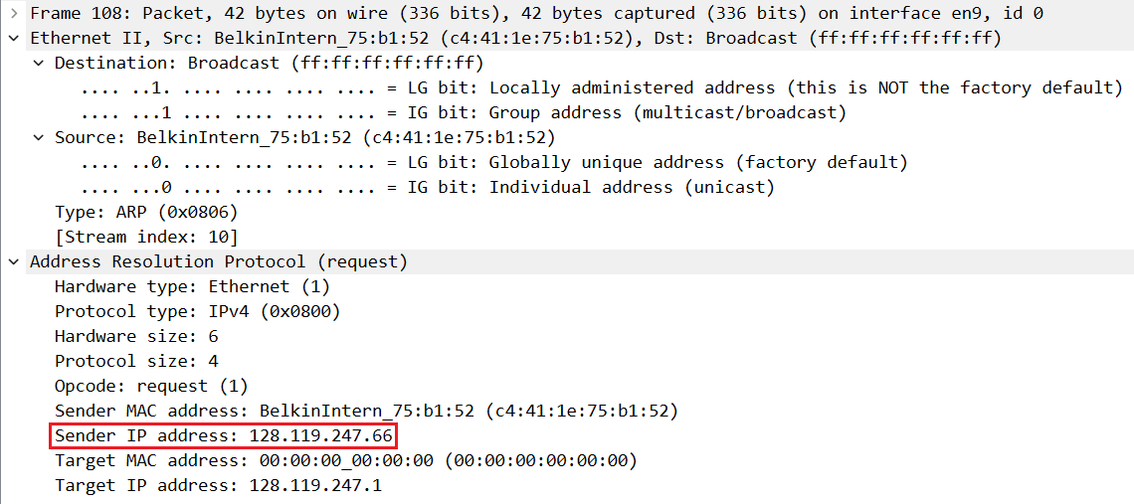
Fig: Sender IP Address

- What is the IP address of the device whose corresponding Ethernet address is being requested in the ARP request message sent by your computer? [Marks: 5]

Answer:

The IP address whose corresponding Ethernet address is being requested is 128.119.247.1.

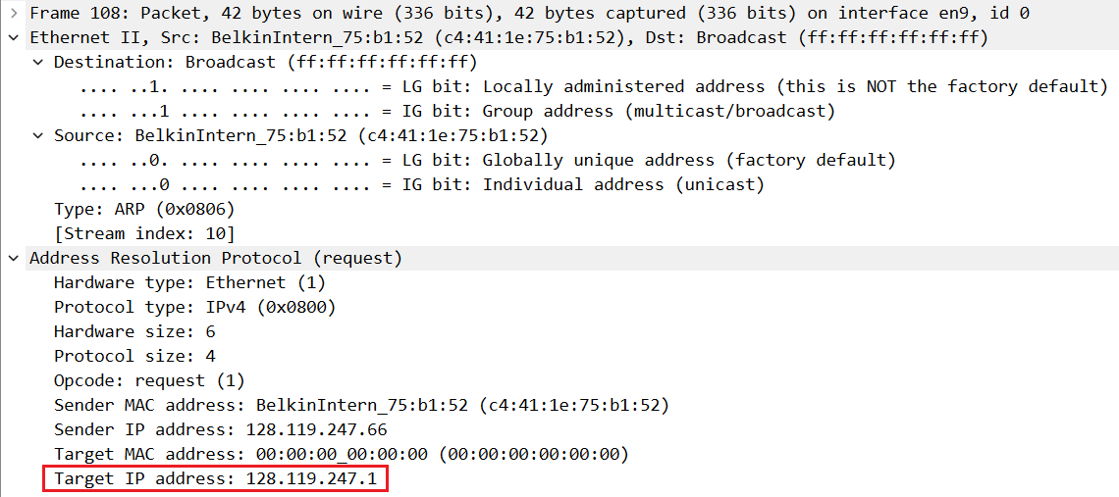
Fig: Target IP Address

Now find the ARP reply message that was sent in response to the ARP request from the
host computer.

- What is the value of the opcode field within the ARP reply message received by your computer? [Marks: 5]

Answer:

The opcode value in the ARP reply message is 2, which indicates an ARP reply.

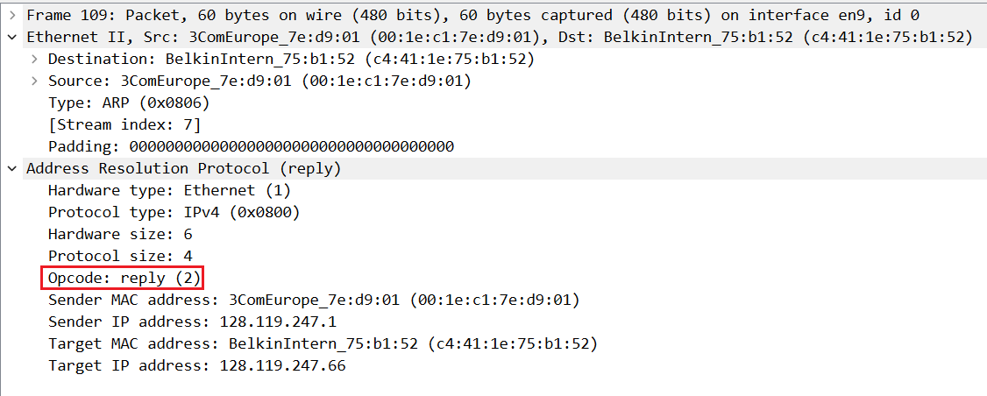
Fig: Opcode

- Finally (!), let’s look at the answer to the ARP request message! What is the Ethernet address corresponding to the IP address that was specified in the ARP request message sent by the host computer (see question 18)? [Marks: 5]

Answer:

The Ethernet (MAC) address corresponding to the IP address 128.119.247.1 is 00:1e:c1:7e:d9:01.

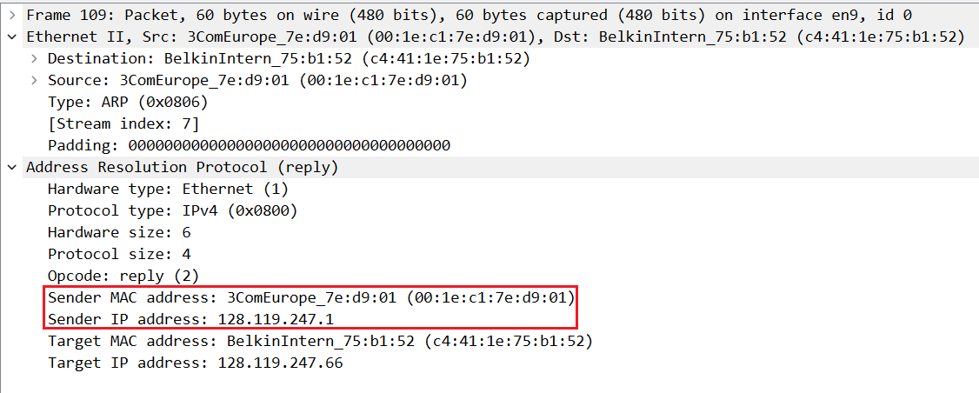
Fig: MAC-Address

- We’ve looked the ARP request message sent by your computer running Wireshark, and the ARP reply message sent in response. But there are other devices in this network that are also sending ARP request messages that you can find in the trace. Why are there no ARP replies in your trace that are sent in response to these other ARP request messages? [Marks: 5]

Answer:

There are no ARP replies to the other devices’ ARP requests in my trace because those replies are typically unicast back to the requesting host and are not delivered to my computer’s network interface on a switched LAN. Since Wireshark captures only frames that my NIC receives (plus broadcasts), it can show the broadcast ARP requests from other devices, but it may not capture the unicast ARP replies sent only to those devices.

Extra Credit
EX-1. The arp command:
arp -s InetAddr EtherAddr
allows you to manually add an entry to the ARP cache that resolves the IP address InetAddr to the physical address EtherAddr. What would happen if, when you manually added an entry, you entered the correct IP address, but the wrong Ethernet address for that remote interface? A security attack known as “ARP poisoning” https://www.varonis.com/blog/arp-poisoning/ spoofs ARP messages and causes incorrect entries to be made into an ARP table!
Answer:
If the correct IP address is mapped to the wrong Ethernet (MAC) address, packets meant for the real device will be sent to the wrong machine. As a result, communication with the intended host will fail or be intercepted. This situation can allow an attacker to capture or modify traffic and is known as ARP poisoning or ARP spoofing.

EX-2. What is the default amount of time that an entry remains in your ARP cache before being removed? You can determine this empirically (by monitoring the cache contents) or by looking this up in your operating system documentation. Indicate how/where you determined this value.

Answer:
In Windows, a dynamic ARP cache entry remains for about 10 minutes before being removed if it is not used. This was done by running the arp -a command and watching the entries marked as dynamic. By looking the ARP table over time, dynamic entries disappear automatically after a period of inactivity, while static entries remain in the cache.

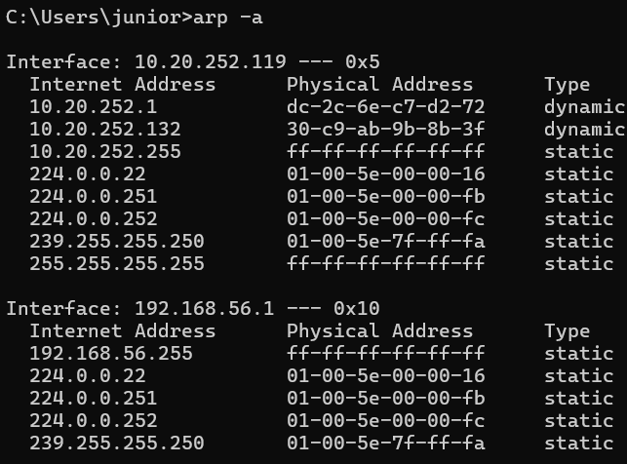Fig: Arp entries

