Computer and Network System
Wireshark-TCP-lab-book



Submitted by:
Full Name: Anish Adhikari
Orbund ID: 11147
Student ID: 24071101
Kathmandu, Nepal

- What is the IP address and TCP port number used by the client computer (source) that is transferring the alice.txt file to gaia.cs.umass.edu? [Marks: 7]

Answer:
The IP address used by the client computer is 192.168.86.68 and the TCP port number used by the client computer is 55639.

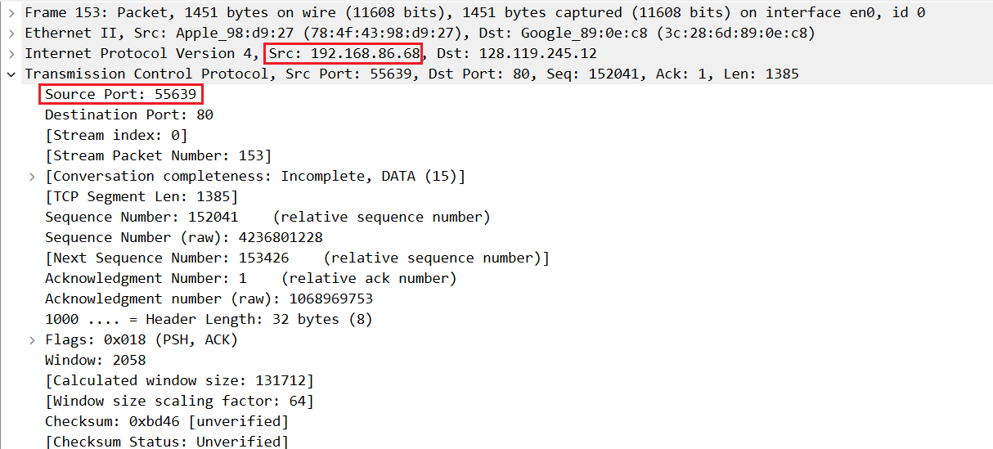
Fig: Source IP and Port

- What is the IP address of gaia.cs.umass.edu? On what port number is it sending and receiving TCP segments for this connection? [Marks: 5]

Answer:

The IP address of gaia.cs.umass.edu is 128.119.245.12 and the port number it is sending and receiving TCP segment for this connection is port 80.

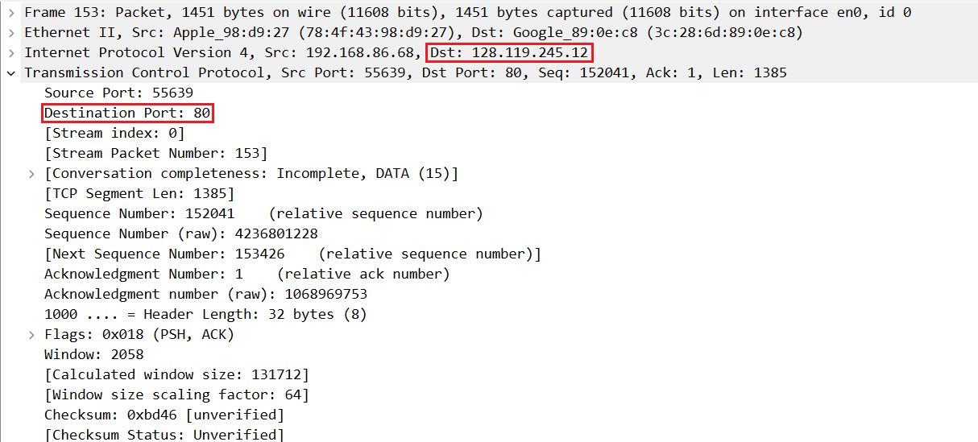
Fig: Destination IP and Port

- What is the sequence number of the TCP SYN segment that is used to initiate the TCP connection between the client computer and gaia.cs.umass.edu? What is it in this TCP segment that identifies the segment as a SYN segment? Will the TCP receiver in this session be able to use Selective Acknowledgments (allowing TCP to function a bit more like a “selective repeat” receiver, see section 3.4.5 in the text)? [Marks: 10]

Answer:

The raw sequence number of the TCP SYN segment used to initiate the TCP connection is 4236649187. The segment is identified as a SYN segment by the
Flags: 0x002 (SYN) being set in the TCP header. Yes, the TCP receiver will be able to use Selective Acknowledgments (SACK), as indicated by the SACK permitted option present in the TCP options field.
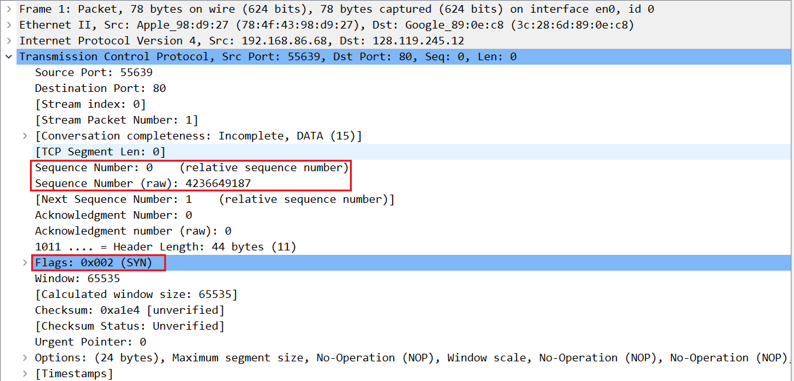
Fig: Sequence Number

- What is the sequence number of the SYNACK segment sent by gaia.cs.umass.edu to the client computer in reply to the SYN? What is it in the segment that identifies the segment as a SYNACK segment? What is the value of the Acknowledgement field in the SYNACK segment? How did gaia.cs.umass.edu determine that value? [Marks: 10]

Answer:

The raw sequence number of the SYN-ACK segment sent by gaia.cs.umass.edu is
1068969752. The segment is identified as a SYN-ACK segment because both the
SYN and ACK flags are set in the TCP header. The value of the Acknowledgement
field is 4236649188.
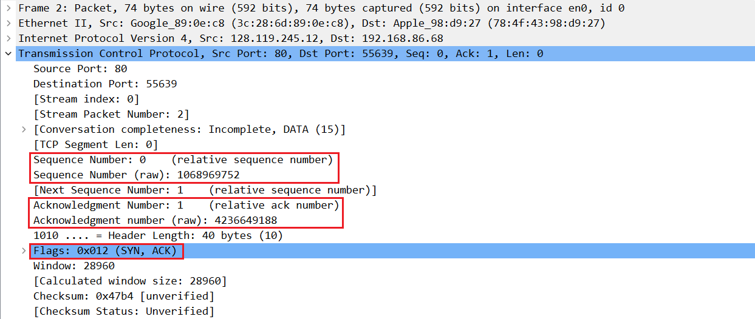
Fig: Sequence and Acknowledgement Number

- What is the sequence number of the TCP segment containing the header of the HTTP POST command? Note that in order to find the POST message header, you’ll need to dig into the packet content field at the bottom of the Wireshark window, looking for a segment with the ASCII text “POST” within its DATA field , . How many bytes of data are contained in the payload (data) field of this TCP segment? Did all of the data in the transferred file alice.txt fit into this single segment? [Marks: 10]
Ans: The TCP segment that contains the header of the HTTP POST command has raw
sequence number 4236801228. The payload (TCP segment data) carried in this
segment is 1385 bytes. No, the entire alice.txt file did not fit into this single
segment; the file is much larger than one TCP segment and is therefore transmitted
across many TCP segments.
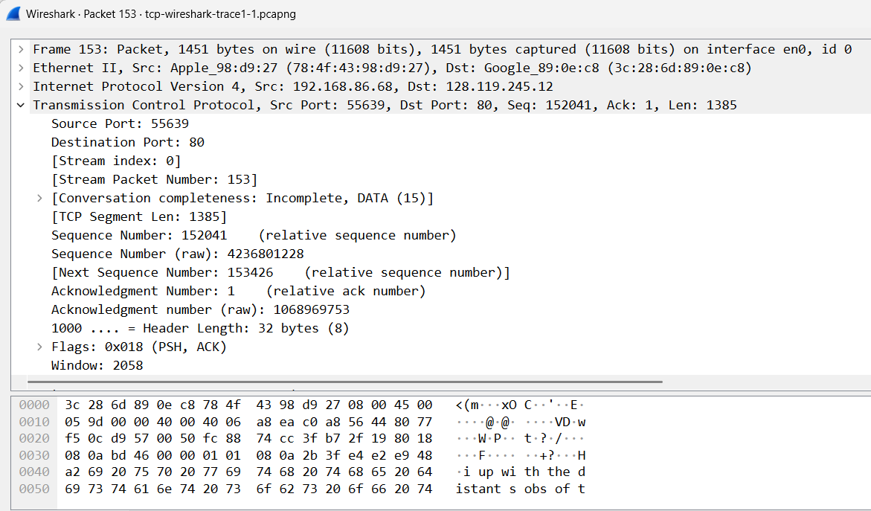

- Consider the TCP segment containing the HTTP “POST” as the first segment in the data transfer part of the TCP connection.
- At what time was the first segment (the one containing the HTTP POST) in the data-transfer part of the TCP connection sent?
Ans:
t₁_send = 0.147682 s
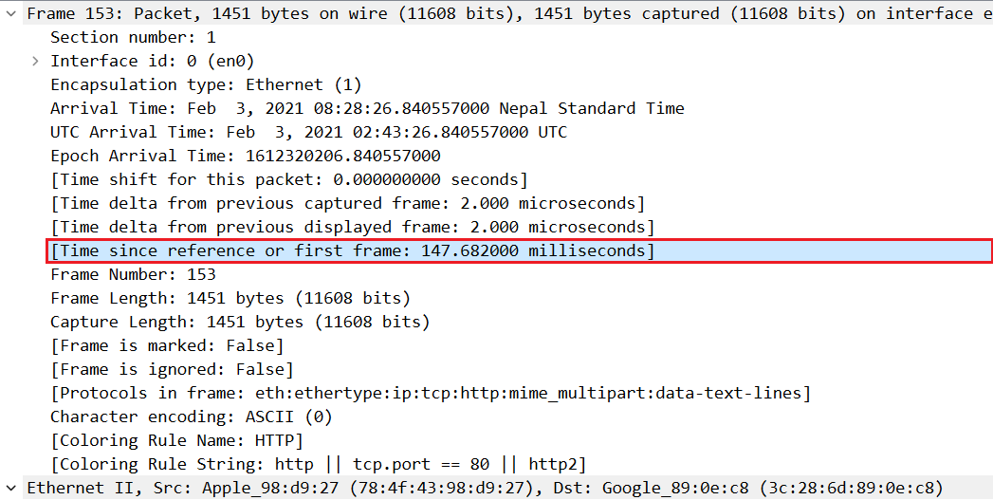

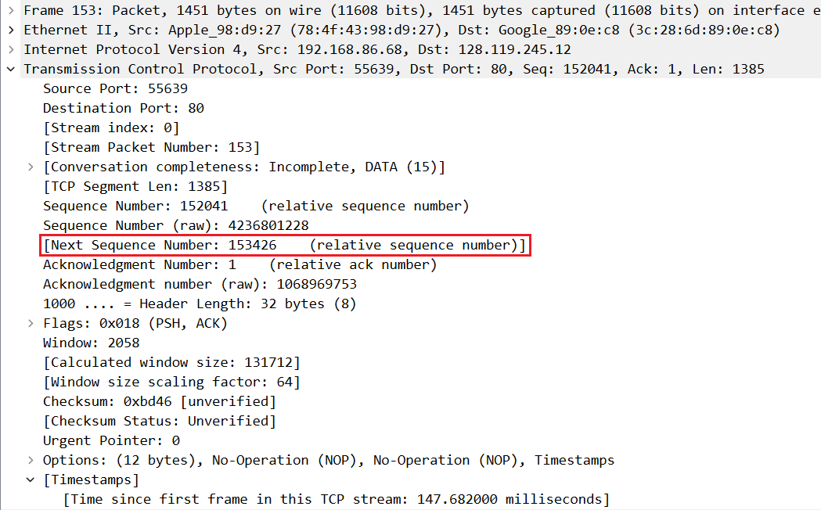
- At what time was the ACK for this first data-containing segment received?
- What is the RTT for this first data-containing segment?

t₁_ack = 0.191496 s

- What is the RTT value the second data-carrying TCP segment and its ACK?
RTT1 = t₁_ack − t₁_send
Let’s subtract carefully:
0.191496 − 0.147682
= (191.496 ms − 147.682 ms)
= 43.814 ms
= 0.043814 s

- What is the EstimatedRTT value (see Section 3.5.3, in the text) after the ACK for the second data-carrying segment is received? Assume that in making this calculation after the received of the ACK for the second segment, that the initial value of EstimatedRTT is equal to the measured RTT for the first segment, and then is computed using the EstimatedRTT equation on page 242, and a value of a = 0.125.
(Hint : use the following equation to calculate NewEstimatedRTT:
$NewEstimatedRTT=0.875×previousEstimatedRTT+0.125×SampleRTT$
Where previousEstimatedRTT is the measured RTT for the first segment and sampleRTT is the measured RTT for the second segment.)
Note: Wireshark has a nice feature that allows you to plot the RTT for each of the TCP segments sent. Select a TCP segment in the “listing of captured packets” window that is being sent from the client to the gaia.cs.umass.edu server. Then select: Statistics->TCP Stream Graph->Round Trip Time Graph. Take a screenshot of it and show it to your tutor. [Marks: 10]

- What is the length (header plus payload) of each of the first four data-carrying TCP segments? [Marks: 5]

Ans:

The lengths (header plus payload) of the first four data-carrying TCP segments are 1514 bytes each. These values were obtained from the Frame Length field in Wireshark for the first four TCP segments sent from the client that contain data (tcp.len > 0).

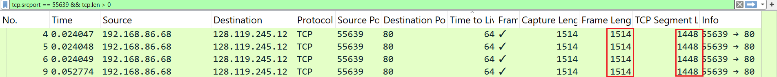

- What is the minimum amount of available buffer space advertised to the client by gaia.cs.umass.edu among these first four data-carrying TCP segments? Does the lack of receiver buffer space ever throttle the sender for these first four data-carrying segments? [Marks: 5]

Ans.
- Data sent in first four segments
  - Each payload ≈ 1448 bytes
  - Total in flight ≈ 4 × 1448 = 5792 bytes
- Minimum advertised receive window
  - 31,872 bytes
Conclusion:
$$31,872≫5,792$$
The minimum amount of available buffer space advertised by gaia.cs.umass.edu among the first four data-carrying TCP segments is 28,960 bytes.
The lack of receiver buffer space does not throttle the sender for these segments, since the advertised window size is much larger than the amount of data sent in each TCP segment.
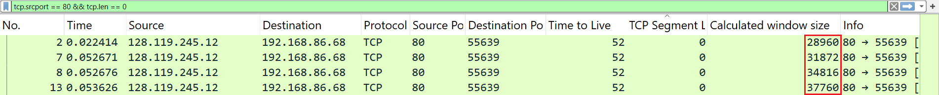

- Are there any retransmitted segments in the trace file? What did you check for (in the trace) in order to answer this question? [Marks: 5]

o, there are no retransmitted TCP segments in the trace. I checked by applying the Wireshark filter tcp.analysis.retransmission (and also looked in the Info column for any “Retransmission/Fast Retransmission” labels). The filter returned no matching packets, indicating that no retransmissions occurred.

10. How much data does the receiver typically acknowledge in an ACK among the first ten data-carrying segments sent from the client to gaia.cs.umass.edu? Can you identify cases where the receiver is ACKing every other received segment (see Table 3.2 in the text) among these first ten data-carrying segments? [Marks: 7]

Among the first ten data-carrying TCP segments sent from the client to gaia.cs.umass.edu, the receiver typically acknowledges 1448 bytes in each ACK. This was determined by examining successive ACK numbers in the ACK packets sent by gaia and observing that each ACK value increases by 1448 bytes, which matches the payload size of one TCP segment.
here are cases where the ACK number increases by 2896 bytes, which equals 2 × 1448. For example, the ACK increases from 15929 to 18825, acknowledging 2896 bytes. This indicates the receiver is sometimes ACKing every other segment, consistent with the delayed ACK behavior.

11 What is the throughput (bytes transferred per unit time) for the TCP connection? Explain how you calculated this value. [Marks: 5]

The throughput of the TCP connection was obtained using Wireshark’s TCP Stream Graph → Throughput option. The graph shows the average throughput over time for the TCP connection transferring the alice.txt file. From the throughput graph, the average throughput reaches approximately above 6 kbps. This value represents the rate at which data was successfully transferred from the client to the server during the TCP session.
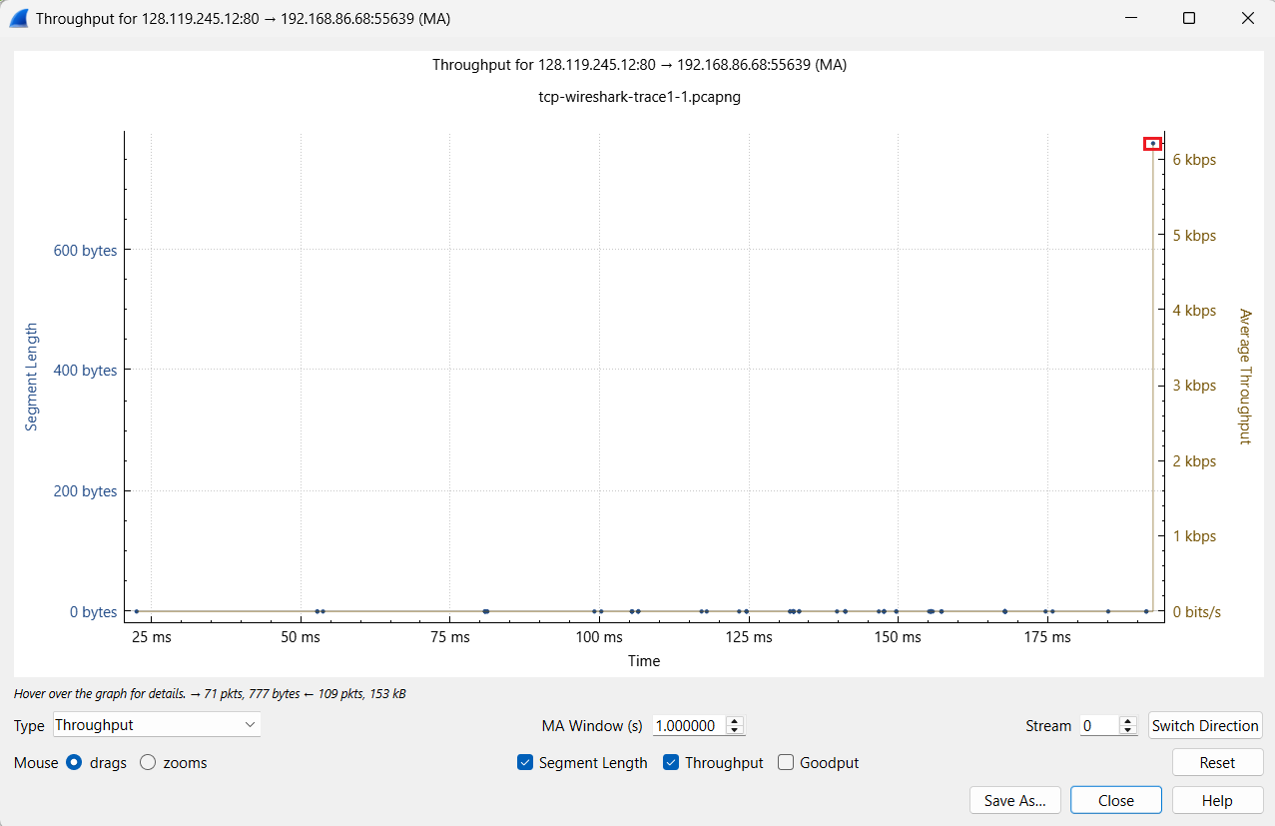
12. Use the Time-Sequence-Graph(Stevens) plotting tool to view the sequence number versus time plot of segments being sent from the client to the gaia.cs.umass.edu server. Consider the “fleets” of packets sent around t = 0.025, t = 0.053, t = 0.082 and t = 0.1. Comment on whether this looks as if TCP is in its slow start phase, congestion avoidance phase or some other phase. Figure 6 shows a slightly different view of this data. [Marks: 7]
Ans: The fleets of packets occur at approximately 0.0241 s, 0.05363 s, 0.08077 s, and 0.09907 s. The time difference between consecutive fleets is roughly 0.02–0.03 seconds, which is approximately constant. This periodicity corresponds to the round-trip time (RTT) of the TCP connection. Since each fleet increases in size compared to the previous one, this indicates that TCP is operating in the slow start phase.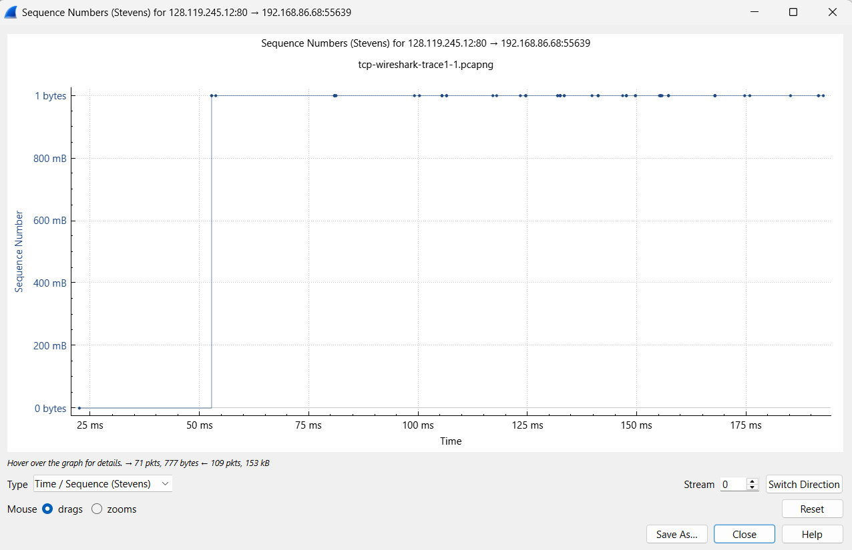

13.These “fleets” of segments appear to have some periodicity. What can you say about the period? [Marks: 7]

Ans: Using the Time-Sequence-Graph (Stevens) for the TCP segments transferring the file, the packets are sent in distinct fleets. Each successive fleet increases in size, which indicates that TCP is operating in the slow start phase. The time gap between consecutive fleets is approximately constant at around 0.02–0.03 seconds, which corresponds to the round-trip time (RTT) of the connection.
14. Answer each of two questions above for the trace that you have gathered when you transferred a file from your computer to gaia.cs.umass.edu [Marks: 7]

Ans: For the trace gathered during the file transfer from the client to gaia.cs.umass.edu, the Time-Sequence-Graph (Stevens) shows that TCP packets are sent in clear fleets. Each successive fleet increases in size compared to the previous one, which indicates that TCP is operating in the slow start phase of congestion control.
The fleets appear at regular time intervals, with the time gap between consecutive fleets being approximately constant. This periodicity corresponds to the round-trip time (RTT) of the TCP connection, as the sender transmits a new window of packets after receiving acknowledgements from the receiver.

