This study was conducted December- February 2016 on two adjacent sites in Banni Grasslands in the Kachchh district of Gujarat. One site was dominated by *Prosopis* while the other had only sparse *Prosopis* cover.

Livetrapping using Sherman traps indicates that the rodents in this habitat are the Indian gerbil (Tatera indica), Wagner’s gerbil (Gerbillus nanus), the sand rat and the field mouse. These rodents are nocturnal and granivorous(?).

Plant cover was measured by counting the number of Prosopis trees and bushes greater than 1m2 in 10m2 grids in each of the four grids.

1. **Habitats with dense *Prosopis* cover are perceived as being safer than those with sparse *Prosopis* cover**

**Methods:** Each site had two experimental grids separated by a distance of 150m. Each grid had four pairs of feeding trays separated by a distance of 40m from each other. This distance is greater than the average home range of the largest rodent, *Tatera indica* found in these habitats. To account for microhabitat differences in predation risk, one tray was placed under a *Prosopis* tree and one was placed 3.5m away from the tree. The trays were filled with 3l of sifted sand mixed with 3g of pearl millet seeds. Each tray had a 3m track plot around it. The track plots were smoothened and seeds were replaced daily in the evening (17:00- 19:00) over 4-day periods centred on each moon phase. The seeds remaining the following morning were sifted through a sieve and collected. Data collection began on the second day as the first day served as an acclimation period. Collected seeds were then processed in the laboratory by separating it from other particles and weighing the seeds. This process was repeated twice for each moon phase.

1. ***Feeding stations in dense Prosopis habitats have more activity compared to those in sparse Prosopis habitats***

**Analysis:** Rodent activity, measured as the number of footprints entering the track plot, was examined using linear mixed models. The model treated habitat type (i.e., dense and sparse), moon phase (i.e., full, wane, new, wax), month (month1 and month2), and microhabitat (i.e., tree and open) as fixed effects; Feeding station was treated as a random effect to account for repeated measures over multiple nights and two months.

Akaike’s information criterion was also used to select between different models using a likelihood ratio test.

**Results:**

Activity was significantly higher in feeding trays next to cover (near tray mean= 4.9550 ± 3.5544, p= 0.0004) and in sparse habitats (6.1471 ± 3.3992, p= 0.00012). The main effect of moon phase also had a significant effect on activity (p= 2.2e-16), with highest activity during the waning moon phase (5.8522 ± 3.7017) and lowest during the full moon phase (2.9479 ± 2.1463). Interactions between feeding tray position and habitat (p= 0.014) and moon phase and month (p= 0.011) were also significant. There were no significant differences for two-way interactions between habitat and moon phase, habitat and month or for three-way and four-way interactions between the fixed effects.

The likelihood ratio test showed that the three-way interaction between moon phase, habitat and feeding tray position best explained rodent activity (Table 2).

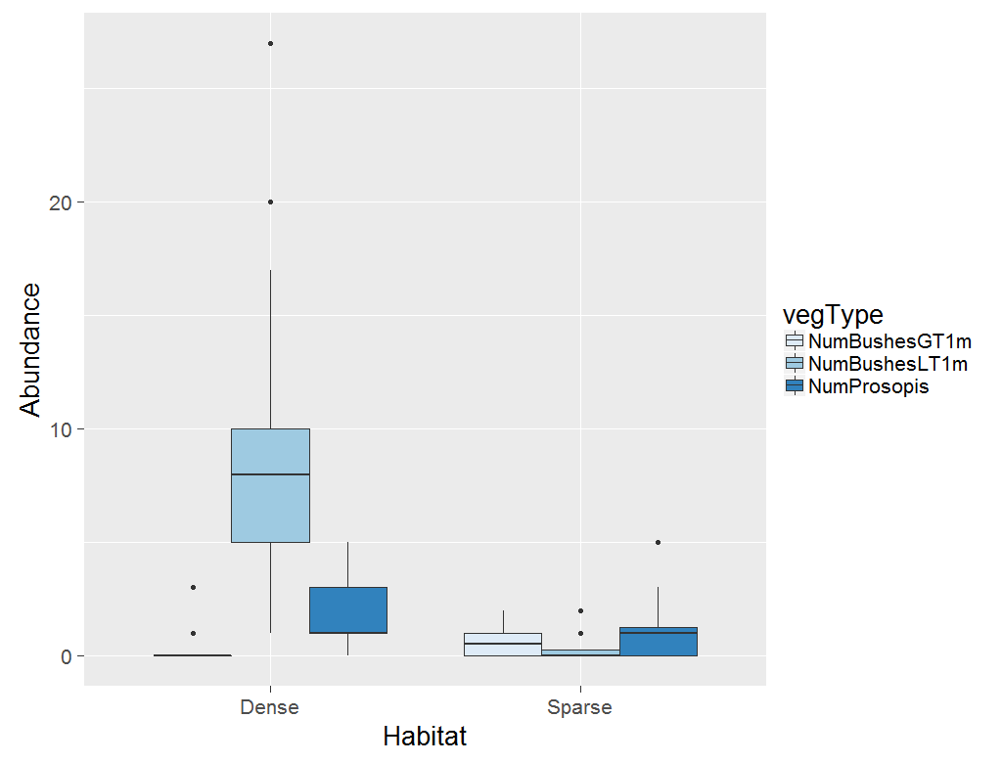

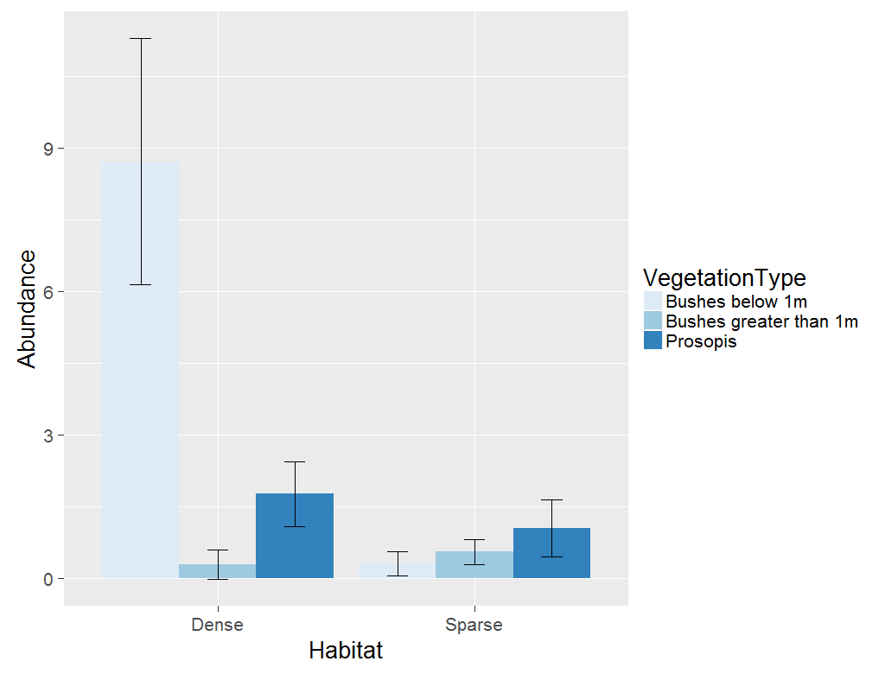

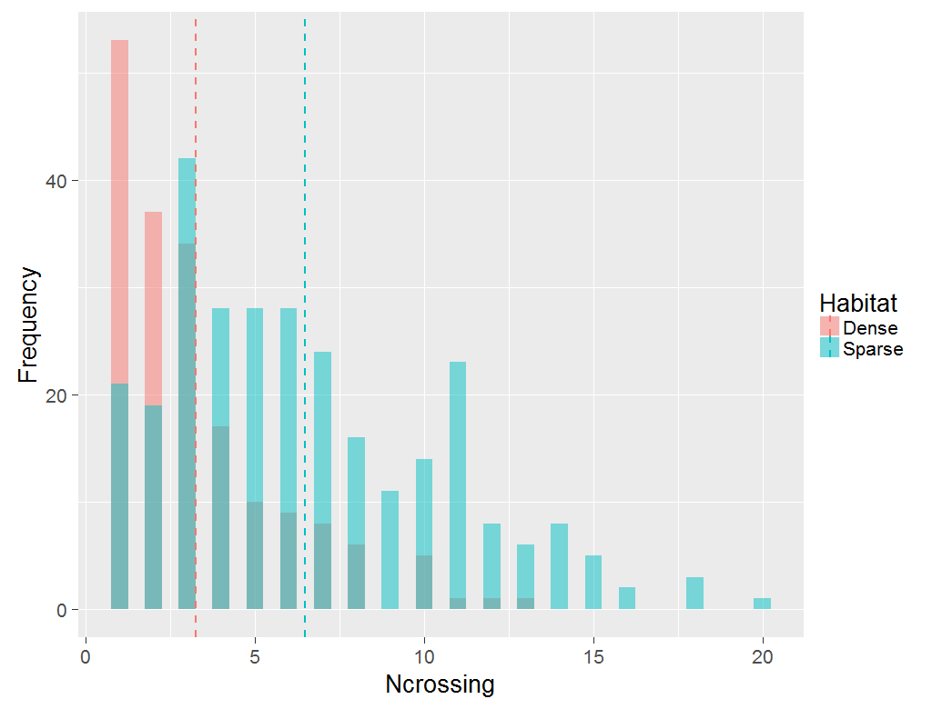

Figure 1. Frequency distribution of number of crossings (activity) in the sparse and dense Prosopis habitats

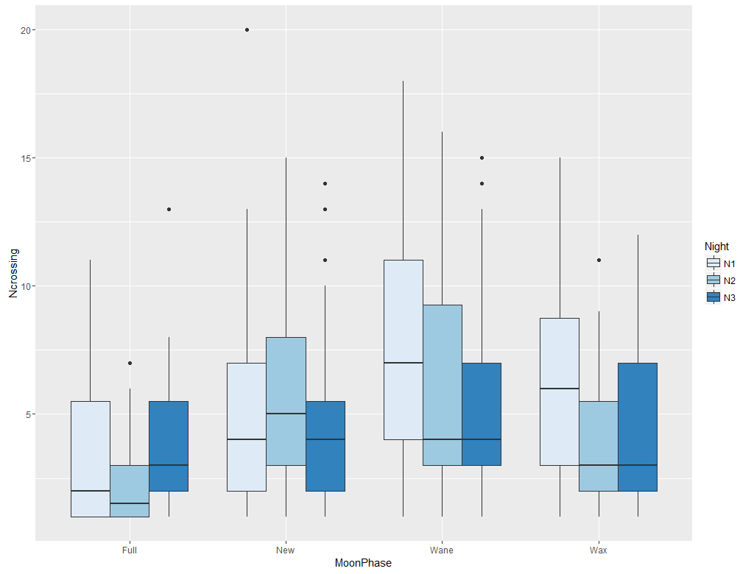

Figure 2. Rodent activity on each night for each moon phase

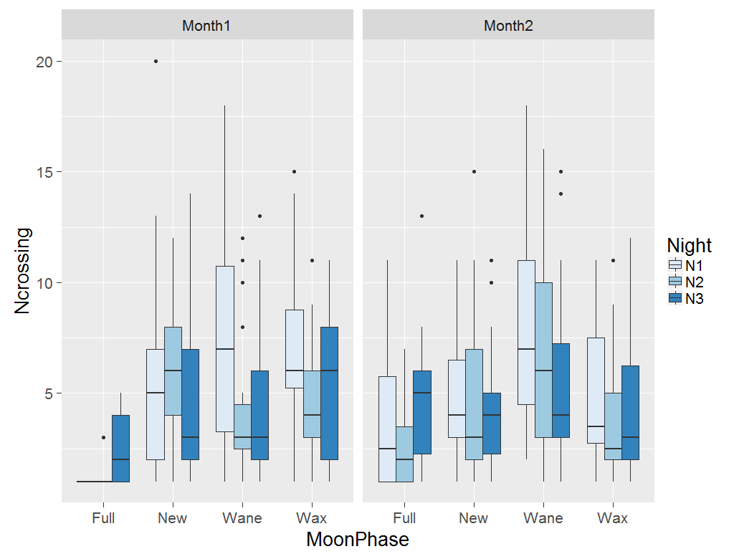

**Figure 3.** Rodent activity on each night for each moon phase

|  |
| --- |
| Main effects Chisq Df Pr(>Chisq) |
| FeedingTrayPosition 12.2659 1 0.0004613 ***  habitat 14.7926 1 0.0001200 ***  moonPhase 78.0592 3 < 2.2e-16 ***  month 2.1739 1 0.1403665  FeedingTrayPosition:habitat 6.0137 1 0.0141953 *  habitat:moonPhase 3.0737 3 0.3804027  habitat:month 0.9854 1 0.3208763  moonPhase:month 10.9714 3 0.0118817 *  FeedingTrayPosition:month 4.1684 1 0.0411849 *  FeedingTrayPosition:moonPhase 2.7998 3 0.4235327  habitat:moonPhase:month 3.4962 3 0.3212504  FeedingTrayPosition:habitat:month 1.4324 1 0.2313662  FeedingTrayPosition:habitat:moonPhase 2.4602 3 0.4825344  FeedingTrayPosition:moonPhase:month 6.2241 3 0.1012011  FeedingTrayPosition:habitat:moonPhase:month 4.2004 3 0.2406255 |
|  |

**Table 1.** Analysis of variance table for rodent activity around feeding trays

|  |
| --- |
| Main effects Df AIC BIC logLik deviance Chisq Chi Df Pr(>Chisq) |
|  |
| Null model 3 993.77 1003.77 -493.89 987.77 |
| microhabitat 4 990.82 1004.15 -491.41 982.82 4.9577 1 0.025974 * |
| habitat 4 983.35 996.68 -487.68 975.35 7.4636 0 < 2.2e-16 *** |
| month 4 995.75 1009.08 -493.87 987.75 0.0000 0 1.000000 |
| moonPhase 6 952.87 972.87 -470.44 940.87 46.8715 2 6.637e-11 *** |
| habitat.microhab.int 6 976.35 996.34 -482.17 964.35 0.0000 0 1.000000 |
| habitat.mon 6 987.27 1007.27 -487.64 975.27 0.0000 0 1.000000 |
| hab.microhab.mon.int 10 981.15 1014.48 -480.58 961.15 14.1245 4 0.006908 ** |
| habitat.moonph.int 10 945.97 979.30 -462.99 925.97 35.1799 0 < 2.2e-16 *** |
| hab.moonph.mon.int 18 947.39 1007.38 -455.70 911.39 14.5793 8 0.067861 . |
| hab.moonph.microhab 18 941.91 1001.90 -452.95 905.91 5.4841 0 < 2.2e-16 *** |
| int.full 19 942.03 1005.35 -452.01 904.03 1.8816 1 0.170152 |
|  |
|  |
| --- |
| Signif. codes: 0 ‘***’ 0.001 ‘**’ 0.01 ‘*’ 0.05 ‘.’ 0.1 ‘ ’ 1 |

**Table 2.** Comparison of different linear mixed models using a likelihood ratio test

|  |
| --- |
| **Estimate Std. Error z value Pr(>|z|)** |
| New - Full == 0 2.1413 0.4566 4.690 < 0.001 *** |
| Wane - Full == 0 3.4902 0.4529 7.707 < 0.001 *** |
| Wax - Full == 0 1.5707 0.4640 3.385 0.00380 ** |
| Wane - New == 0 1.3489 0.3708 3.638 0.00154 ** |
| Wax - New == 0 -0.5706 0.3923 -1.455 0.46294 |
| Wax - Wane == 0 -1.9196 0.3872 -4.958 < 0.001 *** |

**Table 3.** Post-hoc analysis of moon phase

a.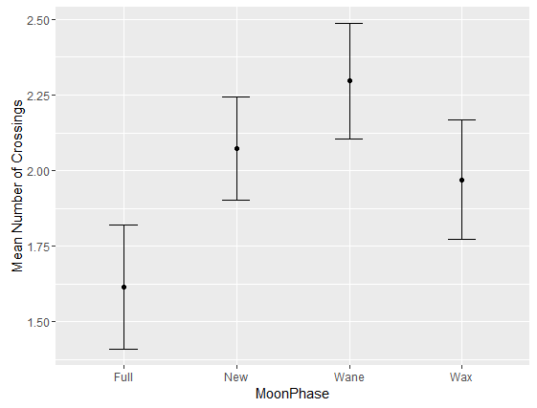 b.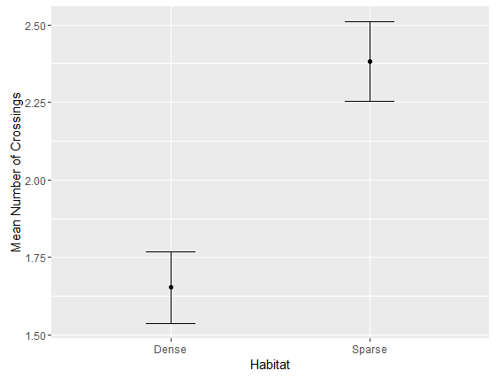

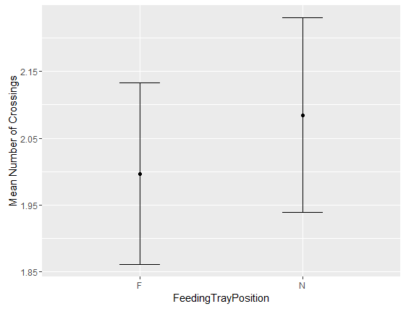

c.

**Figure 4.** Effects of moon phase (a), habitat (b) and feeding tray position (c) on gerbil activity

a.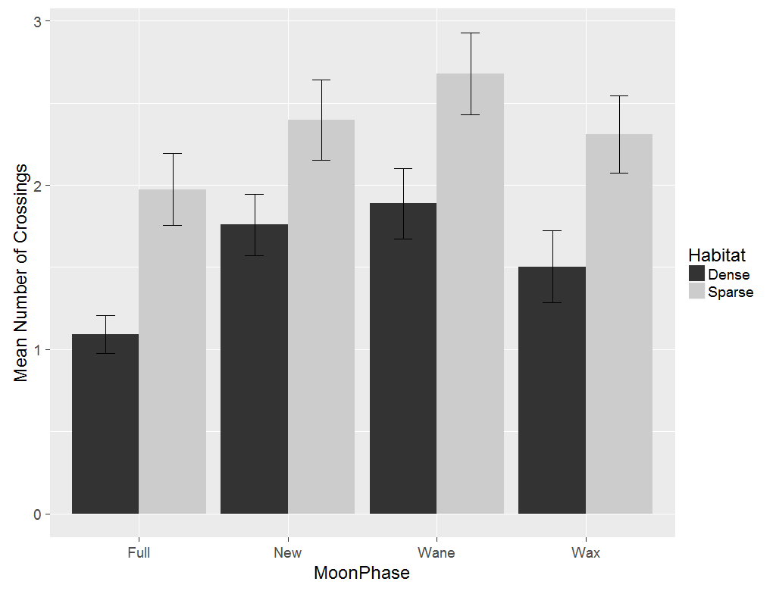b.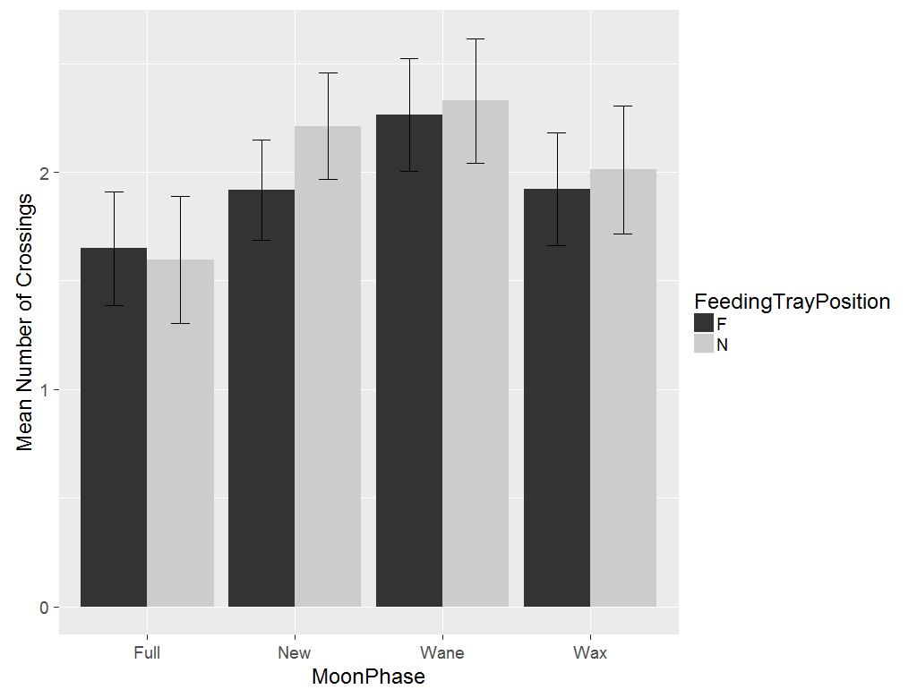

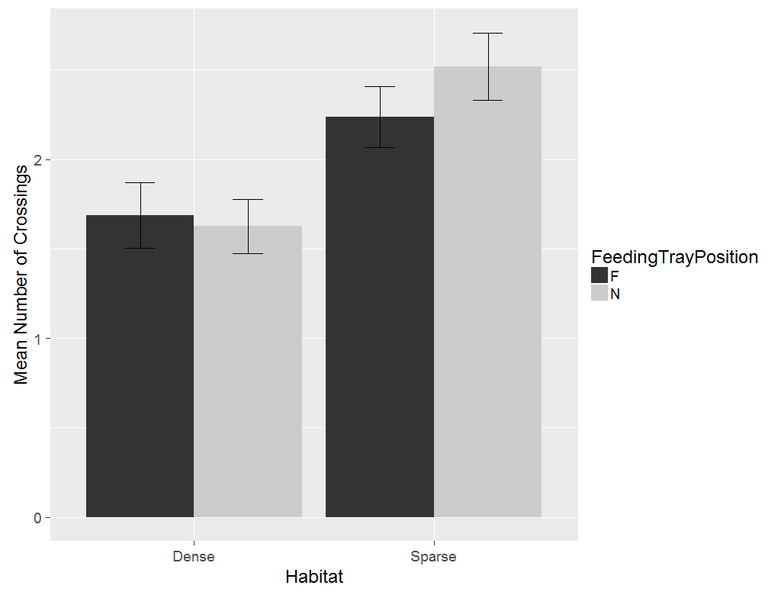  
c.

**Figure 5.** Effects of moon phase and habitat (a), moon phase and feeding tray position (b) and habitat and feeding tray position (c) on gerbil activity

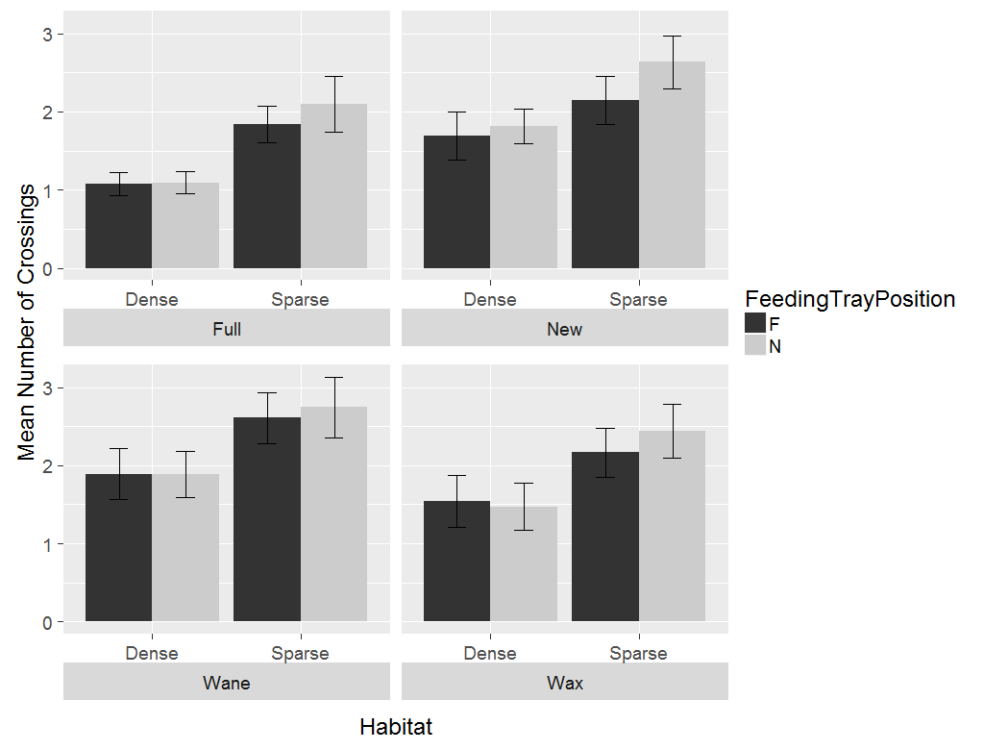

**Figure 6.** Effects of microhabitat, habitat and moon phase on gerbil activity

1. ***Feeding stations in habitats with dense Prosopis cover are harvested more than those in dense prosopis habitats***

**Analysis**: The giving-up density (GUD) for each feeding tray is averaged across three days for each moon phase. The values for the GUDs were strongly left-skewed (Figure 4).

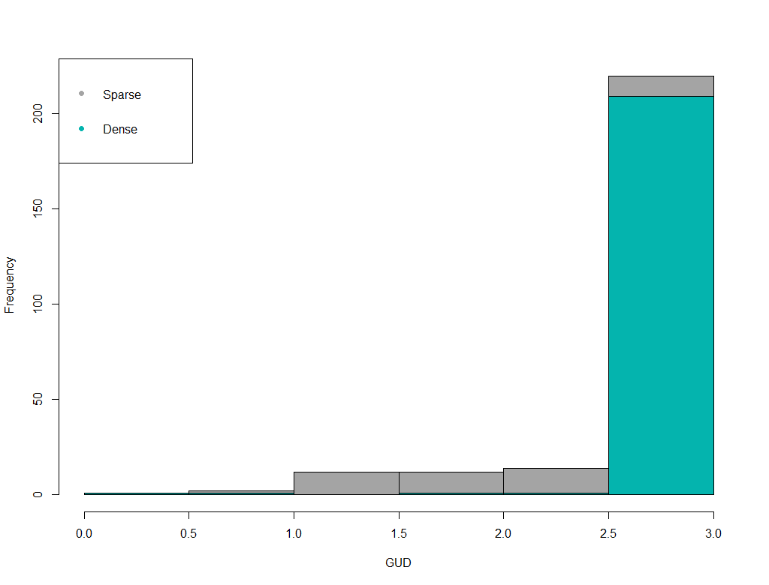

Figure 7. Frequency distribution of mean GUDs

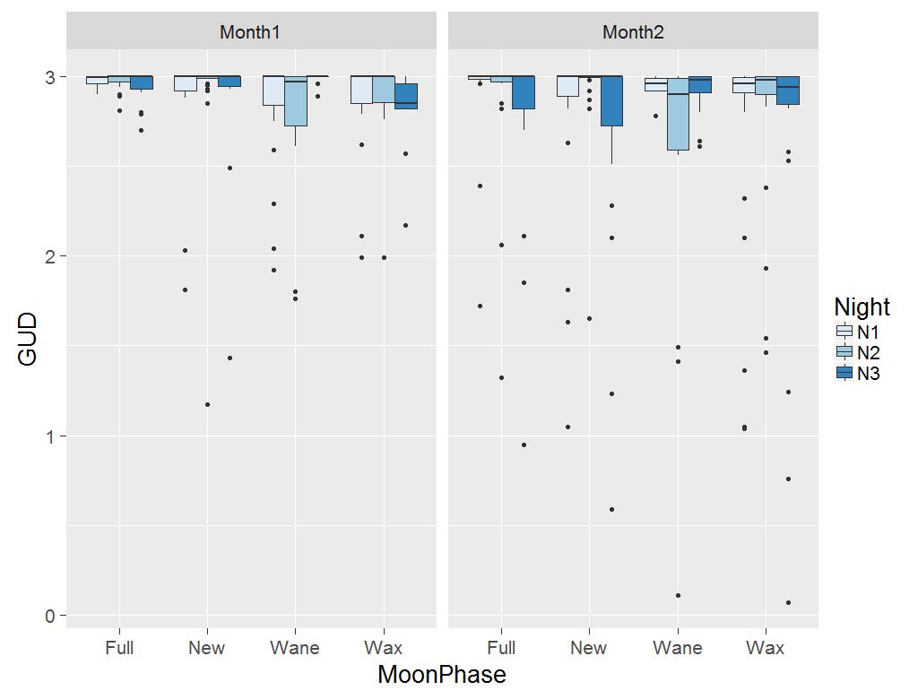 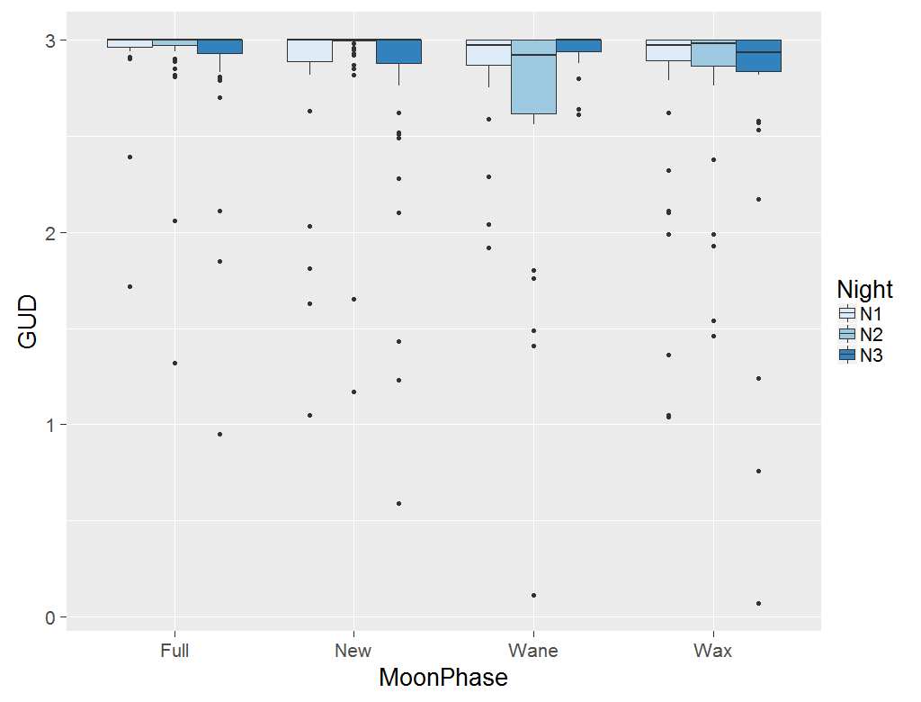**Figure 7.** GUDs on each night for different moon phases

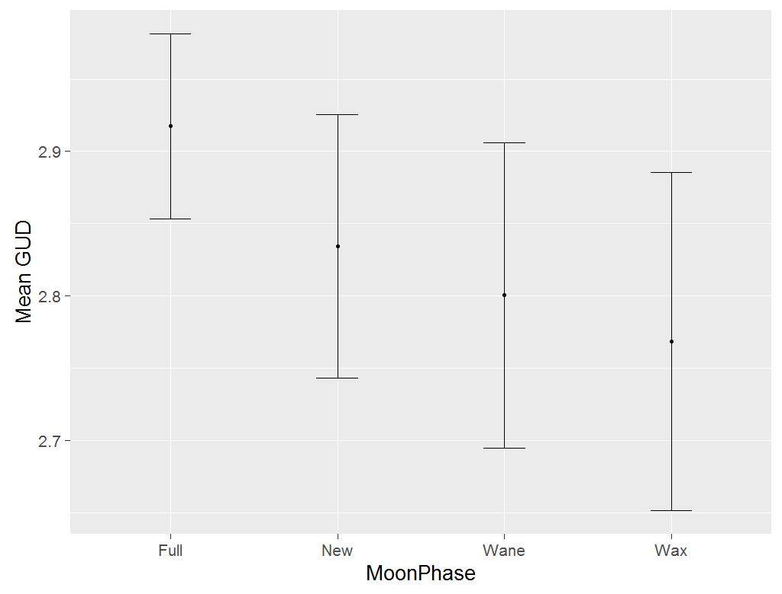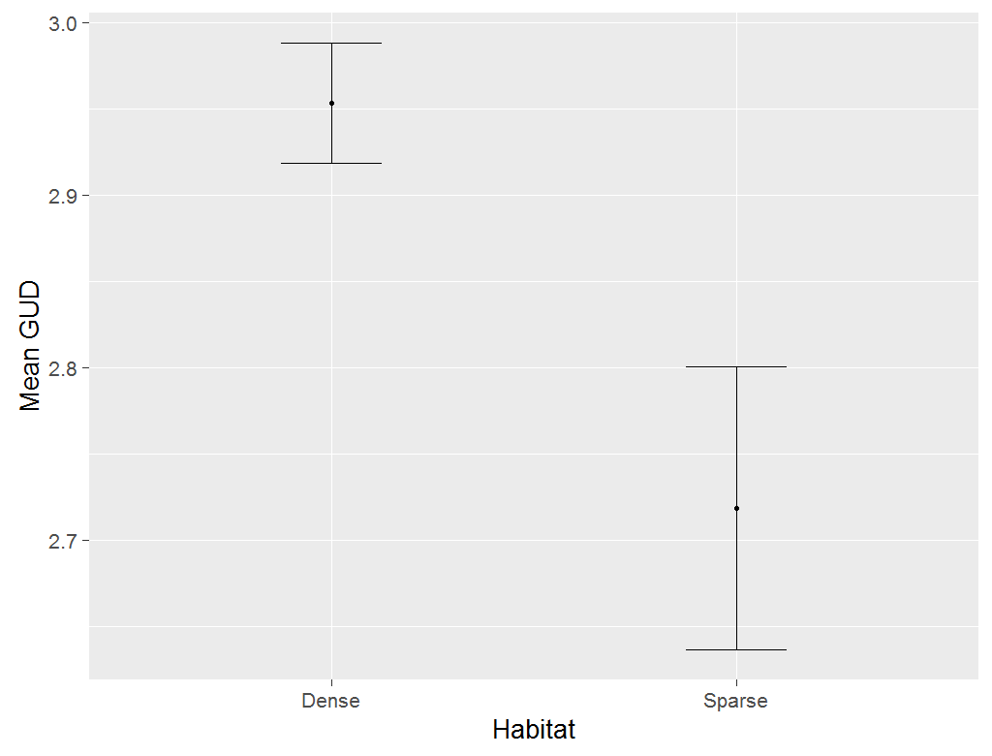

b.

a.

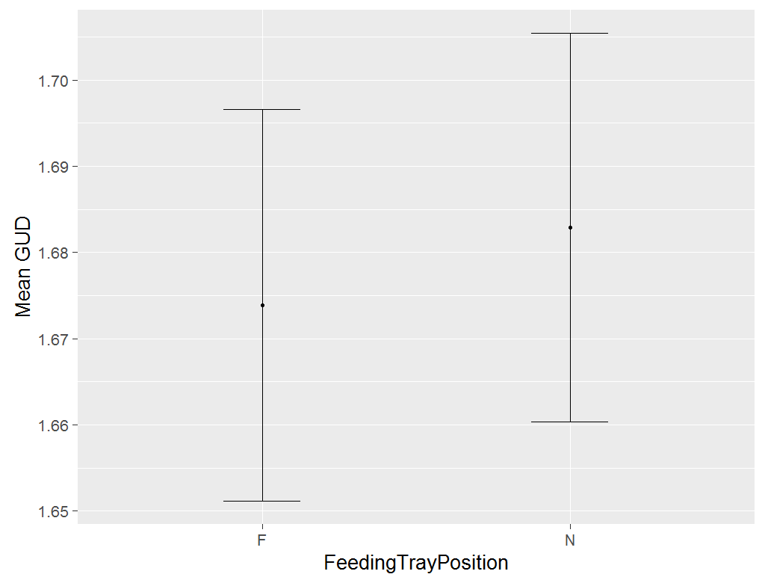 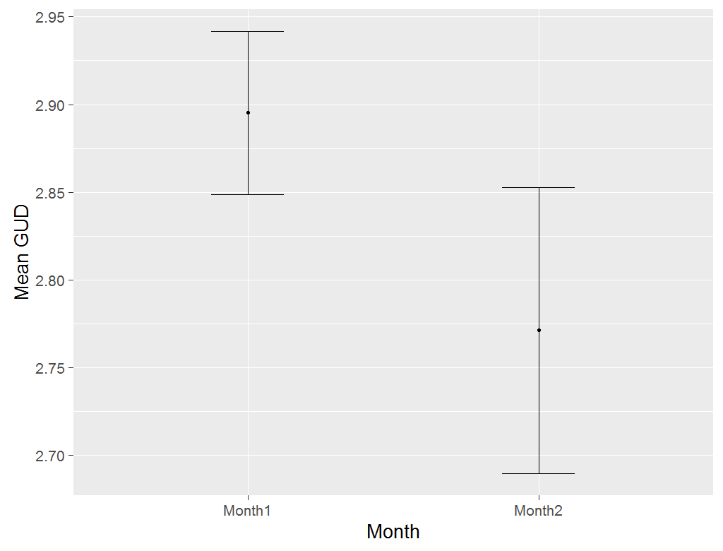

d.

c.

**Figure 8.** Effects of moon phase (a), habitat (b), feeding tray position (c) and month (d) on mean GUDs

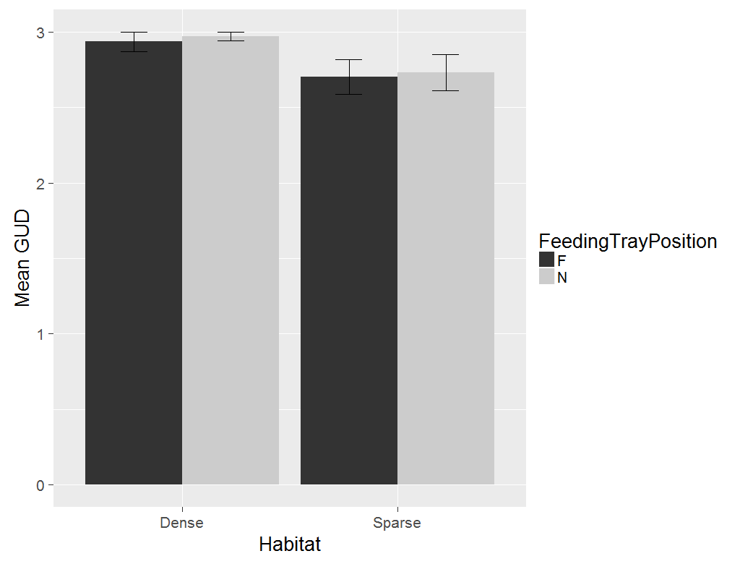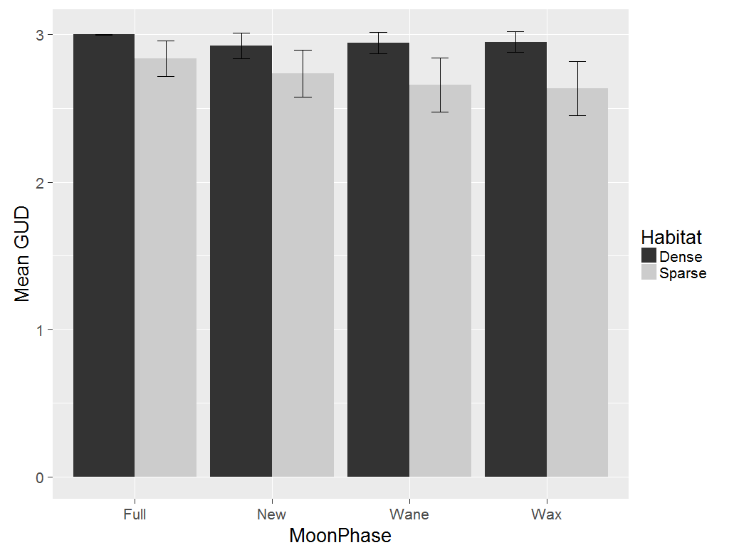

b.

a.

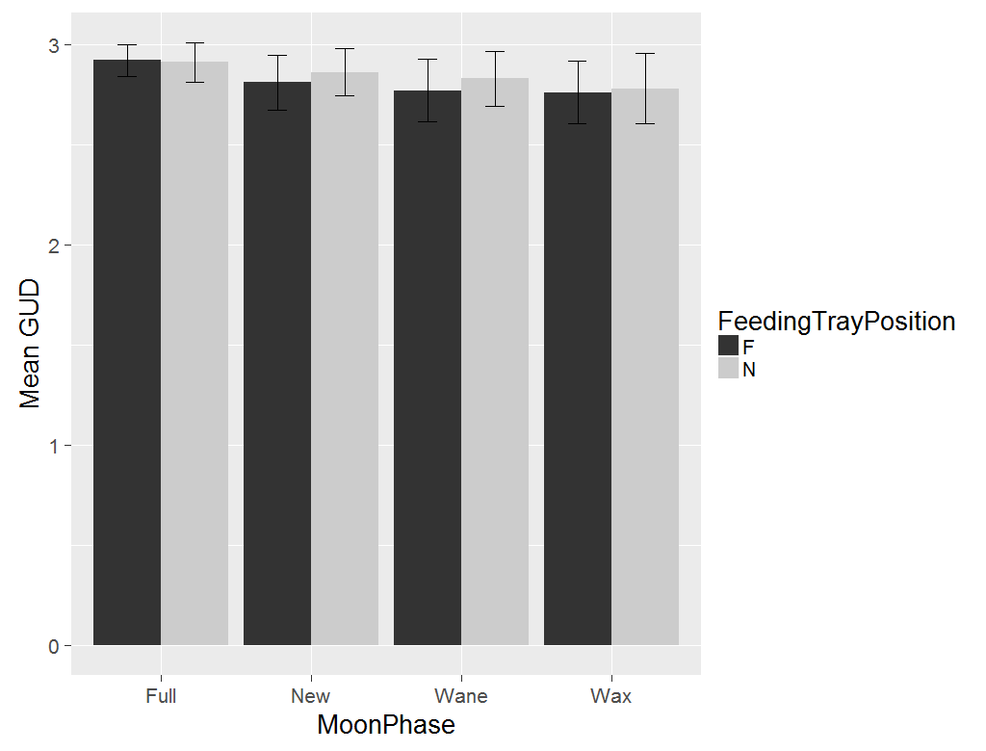 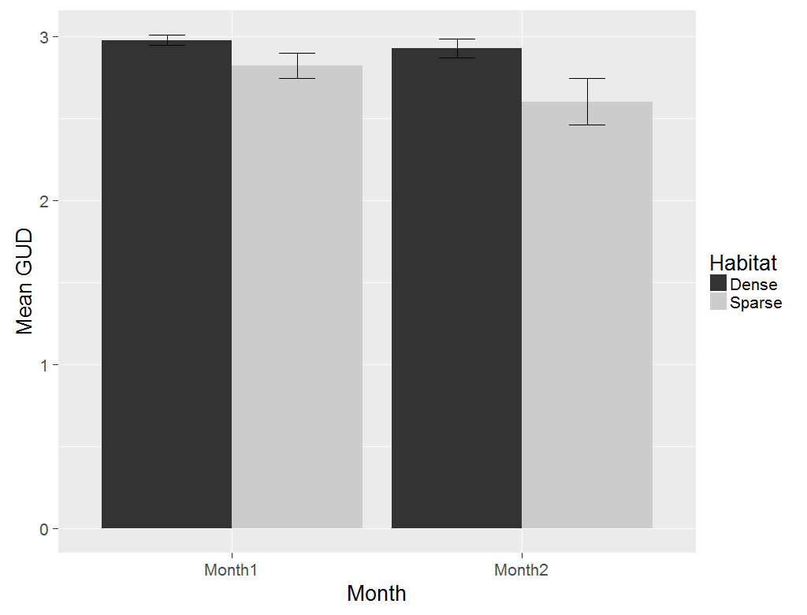

d.

c.

**Figure 9.** Effects of two-way interactions of habitat and feeding tray position (a), moon phase and habitat (b), moon phase and feeding tray position (c) and habitat and month on mean GUDs

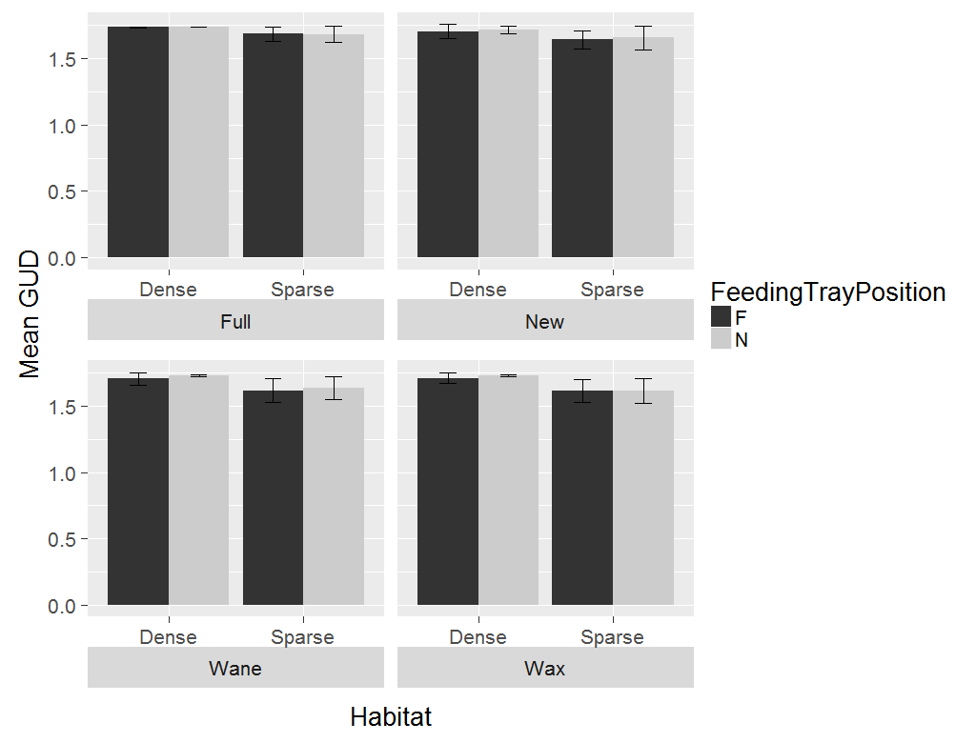

**Figure 10.** Effects of the three-way interaction between habitat, feeding tray position and moon phase on mean GUDs

1. ***How does removal of Prosopis affect rodent behaviour?***

**Methods:** A paired design was used to test for the effects of Prosopis removal on rodent foraging behaviour. Eight pairs of trees in a hundred metre square area were selected so that each tree that was cut had a control tree 10m away that was not cut. Additionally, two pairs of trees with 1x2m2 track plots were included to help better understand rodent activity. To account for microhabitat differences in foraging before and after the tree was cut, a pair of feeding trays were placed under each tree such that one tray was under cover and the other 3.5m away from cover. The trays were filled with 3l of sifted sand mixed with 3g of pearl millet seeds. Each tray had a 3m track plot around it. The track plots were smoothened and seeds were replaced daily for a five day period.

Data was collected three days prior to the cutting of trees, on the day the trees were cut and two days after the trees were cut.

1. ***How is rodent activity affected by the removal of Prosopis?***

**Analysis:** Rodent activity, measured as the number of footprints entering the track plot, was examined before, on and after trees were cut using linear mixed models. The model treated microhabitat (i.e., tree and open) and time of tree cutting (i.e., before, on and after) as fixed effects; Feeding station was treated as a random effect to account for repeated measures over multiple nights.

Tukey’s test was used to determine pairwise differences of GUDs and rodent activity between the time of tree cutting.

**Results:**

Time of cutting had a significant effect on rodent activity for cut trees (p= 2.842e-05, Table 4) as well as uncut trees (p= 0.022, Table 5). For cut trees, activity reduced in the order of Before > On > After (mean activity before trees were cut = 5.15 ± 3.74; on = 3 ± 1.26; after= 2.57 ± 1.52, Fig. 11). A similar, but weaker trend was exhibited around uncut trees (mean activity before cutting= 4.30 ± 3.27; on= 3.14 ± 1.82; after= 3.09 ± 1.51, Fig. 11).

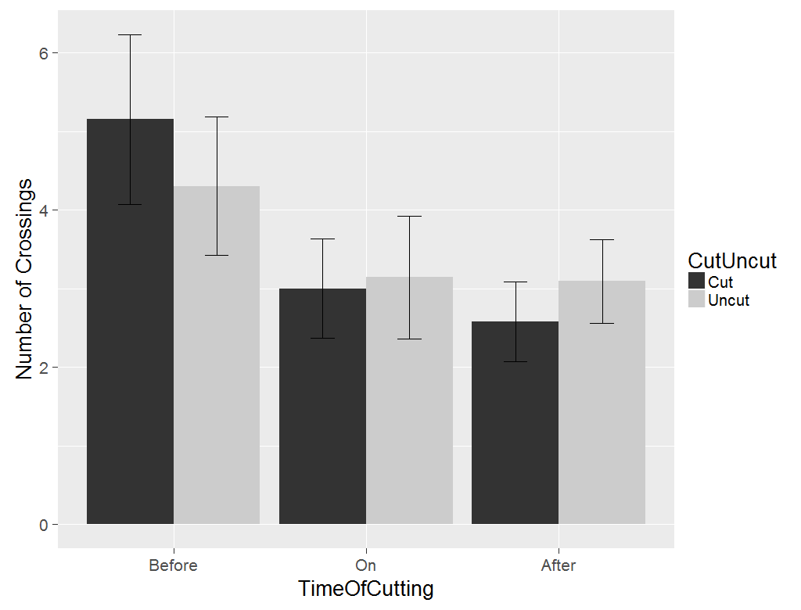 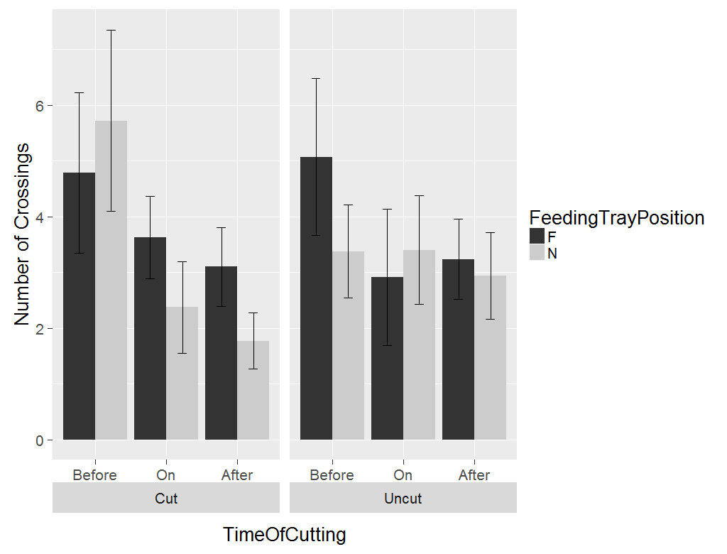

**Figure 11.** Effect of time of cutting tree (a) and the two-way interaction of time of cutting tree and feeding tray position on rodent activity

|  |
| --- |
| Chisq Df Pr(>Chisq) |
| TimeOfCutting 20.9368 2 2.842e-05 *** |
| NF 3.5277 1 0.06035 . |
| TimeOfCutting:NF 3.4745 2 0.17600 |

**Table 4.** Analysis of variance table for rodent activity around cut trees

|  |
| --- |
| Chisq Df Pr(>Chisq) |
| TimeOfCutting 7.6240 2 0.022104 * |
| NF 6.8218 1 0.009005 ** |
| TimeOfCutting:NF 10.1832 2 0.006148 ** |

**Table 5.** Analysis of variance table for rodent activity around uncut trees

|  |
| --- |
| **Estimate Std. Error z value Pr(>|z|)** |
| On - Before -1.8679 0.6671 -2.800 0.0137 * |
| After - Before -2.2415 0.5159 -4.345 <0.001 *** |
| After - On -0.3736 0.6792 -0.550 0.8450 |

**Table 6.** Post-hoc analysis of rodent activity around cut trees, according to time of cutting tree

|  |
| --- |
| Estimate Std. Error z value Pr(>|z|) |
| On - Before -0.7514 0.5575 -1.348 0.3661 |
| After - Before -1.2678 0.4927 -2.573 0.0267 * |
| After – On -0.5164 0.6172 -0.837 0.6780 |

**Table 7.** Post-hoc analysis of rodent activity around uncut trees, according to time of cutting tree

1. **How is foraging behaviour altered by removal of *Prosopis?***

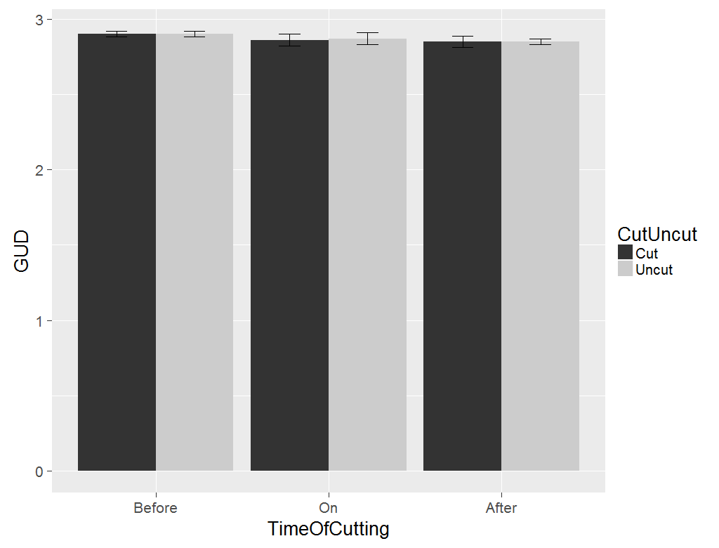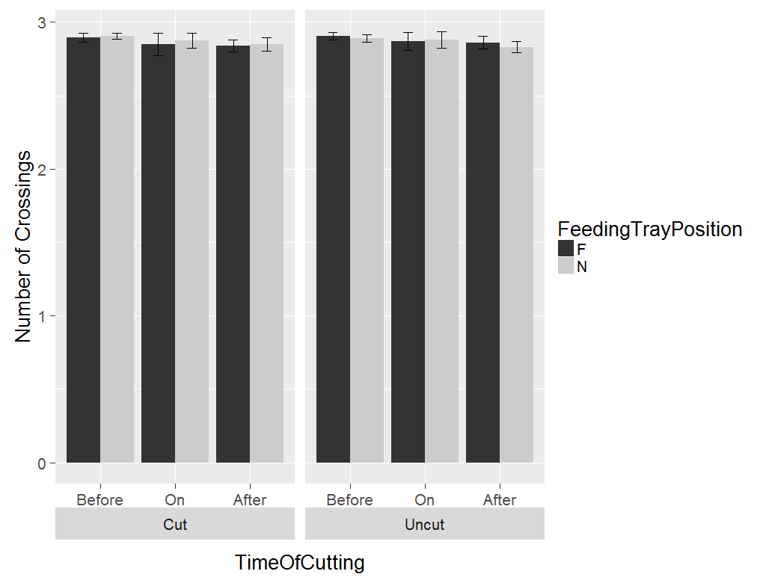

**Figure 11.** Effect of time of cutting tree (a) and the two-way interaction of time of cutting tree and feeding tray position on GUD

|  |
| --- |
| **Chisq Df Pr(>Chisq)** |
| TimeOfCutting 11.1850 2 0.003726 **  NF 0.6052 1 0.436597  TimeOfCutting:NF 0.1217 2 0.940974 |

**Table 7.** Analysis of variance table for GUDs for cut trees

|  |
| --- |
| **Chisq Df Pr(>Chisq)** |
| TimeOfCutting 13.2857 2 0.001303 ** |
| NF 1.1305 1 0.287669 |
| TimeOfCutting:NF 1.3424 2 0.511106 |

**Table 8.** Analysis of variance table for GUDs for uncut trees

|  |
| --- |
| **Estimate Std. Error z value Pr(>|z|)** |
| B - A == 0 0.05100 0.01560 3.268 0.00318 ** |
| O - A == 0 0.01681 0.02063 0.815 0.69140 |
| O - B == 0 -0.03420 0.01962 -1.743 0.18701 |

**Table 9.** Post-hoc analysis of rodent activity around uncut trees, according to time of cutting tree (B= Before, O=   
 On, A= After)

|  |
| --- |
| **Estimate Std. Error z value Pr(>|z|)** |
| B - A == 0 0.05148 0.01424 3.614 <0.001 *** |
| O - A == 0 0.02856 0.01888 1.513 0.282 |
| O - B == 0 -0.02291 0.01811 -1.265 0.411 |

**Table 10.** Post-hoc analysis of rodent activity around uncut trees, according to time of cutting tree

