1. **Linear model for activity**

Call:

lm(formula = log(mAct.df$meanCrossings) ~ mAct.df$moonPhase +

mAct.df$`Feeding tray position` + mAct.df$habitat)

Residuals:

Min 1Q Median 3Q Max

-1.67625 -0.41020 0.03863 0.45405 1.28632

Coefficients:

Estimate Std. Error t value Pr(>|t|)

(Intercept) 0.26915 0.12964 2.076 0.03915 *

mAct.df$moonPhaseNew 0.60607 0.13093 4.629 6.59e-06 ***

mAct.df$moonPhaseWane 0.78830 0.13131 6.003 8.89e-09 ***

mAct.df$moonPhaseWax 0.41149 0.13613 3.023 0.00283 **

mAct.df$`Feeding tray position`N 0.14105 0.08409 1.677 0.09503 .

mAct.df$habitatSparse 0.80103 0.08410 9.525 < 2e-16 ***

---

Signif. codes: 0 ‘***’ 0.001 ‘**’ 0.01 ‘*’ 0.05 ‘.’ 0.1 ‘ ’ 1

Residual standard error: 0.6004 on 201 degrees of freedom

Multiple R-squared: 0.3789, Adjusted R-squared: 0.3635

F-statistic: 24.53 on 5 and 201 DF, p-value: < 2.2e-16

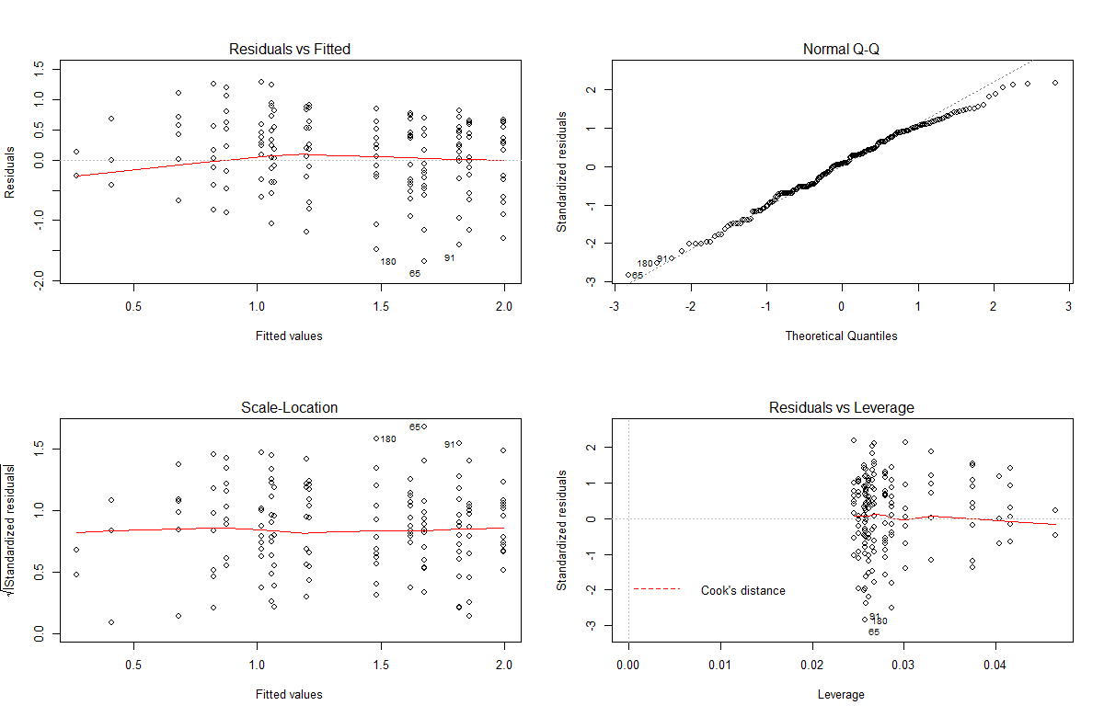

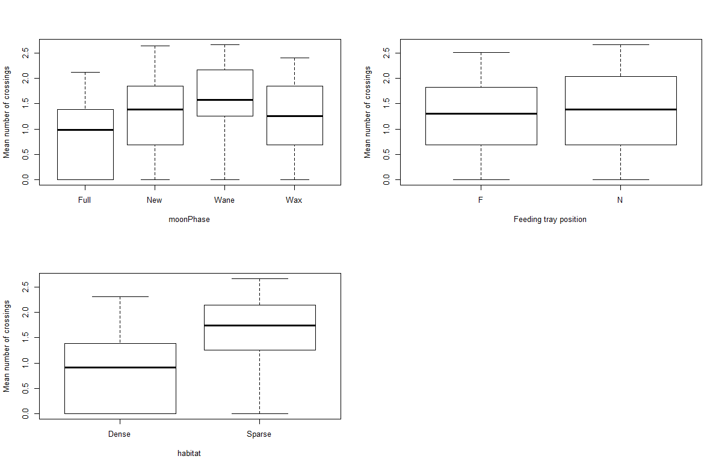

1. **Linear model for GUDs**

Call:

lm(formula = log(gMean$meanGUD) ~ gMean$moonPhase + gMean$nf +

gMean$habitat)

Residuals:

Min 1Q Median 3Q Max

-3.15721 0.00414 0.05582 0.10930 0.22514

Coefficients:

Estimate Std. Error t value Pr(>|t|)

(Intercept) 1.10686 0.05146 21.509 < 2e-16 ***

gMean$moonPhaseNew -0.05836 0.05549 -1.052 0.29413

gMean$moonPhaseWane -0.15693 0.05842 -2.686 0.00781 **

gMean$moonPhaseWax -0.05302 0.05945 -0.892 0.37348

gMean$nfN -0.01239 0.04089 -0.303 0.76213

gMean$habitatSparse -0.06407 0.04036 -1.588 0.11390

---

Signif. codes: 0 ‘***’ 0.001 ‘**’ 0.01 ‘*’ 0.05 ‘.’ 0.1 ‘ ’ 1

Residual standard error: 0.2932 on 209 degrees of freedom

Multiple R-squared: 0.04824, Adjusted R-squared: 0.02547

F-statistic: 2.119 on 5 and 209 DF, p-value: 0.06448

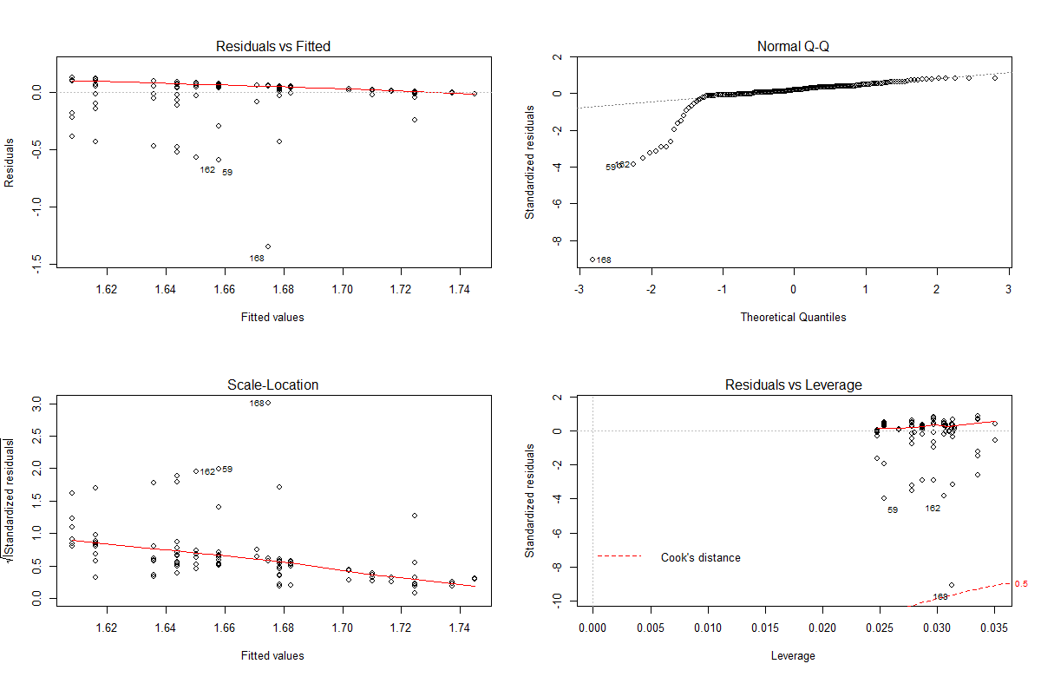

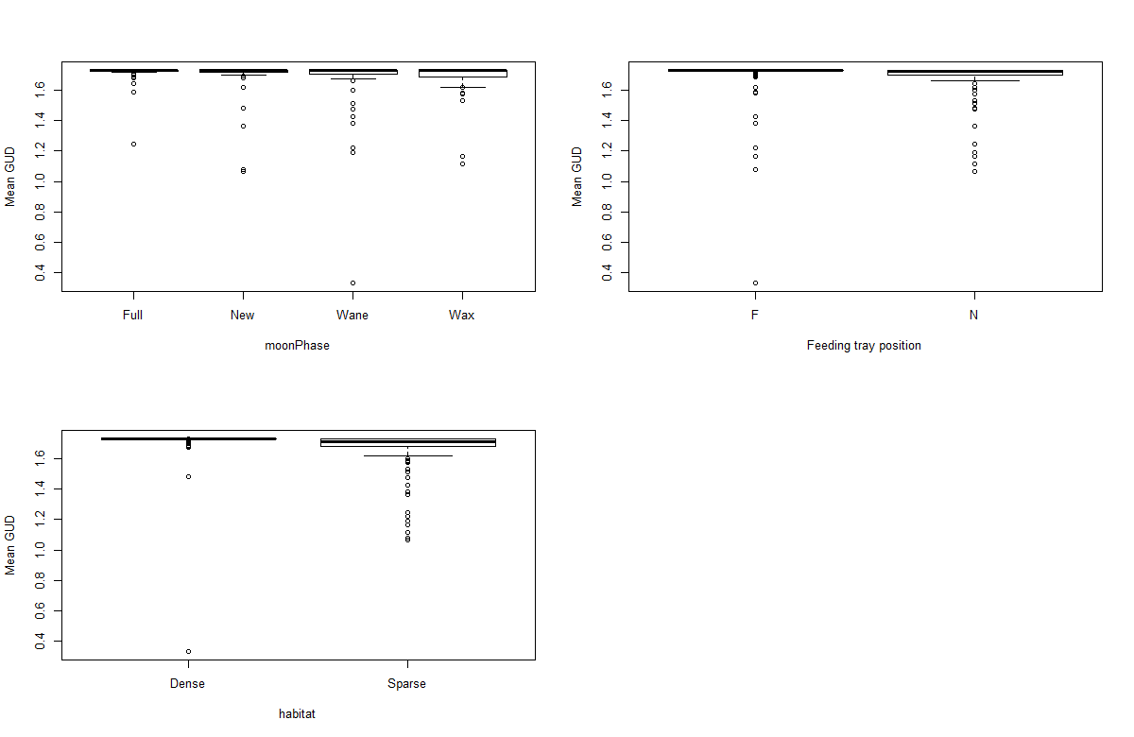

1. **Amount of seeds harvested by ants and birds**

