Manual Testing Assignment 2– QA

Part 1 – Bug Reporting (Realistic Scenario)

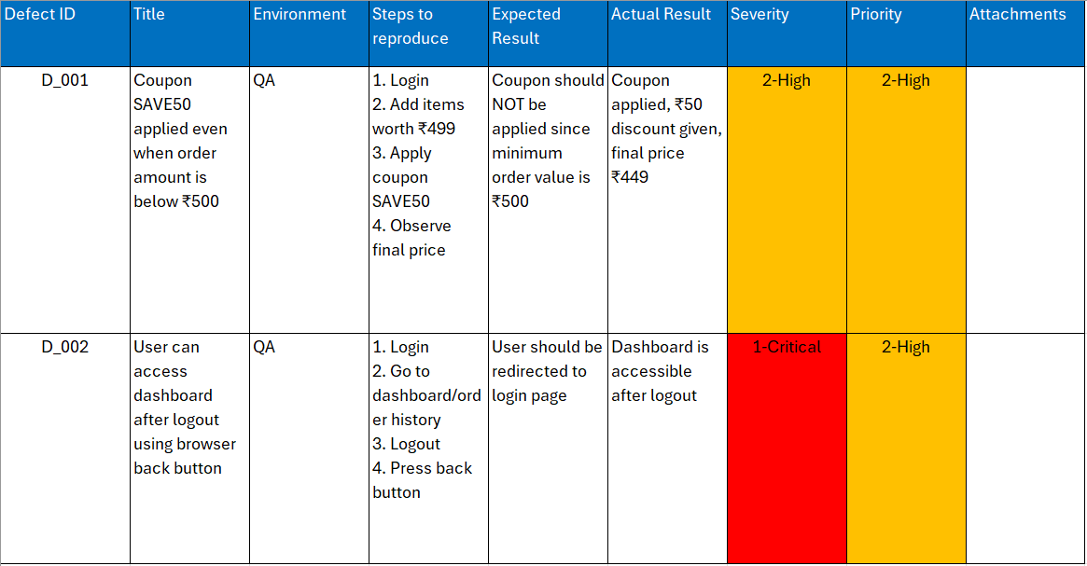

Part 2 – Black Box Testing
Test Case ID | Scenario | Input | Expected Result
TC_01 | Valid login | Email: test@gmail.com  Password: Abc12345 | Login successful
TC_02 | Email without @ | testgmail.com | Error message
TC_03 | Email without domain | test@ | Error message
TC_04 | Invalid domain | test@gmail | Error message
TC_05 | Password less than 8 chars | Abc123 | Error message
TC 06 | Password exactly 8 chars  (Boundary) | Abc12345 | Accepted
TC_07 | Password without uppercase | abc12345 | Error message
TC_08 | Password without number | Abcdefgh | Error message
TC_09 | Empty fields | “” | Error message
TC_10 | Valid different domain | test@yahoo.in Abc12345 | Login successful

Part 3 – White Box Testing (Logic Based)
- Decision Table
Condition | Order > 500 | User Type | Discount
Rule 1 | Yes | PREMIUM | 20%
Rule 2 | Yes | NORMAL | 10%
Rule 3 | No | PREMIUM | 0%
Rule 4 | No | NORMAL | 0%

2. Test cases to cover all branches
Test Case | Order Amount | User Type | Expected  Discount
TC_01 | 600 | PREMIUM | 20%
TC_02 | 600 | NORMAL | 10%
TC_03 | 500 | PREMIUM | 0%
TC_04 | 400 | NORMAL | 0%

3. Cyclomatic Complexity

Formula: M = E - N + 2P
- Number of Decision points +1
- Decision Points:
- orderAmount >500
- UserType == Premium

M = 2+1=3
Cyclomatic Complexity = 3

