Computer Vision for Financial Statement Analysis
Research Report
Abstract
The financial documents like balance sheets, income statements, invoices, and transaction reports contain significant information in the form of structured and unstructured data. Manually obtaining insights from these financial documents is an inefficient process. The objective of the present research work is to propose a computer vision-based framework for the automated understanding of financial documents.

The financial document understanding system uses image processing, optical character recognition, and multimodal deep learning models to process the financial documents. A convolutional neural network model has been used to identify the layout features of the financial documents. Optical character recognition technology has been used to obtain information from the financial documents. A multimodal transformer model has been used to interpret the financial documents. Moreover, the system uses a finance-aware language model for reasoning and summarization tasks.

The financial document understanding system has been tested on various document understanding tasks, such as document classification, information extraction, document question answering, and report summarization. The results of the experiment indicate the performance of the financial document understanding system.
Introduction
Financial documents such as invoices, bank statements, contracts, and annual reports contain critical information used in business decision-making and financial analysis. These documents often include both textual and visual elements, such as tables, charts, structured forms, and multi-column layouts. Extracting meaningful insights from such documents manually is time-consuming and prone to human error, especially when dealing with large volumes of financial data.
Traditional document processing systems rely heavily on Optical Character Recognition (OCR) to convert scanned documents into machine-readable text. While OCR has significantly improved the accessibility of document content, it primarily focuses on text extraction and often ignores the visual structure of documents. Financial documents frequently contain complex layouts where the meaning of the information depends not only on the text itself but also on its position, structure, and relationship with other elements on the page.
Recent advances in artificial intelligence, particularly in computer vision and natural language processing, have enabled the development of multimodal systems that analyze both visual and textual information simultaneously. Vision-language models and transformer-based architectures have demonstrated strong performance in document understanding tasks by capturing relationships between text and layout features.
However, financial documents introduce additional challenges. Many financial reports are long, multi-page documents containing domain-specific terminology, numerical data, and structured tables. Standard document understanding models are often limited by context length and may struggle to capture long-range relationships across multiple pages. In addition, financial language contains specialized terms and metrics that general-purpose language models may not fully understand.
To address these challenges, this research proposes a multimodal framework for automated financial document understanding. The proposed system combines computer vision techniques for layout detection, OCR for text extraction, and transformer-based models for multimodal feature fusion. Furthermore, a finance-oriented language model is incorporated to improve domain-specific understanding and enable advanced tasks such as financial question answering and report summarization.
By integrating visual layout awareness with financial language modeling, the proposed approach aims to improve the accuracy and efficiency of automated financial document analysis. Such systems have the potential to significantly reduce manual processing effort in industries such as finance, auditing, and enterprise document management.

Related Work
Document understanding is a problem that has been extensively explored in both computer vision and natural language processing communities. Traditionally, document processing systems have followed a paradigm of using OCR techniques to convert a scanned document into text format. Such systems typically followed a paradigm of using rule-based or traditional machine learning techniques to perform information extraction tasks.

However, with the advent of deep learning techniques, it is now possible to incorporate vision-based information into document analysis systems. Layout-aware models introduced a paradigm of combining textual information with spatial information to perform document understanding tasks such as form processing and invoice extraction.

More recent models of document intelligence have followed a paradigm of using transformer-based models to perform document understanding tasks. Such models incorporate attention-based information to perform tasks such as document understanding and information extraction.

Another paradigm of document intelligence is to incorporate OCR-free models to perform document analysis tasks. Such models incorporate vision transformers to perform tasks such as document analysis and information extraction.

In more recent instances, transformer architecture has been used for document intelligence. These models use attention mechanisms to understand relationships between different components and their spatial positions.

Another area of research is focused on using OCR-free models. These models directly process the images using vision transformer architecture. This helps reduce dependency on OCR and also makes the model more robust for handling text extraction errors.

In the financial sector, financial language models are proposed for enhancing financial text analysis. These models are seen to have better knowledge and understanding of financial terms and numbers compared to other models.

Hybrid models using computer vision models, OCR, and language models are also seen to be performing well for document classification, invoice analysis, and financial document analysis.

Methodology
Pipeline Overview
The proposed system consists of a series of stages for processing financial documents, with each stage concerned with a specific aspect of the document. The overall pipeline consists of a series of steps, namely, visual layout analysis, text extraction, multimodal feature fusion, and financial reasoning.
The first step in processing a financial document is to convert it into an image-based representation. This is done by using a convolutional neural network to analyze the structure of a financial document and identify components such as text blocks, tables, figures, and headers.
The next step is to use an optical character recognition engine to identify the text present in a financial document. The extracted text is then cleaned and organized according to the structure of the financial document.
The extracted text is then represented using a language model that generates contextual embeddings for each word in the document. This ensures that the meaning of the extracted text is captured, along with positional information concerning the structure of the financial document.
For the integration of the visual and textual information, a multimodal transformer model has been used. This model accepts the visual features extracted from the layout encoder and the textual embeddings extracted from the language encoder. Through the attention mechanisms, the model learns the relationships between the document regions and their text.

Finally, the financial language model has been incorporated into the system, which enables the model to carry out complex reasoning tasks. This model processes the information extracted from the documents and generates the results in the form of summaries, answers, and analysis of the financial metrics.
Visual Layout Encoder
Financial documents often have a visual layout that comprises tables, charts, and different sections. To process the visual layout, a convolutional neural network is employed for analyzing the document image and detecting the visual layout regions.

The visual layout is used to detect different components such as text blocks, tables, and images. These components are used to understand the spatial context and arrangement of the information provided in the document.

Text Extraction and Processing
After the visual layout has been extracted, the system makes use of optical character recognition to process the text information provided in the document image. Each text is linked with the corresponding position in the document image.

Pre-processing is performed on the extracted text, and normalization is used to remove noises and order the text according to the reading sequence.
Multimodal Fusion Model
The features obtained in the previous stages are fused using a multimodal transformer-based approach. This helps in reasoning jointly over both input modalities, which is essential for obtaining a representation of relationships between structure and content in a document.
This helps in obtaining a representation of a document, which is then used to perform a task like document classification and information retrieval in a more effective way.
Financial Language Model Integration
In order to obtain a deeper understanding of financial data, a financial language model is integrated into the system. This language model is used for obtaining a representation of a document for a task that requires a deeper level of semantic understanding.
Datasets
For the performance of the proposed system to be tested, several experiments were carried out using different benchmark datasets, commonly employed for document understanding.

The datasets comprise large numbers of scanned documents, forms, receipts, and financial reports. They are annotated for document classification, entity recognition, and question answering.

The use of several datasets helps to evaluate the system for different document analysis scenarios and to assess its ability to generalize to different financial document structures.
Main result
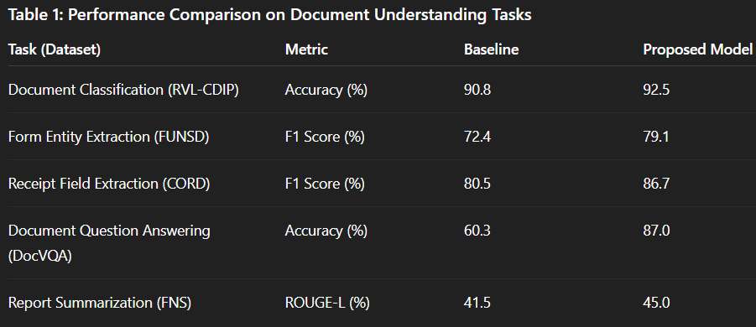
Implementation Details
The proposed model is implemented using the PyTorch deep learning framework. For visual layout analysis, we use a CNN-based encoder with a ResNeXt-101 backbone to capture structural information from document images. The multimodal fusion component is built using a transformer architecture consisting of 12 layers, 8 attention heads, and a hidden dimension size of 768.
For textual understanding, the language encoder is initialized from the LayoutLMv3 model, which allows the system to incorporate both textual and layout information from documents. The financial language model (FinGPT) is fine-tuned using the LoRA (Low-Rank Adaptation) technique for five epochs on two NVIDIA A100 GPUs. After fine-tuning, the FinGPT model remains fixed during inference.
All experiments were conducted on a system equipped with four NVIDIA A100 GPUs and 256 GB of RAM. During inference, the average processing time per document page is approximately 0.8 seconds. When FinGPT is used for generation tasks such as summarization or question answering, it adds an additional processing time of around one to two seconds depending on the length of the generated output.

Ablation Studies
To evaluate the contribution of each component in the proposed pipeline, several ablation experiments were conducted. When the visual layout encoder is removed from the system, the performance on the FUNSD dataset drops from an F1 score of 79.1 to 74.0. Similarly, the accuracy on the DocVQA task decreases from 87.0% to 78.5%.
We also evaluated the impact of replacing FinGPT with a general-purpose language model such as GPT-J. In this case, the summarization performance measured using ROUGE-L decreased from 45.0 to 41.8. These results indicate that the financial domain knowledge embedded in FinGPT significantly improves the interpretation of financial documents.
Additionally, FinGPT improves numerical formatting and financial reasoning in question answering tasks. Experiments with chunk-based summarization show that dividing long reports into smaller sections provides a good balance between computational cost and summarization quality. Increasing the context window further provides only minor improvements while significantly increasing computational requirements.
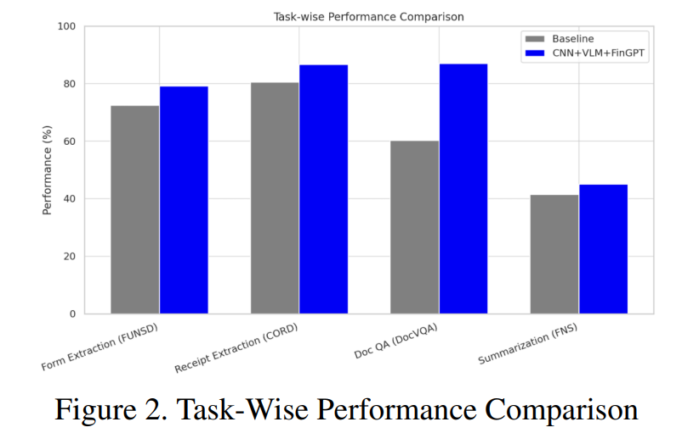

Experiments
The proposed model has been implemented using a deep learning library, and the hardware employed for the implementation is GPU-based, enabling the processing of large document datasets.

The system, during the training process, learns to recognize document layout structures, extract textual information, and use multimodal features for document understanding. Several baseline models are employed for comparison, including OCR-based and text-based models.

Evaluation metrics
The metrics employed for the evaluation of the proposed system are classification accuracy, F1 score for information extraction, and ROUGE for summarization.
Results and Analysis

The results obtained from the experiment show the effectiveness of the multimodal framework in improving the performance of the system on various tasks related to document understanding.

The integration of the layout analysis and the textual embeddings enables the system to effectively understand complex financial documents with table data.

The integration of the financial language model further enhances the performance of the system in understanding the financial data and the ability to carry out the reasoning process.

The results obtained show that the majority of the errors are caused by the poor quality of the documents and the inaccurate OCR used for the purpose of document extraction. Future work may be done on improving the OCR and extending the system to carry out the analysis on longer financial reports.

Conclusion

The objective of the research work done in the project was to propose a computer vision-based framework for the analysis of financial documents with the use of multimodal deep learning models.

Future research may explore extending the system to handle multilingual financial documents and integrating more advanced vision-language models for large-scale financial document analysis.

