## **Assignment 3**

Data Files needed for the Review Assignments: dlr_mornings_txt.html, dlr_tables2_txt.css, dlr_columns2_txt.css, 2 css files, 3 PNG files

Kyle has reviewed your work on the DLR nightly schedule page. He wants you to make a few changes to the layout and apply those changes to a new page that describes the DLR morning schedule. Kyle already has entered much of the web page content and style. He wants you to complete his work by creating and designing the web table listing the times and programs for the morning schedule. Figure (1) shows a preview of the morning schedule page.

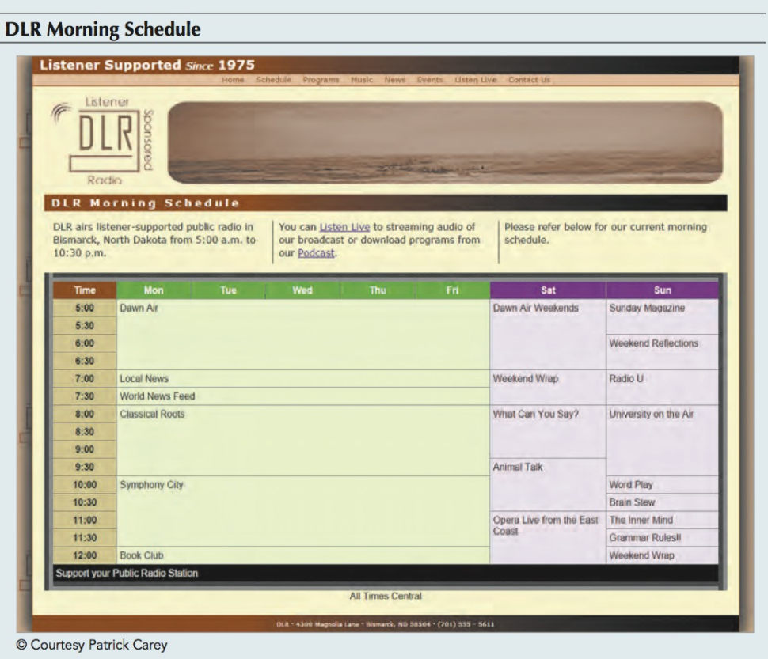

Figure (1)

**Complete the following:**

1. Use your HTML editor to open the dlr_mornings_txt.html, dlr_tables2_txt.css and dlr_columns2_txt.css files from the html06 c review folder. Enter your name and the date in the comment section of each file, and save them as dlr_mornings.html, dlr_tables2.css and dlr_columns2.css respectively.

2. Go to the dlr_mornings.html file in your editor. Insert links to the dlr_tables2.css and dlr_columns2.css style sheets.

3. Scroll down the file and directly below the paragraph element, insert a web table with the class name programs.

4. Add a table caption containing the text All times central.

5. Below the caption, insert a colgroup element containing three columns. The first col element should have the class name timecolumn. The second col element should have the class name wDaycolumns and span five columns in the table that will contain the weekday programs. The last col element should have the class name wendcolumns and span the last two columns containing the weekend programming.

6. Add the thead row group element containing a single table row with th elements containing the text shown in Figure (1).

7. Add the tfoot row group element containing a single row with a single td element that spans 8 columns and contains the text support your Public Radio station.

8. Add the tbody row group element containing the times and names of the different DLR programs from 5:00 a.m. to 12:00 p.m., Monday through Sunday, in half-hour intervals. The times should be placed in th elements and the program names in td elements. Create row- and column- spanning cells to match the layout of the days and times shown in Figure (1).

9. Close the dlr_mornings.html file, saving your changes.

10. Return to the dlr_tables2.css file in your editor and go to the Table Styles section. Create a style rule for the programs table that: a) sets the width of the table to 100%, b) adds a 15-pixel outset border with a color value of rgb(151, 151, 151), c) defines the borders so that they are collapsed around the table, and d) sets the font family to the font stack: Arial, Verdana, and sans-serif.

11. Create a style rule that sets the height of every table row to 25 pixels.

12. Create a style rule for every th and td element that: a) adds a 1-pixel solid gray border, b) aligns the cell content with the top of the cell, and c) sets the padding space 5 pixels.

13. Go to the Table Caption Styles section and create a style rule that places the caption element at the bottom of the table and centered horizontally.

14. Go to the Table Column Styles section. For col elements belonging to the timeColumn class, create a style rule that sets the column width to 10% and the background color to the value rgb(215, 205, 151).

15. For col elements of the wDayColumns class, create a style rule that sets the column width to 11% and the background color to rgb(236, 255, 211).

16. For col elements of the wEndColumns class, create a style rule that sets the column width to 17% and the background color to rgb(255, 231, 255).

17. Kyle wants you to format the table heading cells from the table header row. Go to the Table Header Styles section and create a style rule to set the font color of the text within the thead element to white and the background color to a medium green with the value rgb(105, 177, 60).

18. The different cells in the table header row should be formatted with different text and background colors. Using the first-of-type pseudo-class, create a style rule that changes the background color of the first th element with the thead element to rgb(153, 86, 7).

19. Using the nth-of-type pseudo-class, create style rules that change the background color of the 7th and 8th th elements within the thead element to rgb(153, 0, 153).

20. Kyle wants the table footer to be formatted in a different text and background color from the rest of the table. Go to the Table Footer Styles section. Create a style rule for the tfoot element that sets the font color to white and the background color to black.

21. Save your changes to the dlr_tables2.css style sheet.

22. Return to the dlr_columns2.css file in your editor. Kyle wants the introductory paragraph to appear in a three column layout for desktop devices. Within the Column Styles section, create a media query for screen devices with minimum widths of 641 pixels.

23. Within the media query, create a style rule for the paragraph element that: a) sets the column count to 3, b) sets the column gap to 20 pixels, and c) adds a 1-pixels solid black dividing line between columns. (Note: Remember to use web extensions to provide support for older browsers.)

24. Save your changes to the dlr_columns2.css style sheet and then open the dlr_mornings.html file in your browser and verify that the table layout and design resemble that shown in Figure (1).