**VISVESVARAYA TECHNOLOGICAL UNIVERSITY**

**BELGAUM, 590018**

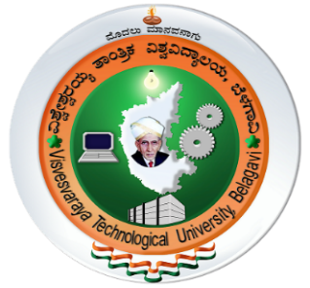

**Mini Project Report**

On

OpenGL Nature: Simulation of SaIT

A mini project submitted in partial fulfillment of the requirements for the

# Computer Graphics & Visualization Laboratory

**of**

**Bachelor of Engineering**

**in**

**Computer Science & Engineering**

**Submitted by**

**Dilip Chaudhary 1ST15CS038**

**Anish Miya Ansari 1ST15CS019**

Under the Guidance of

Mrs. Anitha K

. Asst Prof., Dept of CSE



# Department of Computer Science & Engineering

**Sambhram Institute of Technology Bangalore-560097**

**2017-2018**

**SAMBHRAM INSTITUTE OF TECHNOLOGY**

BENGALURU-97

(Affiliated to Visvesvaraya Technological University, Belgaum)



# Department of Computer Science & Engineering

**CERTIFICATE**

This is to certify that the mini project entitled **“OpenGL Nature: Simulation of SaIT”** is bonafied work carried out by **Anish Miya Ansari** (**USN 1ST15CS019)** and **Dilip Chaudhary**(**USN 1ST15CS038)** in partial fulfillment requirement of sixth semester **Bachelor of Computer Science and Engineering** of the Visvesvaraya Technological University Belgaum, during the academic year 2017-2018.It is also here by ,ensured that all the correction/suggestion indicated for Internal Assessment have been incorporated while submitting this report. The mini project has been approved as it satisfied the academic requirements in respect of mini project work for said course.

…………………………………… ……………………………………. **Mrs. Anitha K**  **Dr. T. John Peter**

Asst Prof., Dept of CSE HOD, Dept. of CSE, SaIT

Examiner Signature with date

1……………………. ………………………..

2…………………….. …………………………