CSC 352 / 452: Database Programming
assignment #2 (70 Points)
(Due on WEDNESDAY, 7/27/2011)

Any homework that is late will lose 50% of the points for each day that it is late. No homework will be accepted more than two days after its due date.

If you modified the EMPLOYEE table created in Assignment #1, you need to truncate and re-populate the table.
1) (10 points)
Based on the EMPLOYEE table created in Assignment #1, write a PL/SQL anonymous block that accepts an employee ID from the user input and finds whether the employee ID is in the EMPLOYEE table.

To avoid complicating issues, you can assume that the user always enters input from keyboard that consists only of the digits 0 through 9 and Enter.

The EXCEPTION Section is NOT allowed in your program.
Explicit cursors are NOT allowed in your program.

Example:

ACCEPT p_1 PROMPT 'Please enter the Employee ID:'
DECLARE
-- Your statements

BEGIN
-- Your statements
END;

Test your program to ensure that you get the following results.

Case 1)
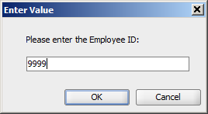

Output:
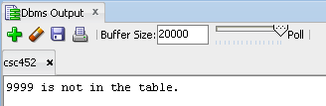

Case 2)
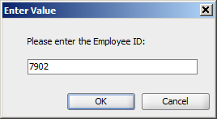

Output:
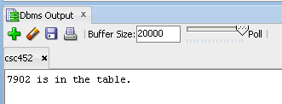

2) (30 points)
Based on the EMPLOYEE table created in Assignment #1, write a PL/SQL anonymous block that accepts an employee ID from the user input and displays name, salary, department name, manager name, and manager salary for the employee.

To avoid complicating issues, you can assume that the user always enters input from keyboard that consists only of the digits 0 through 9 and Enter.

The EXCEPTION Section is NOT allowed in your program.
Explicit cursors are NOT allowed in your program.

Example:

ACCEPT p_1 PROMPT 'Please enter the Employee ID:'
DECLARE
-- Your statements

BEGIN
-- Your statements
END;

Test your program and ensure that the output of your program should match the following:

Case 1)

Output:

Case 2)

Output:

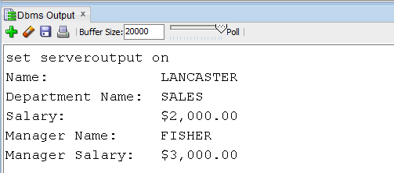

Case 3)
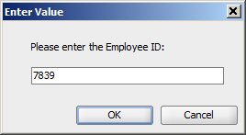

Output:

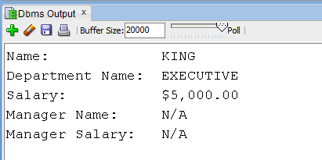

3a) (CSC 352 only - 30 points)

Write a PL/SQL program that accepts a text and a pattern as input strings, and displays the number of times the pattern appears in the text. For example, given “CORPORATE FLOOR” as the input text and “OR” as the pattern, your program should display 3. You can assume that the maximum length of the input text is 256.

Hint: You may use the INSTR(string, substring, position, occurrence) function and find the maximum occurrence.

You can find the examples from c1_Review_of_Basic_Oracle_SQL_Features.doc.

Test your program and ensure that the output of your program should match the following:

Case 1)

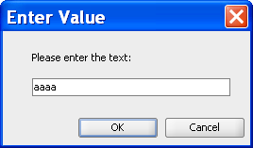

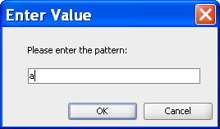

Output:

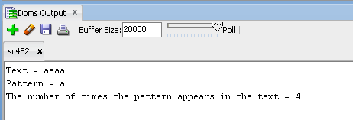

Case 2)
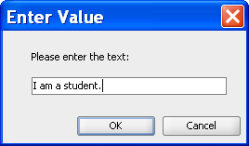

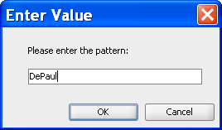

Output:
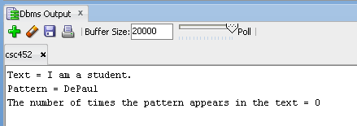

3b) (CSC 452 only - 30 points)

In a bug tracking database, there is a table called BUGS. The table has several columns: BUG_ID, REPORTED_DATE, DESCRIPTION, PRIORITY, ASSIGNED_TO, CLOSED_DATE, and NOTE.

a) Create table BUGS as described below.

CREATE TABLE bugs
(
BUG_ID NUMBER PRIMARY KEY,
REPORTED_DATE DATE NOT NULL,
DESCRIPTION VARCHAR2(20),
PRIORITY NUMBER(2),
ASSIGNED_TO VARCHAR2(10),
CLOSED_DATE DATE,
NOTE VARCHAR2(20)
);

b) Populate the BUGS table.

INSERT INTO BUGS VALUES (1230, '25-APR-09', NULL, 3, 'Team 3', '28-APR-09', NULL);
INSERT INTO BUGS VALUES (1231, '29-APR-09', NULL, 1, 'Team 1', '29-APR-09', NULL);
INSERT INTO BUGS VALUES (1232, '01-MAY-09', NULL, 1, 'Team 1', '01-MAY-09', NULL);
INSERT INTO BUGS VALUES (1233, '01-MAY-09', NULL, 1, 'Team 3', '01-MAY-09', NULL);
INSERT INTO BUGS VALUES (1234, '01-MAY-09', NULL, 2, 'Team 5', '04-MAY-09', NULL);
INSERT INTO BUGS VALUES (1235, '01-MAY-09', NULL, 2, 'Team 1', '04-MAY-09', NULL);
INSERT INTO BUGS VALUES (1236, '01-MAY-09', NULL, 5, 'Team 6', NULL, NULL);
INSERT INTO BUGS VALUES (1237, '05-MAY-09', NULL, 1, 'Team 2', '06-MAY-09', NULL);
INSERT INTO BUGS VALUES (1238, '05-MAY-09', NULL, 3, 'Team 3', '10-MAY-09', NULL);
INSERT INTO BUGS VALUES (1239, '07-MAY-09', NULL, 4, 'Team 5', '16-MAY-09', NULL);
INSERT INTO BUGS VALUES (1240, '09-MAY-09', NULL, 5, 'Team 2', '30-MAY-09', NULL);
INSERT INTO BUGS VALUES (1241, '09-MAY-09', NULL, 1, 'Team 1', '09-MAY-09', NULL);
INSERT INTO BUGS VALUES (1242, '10-MAY-09', NULL, 4, 'Team 4', '20-MAY-09', NULL);
INSERT INTO BUGS VALUES (1243, '15-MAY-09', NULL, 4, 'Team 3', '01-NOV-09', NULL);
INSERT INTO BUGS VALUES (1244, '15-MAY-09', NULL, 2, 'Team 4', '20-MAY-09', NULL);
INSERT INTO BUGS VALUES (1245, '25-MAY-09', NULL, 2, 'Team 1', '25-MAY-09', NULL);
INSERT INTO BUGS VALUES (1246, '30-MAY-09', NULL, 1, 'Team 1', '01-JUN-09', NULL);
INSERT INTO BUGS VALUES (1247, '05-JUN-09', NULL, 1, 'Team 2', '07-JUN-09', NULL);
COMMIT;

c) “Open Bugs” - A bug is considered open on a given day if its “REPORTED_DATE” is on or before that day, and its “CLOSED_DATE” is on or after that day.

d) Write a PL/SQL anonymous block that generates a report to show the number of open bugs from 5/1/2009 through 5/31/2009. Assume that there were no open bugs on 4/30/2009.

Hint:

DECLARE
v_date date := '01-MAY-09';
v_end_date date := '31-MAY-09';
……
BEGIN
……

WHILE v_date <= v_end_date LOOP

……
v_date := v_date + 1;
END LOOP;
END;

The output of your program should match the following:

Date Number of Open Bugs
01-MAY-09 5
02-MAY-09 3
03-MAY-09 3
04-MAY-09 3
05-MAY-09 3
06-MAY-09 3
07-MAY-09 3
08-MAY-09 3
09-MAY-09 5
10-MAY-09 5
11-MAY-09 4
12-MAY-09 4
13-MAY-09 4
14-MAY-09 4
15-MAY-09 6
16-MAY-09 6
17-MAY-09 5
18-MAY-09 5
19-MAY-09 5
20-MAY-09 5
21-MAY-09 3
22-MAY-09 3
23-MAY-09 3
24-MAY-09 3
25-MAY-09 4
26-MAY-09 3
27-MAY-09 3
28-MAY-09 3
29-MAY-09 3
30-MAY-09 4
31-MAY-09 3

Please submit a text file containing all the source codes to COL before or on due date.

