CSC 352 / 452: Database Programming
assignment #4 (70 Points)
(Due on WEDNESday, 8/3/2011)

Any homework that is late will lose 50% of the points for each day that it is late. No homework will be accepted more than two days after its due date.

You do not need to use Oracle collections in this assignment.

You are not allowed to create temporary tables/views.
The EXCEPTION Section is NOT allowed in your program.
Hard coding (e.g., if child_name = 'Chicago' then ...) is not allowed in your program.

1) (CSC 352 – 25 points | CSC 452 – 20 points)
Based on the tables created in Assignment #1, write a PL/SQL anonymous block to find all employees whose salary is higher than the average salary for their department and higher than the average salary for the whole company. Sort the data by the department name and employee name.

If you modified the tables created in Assignment #1, you need to truncate and re-populate them.
The output of your program should match the following:

D_NAME E_NAME E_SALARY D_AVG_SALARY C_AVG_SALARY
----------------------------------------------------------------
ACCOUNTING JONES 3000.00 2750.00 2853.33
EXECUTIVE KING 5000.00 4500.00 2853.33
IT SMITH 2900.00 2100.00 2853.33
RESEARCH WILSON 3000.00 2633.33 2853.33
SALES FISHER 3000.00 2500.00 2853.33

2) (CSC 352 – 45 points | CSC 452 – 35 points)
The table REGIONS contains some regions of the world.

CREATE TABLE regions
(
PARENT_NAME VARCHAR2(30),
CHILD_NAME VARCHAR2(30)
);

INSERT INTO regions VALUES(NULL,'Asia');
INSERT INTO regions VALUES(NULL,'Australia');
INSERT INTO regions VALUES(NULL,'Europe');
INSERT INTO regions VALUES(NULL,'North America');
INSERT INTO regions VALUES('Asia','China');
INSERT INTO regions VALUES('Asia','Japan');
INSERT INTO regions VALUES('Australia','New South Wales');
INSERT INTO regions VALUES('New South Wales','Sydney');
INSERT INTO regions VALUES('Canada','Ontario');
INSERT INTO regions VALUES('China','Beijing');
INSERT INTO regions VALUES('England','London');
INSERT INTO regions VALUES('Europe','United Kingdom');
INSERT INTO regions VALUES('Illinois','Aurora');
INSERT INTO regions VALUES('Illinois','Chicago');
INSERT INTO regions VALUES('Illinois','Rockford');
INSERT INTO regions VALUES('Japan','Osaka');
INSERT INTO regions VALUES('Japan','Tokyo');
INSERT INTO regions VALUES('North America','Canada');
INSERT INTO regions VALUES('North America','United States');
INSERT INTO regions VALUES('Ontario','Ottawa');
INSERT INTO regions VALUES('Ontario','Toronto');
INSERT INTO regions VALUES('United States','Colorado');
INSERT INTO regions VALUES('United States','Illinois');
INSERT INTO regions VALUES('United States','Texas');
INSERT INTO regions VALUES('United Kingdom','England');
COMMIT;

Based on the REGIONS table, write a PL/SQL anonymous block that accepts a region name from the user input and display all its parent regions.

Hints:

- Check whether the region name that the user entered is in the REGIONS table.
- Check whether the region name that the user entered has a parent.
- Define a cursor to find the parent for a given child.
- Find all the parents by referencing your cursor repeatedly.
- Use the UPPER function to compare two names.

Test your program to ensure that you get the correct results.

Case 1)

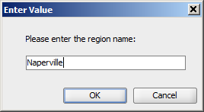

Output:

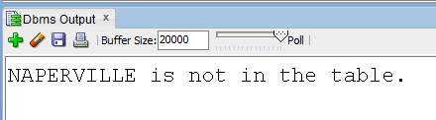

Case 2)

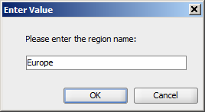

Output:

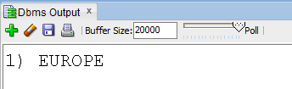

Case 3)

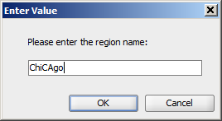

Output:

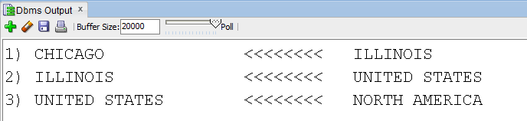

3) (CSC 452 only – 15 points)

We may have duplicate city names in the CHILD_NAME column. Modify your program created in (2) such that all parent regions of the duplicate city names can be displayed.

1) Add two new rows into the REGIONS table as follows,

INSERT INTO regions VALUES('Texas','Rockford');
INSERT INTO regions VALUES('Colorado','Aurora');
COMMIT;

2) Write a PL/SQL anonymous block that accepts a region name from the user input and display all its parent regions.

3) Test your program to ensure that you get the correct results.

Case 1) User input: Naperville
Case 2) User input: Europe
Case 3) User input: Chicago
Case 4) User input: Aurora

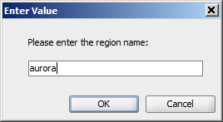

Output:

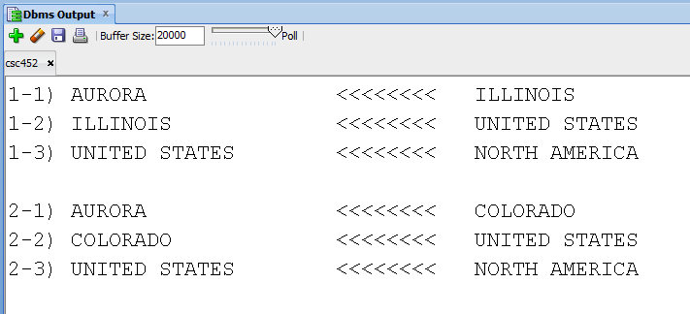

Case 5) User input: Rockford

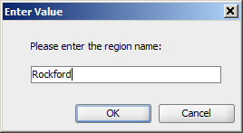

Output:

