CSC 352 / 452: Database Programming
assignment #5 (60 Points)
(Due on MONday, 8/15/2011)

Any homework that is late will lose 50% of the points for each day that it is late. No homework will be accepted more than two days after its due day.

(1) (5 Points)

Create and populate the MEMBERS table as described below.

MEMBERS(USERNAME, NAME, PHONE, JOIN_DATE, STATUS);

USERNAME: Primary Key
STATUS: A – Active, C – Cancelled

CREATE TABLE members
( USERNAME VARCHAR2(50) PRIMARY KEY,
NAME VARCHAR2(20) NOT NULL,
PHONE VARCHAR2(15) NOT NULL,
JOIN_DATE DATE NOT NULL,
STATUS CHAR NOT NULL CONSTRAINT ck_member CHECK (STATUS in ('A', 'C')));

INSERT INTO members
VALUES('king@yahoo.com','KING', '630-922-1234', '02-MAY-02', 'A');

INSERT INTO members
VALUES('blake@hotmail.com','BLAKE','312-213-9999', '02-JUN-02', 'A');

INSERT INTO members
VALUES('clark@abc.com','CLARK','847-123-4567', '09-FEB-03', 'A');

INSERT INTO members
VALUES('jones@gmail.com','JONES','773-234-9090', '02-APR-03', 'A');

INSERT INTO members
VALUES('martin@dpu.edu','MARTIN','630-234-9900','28-SEP-03', 'A');

INSERT INTO members
VALUES('allen@ual.com','ALLEN', '847-998-8989','12-OCT-03', 'A');

INSERT INTO members
VALUES('terry@yahoo.com','TERRY', '847-998-1111','12-OCT-01', 'C');
COMMIT;

(2) (30 Points)
Create a function called is_member to 1) check whether a username is in the MEMBERS table, and 2) the status of the username.

The function header is

CREATE OR REPLACE FUNCTION is_member
( p_username VARCHAR2

) RETURN CHAR

Return values:
'A': the username is in the MEMBERS table, and the status = ‘A’
'C': the username is in the MEMBERS table, and the status = ‘C’
'E': Exceptions (run-time errors)
'N': the username is not in the MEMBERS table

c) Testing your function

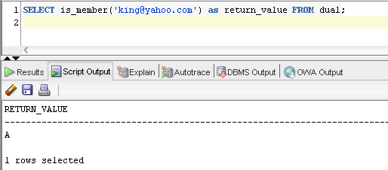

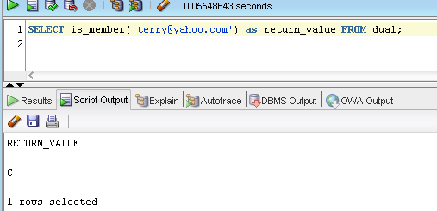

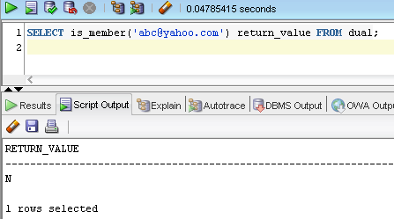

(3) (25 Points)
Based on the MEMBERS table created in (1), Create a procedure called membership_cancellation to cancel an existing membership (You may need to update the members table, MEMBERS(STATUS) → 'C').

(Best practice: You should call function is_member() in your procedure.)

The procedure header is

CREATE OR REPLACE PROCEDURE membership_cancellation (p_username VARCHAR2)

You may need to consider the following cases:

Case 1)
DBMS_OUTPUT.PUT_LINE(p_username || ' ' || 'is not a member.');

Case 2)
Update the MEMBERS table.
DBMS_OUTPUT.PUT_LINE(p_username || ' ' || 'account has been cancelled.');

Case 3)
DBMS_OUTPUT.PUT_LINE(p_username || ' ' || 'account has already been cancelled.');

