CSC 352 / 452: Database Programming
assignment #6 (60 Points)
(Due on WEDNESday, 8/17/2011)

Any homework that is late will lose 50% of the points for each day that it is late. No homework will be accepted more than two days after its due (this includes Saturday and Sunday).

1) (20 points)
Employees may move to different departments. We want to keep track of the departments where each employee has been. To do so we create a new table emp_dept_hist that keeps track of such history. Write a trigger emp_dept_trg that monitors the employee table and whenever an employee changes department (department_id), it automatically inserts a new record to the emp_dept_hist table.
You can assume that the update statement (UPDATE employee SET department_id = …) does not violate the integrity constraint.

Step 1) Create the emp_dept_hist table,
CREATE TABLE emp_dept_hist
(
EMPLOYEE_ID NUMBER(4),
EMPLOYEE_NAME VARCHAR2(20),
OLD_DEPARTMENT_NAME VARCHAR2(20),
NEW_DEPARTMENT_NAME VARCHAR2(20),
OPERATION_TIME DATE
);

Step 2) Create the trigger emp_dept_trg.

Step 3) Test your trigger as follows,

Case 1)

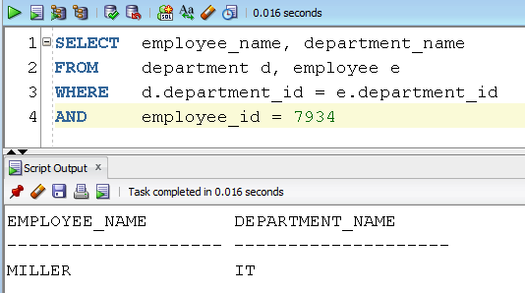

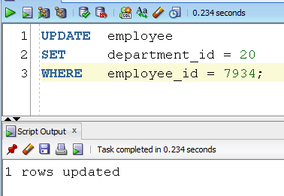

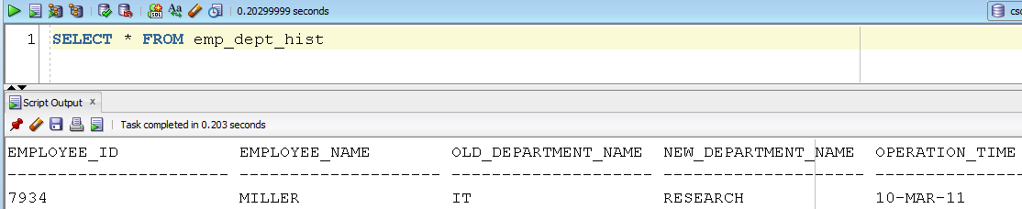

Case 2)

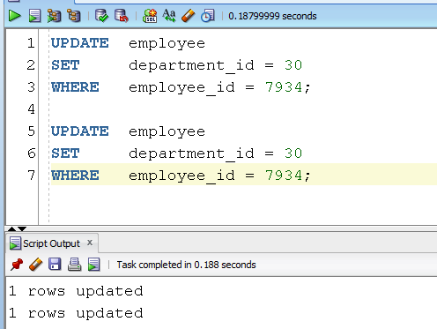

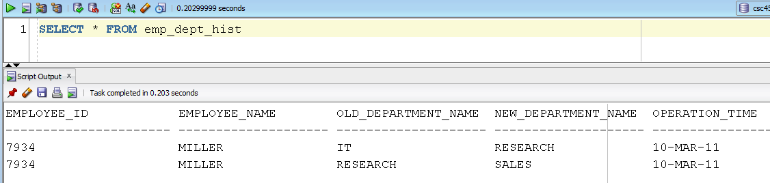

Hint: The second update statement does not move Miller to a different department.

Case 3)

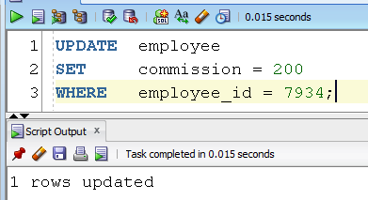

2) (15 points)

Step 1) Create a main table and its shadow table.
CREATE TABLE parts (pid NUMBER(4), pname VARCHAR2(30));
CREATE TABLE parts_log(pid NUMBER(4), pname VARCHAR2(30));

Step 2) Create a trigger, parts_trg, to log all inserts into the parts table, even those that roll back.

Step 3) Test your trigger as follows,

INSERT INTO parts VALUES (1000, 'Screw');
COMMIT;

SELECT * FROM parts;

PID PNAME
---------------------- ---------------
1000 Screw

SELECT * FROM parts_log;

PID PNAME
---------------------- ---------------
1000 Screw

INSERT INTO parts VALUES (2000, 'Bolt');
ROLLBACK;

SELECT * FROM parts;

PID PNAME
---------------------- ---------------
1000 Screw

SELECT * FROM parts_log;

PID PNAME
---------------------- ---------------
1000 Screw
2000 Bolt
3) (25 points)

Create a trigger called emp_sal_trg on the employee table. When an INSERT or UPDATE statement is issued against the employee table, the trigger is fired to ensure that the value of the SALARY field meets the criteria in the min_sal table.

- If you modified the employee table created in Assignment #1, you need to truncate and re-populate it.
- No temp table/view is allowed in your program.
- Hard coding is not allowed in your program (e.g., salary >= 3000, job = ‘MANAGER’). You must get the minimum salaries from the min_sal table in your program.

Step 1) Create a table min_sal as follows.

CREATE TABLE min_sal
(
JOB VARCHAR2(30) PRIMARY KEY,
MIN_SAL NUMBER(7, 2) NOT NULL
);

Step 2) Populate the min_sal table as follows.

INSERT INTO min_sal VALUES ('ANALYST', 2000);
INSERT INTO min_sal VALUES ('DATABASE ADMINISTRATOR', 2500);
INSERT INTO min_sal VALUES ('PRESIDENT', 4800);
INSERT INTO min_sal VALUES ('PROGRAMMER', 800);
INSERT INTO min_sal VALUES ('PUBLIC ACCOUNTANT', 2400);
INSERT INTO min_sal VALUES ('SALESMAN', 1800);
INSERT INTO min_sal VALUES ('VICE PRESIDENT', 3800);
INSERT INTO min_sal VALUES ('DEFAULT', 500);
COMMIT;

Step 3) Create a trigger called emp_sal_trg on the emp table.

Step 4) Test your trigger as follows,

(1)

INSERT INTO employee
VALUES(8801, 'T01', 'ANALYST', 7654, '09-DEC-89', 1995, 0, 20);
INSERT INTO employee
VALUES(8802, 'T02', 'ANALYST', 7654, '09-DEC-89', 2010, 0, 20);
INSERT INTO employee
VALUES(8803, 'T03', 'SALESMAN', 7900, '09-DEC-89', 1790, 0, 30);
INSERT INTO employee
VALUES(8804, 'T04', 'PROGRAMMER', 7910, '10-DEC-89', 705, 0, 40);
INSERT INTO employee
VALUES(8805, 'T05', 'DEFAULT', 7839, '09-DEC-89', 490, 0, 40);
INSERT INTO employee
VALUES(8806, 'T06', 'DEFAULT', 7839, '09-DEC-89', 510, 0, 40);
COMMIT;

SELECT employee_id, job, salary
FROM employee
WHERE employee_id >= 8801
ORDER BY employee_id;

EMPLOYEE_ID JOB SALARY
---------------------- --------- ------
8801 ANALYST 2000
8802 ANALYST 2010
8803 SALESMAN 1800
8804 PROGRAMMER 800
8805 DEFAULT 500
8806 DEFAULT 510

(2)

UPDATE employee SET salary = 1999 WHERE employee_id = 8801;
UPDATE employee SET salary = 2001 WHERE employee_id = 8802;
UPDATE employee SET salary = 1799 WHERE employee_id = 8803;
UPDATE employee SET salary = 801 WHERE employee_id = 8804;
UPDATE employee SET salary = 499 WHERE employee_id = 8805;
UPDATE employee SET salary = 501 WHERE employee_id = 8806;
COMMIT;

SELECT employee_id, job, salary
FROM employee
WHERE employee_id >= 8801
ORDER BY employee_id;

EMPLOYEE_ID JOB SALARY
---------------------- --------- ------
8801 ANALYST 2000
8802 ANALYST 2001
8803 SALESMAN 1800
8804 PROGRAMMER 801
8805 DEFAULT 500
8806 DEFAULT 501

(3)

UPDATE employee SET job= 'VICE PRESIDENT' WHERE employee_id = 8803;

SELECT employee_id, job, salary
FROM employee
WHERE employee_id = 8803;

EMPLOYEE_ID JOB SALARY
---------------------- --------- ------
8803 VICE PRESIDENT 3800

UPDATE employee SET job = 'SALESMAN' WHERE employee_name = 'JOST'

SELECT employee_id, job, salary
FROM employee
WHERE employee_name = 'JOST';

EMPLOYEE_ID JOB SALARY
---------------------- --------- ----------------------
7698 SALESMAN 4500

Please submit a text file containing all the source codes to COL before or on due date.

