CSC 352 / 452: Database Programming
Project
(300 Points)
(Due on FRIDay, 8/19/2011)

Late projects will not be accepted or graded.
You’ll receive no points if your programs do not compile.

Please, remember that this project is individual work. So do not consult with anybody in class or outside class.

Your task is to build a PL/SQL-based application to insert and update records in a video rental store database and generate some reports.

Hard coding is not allowed in your program.
You are not allowed to create temporary tables and views.

The database consists of only the following essential tables.

MEMBERS(USERNAME, NAME, PHONE, JOIN_DATE, STATUS);
VIDEO_TITLES(TITLE_ID, TITLE, RELEASE_DATE);
VIDEO_COPIES(COPY_ID, TITLE_ID*, STATUS);
RENTALS(USERNAME*, COPY_ID*, RENTAL_DATE, DUE_DATE, RETURN_DATE).

The primary keys are underlined and the foreign keys are marked with asterisks.

MEMBERS(USERNAME): Email address
MEMBERS(STATUS): A – Active, C – Cancelled
VIDEO_COPIES(STATUS): A – Available, R - Rented

A video title may have one or many video copies.

Part 1) Create and populate the following tables.

CREATE TABLE members
( USERNAME VARCHAR2(50) PRIMARY KEY,
NAME VARCHAR2(20) NOT NULL,
PHONE VARCHAR2(15) NOT NULL,
JOIN_DATE DATE NOT NULL,
STATUS CHAR NOT NULL CONSTRAINT ck_member CHECK (STATUS in ('A', 'C')));

INSERT INTO members
VALUES('king@yahoo.com','KING', '630-922-1234', '02-MAY-02', 'A');

INSERT INTO members
VALUES('blake@hotmail.com','BLAKE','312-213-9999', '02-JUN-02', 'A');

INSERT INTO members
VALUES('clark@abc.com','CLARK','847-123-4567', '09-FEB-03', 'A');

INSERT INTO members
VALUES('jones@gmail.com','JONES','773-234-9090', '02-APR-03', 'A');

INSERT INTO members
VALUES('martin@dpu.edu','MARTIN','630-234-9900','28-SEP-03', 'A');

INSERT INTO members
VALUES('allen@ual.com','ALLEN', '847-998-8989','12-OCT-03', 'A');

INSERT INTO members
VALUES('terry@yahoo.com','TERRY', '847-998-1111','12-OCT-01', 'C');
COMMIT;

CREATE TABLE video_titles
( TITLE_ID NUMBER(4) PRIMARY KEY,
TITLE VARCHAR2(20) NOT NULL,
RELEASE_DATE DATE NOT NULL);

INSERT INTO video_titles VALUES(1000, 'PRETTY WOMAN ', '28-SEP-90');
INSERT INTO video_titles VALUES(1010, 'TOY STORY', '01-MAY-95');
INSERT INTO video_titles VALUES(1020, 'TITANIC', '09-FEB-97');
INSERT INTO video_titles VALUES(1030, 'THE PLANETS', '02-APR-99');
INSERT INTO video_titles VALUES(1040, 'TARZAN', '04-JUN-99');
INSERT INTO video_titles VALUES(1050, 'DIE ANOTHER DAY','12-MAR-02');
INSERT INTO video_titles VALUES(1060, 'DOWN WITH LOVE', '20-FEB-03');
INSERT INTO video_titles VALUES(1070, 'TOY STORY 2', '24-NOV-99');
COMMIT;

CREATE TABLE video_copies
( COPY_ID NUMBER(4) PRIMARY KEY,
TITLE_ID NUMBER(4) NOT NULL REFERENCES VIDEO_TITLES (TITLE_ID),
STATUS CHAR NOT NULL CONSTRAINT ck_item CHECK
(STATUS in ('A', 'R')));

INSERT INTO video_copies VALUES(6000, 1000, 'A');
INSERT INTO video_copies VALUES(6001, 1000, 'A');
INSERT INTO video_copies VALUES(6002, 1020, 'R');
INSERT INTO video_copies VALUES(6003, 1020, 'R');
INSERT INTO video_copies VALUES(6004, 1020, 'A');
INSERT INTO video_copies VALUES(6005, 1030, 'R');
INSERT INTO video_copies VALUES(6006, 1040, 'R');
INSERT INTO video_copies VALUES(6007, 1050, 'R');
INSERT INTO video_copies VALUES(6008, 1050, 'A');
INSERT INTO video_copies VALUES(6009, 1050, 'A');
INSERT INTO video_copies VALUES(6010, 1060, 'A');
INSERT INTO video_copies VALUES(6011, 1010, 'A');
INSERT INTO video_copies VALUES(6012, 1070, 'A');
INSERT INTO video_copies VALUES(6013, 1070, 'A');
COMMIT;

CREATE TABLE rentals
( USERNAME VARCHAR2(50) REFERENCES MEMBERS (USERNAME),
COPY_ID NUMBER(4) REFERENCES VIDEO_COPIES (COPY_ID),
RENTAL_DATE DATE NOT NULL,
DUE_DATE DATE NOT NULL,
RETURN_DATE DATE,
CONSTRAINT pk_rental PRIMARY KEY (USERNAME, COPY_ID, RENTAL_DATE));

INSERT INTO rentals
VALUES('king@yahoo.com', 6000, '12-OCT-10', '19-OCT-10', '18-OCT-10');

INSERT INTO rentals
VALUES('king@yahoo.com', 6009, '20-OCT-10', '27-OCT-10', '27-OCT-10');

INSERT INTO rentals
VALUES('clark@abc.com', 6005, '21-OCT-10', '28-OCT-10', '23-OCT-10');

INSERT INTO rentals
VALUES('blake@hotmail.com', 6002, '11-NOV-10', '18-NOV-10', '18-NOV-10');

INSERT INTO rentals
VALUES('clark@abc.com', 6007, '12-NOV-10', '19-NOV-10', '13-NOV-10');

INSERT INTO rentals
VALUES('jones@gmail.com', 6010, '20-DEC-10', '27-DEC-10', '27-DEC-10');

INSERT INTO rentals
VALUES('jones@gmail.com', 6002, '17-FEB-11', '16-MAR-11', '');

INSERT INTO rentals
VALUES('martin@dpu.edu', 6003, '18-FEB-11', '17-MAR-11', '');

INSERT INTO rentals
VALUES('martin@dpu.edu', 6007, '19-FEB-11', '28-FEB-11', '');

INSERT INTO rentals
VALUES('allen@ual.com', 6006, '20-FEB-11', '10-MAR-11', '');

INSERT INTO rentals
VALUES('king@yahoo.com', 6005, '20-FEB-11', '10-MAR-11', '');
COMMIT;

Part 2) [300 Points]
Complete the database design by writing PL/SQL programs to perform the following actions. For each subprogram, you need to handle exceptions and print out messages on the screen with the results of the corresponding operations.

1) [0 Point] - is_member() (Please reference your homework 5.)

Create a function called is_member to check whether a username is already in the MEMBERS table.

The function header is

CREATE OR REPLACE FUNCTION is_member
( p_username VARCHAR2

) RETURN CHAR

Return values:
'A': the username is in the MEMBERS table, and the status = ‘A’
'C': the username is in the MEMBERS table, and the status = ‘C’
'E': Exceptions (run-time errors)
'N': the username is not in the MEMBERS table

2) [0 Point] - new_member_sign_up()

Create a procedure called new_member_sign_up to add a new member to the MEMBERS table or enable a cancelled membership in the MEMBERS table. No duplicate username is allowed in the MEMBERS table.

(You may use my example in your project.)

The procedure header is

CREATE OR REPLACE PROCEDURE new_member_sign_up
( p_username VARCHAR2,
p_name VARCHAR2,
p_phone VARCHAR2,
p_join_date DATE)

Consider the following special cases:
1) The person with the username is already a member.
2) The value of p_join_date is greater than the current date.

Example

CREATE OR REPLACE PROCEDURE new_member_sign_up
( p_username VARCHAR2,
p_name VARCHAR2,
p_phone VARCHAR2,
p_join_date DATE
)
IS
v_ret CHAR;
v_error_code NUMBER;
v_error_message VARCHAR2(255);
BEGIN

v_ret := is_member(p_username);

CASE UPPER(v_ret)
WHEN 'A' THEN
DBMS_OUTPUT.PUT_LINE
(p_username || ' is already the member!');
RETURN;

WHEN 'C' THEN
UPDATE members
SET phone = p_phone,
status = 'A'
WHERE UPPER(username) = UPPER(p_username);
COMMIT;

DBMS_OUTPUT.PUT_LINE
(p_username || '''s status has been updated (A).');

RETURN;
WHEN 'N' THEN
IF p_join_date > sysdate THEN
DBMS_OUTPUT.PUT_LINE('Invalid join_date!');
RETURN;
END IF;

INSERT INTO members
VALUES(p_username, p_name, p_phone, p_join_date, 'A');

DBMS_OUTPUT.PUT_LINE
(p_username || ' has been added into the table.');
COMMIT;
RETURN;
ELSE
DBMS_OUTPUT.PUT_LINE('Return value = ' || v_ret);
RETURN;
END CASE;
EXCEPTION
WHEN OTHERS THEN
v_error_code := SQLCODE;
v_error_message := SQLERRM;
DBMS_OUTPUT.PUT_LINE('My exception: ' ||
TO_CHAR(v_error_code) || ' ' || v_error_message);
END;

Testing the procedure

1)

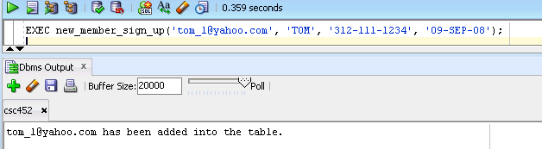

2)

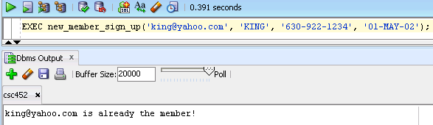

3)
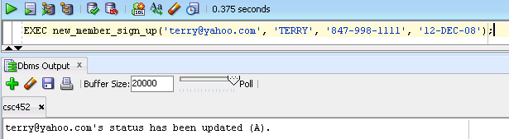

4)

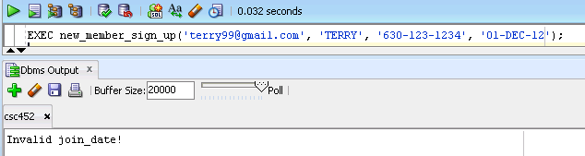

3) [0 point] - membership_cancellation() (Please reference your homework 5.)

Create a procedure called membership_cancellation to cancel an existing membership (MEMBERS(STATUS) → 'C ').

The procedure header is

CREATE OR REPLACE PROCEDURE membership_cancellation (p_username VARCHAR2)

4) [CSC 352 – 50 points | CSC 452 – 40 Points] - search_title()

Create a procedure called search_title to search a title and display the information (title, copy_id, and status) of the title’s copies.

Assume that each title in the VIDEO_TITLES table has at least one copy in the VIDEO_COPIES table.

The procedure header is

CREATE OR REPLACE PROCEDURE search_title (p_title VARCHAR2)

Hint: WHERE UPPER(title) like '%' || UPPER(p_title) || '%';

Testing the procedure

1)

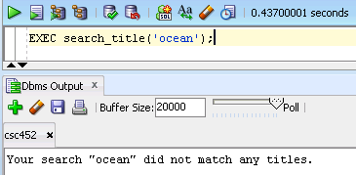

2)

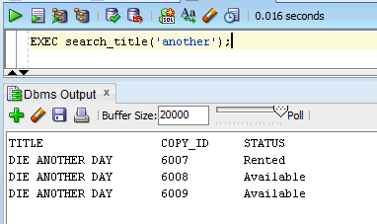
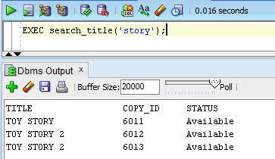

5) [CSC 352 –50 points | CSC 452 – 50 Points] - video_checkout()

Create a procedure called video_checkout to record a new rental. When the video is successfully checked out, you need to update both the RENTALS table and the VIDEO_COPIES table.

The procedure header is

CREATE OR REPLACE PROCEDURE video_checkout
( p_username VARCHAR2,
p_copy_id NUMBER,
p_rental_date DATE,
p_due_date DATE)

A member whose account status is “C” is not able to make a rental.

Consider the following special cases:
1) The person with the username is not an active member.
2) The video (copy) is not available.
3) The value of p_rental_date is greater than the value of p_due_date.
4) The value of p_rental_date is greater than the current date.

5) A member may have up to four videos checked out at any one time.
(For example, Tom has four videos checked out; he cannot rent a video before he
returns one of the four videos he checked out.)
6) (CSC 452 only) Before a member returns a video, he/she cannot rent a second copy of
the same title.

Testing the procedure
You need to test your procedure.

6) [50 points] - video_return()

Create a procedure called video_return to change the rental status for that returned video. When the video is successfully checked in, you need to update both the RENTALS table and the VIDEO_COPIES table. Otherwise, the action is denied. The procedure header is

CREATE OR REPLACE PROCEDURE
video_return(p_copy_id NUMBER, p_return_date DATE)

Consider the following special cases:
1) The value of p_copy_id does not exist in the corresponding attribute of the
VIDEO_COPY table.
2) The status of that copy is not "R" (rented).
3) The value of p_return_date is greater than the current date.

Testing the procedure
You need to test your procedure.

7) [CSC 352 – 50 points | CSC 452 – 40 Points] - print_unreturned_video()

Create a procedure called print_unreturned_video to retrieve all the videos that a member hasn't returned. The output should include the member's username, name, title, copy (copy_id), and due dates of the rentals. The procedure header is

CREATE OR REPLACE PROCEDURE print_unreturned_video(p_username VARCHAR2)

Consider the following special cases:
1) The username is not in the members table.
2) The member has returned all videos.

Testing the procedure

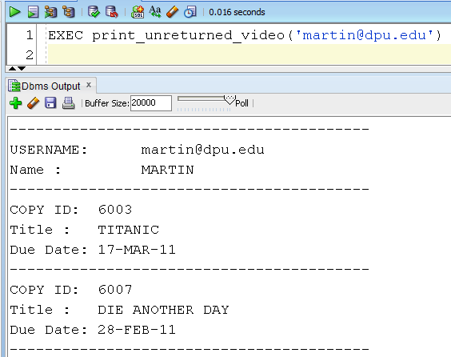
……..

8) [CSC 352 – 50 points | CSC 452 – 40 Points] - print_rental_summary()

Create a procedure called print_rental_summary to retrieve a member's history of renting videos. (Members may have status Active or Cancelled.) The output should include the member's username, name, video (title) rented, and dates of the rentals (rental_date).
The procedure header is

CREATE OR REPLACE PROCEDURE print_rental_summary (p_username VARCHAR2)

Consider the following special cases:
1) The username is not in the members table.
2) The member hasn't rented any videos.

Testing the procedure

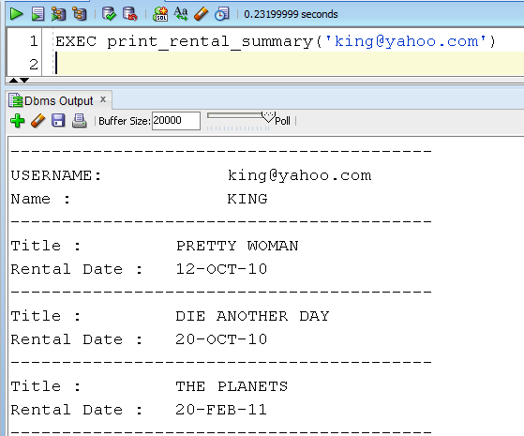

……..

9) [CSC 352 – 50 points | CSC 452 – 40 Points] – Package video_rental_store_pkg

Group all the above subprograms (is_member, new_member_sign_up, membership_cancellation, search_title, video_checkout, video_return, print_unreturned_video, and print_rental_summary) together in a package (package specification and package body) called video_rental_store_pkg.

Testing the package
You need to test your package.

Part 3) [CSC 452 only – 40 points]

Create a standalone function (it is not embedded within a package) called top_rental to find the top rentals for the given period. Allow for more than one top rental. The function returns a dataset that contains username and the number of rentals. You are not allowed to use the DBMS_OUTPUT.PUT_LINE statements in your function. Hard coding is not allowed in your program.

First, you need to create a new object type that contains the fields that are going to be returned.

CREATE OR REPLACE TYPE top_rental_type AS OBJECT (
USERNAME VARCHAR2(50),
TOTAL NUMBER);

Then, out of this new type, a nested table type must be created.

CREATE OR REPLACE TYPE top_rental_table AS TABLE OF top_rental_type;

The function header is

CREATE OR REPLACE FUNCTION top_rental
(p_start_date DATE,
P_end_date DATE) RETURN top_rental_table

Testing the function

1)

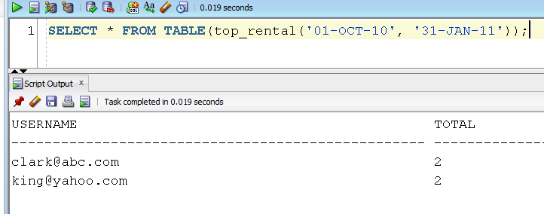

Case 2)

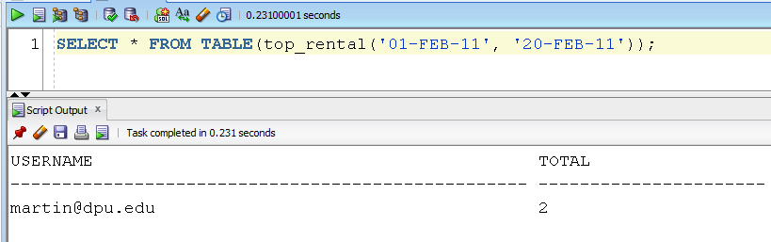

3)

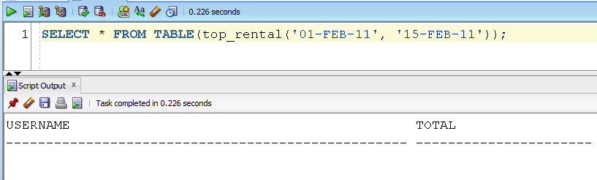

Please submit a text file containing all the source codes to COL before or on due date.

