JOptionPane: showInputDialog() and showMessageDialog() Methods

JOptionPane is a very useful class for displaying dialog boxes and messages to the user. Here is the API for this class. There are two methods in particular that are very helpful: showInputDialog() and showMessageDialog(). Note that the JOptionPane class is in the javax.swing package.

The particular version of the method showInputDialog() that we will focus on (it has been overloaded) accepts one argument of type String. (Actually it accepts one argument of type Object, but we won’t worry about that distinction until later in the course). The method draws a graphical dialog box and then prompts the user with the string provided to the method.

When the user types in a response and clicks the ‘OK’ button, the method returns a String corresponding to the user’s entry. So you could have the following:
String name;
name = JOptionPane.showInputDialog(“What is your name?”);

The method would draw the following dialog box:

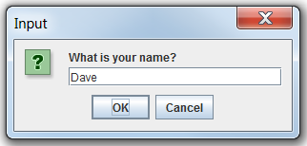

When the user clicks on ‘OK’, the variable name will hold the string ‘Dave’.

Important: Whenever you make use of a dialog box from the JOptionPane class, you should include the following statement at the end of your program:
System.exit(0);

Wrappers
Note that the showInputDialog() method returns a String. What if you wanted to retrieve a different data type?
int age;
age = JOptionPane.showInputDialog("How old are you?");

Do you see the type mismatch? Java will not compile this code. You might be tempted to think that you can cast a String to an int, but Java won’t let you do that either.

However, the Java API does include methods that try their darndest to convert between data types. There is an method called parseInt() (in a class called Integer) that tries to convert data to integers. So you could try the following:
int age;
String response;
response = JOptionPane.showInputDialog("How old are you?");
age = Integer.parseInt(response);

In this case, the parseInt() method will look at the value of ‘response’ and attempt to convert it into an integer. If the value of response contains only digits, the method will indeed convert the String of digits into an integer. If, however, there are any non-digit characters present, an error will result.

The technique just described would work perfectly, but here is a shortcut you can use:
//Shortcut:
int age;
age = Integer.parseInt(JOptionPane.showInputDialog("How old are you?"));

The showInputDialog() method will execute first (since it’s inside parentheses) and return a String. That String will then promptly be converted to an int by the parseInt() method.

There is a corresponding parseDouble() method in a class called Double that can be used as well:
double answer;
answer = Double.parseDouble(JOptionPane.showInputDialog("What is 5/2?"));

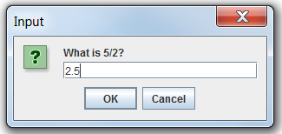

The showInputDialog() method is very useful as a quick ‘n’ dirty way of getting input from the user. But remember that if you are asking for any kind of data type other than String, you’ll need one of the so-called ‘wrapper’ classes to do so. We’ll discuss wrapper classes in more detail another time. However, you must be able to make basic use of them now.

The showMessageDialog() Method
The JOptionPane class also gives you a way of outputting information to a graphical window instead of the boring old console. This method is called showMessageDialog(). The first argument you will need to pass to this method will not make sense just yet, but again,will be explained in more detail down the road. Here is the method in action:

JOptionPane.showMessageDialog(null, "Have a great day!");
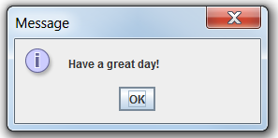

And don’t forget System.exit(0); !!

If interested, there is also a very nice tutorial on how to use dialog boxes in Java here, but it contains a lot more than you need to know at this point.

