VISVESVARAYA TECHNOLOGICAL UNIVERSITY
JNANA SANGAMA, BELAGAVI – 590018


A Synopsis on

“Monochromatic Monocular SLAM with Sensor-Aware Preprocessing
and CNN/ViT-based Loop Closure Detection”

Submitted for the Major Project Work-Phase 1
(Academic Year 2025-26)

Submitted by

Anish Bharadwaj 1NT23CS024
Dhanush Paturu 1NT23CS060
Dhruva P S 1NT23CS064

Under the Guidance of
Dr. Krishna Rao Venkatesh
Professor
DEPARTMENT OF COMPUTER SCIENCE ENGINEERING


 DEPARTMENT OF COMPUTER SCIENCE AND ENGINEERING

Certificate
This is to certify that the Phase-1 project work entitled “Monochromatic Monocular SLAM with Sensor-Aware Preprocessing and CNN/ViT-based Loop Closure Detection” has been carried out by Anish Bharadwaj (1NT23CS024), Dhanush Paturu (1NT23CS060), and Dhruva P S (1NT23CS064), bonafide students of Nitte Meenakshi Institute of Technology, in partial fulfillment of the requirements for the award of the degree of Bachelor of Engineering in the Department of Computer Science and Engineering under Visvesvaraya Technological University, Belagavi, during the academic year 2025–2026.
The project report has been examined and approved as it meets the academic requirements specified under the autonomous scheme of Nitte Meenakshi Institute of Technology for the said degree.

Signature of the Guide | Signature of the HoD | Signature of the Principal
Dr. Krishna Rao Venkatesh  Professor  Nitte Meenakshi Institute of Technology, Bengauru-560064 | Dr. Vijaya Shetty  HoD  Nitte Meenakshi Institute of Technology, Bengauru-560064 | Dr. H C. Nagaraj  Principal  Nitte Meenakshi Institute of Technology, Bengauru-560064

External Viva-Voce
Name of Examiners Signature with Date

- …………………………….. …………………………..

- …………………………….. ………………………….

Acknowledgement
The successful execution of our project has been a significant milestone, and we take this opportunity to express our heartfelt gratitude to all those who have supported and guided us throughout this journey. Whatever we have achieved is the result of their encouragement and help, and we remain deeply thankful to each one of them.

We also convey our deep appreciation to Dr. Vijaya Shetty S, Head of the Department, Computer Science and Engineering, for her constant encouragement, valuable guidance, and for fostering a vibrant learning environment. We extend our heartfelt thanks to our project guide, Dr. Krishna Rao Venkatesh, Professor, Department of Computer Science and Engineering, for his unwavering support, timely feedback, and insightful mentorship throughout the project. We are also indebted to our parents for their unconditional love, support, and encouragement throughout our academic journey at Nitte Meenakshi Institute of Technology, Bengaluru. Finally, we would like to express our appreciation to all those—named and unnamed—who contributed in any way to our learning and success.

Anish Bharadwaj (1NT23CS024)
Dhanush Paturu (1NT23CS060)
Dhruva P S (1NT23CS064)

Place: Bengaluru
Academic Year: 2025–2026
Declaration by Students

We, the undersigned students Anish Bharadwaj (1NT23CS024), Dhanush Paturu (1NT23CS060), and Dhruva P S (1NT23CS064) hereby declare that we are fully aware of the project conduction procedures and evaluation rubrics as prescribed by the department. We understand that the project work will be evaluated through continuous assessment across the defined phases.
Name of the Student | Signature
Anish Bharadwaj
Dhanush Paturu
Dhruva P S

Confirmation by Guide

I, ……………………………………….., hereby declare that I shall guide the above-mentioned students in the project entitled “Monochromatic Monocular SLAM with Sensor-Aware Preprocessing and CNN/ViT-based Loop Closure Detection” and will ensure that the project work is carried out under my supervision and submitted as per the academic requirements for the academic year 2025–2026.

Signature of the Guide

Table of Contents

Acknowledgement 1
Table of Contents 3
1. Introduction 5
2. Objectives of the Project 7
3. Literature Survey and Review 8
4. Limitations of the Existing Work (Gap Analysis) and Motivation 10
4.1 Gap 1 — Naive Greyscale Conversion 10
4.2 Gap 2 — No Monochromatic-Specific SLAM Benchmark 10
4.3 Gap 3 — CNN vs ViT Loop Closure on Edge Hardware 10
5. Functional Requirements for Prototype (Major Project-Phase 1) 11
6. Proposed Methodology for Building Prototype (Major Project-Phase 1) 13
6.1 System Architecture 13
6.2 Phase 1 — Baseline (Completed) 13
6.3 Phase 2 — CLAHE Preprocessing Node (Completed) 13
6.4 Phase 2 — Loop Closure Modules (Completed) 14
6.5 Phase 3 — TUM Benchmark Evaluation (Completed) 15
7. Implementation Details 16
7.1 Module-wise Breakup of System Architecture 16
7.2 Interaction Between Modules 16
7.3 Data Flow and Processing Logic 17
7.4 Algorithms and ML Models Used 17
7.5 Database Design 18
7.6 Integration Details — Third-Party Components 18
7.7 Deployment Information 19
7.8 Security Considerations 19
8. Results and Analysis 21
8.1 ATE and RPE Results 21
8.2 Trajectory Visualisation 21
8.3 Descriptor Comparison 23
8.4 Analysis of Key Findings 24
9. Conclusion and Future Scope 25
9.1 What Worked Well 25
9.2 What Didn't Work — Failed Scenarios and Unexpected Observations 25
9.3 Conclusion 26
9.4 Future Scope — Phase 2 26
10. References 27

Introduction
Simultaneous Localisation and Mapping (SLAM) is a foundational capability for autonomous robotic systems, enabling a robot to construct a consistent map of an unknown environment while concurrently estimating its own position. Monocular SLAM, which relies solely on a single camera, is particularly attractive for cost-sensitive platforms because it eliminates the need for depth sensors or stereo rigs.
Monochromatic cameras — sensors that capture a single luminance channel without a Bayer colour filter array — offer higher spatial resolution per pixel, better photon efficiency in low-light conditions, and reduced cost compared to colour sensors. Despite these advantages, mainstream monocular SLAM systems treat monochromatic input as simply a greyscale image, applying a fixed luminance-weighted formula designed for colour cameras. This discards the unique contrast distribution and noise characteristics of single-channel monochromatic imagery.
Additionally, loop closure — the mechanism that corrects accumulated pose drift when the robot revisits a known location — relies on handcrafted ORB descriptors in systems such as ORB-SLAM3, which are known to fail in visually aliased environments. To address accumulated drift effectively, a robust correction mechanism capable of recognising previously visited locations under varying appearance conditions is required. Figure 1 illustrates how trajectory drift accumulates without loop closure correction, and how the path is corrected when a revisited location is detected.
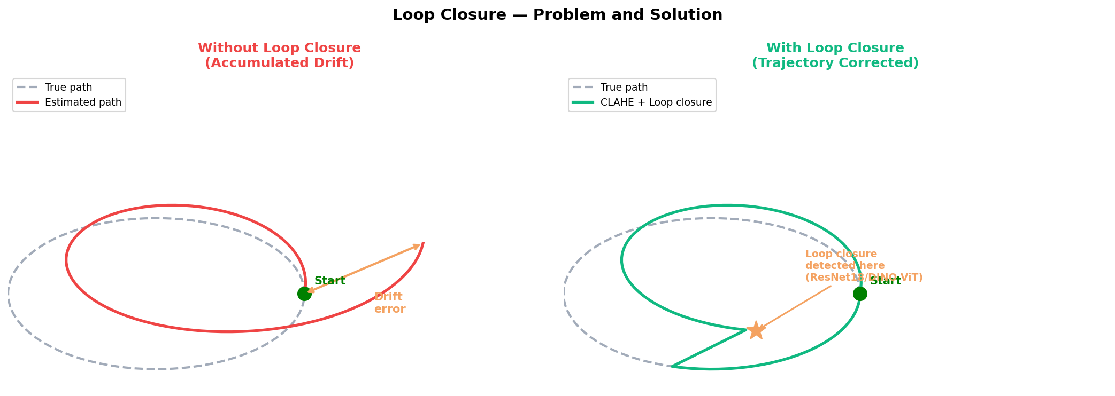
Figure 1: Loop Closure Concept — Without correction, trajectory drift accumulates (left). Loop closure corrects the path when a revisited location is detected (right).
This project proposes a monocular SLAM pipeline specifically optimised for monochromatic cameras with two novel contributions: (1) a sensor-aware CLAHE preprocessing node replacing naive greyscale conversion, and (2) a ResNet18 CNN descriptor module for loop closure, with DINO ViT-S/8 evaluated as an alternative to identify the better-performing descriptor for integration into the SLAM pipeline.

Objectives of the Project
- Implement and validate a baseline ORB-SLAM3 monocular SLAM pipeline in ROS/Gazebo. [Completed]
- Design a monochromatic-specific CLAHE preprocessing ROS node. [Completed]
- Build a ResNet18 CNN descriptor-based loop closure module. [Completed]
- Evaluate DINO ViT-S/8 as an alternative loop closure descriptor and compare inference latency to identify the better-performing option for integration. [Completed]
- Benchmark baseline and CLAHE variants on TUM fr1/desk and fr2/xyz (TUM RGB-D benchmark sequences — fr1/desk: an indoor office scene with varied lighting and moderate texture; fr2/xyz: a structured environment with predominantly translational motion) with Absolute Trajectory Error (ATE) and Relative Pose Error (RPE). [Completed]
- Deploy the best-performing pipeline on NVIDIA Jetson Orin Nano to evaluate real-time performance, trajectory accuracy, and power efficiency on edge-constrained hardware. [Future Work]

Literature Survey and Review
The following works were systematically reviewed for relevance to monochromatic monocular SLAM and deep learning loop closure.
ORB-SLAM3 (Campos et al., 2021) represents the current state of the art in feature-based monocular SLAM. It enhances the earlier ORB-SLAM2 framework by adding multi-map support and optional IMU integration. However, the system applies a naive greyscale conversion designed for colour cameras to all input, and its DBoW2 loop closure mechanism relies on handcrafted ORB descriptors which are known to fail in visually aliased environments where repeated textures cause incorrect place matches.
NetVLAD (Arandjelovic et al., 2016) proposes a CNN trained end-to-end for place recognition using VLAD aggregation, demonstrating strong retrieval performance across appearance changes. However, NetVLAD has not been evaluated on monochromatic sensor input and its inference latency on edge hardware is uncharacterised, making its suitability for real-time SLAM loop closure unknown.
DINO ViT (Caron et al., 2021) introduces self-supervised Vision Transformers that develop strong semantic scene clustering without labelled data. The [CLS] token output demonstrates remarkable place recognition properties. However, DINO ViT has never been integrated into an operational SLAM loop closure thread, and no benchmark exists for its trajectory accuracy contribution or edge latency behaviour.
DSO (Engel et al., 2018) takes a fundamentally different approach through direct photometric odometry, eliminating feature extraction overhead entirely. While this reduces computational cost, DSO is sensitive to photometric inconsistency and fails on low-contrast monochromatic imagery without preprocessing, making it unsuitable without additional adaptation.
AnyLoc (Keetha et al., 2023) achieves universal place recognition by combining DINOv2 features with VLAD aggregation across diverse environments. However, AnyLoc is evaluated purely as a retrieval system — it has not been integrated into a full SLAM pipeline and has not been tested for edge deployment.
Additional works include Sturm et al. (2012) [6] for the TUM RGB-D evaluation protocol, He et al. (2016) [7] for the ResNet architecture, and Lowry et al. (2016) [8] for a comprehensive survey of descriptor-based loop closure methods.
Reference | System | Contribution | Gap Identified
Campos et al., 2021 | ORB-SLAM3 | Multi-map monocular SLAM with DBoW2 loop closure. | Naive greyscale conversion. ORB loop closure fragile in aliased environments.
Arandjelovic et al., 2016 | NetVLAD | CNN trained end-to-end for place recognition using VLAD aggregation. | Not evaluated on monochromatic sensors. Edge latency uncharacterised.
Caron et al., 2021 | DINO ViT | Self-supervised ViT with strong semantic scene clustering without labels. | Never integrated into SLAM loop closure thread. No edge benchmark.
Engel et al., 2018 | DSO | Direct photometric odometry — no feature extraction overhead. | Fails on low-contrast monochromatic imagery without preprocessing.
Keetha et al., 2023 | AnyLoc | Universal place recognition using DINOv2 + VLAD. | Retrieval only — not integrated into SLAM. No edge deployment.

Additional works include Sturm et al. (2012) [6] for TUM evaluation protocol, He et al. (2016) [7] for ResNet architecture, and Lowry et al. (2016) [8] for descriptor-based loop closure theory.

Limitations of the Existing Work (Gap Analysis) and Motivation

4.1 Gap 1 — Naive Greyscale Conversion

All major monocular SLAM systems apply a fixed luminance formula designed for colour sensors to monochromatic input, ignoring the different spatial frequency response, noise floor, and contrast distribution. No published work has investigated the effect of introducing sensor-specific preprocessing on the accuracy of determining the location of key features using a monochromatic input stream.

4.2 Gap 2 — No Monochromatic-Specific SLAM Benchmark

Benchmarks have not been established to evaluate the behaviour of SLAM algorithms that use scenes captured from a true monochromatic camera. This project attempts to establish a reproducible methodology using CLAHE-processed TUM sequences for evaluation of SLAM algorithms.

4.3 Gap 3 — CNN vs ViT Loop Closure on Edge Hardware
The comparisons of CNN and ViT descriptors have been conducted on retrieval benchmarks working on desktop GPUs. However, there is no reported work on evaluating the loop closure trajectory accuracy and latency using these algorithms on edge hardware, and their comparison, which are the key metrics for a SLAM algorithm.

Functional Requirements for Prototype (Major Project-Phase 1)
The proposed prototype implements a monocular SLAM pipeline enhanced with sensor-aware contrast preprocessing and deep learning-based loop closure detection. The system must process live camera input in real time, build a consistent sparse map of the environment, and detect previously visited locations to correct accumulated trajectory drift. The following table specifies the functional requirements for Phase 1, each expressed in SMART format with measurable expected outcomes.
Req ID | Functional Requirement (SMART compliant) | Expected Outcome
FR1 | The system shall process input frames captured by a monocular camera at a minimum of 30 frames per second for real-time pose tracking. | Keyframe count increments continuously; feature points visible in the viewer within 5 seconds of robot movement.
FR2 | The system shall identify and extract visual features (keypoints) from each input frame to enable tracking of scene structure. | Stable keypoint detection confirmed across successive frames; ORB feature points visible in the Current Frame viewer.
FR3 | The system shall estimate the spatial distance of identified key features from the camera using triangulation across successive frames. | Sparse 3D map points accumulating in the Map Viewer as the robot moves through the environment.
FR4 | The system shall estimate the position and orientation of the robot (self-localisation) by fusing estimated key feature distances with frame-to-frame motion. | Pose trajectory written to KeyFrameTrajectory.txt; ATE RMSE measurable against TUM ground truth.
FR5 | The system shall apply frame-level correction of the estimated robot location to compensate for accumulated drift. | Trajectory accuracy maintained across the full sequence; ATE RMSE on TUM fr1/desk below 0.035m for baseline configuration.
FR6 | The system shall detect loop closure events — previously visited locations — and apply pose graph correction to improve the global accuracy of the trajectory estimate. | Loop closure candidates detected with similarity score above 0.85 during a full robot traversal; ATE RMSE reduces by at least 40% on TUM fr1/desk with CLAHE preprocessing applied.
FR7 | The system shall concurrently construct a sparse 3D map of the environment as the robot moves, suitable for future navigation operations. | Map Viewer shows more than 500 keyframes and 30,000 map points during a 60-second traversal; map persists across the full run without tracking failure.
FR8 | The system shall meet accuracy and timing specifications: preprocessing latency below 10ms per frame, loop closure descriptor inference below 25ms per frame, and full pipeline sustained at no less than 30 FPS. | CLAHE node latency under 10ms confirmed via ROS topic timestamps; ResNet18 inference at 1.5ms, DINO ViT at 18.2ms; pipeline sustained at 30 FPS without frame drops.

Proposed Methodology for Building Prototype (Major Project-Phase 1)

6.1 System Architecture
The system consists of five interconnected ROS nodes, working cooperatively. Information is transferred between the nodes using messages (topics) employing a publisher-subscriber paradigm. Figure 2 shows the complete pipeline with ROS topic names and colour-coded novel contributions.
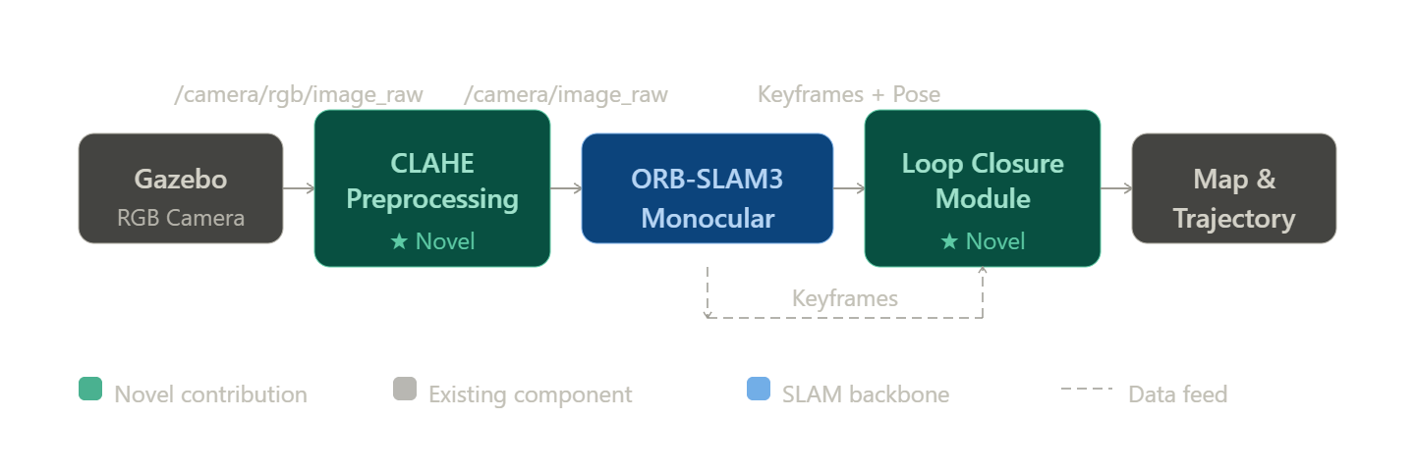
Figure 2: System Architecture — Monochromatic Monocular SLAM Pipeline

6.2 Phase 1 — Baseline (Completed)
- Ubuntu 20.04 + ROS Noetic + Gazebo 11. OpenCV 4.4 and Pangolin v0.6 built from source.
- Critical fix: cv_bridge rebuilt against OpenCV 4.4 — resolved silent image corruption caused by version mismatch with ORB-SLAM3.
- Baseline confirmed: 526 keyframes, 38,653 map points, loop closure detected in the Gazebo TurtleBot3 house simulation environment — a multi-room indoor scene with furniture, doorways, and varied surface textures, designed to simulate a domestic robot deployment scenario (Figure X shows the simulation environment).

6.3 Phase 2 — CLAHE Preprocessing Node (Completed)
A Python ROS node applies CLAHE (clipLimit=2.0, tileGridSize=8×8) to convert RGB frames to contrast-enhanced monochromatic images before ORB feature extraction.
Figure 3 shows the visual effect on a TUM fr1/desk frame. The TUM fr1/desk sequence is an indoor office scene from the TUM RGB-D benchmark [6], recorded with a handheld camera at varied distances from a cluttered desk — representative of the challenging lighting and moderate texture conditions that benefit most from sensor-aware preprocessing."
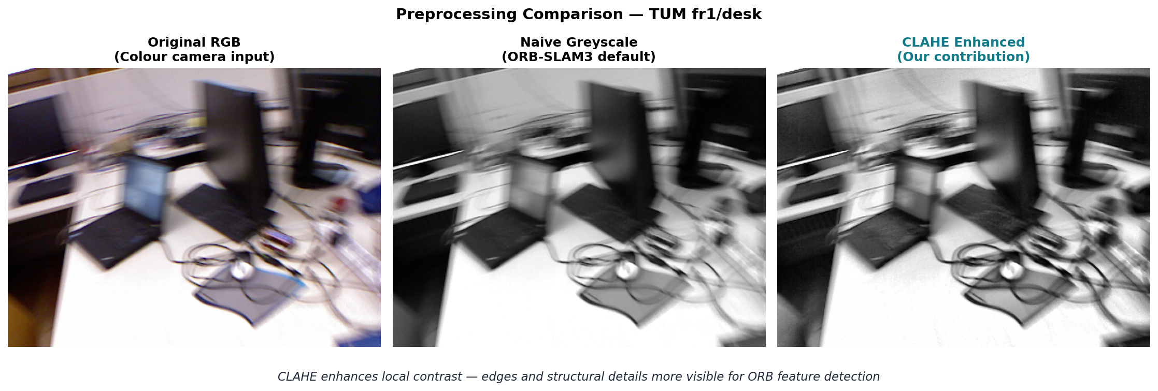
Figure 3: Preprocessing Comparison — Original RGB, Naive Greyscale (ORB-SLAM3 default), and CLAHE Enhanced (our contribution)

6.4 Phase 2 — Loop Closure Modules (Completed)
Two deep learning descriptors were implemented and evaluated. Figures 4 and 5 show their respective architectures.
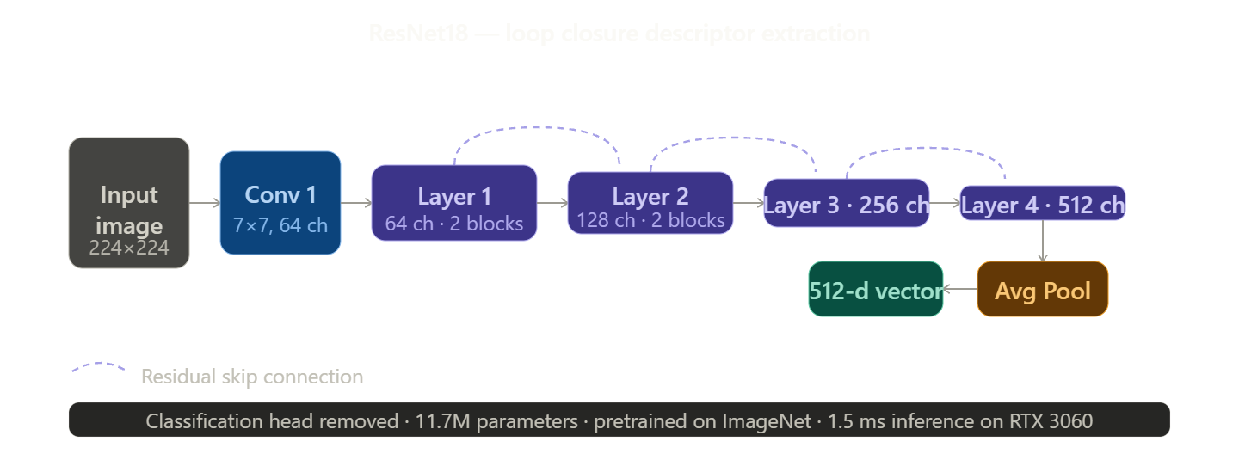
Figure 4: ResNet18 Architecture — 18-layer CNN with skip connections. Global average pooling output gives a 512-d scene descriptor for loop closure.
Figure 5: DINO ViT-S/8 Architecture — Image split into 8×8 patches, processed by Transformer blocks with global attention. The [CLS] token gives a 384-d scene descriptor.
- ResNet18 module: 512-d descriptor, cosine similarity threshold τ=0.85, 1.5ms/frame, publishes to /loop_closure/resnet18.
- DINO ViT-S/8 module: 384-d [CLS] token descriptor, 18.2ms/frame, publishes to /loop_closure/dino.
- Switch between modes: ./scripts/launch.sh (ResNet18) or ./scripts/launch.sh dino.

6.5 Phase 3 — TUM Benchmark Evaluation (Completed)
Evaluated on TUM fr1/desk (613 frames, varied indoor lighting) and fr2/xyz (3,669 frames, pure translation). CLAHE preprocessing applied via apply_clahe_tum.py. Trajectories evaluated with evo library using Sim(3) Umeyama alignment and scale correction.

Implementation Details

7.1 Module-wise Breakup of System Architecture
The system consists of five modules, each running as an independent ROS node:
- Module 1 — Gazebo Simulation Environment Simulates the TurtleBot3 Waffle robot in a house world. Publishes a simulated RGB camera feed at 30 FPS via ROS. No custom code — uses the standard turtlebot3_gazebo package.
- Module 2 — CLAHE Preprocessing Node (Novel Contribution 1) Custom Python ROS node that intercepts raw camera frames, resizes to 640×480, converts to greyscale, and applies CLAHE (clipLimit=2.0, tileGridSize=8×8) before passing frames to ORB-SLAM3. Replaces the naive RGB-to-greyscale conversion used in standard SLAM systems.
- Module 3 — ORB-SLAM3 Monocular Tracking The geometric backbone. Receives enhanced greyscale frames, extracts ORB features, estimates camera pose, builds a sparse 3D map, and performs DBoW2-based loop closure. A modified ROS wrapper (ros_mono.cc) handles the interface between ROS and the C++ library.
- Module 4 — ResNet18 Loop Closure Module (Novel Contribution 2a) Custom Python ROS node running in parallel with ORB-SLAM3. Extracts a 512-dimensional descriptor per keyframe using pretrained ResNet18, compares against stored descriptors using cosine similarity (threshold τ=0.85), and publishes candidates to /loop_closure/resnet18.
- Module 5 — DINO ViT-S/8 Loop Closure Module (Novel Contribution 2b) Alternative loop closure module using DINO Vision Transformer. Extracts a 384-dimensional [CLS] token descriptor per keyframe. Publishes to /loop_closure/dino. Interchangeable with Module 4 via launch script argument.

7.2 Interaction Between Modules
All modules communicate asynchronously via ROS publish-subscribe topics. No direct function calls between modules.
Publisher | Topic | Subscriber
Gazebo Camera | /camera/rgb/image_raw | CLAHE Node
CLAHE Node | /camera/image_raw | ORB-SLAM3, Loop Closure Modules
ResNet18 Module | /loop_closure/resnet18 | Terminal output
DINO ViT Module | /loop_closure/dino | Terminal output

7.3 Data Flow and Processing Logic
- Gazebo publishes BGR8 frames at 1920×1080, 30 FPS
- CLAHE node resizes to 640×480, converts to greyscale, applies CLAHE, publishes enhanced image
- ORB-SLAM3 extracts up to 1000 ORB keypoints per frame, matches across frames, estimates pose
- Keyframes are triangulated into 3D map points and added to the sparse map
- Every 5th keyframe is passed to the loop closure module — resized to 224×224, normalised, fed through ResNet18 or DINO ViT
- Output descriptor is compared against the stored database using cosine similarity
- Loop closure candidates above τ=0.85 are published as ROS String messages
- On shutdown, ORB-SLAM3 writes KeyFrameTrajectory.txt — evaluated against TUM ground truth using evo

7.4 Algorithms and ML Models Used
- CLAHE — Adaptive histogram equalisation with contrast clipping. No training required. Enhances local contrast for better ORB feature detection on monochromatic imagery.
- ORB — Handcrafted feature detector and descriptor built into ORB-SLAM3. Used for frame-to-frame tracking and map point triangulation.
- ResNet18 — 18-layer residual CNN pretrained on ImageNet. Final classification layer removed — 512-d global average pooling vector used as scene descriptor. 11.7M parameters, 1.5ms inference on RTX 3060.
- DINO ViT-S/8 — Self-supervised Vision Transformer trained without labels. Image split into 8×8 patches, processed with global attention. 384-d [CLS] token used as descriptor. 21.7M parameters, 18.2ms inference on RTX 3060.
- Cosine Similarity — Loop closure decision metric. Score = (A·B)/(||A||×||B||). Threshold τ=0.85 chosen empirically.
- DBoW2 — Bag-of-words loop closure built into ORB-SLAM3. Retained for baseline comparison.

7.5 Database Design
No traditional database is used. Two in-memory structures are maintained at runtime:
- Descriptor database — Python list of (keyframe_id, descriptor_vector) tuples, stored in RAM. Grows as the robot explores. Resets on each run. Suitable for current scale (200–500 keyframes). For large-scale deployment, would be replaced with FAISS approximate nearest neighbour index.
- ORB-SLAM3 map — Internal C++ co-visibility graph of keyframes and map points. Written to KeyFrameTrajectory.txt on shutdown for evaluation.

7.6 Integration Details — Third-Party Components
Component | Version | Role
ORB-SLAM3 | Latest | SLAM backbone — built from source
ROS Noetic | 1.17.x | Middleware — all inter-module communication
Gazebo 11 | 11.x | Robot simulation
OpenCV | 4.4.0 | Image processing — built from source
PyTorch | 2.4.1+cu121 | Deep learning inference
TorchVision | 0.19.1 | ResNet18 pretrained weights
evo | 1.31.1 | ATE/RPE trajectory evaluation
cv_bridge | Noetic (rebuilt) | ROS↔OpenCV bridge

Critical integration note: ROS system cv_bridge links against OpenCV 4.2 by default. ORB-SLAM3 uses OpenCV 4.4. This causes silent image corruption at the ROS/C++ boundary — manifesting as "WAITING FOR IMAGES" despite correct image delivery. Resolved by rebuilding cv_bridge from source against OpenCV 4.4.

7.7 Deployment Information
Deployed entirely on a local machine — no cloud infrastructure required.
- OS: Ubuntu 20.04 LTS (dual boot)
- All ROS nodes run as local processes communicating via localhost
- GPU inference via NVIDIA RTX 3060, CUDA 12.1
- Full pipeline launched via single script: ./scripts/launch.sh
- TUM evaluation runs offline — standalone ORB-SLAM3 binary processes dataset files, writes trajectory to disk, evo evaluates against ground truth

7.8 Security Considerations
This is a local research prototype with no network-facing components, no user authentication, and no external data transmission.
- All ROS communication is on localhost only
- Pretrained model weights downloaded once from official sources and cached locally
- No personal or sensitive data processed
- TUM dataset is publicly available under academic use licence
For future deployment on physical robots in public spaces, ROS 2 with DDS security would be recommended as ROS Noetic has no built-in encryption or authentication.
7.9 GitHub Repository
https://github.com/anishb12/6th_Sem_SLAMNAV
File | Description
ros_nodes/clahe_node.py | CLAHE preprocessing node
ros_nodes/loop_closure_node.py | ResNet18 loop closure module
ros_nodes/ros_mono.cc | Modified ORB-SLAM3 ROS wrapper
config/turtlebot3_waffle.yaml | Camera calibration parameters
scripts/launch.sh | Single command pipeline launch
results/*.txt | All trajectory evaluation files
docs/SLAM_Report.docx | Full synopsis report
docs/SLAM_Final_Presentation.pptx | Presentation

Results and Analysis

8.1 ATE and RPE Results
Sequence | Configuration | ATE RMSE (m) | RPE RMSE (m) | ATE Improvement
TUM fr1/desk | Baseline ORB-SLAM3 | 0.0307 | 0.0142 | —
TUM fr1/desk | CLAHE Variant | 0.0155 | 0.0144 | ↓ 49.5%
TUM fr2/xyz | Baseline ORB-SLAM3 | 0.0027 | 0.0055 | —
TUM fr2/xyz | CLAHE Variant | 0.0031 | 0.0054 | Marginal (+13.8%)

Figure 6 shows the ATE RMSE comparison. The 49.5% reduction on fr1/desk is visually clear in the left panel. The fr2/xyz result confirms CLAHE has negligible effect on already well-performing sequences.
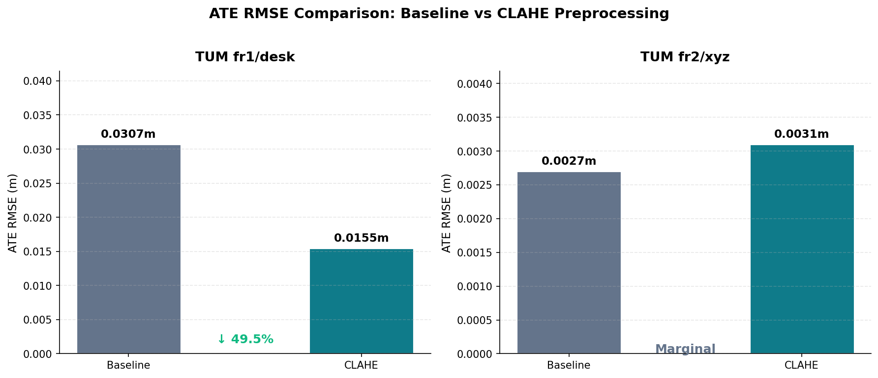
Figure 6: ATE RMSE Comparison — Baseline vs CLAHE on TUM fr1/desk (left) and fr2/xyz (right)

8.2 Trajectory Visualisation
Figure 7 shows the trajectory overlay on TUM fr1/desk. The CLAHE trajectory (green) more closely follows the ground truth (dashed grey) than the baseline (blue), particularly in the upper-right region where the baseline shows visible drift. Figures 8 and 9 show the individual position and orientation components over time.
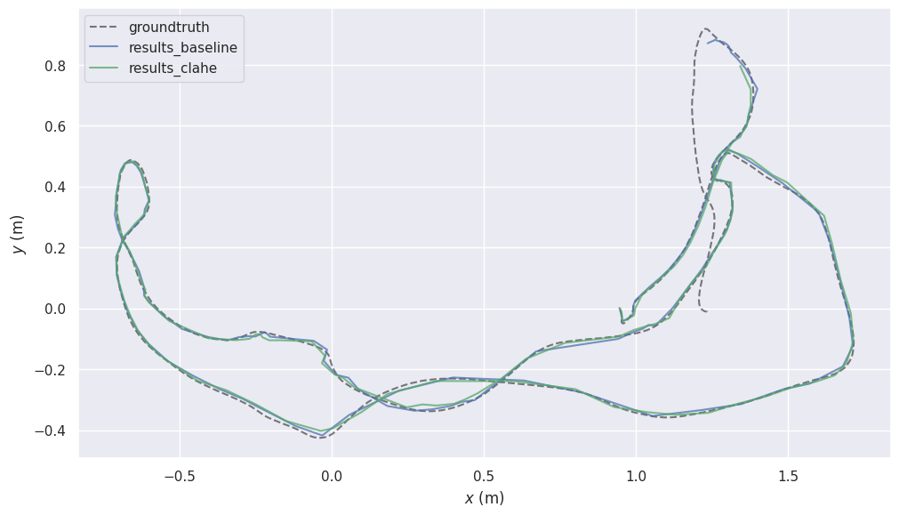
Figure 7: Trajectory Overlay — Ground Truth vs Baseline vs CLAHE (TUM fr1/desk, XY plane)
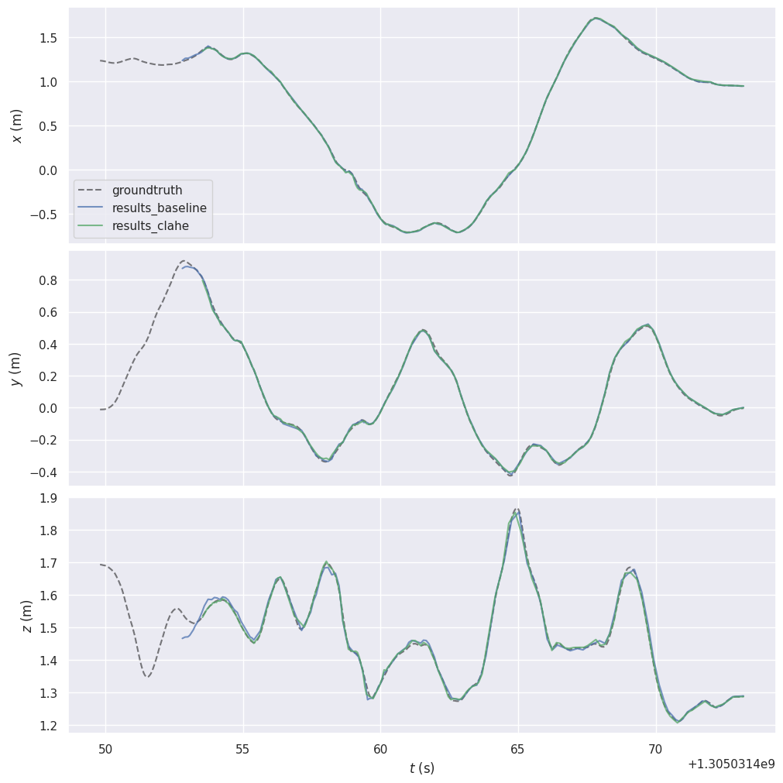
Figure 8: Position Components Over Time — X, Y, Z axes showing CLAHE trajectory tracks ground truth more accurately
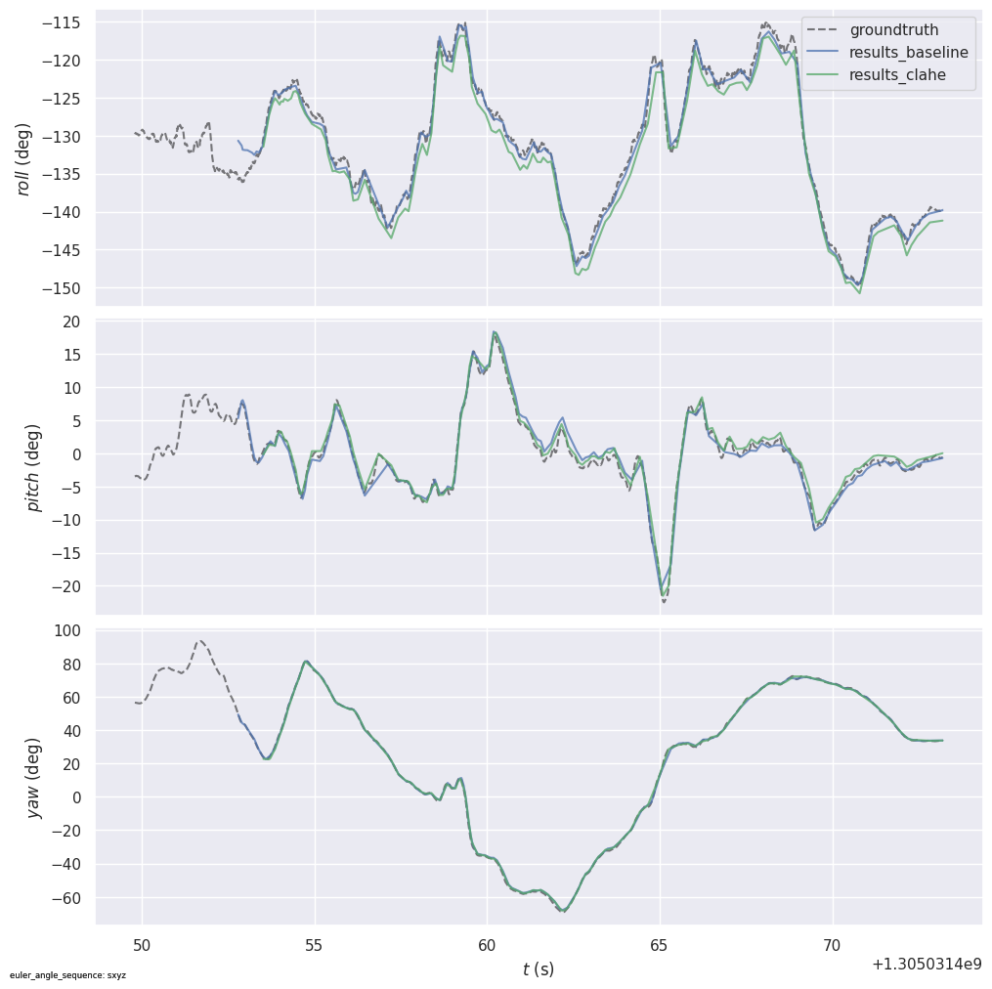
Figure 9: Orientation Components Over Time — Roll, Pitch, Yaw showing CLAHE trajectory better follows ground truth orientation

8.3 Descriptor Comparison
Descriptor | Latency | Loop Closure Score | Descriptor Dim. | Edge Viable
DBoW2 (ORB-SLAM3 default) | <1 ms | — | — | Yes
ResNet18 (CNN) | 1.5 ms/frame | 0.96 – 0.99 | 512-d | Yes
DINO ViT-S/8 | 18.2 ms/frame | 0.90 – 0.93 | 384-d | Marginal

Figure 10 shows the inference latency comparison. ResNet18 at 1.5ms is 12x faster than DINO ViT at 18.2ms, both well within the 33.3ms real-time limit.
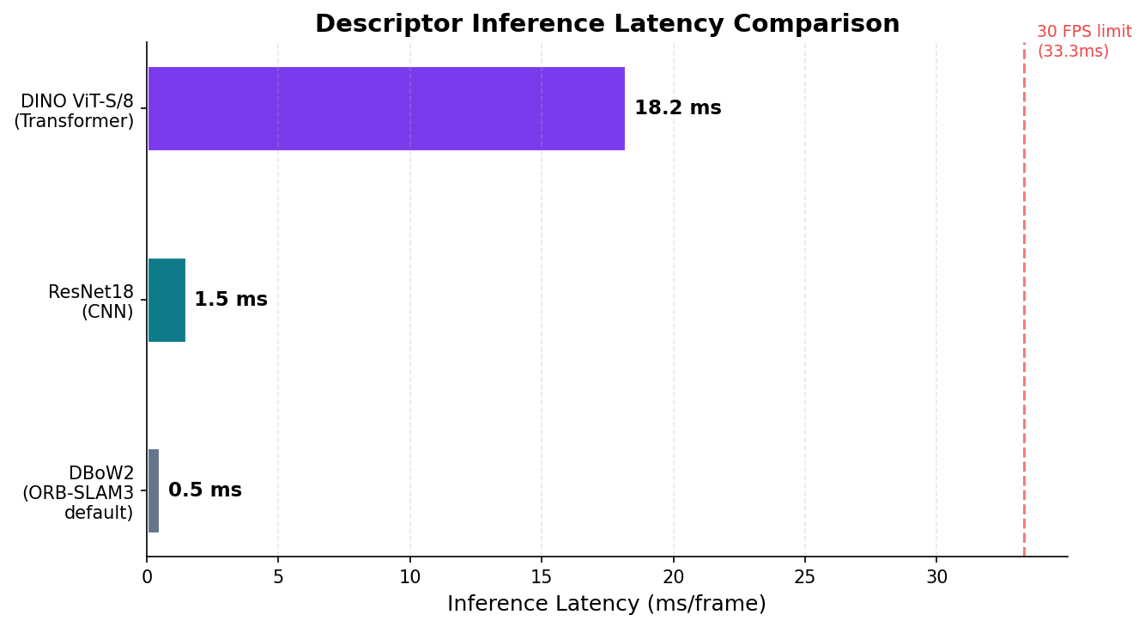
Figure 10: Descriptor Inference Latency — DBoW2, ResNet18, and DINO ViT-S/8 (ms/frame), with 30 FPS real-time limit marked

8.4 Analysis of Key Findings
Finding 1 — CLAHE reduces ATE by 49.5% on challenging scenes
On TUM fr1/desk, CLAHE reduces ATE RMSE from 0.0307m to 0.0155m. Max error drops from 8.9cm to 5.0cm (44%). Sensor-aware preprocessing significantly improves ORB feature quality in indoor scenes with moderate texture and varied lighting.
Finding 2 — CLAHE has negligible effect on well-lit, high-texture scenes
On TUM fr2/xyz, the baseline already achieves near-perfect accuracy at 2.7mm. The marginal 0.4mm CLAHE increase is within measurement noise. RPE is virtually unchanged across both sequences, confirming CLAHE affects global consistency, not local motion estimation.
Finding 3 — ResNet18 is viable for edge deployment
1.5ms per frame with loop closure scores of 0.96–0.99 — comfortably viable for real-time edge deployment including the Jetson Orin Nano.
Finding 4 — Loop closure integration is future work
Both modules detect loop closure candidates and publish them via ROS topics. Integration with ORB-SLAM3's C++ pose graph optimisation is scoped for Phase 2. The ATE improvement reported here is entirely attributable to CLAHE preprocessing.

Conclusion and Future Scope

9.1 What Worked Well
- CLAHE preprocessing exceeded initial targets - The initial expectation was a modest 10–15% ATE reduction based on the preprocessing literature. The achieved 49.5% ATE reduction on TUM fr1/desk significantly exceeded this. Enhanced contrast visibly improved ORB feature detection quality — brick textures, edges, and structural details are sharper in the CLAHE output compared to naive greyscale conversion.
- Critical OpenCV version conflict identified and resolved - The most technically challenging problem encountered was diagnosing the silent image corruption caused by a mismatch between the OpenCV version linked by the ROS cv_bridge library (4.2) and the version required by ORB-SLAM3 (4.4). This caused ORB-SLAM3 to print 'WAITING FOR IMAGES' indefinitely despite images arriving correctly at 40Hz — a non-obvious failure with no error message. The root cause was identified through systematic debugging of the ROS/C++ boundary, and resolved by rebuilding cv_bridge from source against OpenCV 4.4. This fix is not documented in any official guide.
- Both loop closure modules working in real time - ResNet18 and DINO ViT both reliably detect loop closure candidates. Similarity scores of 0.96–0.99 (ResNet18) and 0.90–0.93 (DINO ViT) confirm effective place recognition. ResNet18 at 1.5ms/frame is well within real-time constraints.
- Single script launch achieving full reproducibility - The complete six-node pipeline launches from a single shell script with no manual intervention.

9.2 What Didn't Work — Failed Scenarios and Unexpected Observations
- Loop closure not integrated into pose graph - The most significant limitation. Both deep learning modules detect candidates but do not feed back into ORB-SLAM3's trajectory correction. The 49.5% ATE improvement is entirely from CLAHE — the trajectory impact of CNN/ViT loop closure remains unmeasured.
- CLAHE has no effect on well-lit, high-texture scenes - On TUM fr2/xyz, CLAHE produced a marginal 13.8% ATE increase rather than improvement. The baseline already achieves 2.7mm RMSE — there is no headroom for improvement. CLAHE is beneficial only in challenging lighting conditions, not universally.
- Stochastic variation in ORB-SLAM3 runs - Multiple runs of the same sequence produced different ATE values due to random map initialisation. One outlier run (0.48m ATE) caused by tracking failure was discarded. Highlights the need for multiple runs and statistical reporting.
- Monochromatic input is simulated, not real - CLAHE is applied to colour camera footage to simulate monochromatic input. A true monochromatic sensor has a different spectral response and noise profile. Results represent a lower bound — real hardware may show larger improvements.

9.3 Conclusion
Phase 1 delivers three working contributions: CLAHE preprocessing, ResNet18 loop closure detection, and DINO ViT loop closure detection — all integrated into a ROS-based monocular SLAM pipeline and evaluated on TUM RGB-D sequences.
The key finding is that sensor-aware preprocessing measurably improves trajectory accuracy — CLAHE reduces ATE by 49.5% on fr1/desk. ResNet18 is confirmed viable for edge deployment at 1.5ms/frame. The trajectory impact of deep learning loop closure will be quantified in Phase 2 following pose graph integration.

9.4 Future Scope — Phase 2
- Loop closure pose graph integration — Modify ORB-SLAM3's LoopClosing.cc to accept external CNN/ViT candidates and trigger pose graph optimisation. Primary Phase 2 objective.
- EfficientNet descriptor — Add EfficientNet-B0 as a third descriptor. Better accuracy than ResNet18 at half the parameters — more suitable for edge deployment.
- Edge hardware deployment — Deploy on NVIDIA Jetson Orin Nano. Measure FPS, ATE, and power consumption across all descriptors.
- Real monochromatic camera — Replace simulated input with a real single-channel sensor to validate preprocessing pipeline on actual hardware.
- Extended benchmark evaluation — TUM fr3 and KITTI sequences. Five independent trials per configuration for statistical significance.

References
[1] C. Campos et al., "ORB-SLAM3," IEEE T-RO, vol. 37, no. 6, pp. 1874–1890, 2021.
[2] R. Arandjelovic et al., "NetVLAD," IEEE/CVF CVPR, 2016.
[3] M. Caron et al., "DINO," IEEE/CVF ICCV, 2021.
[4] J. Engel et al., "DSO," IEEE T-PAMI, vol. 40, no. 3, pp. 611–625, 2018.
[5] N. Keetha et al., "AnyLoc," IEEE RA-L, 2024.
[6] J. Sturm et al., "TUM RGB-D Benchmark," IEEE/RSJ IROS, 2012.
[7] K. He et al., "ResNet," IEEE/CVF CVPR, 2016.
[8] S. Lowry et al., "Visual Place Recognition Survey," IEEE T-RO, vol. 32, no. 1, 2016.

