Anish Dhesikan

Research Topic Algorithms and Data 2015

I have been working on a first-person puzzle game since May of 2014. I am the Lead Programmer and Lead Designer, and have done all the programming up to this point. The game is called Retrgrade (for now), and has been approved on Steam Greenlight, a community that votes for games to be sellable on the largest PC game store, Steam.

In the game, there are cubes that activate buttons (similar to Portal, if you know it). These buttons then have pointers that indicate which door they open (see image below). Thus far, I have been hand-placing these indicators. What I want to do for my project is create a pathfinding algorithm in 3D space that will automate the placing of these indicators from a button to a door. This algorithm may be extensible to 3d pathfinding on surfaces in general, similar to the way a spider behaves. For example, if a spider is on the left wall, what is the optimal path for it to get to the center of the right wall? This may be able to be used in Minecraft for their spider mobs to actually be able to climb up walls instead of just floating up the wall towards the player. There may need to be additional settings that handle obstacles or let the user set points that must be included in the path so that it is easier for use in my game (there may be multiple “shortest” paths, so these options will help find the one that will look the best in the game).

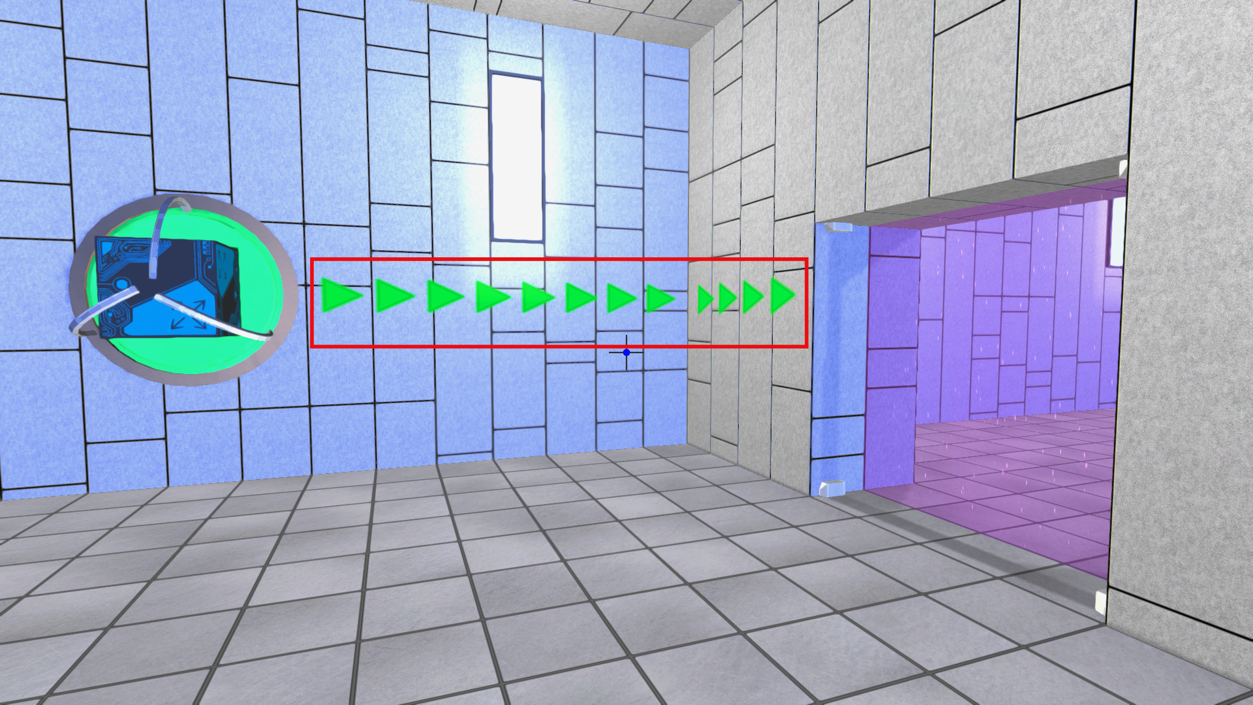

Here are some references for possible research. There is no algorithm publicly researched that directly solves this “spider problem” as far as I know. However, the following sources may be useful for pathfinding in general.

<http://www.policyalmanac.org/games/aStarTutorial.htm>

<http://en.wikipedia.org/wiki/Pathfinding>

I may even be able to convert this 3D pathfinding problem into a simpler one that uses one of the above algorithms.