To,
Human Resources Department
MAF Technologies Pvt Ltd

Dear Madam,

I, (Sneha Patil) – (Employee Code – MTPL117) acknowledge and confirm that with the payment of Rs. 40,107/- (Indian Rupees Fourty Thousand One Hundred Seven only), all my dues will be fully and finally settled and paid by MAF Technologies Pvt as per the Company’s existing policies applicable to me at the time of cessation of my employment.

I confirm that I have no claim (monetary or otherwise) against the MAF Technologies Pvt Ltd.

We thank you for your contribution during the tenure of this engagement and take this opportunity to reiterate key contractual obligations that remain binding beyond the term of the agreement:
1. Confidentiality
As per Clause 7 of the Agreement, you are required to maintain complete confidentiality of all information shared by the Company during the engagement. This obligation shall continue for a period of two (2) years post-expiry, and any disclosure or use without written consent from the Company will be deemed a breach.
2. Intellectual Property Rights
All content, media, strategies, materials, and other work products created during the engagement are the exclusive intellectual property of the Company as per Clause 6. You shall not reproduce, distribute, use, or share any part of these works without prior written approval from the Company.
3. Non-Use Without Consent
You are not permitted to use, modify, or commercialize any deliverables, project outputs, or insights gained from the engagement for your personal, third-party, or commercial use without the express written consent of the Company.
4. Return of Company Materials
You are required to return all files, materials, documents, data (physical or digital), or assets provided during the course of the engagement. If not already submitted.
5. Indemnity and Compliance
Any breach of the above clauses will attract appropriate legal recourse as per Clause 9 of the Agreement. You are also responsible for compliance with any remaining provisions of the Agreement.

We request you to kindly sign and return the acknowledgment below confirming your understanding and agreement to the above.
We appreciate your cooperation and wish you success in your future endeavors.

Date: 04/03/2026

Signature of Employee: 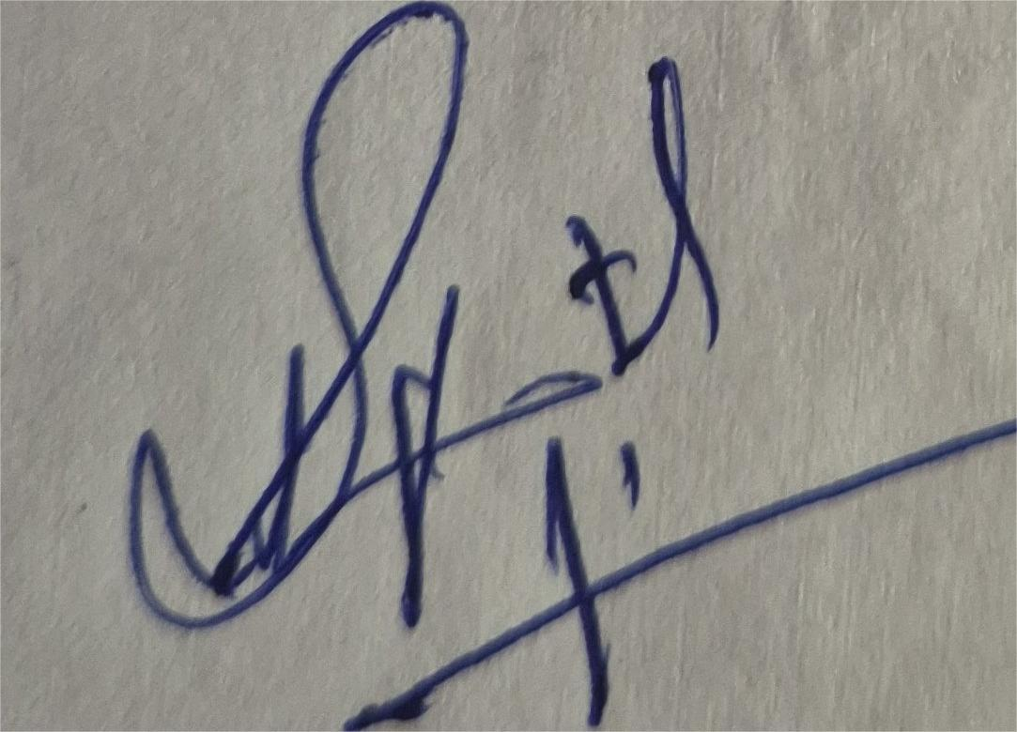
SNEHA PATIL

