🔷 MODULE: KITS DISPATCH MANAGEMENT (WITH MOU INTEGRATION)

🔶 1. MOU DASHBOARD ENHANCEMENT (ENTRY POINT)
Current Flow:
Generate MOU → Save Draft → MOU Pipeline → Upload Signed MOU → MOU Registry (Final Data Entry)
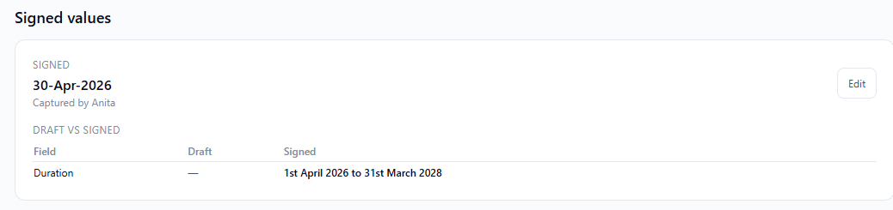
➤ Generate MOU
✅ Key Features:
- Edit allowed till MOU is signed
- Preview screen before final submission
- Calendar-based duration (Start Date – End Date)
➤ New Fields to be Added in Generate MOU:
1. Product Selection
- Options:
  - Tinkrworks
  - Cretile
Behaviour:
- User can select:
  - Only Tinkrworks
  - Only Cretile
  - Both

2. Grade-wise Student Distribution (Optional Field)
Grade | No. of Students | No. of Kits | Type – Tinkrworks or Cretile or Both (Reusable/Consumable)
Grade 1 | ___ | Optional | Dropdown
Grade 2 | ___ |  | Dropdown
… | ___ |  | Dropdown
Grade 12 | ___ |  | Dropdown
Total | Auto-calculated

In MOU Pipeline:
The above added fields should be visible in MOU Pipeline also. If the Sales team doesn’t have the data at the time of MOU Generation then they can enter the data here i,e. at the time of uploading the signed MOU in the system.
Once the signed MOU is submitted, The data will pass on to :
      - MOU registry – where all the payment tracking will happen.
      - Kit Dispatch section (New section) – Tracking the delivery of Kits

🔶 2. NEW TAB: “KITS FOR DISPATCH” (MAIN LIST VIEW)
This tab acts as the central tracking dashboard

➤ List View Columns:
School Name | Payment Status | Product Selected | Dispatch Status
ABC School | Status | Tinkrworks, Cretile | Not Started

➤ Conditions:
- Entry should appear here only after MOU is completed
- Payment status auto-fetch from Payment module
- Single backend → no mismatch across departments

🔶 3. SCHOOL LEVEL VIEW (ON CLICK OF SCHOOL NAME)

➤ Data Behavior:
Case 1: Sales entered data in MOU
→ Auto-reflected
Case 2: Sales DID NOT enter
→ Ops (Shashank) will enter data

➤ Section: Grade-wise Allocation
Grade | No. of Students | No. Of Kits (Qty) | Type (Reusable or Consumable) | Product Name
Grade 6 | 30 |  | Dropdown | Dropdown
Grade 7 | 20 |  | Dropdown | Dropdown

Product Dropdown Rules:
- Should show only products selected in MOU
- Example:
  - If only Tinkrworks selected → only Tinkrworks options visible
  - If both selected → both visible

➤ Action:
- Submit Allocation

➤ NEW VALIDATIONS:
✅ Inventory Linked Restriction
- Allocation cannot exceed available stock
➤ After Submit:
- Notification sent to Assigned Sales Person
🔶 4. SALES APPROVAL WORKFLOW
Sales person receives notification and opens request.

➤ Actions Available:
1. Approve
2. Reject (Mandatory Remarks)

➤ If Rejected:
- Sent back to Shashank
- Allocation becomes editable again
- Sales remarks visible for correction

➤ If Approved:
- System generates Dispatch Planning Summary

🔶 5. DISPATCH SUMMARY (SALES SIDE – EDITABLE)

➤ Auto-Fetched Details:
Field | Value
School Name | Auto from MOU
Address with Pincode | Auto from MOU
Contact Person Name | Auto from MOU
Contact Number | Auto from MOU

If auto fetched data isn’t correct, then the sales guy should be able to edit the same.
➤ IMPORTANT CHANGE:
✅ If Sales edits any above field:
- System updates School Master Data

➤ Kits Planning Table:
Grade | Students | Product | Type | Qty
Grade 6 | 30 | Tinkrpython |  | 7
Grade 7 | 20 | Tinkrsynth |  | 8
Grade 8 | 10 | Cretile G8 Kit |  | 5
Total | 60 |  |  | 20

➤ Additional Field:
- For any remarks that sales guy want to add
(Eg : Kits are returnable after course is completed)
Only school details can be edited and not the kits requirement table.

➤ Once Sales guys approve, It issued be provided a notification to accounts for Dispatch execution.

🔶 7. ACCOUNTS – DISPATCH EXECUTION
Accounts will handle actual dispatch + Tally integration

Once accounts click on the raise request raised -

➤Request Received Example
Field | Value
School Name | ABC School
Address | 123 Street, Nashik - 422001
Contact Person | Mr. Sharma
Contact Number | 9876543210

Grade | Students | Product | Requested Qty
Grade 6 | 30 | Tinkrpython | 7
Grade 7 | 20 | Tinkrsynth | 8
Grade 8 | 10 | Cretile G8 Kit | 5
Total | 60 |  | 20

Also, additional remarks if any added at the time of raising the request.

➤ Real Scenario:
- Cretile stock not available → Partial dispatch

➤ Accounts Entry Screen:
Grade | Students | Product | Requested Qty | Actual Dispatched
Grade 6 | 30 | Tinkrpython | 7 | 7
Grade 7 | 20 | Tinkrsynth | 8 | 8
Grade 8 | 10 | Cretile G8 Kit | 5 | Nil

Rules:
- Only “Actually Dispatched” should be filled by accounts
- Other fields auto filled from request

➤ Delivery Challan Handling:
- Accounts create Delivery Challan in Tally
- System should allow:
  - Upload Delivery Challan
  - Download option
  - Email to Warehouse

🔶 8. STATUS LOGIC (VERY IMPORTANT)

➤ Case 1: Partial Dispatch
Requested | Dispatched
5 | 0
Since Cretile kits were not dispatched.

👉 Status: Pending for Dispatch

➤ Case 2: Fully Dispatched
Requested | Dispatched
20 | 20
👉 Status: Completed

🔶 9. INVENTORY MODULE (INTEGRATED)
➤ Inventory Table:
Product | Available Qty | Inward | Outward

➤ Rules:
- Outward auto-reduced after dispatch
- Inward → only Accounts
- Real-time visibility to all teams

🔶 10. SHIPMENT TRACKING (NEW – CRITICAL ADDITION)
➤ Step After Dispatch:
Handled by Ops
➤ Tracking Fields:
Field | Details
Courier Name | Manual
Tracking ID | Manual
Dispatch Date | Auto/manual
Expected Delivery | Optional
Delivery Status | In Transit / Delivered
POD Upload | Proof of Delivery

➤ POD Logic:
- POD upload = confirmation of delivery
- Mandatory to close dispatch

🔶 11. STATUS LOGIC (UPDATED)
Scenario | Status
Not dispatched | Not Started
Partial dispatch | Pending
Dispatched, no POD | In Transit
POD uploaded | Delivered ✅

🔶 11. FINAL DISPATCH SUMMARY
School | Product | Dispatched Qty | Status | POD

Include the Inventory Module. (Similar to you made for GSL OPS)- Just name of all the kits with actual qty available. Will be reduced as the dispatch is done i.e. Outward. A column to add inward Qty – only accounts to add this.
Include the communication templates –

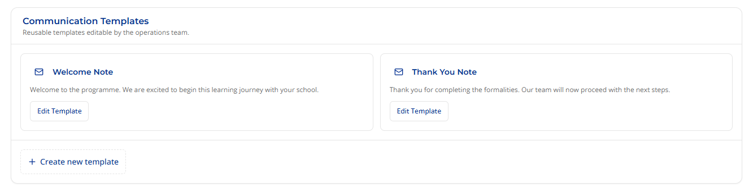

Generate MOU –
To have an edit Option till the document is signed. Their should be a preview screen if possible where Sales person can just go back & edit till the document is signed.

In MOU Pipeline -
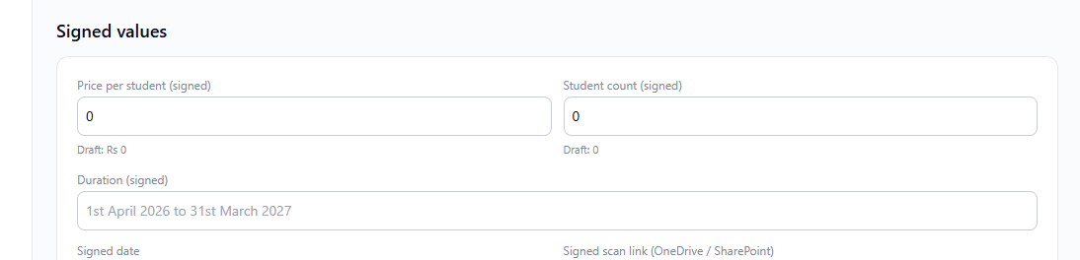

-The duration should be Calender.

Query :
Is it possible for admin to rectify any data entered by the users in the system ? If yes how ?

Thinking
Currently Focusing on the flow to be set. So, entire data is getting captured at one place. Then : Each department : Finance, Ops , Sales (may be Sales rep wise) have separate logins & only the relevant / required data will be visible to them.
For Ops & finance – You have an idea of the requirement. I just want a data source for each dashboard should be same to avoid the mismatch. So, we can just build an add on to the GSL MOU System you created for Finance to include ops to make a whole one system.

